HOW FAR IS KOREA FROM US?

Unit 1
🎓 Grade Level:
6th, 7th, and 8th grades

⏰ Teaching Time:
40 + 40 minutes + Homework

Concepts to Digest: Far-near, distance, geographical distance, travel, means of transportation
Skills to Improve: Spatial awareness, map literacy, understanding change and continuity, understanding time and
chronology, historical empathy, and self-regulation

Core Values: Courage

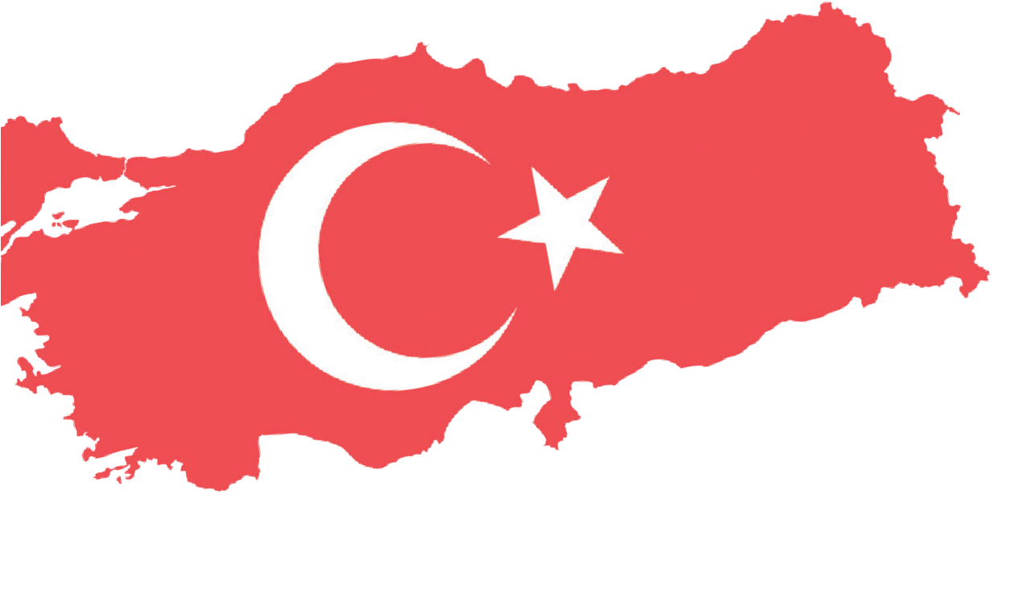


Teaching Methods-Techniques: Lecturing, historical inquiry, oral history, hypothesis-based case study
Teaching-Learning Materials: Outline map, fictional stories, video recordings, internet resources
Overall Learning Aim: This activity aims to help students understand how advances in transportation technologies and vehicles have altered people’s perception of geographical distance, using journeys between Türkiye and Korea in different time periods as examples. Additionally,
the activity seeks to ensure that students learn about the means of transportation used by Turkish troops when traveling to Korea and to understand their experiences during those journeys.
Key Question: How have advances in transportation technologies transformed people's perception of geographical distance and travel experiences in different historical periods?
Guiding Question 1

How have developing means of transportation and technologies changed the
duration, comfort, and the way in which people experience journeys between Türkiye and the Korean Peninsula over time?

Objective 1

To evaluate the effects of developments in transportation technologies on people’s perception of distance and their travel experiences through analyzing fictional journey stories between Türkiye and the Korean Peninsula in different historical times.
Task 1
Students are asked/invited to analyze sources D, E, F, G, H, and I, and to answer the related questions.
Guiding Question 2

How have the preparation for the journey, the challenges encountered during the trip, and the experiences gained by individuals traveling between Türkiye and the Korean Peninsula differed in various historical times/periods?

Objective 2

To develop historical empathy and to compare the living conditions of the past with those of today by examining the travel experiences of people who lived in different times.
Task 2
Students are asked/invited to review sources J, K, and L and write a letter from the perspective of a chosen
historical character, reflecting the conditions of the period.
Guiding Question 3

To what extent might personal narratives about a specific geographical location align with information found in published sources?
Objective 3

To acquire the skills of evaluating the accuracy of historical information and analyzing geographical features by comparing oral history narratives with published sources.
Task 3
Students are asked/invited to compare and contrast the information obtained from
analyzing source M with findings from Internet research and to answer the related questions.

Teaching and Learning Plan

‼ Focus on Activity
Students are asked to examine the Blank Map of Asia provided in Source A. The locations
of Türkiye and the Korean Peninsula, along with the geographical distance between them, are then highlighted.
5 min.
Students are asked/invited to examine sources B and C and to answer the questions.
5 min.

🛎 Task 1
Students are asked/invited to analyze sources D, E, F, G, H, and I and to answer questions about modes of transportation, travel times, and travel routes across different time periods.
🛎 Task 2
Students are asked/invited to examine sources J, K, and L, and to answer the related questions. Afterwards, students write a letter from the perspective of a selected historical figure, reflecting the period's conditions. Some of these student-written letters are then read aloud in class.
🛎 Task 3 (Oral History Activity)

20 min.

25 min.

Students are asked/invited to compare the information obtained from analyzing source M with findings from Internet research and to answer the given questions.
20 min.
🎯 Assessment and Evaluation
Students are asked/invited to answer open-ended questions related to the completed lesson.
5 min.
🏠 Homework
Internet-based research will be conducted at home. The final product of this assignment will be stored electronically in students’ digital portfolios.

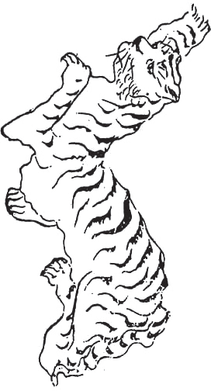
Teaching and Learning Process
Focus on activity: The partial world map below is shown to the students, and the colored areas highlight Türkiye and the Korean Peninsula.
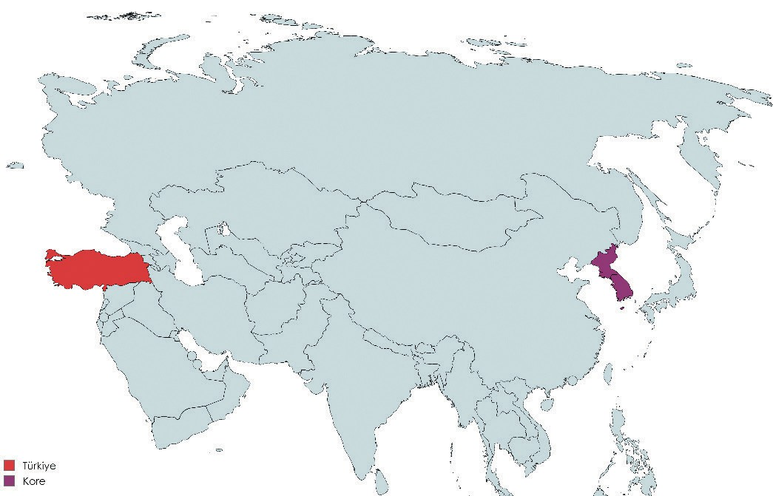
Source A: Blank Map of the Asian Continent (Adapted and prepared by the authors)

Question: What might be the approximate straight-line distance (as the crow flies) between the Korean Peninsula and Türkiye?
Step 1: Students are asked to examine Sources B and C (adapted and prepared by the authors).
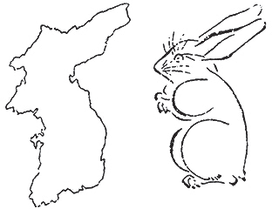
Source B: A map and a figure drawn based on that map
(WikimediaCommons.org, 2024a)
Source C: Another figure produced using the map in Source B as a reference (WikimediaCommons.org, 2024b)

Step 2: Students are asked/invited to answer the following questions based on Sources B and C.
- 1What might be the country or region represented by the map on the left side of Source B?
- What do the figure on the right side of Source B and the one in Source C remind you of?
- Provide three examples of countries located between Türkiye and the Korean Peninsula on a world map.
- Using the latitude and longitude coordinates of Türkiye and the Korean Peninsula, calculate the mathematical distance between the two regions (Türkiye: 36–42° N, 26–45° E; Korean Peninsula: 34–43° N, 124–132° E).

Guiding Question 1: How have the development of means of transportation and technologies changed the duration, comfort, and way in which people experience journeys between Türkiye and the Korean Peninsula over time?
Task 1: Students are asked/invited to analyze sources D, E, F, G, H, and I and to answer related questions about modes of transportation, travel times, and routes across different historical periods.
Step 3: Students are asked/invited to read Sources D, E, and F (prepared by the authors).

Source D: Eda’s Journey | Source E: Seher’s Journey | Source F: Marco’s Journey
My name is Eda. Next month,  I will travel to South Korea to attend a concert of my favorite music group. I estimate that my trip from İstanbul to Seoul will take approximately 10 hours. | I am Nurse Seher. I am traveling to the city of Busan to help those who are there bring our wounded soldiers back home during the Korean War. I think  my journey will take about 20–25 days, similar to the travel time of our soldiers fighting there. | My name is Marco. I am a traveling merchant living in the 13th–14th centuries. I will set out tomorrow for East Asia. I estimate that my journey will take approximately 2.5 years.

Step 4: Students are asked/invited to examine the blank maps in Sources G, H, and I (which were adapted and prepared by the authors).

Source G Source H Source I
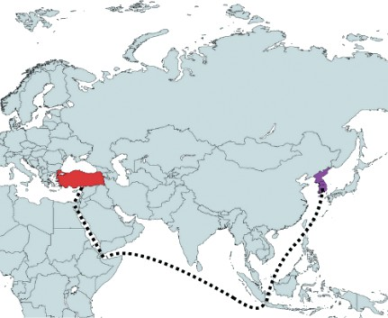
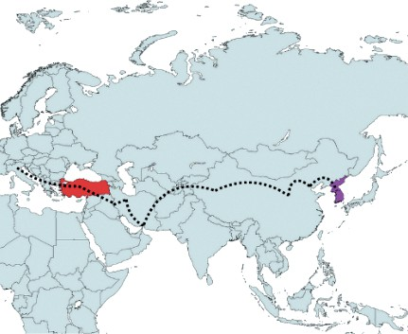
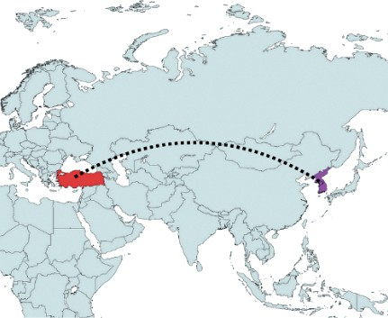

Step 5: Students are asked/invited to answer the following questions based on Sources D, E, F, G, H, and I.
- What means of transportation might Eda, Seher, and Marco be using? Write your answers.
Eda …………….. Seher ……………... Marco ……………..
- Identify which characters correspond to the travel routes shown in the maps in Sources D, E, and F. Eda …………….. Seher …………….. Marco ……………..
- Indicate the historical time or period in which Eda, Nurse Seher, and Marco lived or may have lived.
Eda …………….. Seher …………….. Marco ……………..

Guiding Question 2: How have the preparation for the journey, the challenges encountered during the trip, and the experiences gained by individuals traveling between Turkey and the Korean Peninsula differed in various historical times/periods?
Task 2: Students are asked/invited to review sources J, K, and L and write a letter from the perspective of a chosen historical character, reflecting the conditions of the period.
Step 6: Students are asked/invited to examine the Sources J, K, and L below. (The authors prepared Sources J, K, and L.)

Source J: Eda’s Travel Preparation | Source K: Seher’s Travel Preparation | Source L: Marco’s Travel Preparation
I placed my passport in my bag.  I packed the charger for my smartphone, which I will use in Seoul for communication, getting directions, and taking photos. Even if I forget it,  I can easily find a compatible charger anywhere. It won’t be a problem if my foreign language skills aren't sufficient, because I can use online translation  on my phone and purchase all my tickets online. I don’t even need to ask people for directions because I can get navigation for all locations on my phone. I do not need to carry cash; I can make payments either with my  credit card or with apps on my phone. I purchased an international data plan so that I can share the photos and videos I take on social media. I am very excited to finally be able to eat my favorite Korean dishes in Korea. | Since we will be traveling by ship, we have arrived in  İskenderun. An interpreter has been assigned to accompany us and assist us during the journey. We were told to  keep our passports with us at all times. I have also learned that sea travel can  be both delightful and quite uncomfortable. I heard that the food there is very different from ours. Although I am making this journey as part  of my duty, I feel both excited and anxious because I am worried about my potential encounters with people who have experienced the horrors of war in a foreign land. | I am setting out on a long journey, and with me I am taking my compass, my travel journal, and some gold. I heard that in some places I am going, they use stamped pieces of paper as money. I will pass through many countries during my travels. I heard that in some khanates along my route, nomads live in felt-covered tent-like dwellings. I expect to see many different cities, climates, plants, foods, animals, clothing styles, and objects; I plan to write down these observations and share them with others.

Step 7: Based on the information provided in Sources J, K, and L, students are asked/invited to answer the following questions.
- What kinds of preparations did Eda, Seher, and Marco make for their journeys?
- What can be said about the psychological states and expectations of these three individuals, who lived in different periods but were preparing for journeys along geographically similar routes?
- In your opinion, whose journey, Eda’s, Seher’s, or Marco’s, required the most courage? Why?
- If you were to travel to a country you had never been to before, what would make you anxious most, and what would you do to overcome this anxiety?
- Research who Marco might have been and his historical significance, and explain how his travels contributed to the Silk Road trade and the cultural interaction between Eastern and Western societies.

Step 8: [This part of the activity is assigned as homework.] Students are asked to complete the following task:
Imagine yourself in the shoes of one of the three characters above. Write a letter to a friend back in Türkiye one week after arriving in Korea. In your letter, discuss not only your personal experiences but also your observations on the social, economic, and cultural effects of transportation technologies during that time.

While writing the letter, the following guiding questions may help you:
- What kinds of preparations did you make before the journey?
- Before the journey, what information did you learn about the place you were going (Korea), such as its geographical features, population, culture, livelihoods, etc.?
- What kind of country and what types of people did you expect to encounter when you arrived in Korea?
- To what extent were the items and money you brought with you seem sufficient to meet your needs? Why?
- During your journey:
  - What did you do?
  - Which places did you visit or pass through?
  - Whom did you meet? ç. What did you learn?
  - How did you feel?
- During your journey and after arriving in Korea, how did you meet your nutritional needs? How satisfied were you with the food you had?
- During your journey and after arriving in Korea, how did you communicate with others? What are your first observations/impressions about Korean society and culture?

Dear My Friend ...................

I am writing this letter from Korea, where I arrived just a few days ago. ................................................
..................................................................................................................................................................
..................................................................................................................................................................
..................................................................................................................................................................
..................................................................................................................................................................
..................................................................................................................................................................
..................................................................................................................................................................
..................................................................................................................................................................
..................................................................................................................................................................
..................................................................................................................................................................
..................................................................................................................................................................
..................................................................................................................................................................
..................................................................................................................................................................
..................................................................................................................................................................
..................................................................................................................................................................

Guiding Question 3: To what extent might personal narratives about a specific geographical location align with information found in published sources?
Task 3: Students are asked/invited to compare and contrast the information obtained from analyzing source M with findings from Internet research and to answer the related questions.
Step 9: Students are asked/invited to listen to or read the relevant excerpts from the oral history interview conducted with Korean War veteran Mehmet Cemil Yaşar.
Source M: Selected Excerpts from the Oral History Interview with Veteran M. Cemil Yaşar
(https://koreanwarlegacy.org/interviews/mehmet-cemil-yasar/)

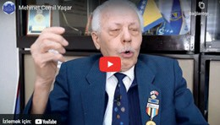
🕒 06:18-06:37
M. C. Yaşar: “Our convoy in Kunuri… Kunuri is like a plain, let’s say, the front part of a small town. Imagine a plain
with high-altitude mountains on its upper side. While we were going, we had gone further ahead beyond those mountains.”
🕒 07:14-07:54
M. C. Yaşar: “The mountains on the upper side are high, rocky places; one side of the road goes downhill, the other side uphill. When our fuel was not enough, we couldn’t climb the hill on the way back. The transport officer said to us, ‘Let me leave you here and send you fuel.’ The slope was very steep. We waited too long for the fuel, but it didn’t arrive, and the weather started getting dark. I made a difficult maneuver and turned the vehicle around. When I turned it backward, the fuel moved to the front. That way, we climbed the hill in reverse. While we were getting out of there, the enemy, the Red Chinese army, was positioned there and waiting for nightfall. From there, they attacked the 11th battalion. The 11th battalion… There was an American liaison officer named Gamby. A liaison officer… They captured him there.”

Step 10: Students are asked/invited to answer the following questions based on the oral history interview with Korean War veteran Mehmet Cemil Yaşar.
- What geographical details stand out in Veteran M. Cemil Yaşar’s narrative?
- What comparisons or metaphors does Veteran M. Cemil Yaşar use in his account?
- What historical inferences can be drawn from his narrative? Why?
- According to his account, what strategic advantages and disadvantages might the landforms of the Kunuri region have presented for the soldiers fighting there?
Step 11: Research what kinds of landforms characterize the Kunuri region on the Korean Peninsula using Internet sources. (You may refer to geographical maps, scientific articles on the physical geography of the Korean Peninsula, guidebooks discussing the topography of the Kunuri region, and military history sources.)
Step 12: Students are asked/invited to answer the following questions.
- To what extent do the details you learned from Internet sources overlap with what Veteran Mehmet Cemil Yaşar described about the Kunuri region?
- The landforms mentioned here can be compared to which regions in Türkiye? Why?



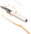

Note: Steps 11 and 12 may be assigned as homework.

🎯Assessment and Evaluation
- How have changes and advancements in transportation technologies affected long-distance travel, and in what ways?
- What are the risky or disadvantageous aspects of traveling to different countries and/or geographical regions? Research and explain.
- What benefits does travel to different countries and/or geographical regions offer to individuals?

References
Han, J. (2018). Interview with Mehmet Cemil Yaşar https://koreanwarlegacy.org/interviews/mehmet-cemil-yasar/ Access Date: 14.01.2024
Wikimedia Commons. (2024a). Bunjiro Koto’s Korean peninsula rabbit. https://commons.wikimedia.org/wiki/ File:Bunjiro_Koto%27s_Korean_peninsula_rabbit.jpg Access Date: 14.01.2024
Wikimedia Commons. (2024b). Choe Nam-seon’s Korean peninsula tiger. https://commons.wikimedia.org/wiki/ File:Choe_Nam-seon%27s_Korean_peninsula_tiger.jpg Access Date: 14.01.2024

🏠
Homework: Internet-Based Research
Research what kinds of landforms characterize the Kunuri region on the Korean Peninsula. Based on your research, write a text that answers the questions below. You may consult the following sources: geographical maps, scientific articles on the physical geography of the Korean Peninsula, guidebooks on the topography of the Kunuri region, and military history sources.
- To what extent do the details you learned from Internet sources overlap with what Veteran Mehmet Cemil Yaşar described about the Kunuri region?
- The landforms described here can be compared to which regions in Türkiye?

