FORMATION OF THE TURKISH BRIGADE
Unit 2
🎓 Grade Level:
6th, 7th and 8th Grades

⏰ Teaching Time:
40 + 40 minutes

Concepts to Digest: War, communication, soldier
Skills to Improve: Historical inquiry and analysis, historical empathy
Core Values: Patriotism, nationalism, altruism, self-sacrifice

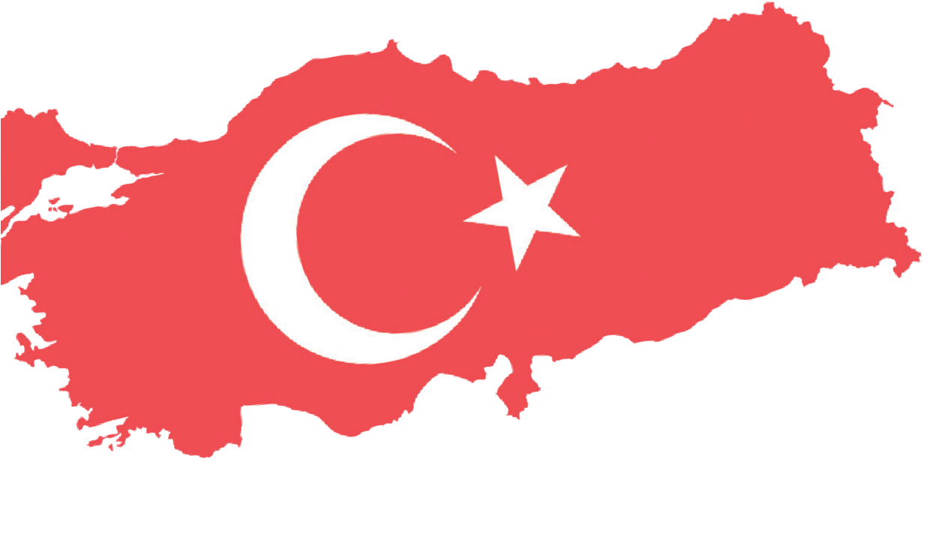
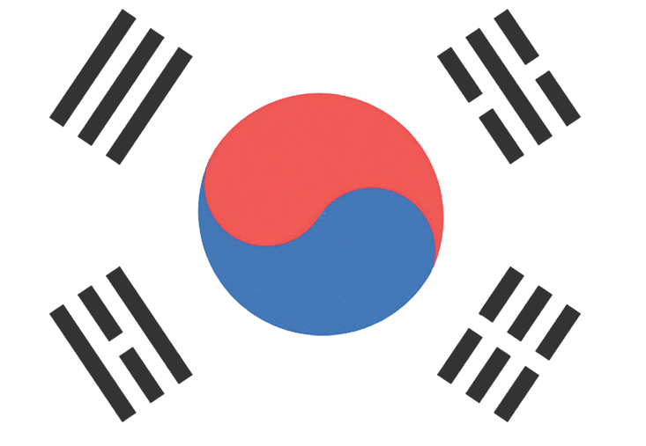

Methods–Techniques: Evidence-based historical research, inquiry
Teaching-Learning Materials: Photograph, diary/memoir
Learning Aim: To identify and understand how the first Turkish military unit planned for deployment to Korea in late 1950 was formed, and what preparations were made before the journey.
Key Question: How the first Turkish military unit sent to Korea on behalf of the United Nations was formed, and what preparations were made before the journey?

Guiding Question 1

According to which criteria were the soldiers selected to join the brigade, and what factors influenced the
determination of these criteria?
Objective 1

To understand according to which criteria the soldiers selected for the Turkish Brigade sent to Korea were chosen.
Task 1

The students are asked/invited to examine Sources B, C, D,
E, F, and G and to answer the related questions.
Guiding Question 2

What equipment was provided to the soldiers who would be sent to Korea, and what types of training did they receive?
Objective 2

To explain what weapons and equipment were provided to the Turkish units sent to Korea and what types of training they received.
Task 2

The students are asked/invited to examine Sources H, I, and J and to complete Tables 1 and 2.
Guiding Question 3

What communication problems did the Turkish soldiers sent
to Korea experience with their counterparts from other countries during the war, and
what solutions were developed to overcome these difficulties?

Objective 3

To analyze the measures taken to address language barriers that the Turkish Brigade might encounter both during the journey and while they were in Korea.

Task 3

The students are asked/invited to examine Sources K, L,
M, and N and to answer the related questions.

Teaching and Learning Plan

‼ Focus on Activity
The lesson begins with a world map excerpt on which Türkiye and Korea are marked. Using direct instruction techniques, the teacher provides students with background information about the Turkish units sent to the Korean War.
5 min.

🛎 Task 1
The students are asked/invited to examine Sources B, C, D, E, F, and G and to answer the
25 min.
related questions.

🛎 Task 2
The students are asked/invited to examine Sources H, I, and J and to complete Table 1 and
20 min.
Table 2.

🛎 Task 3
The students are asked/invited to examine Sources K, L, M, and N and to answer the
20 min.
related questions.

🎯 Assessment and Evaluation
5 min.
The students answer open-ended questions.

🏠 Homework
The students are asked/invited to prepare a presentation by combining the information they learned during class activities with the findings obtained through independent research. These presentations are then stored in the students’ digital portfolios.

Teaching and Learning Process
Focus on activity: The students are asked to examine Source A below. After this, it is explained that the route marked with dashed lines between Türkiye and the Korean Peninsula represents the shortest sea route. The students are then asked to predict what kinds of difficulties the first Turkish Brigade deployed to Korea in 1950 might have faced during their sea voyage.
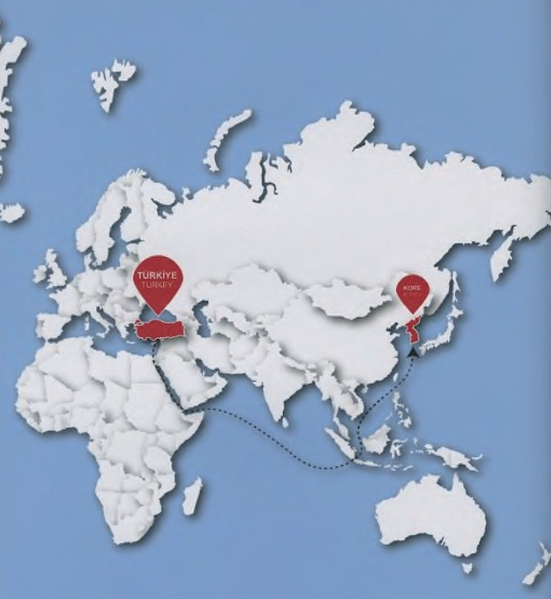
Source A: An excerpt from a blank world map (As. Müze ve Kül. Sit. Kom., 2019, s. 14)

Guiding Question 1: According to which criteria were the soldiers selected to join the Brigade, and what factors influenced the determination of these criteria?
Task 1: The students are asked/invited to examine Sources B, C, D, E, F, and G and to answer the related questions.
Step 1: The students are asked/invited to read Sources B, C, and D.

Source B: On the formation of the Turkish Unit to be sent to Korea
The first Turkish Brigade left on September 17, 1950. The reason for choosing a voluntary system to form the first brigade sent to the Korean War was mainly to prevent disrupting the discharge schedule of soldiers born in 1928, who were already serving and close to finishing their military service. Therefore, besides being born in 1929 and being healthy, no other requirements were needed for volunteering; this avoided the burden of transporting soldiers whose service was nearly over.
Due to the political and social conditions of the time, the deployment to the Korean War attracted substantial interest from both soldiers and the public. Many soldiers born in 1928, along with a number of civilians, volunteered to go to Korea. The government, the press, and even the Directorate of Religious Affairs launched propaganda campaigns about the Korean War. As a result, there was a high number of volunteer applications. Another goal of these propaganda efforts was to reduce potential public opposition to sending troops to Korea.
Additionally, officers, especially those holding the ranks of captain, first lieutenant, and second lieutenant, volunteered because they saw participation in the war as a rare career opportunity to be in combat and showcase their military skills. The first members of the brigade sent to Korea were all officers, non-commissioned officers, and enlisted men selected from active-duty army units (Compiled from Sipahi, 2007 and Işık, 2009).

Source C: Volunteering for Korea
Since the number of volunteers for Korea exceeded the number of soldiers to be sent, a lottery was held to determine which soldiers would be selected, and those chosen were also subjected to a medical examination. During a selection at a company in Kayseri, when the commander gave the order, “Those who wish to volunteer, take two steps forward”, the entire company stepped forward in unison (Sipahi, 2007, p. 96).

Source D: What the mother of a Korean War volunteer said
When an officer who had volunteered to join the unit to be sent to Korea told his mother about his decision, she replied: "Go, my son, you should go as well. I left your father in Çanakkale, and our honor was preserved. Your uncles sacrificed their lives at the War of Independence, and the homeland was saved. You, too, should fight in Korea so that freedom may be secured” (Gençel, 1952, p. 27).

Step 2: Students are asked/invited to answer the following questions based on Source B.
- According to Source B, the primary criterion for selecting soldiers for the Turkish Brigade prepared to be sent to Korea was voluntarism. What might be the main reason or justification for requiring soldiers to volunteer?
- According to Source B, who undertook what kinds of efforts to increase the interest of Turkish soldiers and the public in participating in the Korean War?
- Evaluate how the decisions mentioned in Source B of ‘not disrupting the discharge of soldiers born in 1928’ and ‘Officers wishing to demonstrate their military capabilities’ may have influenced the formation of the Turkish Brigade being prepared for deployment to Korea.
- In Source C, it is stated that all soldiers in a company volunteered to go to Korea, while in Source D, the words of a mother whose son volunteered are shared. What values or characteristics of the Turkish people might be reflected in the behavior of these soldiers and the soldier’s mother? Why?

Step 3: The students are asked/invited to examine Sources E and F.
Source E: Memories of Korean War veteran Ahmet Gökçeli
While I was continuing my military service in Konya in 1950, an order from the General Staff arrived. They requested that each company select soldiers who were impressive in appearance, tall, well-built, and capable. From Konya, we were sent to Ankara for medical examinations. After receiving a ‘fit for service’ report, we were handed over to the United Nations Turkish Brigade for Korea (Korsavaş, 1975).

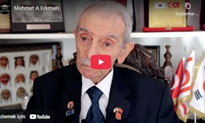
Source F: An excerpt from the oral history interview with veteran M. Aziz Erkmen (https://koreanwarlegacy.org/interviews/mehmet-aziz-erkmen/)
🕒03:08-03:14
M. A. Erkmen: “… I was one of those who was specially selected to
go. Specially chosen, in particular. … I went as a machinist sergeant; I was selected by preference.”

Step 4: The students are asked/invited to answer the following questions based on Sources E and F.
- According to Sources E and F, what additional criteria, other than voluntarism, were used to select soldiers for inclusion in the Turkish unit prepared for deployment to Korea?
- What might be the reasons for using these criteria during the selection process?
- How might the use of these criteria in selecting soldiers for the Turkish unit prepared for deployment to Korea have influenced the success of the military operation?
Step 5: The students are asked/invited to examine Source G.

Source G: Personnel table of the first Turkish Brigade Formed for deployment to Korea
Officers | 259
Non-commissioned Officers (76 of them were company sergeants) | 395
Military clerks/officials | 18
Civilian clerks/officials | 4
Enlisted Soldiers* | 4414
Total | 5090
* Among the enlisted soldiers in the first brigade sent to Korea, there were seventeen non-Muslim Turkish citizens of Armenian, Greek, Syriac, and Jewish origin, and one of these soldiers lost his life in the war. (Compiled from ATASE, 3-91 / 91-1-2; ATASE, 2-51 / 51-2; ATASE, 3-109 / 109-5; Dora, 1967; MSB, 1998.)

Step 6: The students are asked/invited to answer the following questions based on Source G.
  - After examining Source G, put yourself in the place of one of the soldiers who was assigned to travel to Korea or elsewhere to fight, possibly never to return home. Share your thoughts and feelings with your classmates.
  - The presence of non-Muslim citizens in the Turkish unit sent to Korea. What does this indicate about the social structure of Türkiye in the early 1950s?
Guiding Question 2: What equipment was provided to the soldiers who would be sent to Korea, and what types of training did they receive?
Task 2: The students are asked/invited to complete the table below based on the information obtained from analyzing Sources H, I, and J.
Step 7: The students are asked/invited to examine Source H.
Source H: The weapons provided to the Turkish Unit to be sent to Korea
It was decided that, like many units serving in Korea on behalf of the UN, the Turkish units would also be equipped with American weapons. The 241st Infantry Regiment, which arrived in Etimesgut, began guerrilla style training with infantry rifles on 25 August, 1950, under the supervision of an American lieutenant colonel. The following day, Turkish-made weapons were distributed to the other units. The General Staff ’s order dated 2 September, 1950, stated that the weapons and equipment to be taken to Korea would be supplied by the U.S. Army. During the sea voyage, Turkish rifles and pistols were ordered to be distributed to soldiers and officers (except medical personnel) so that they could practice marksmanship; these weapons would later be replaced with American models upon arrival in Korea.
In this order, it was also announced that three hundred American M1 infantry rifles, fifty American pistols, and seven three and a half inch rocket launchers would be procured to conduct training and firing exercises before departure and during the journey. Training with these weapons began on September 8, and brochures explaining their features in Turkish were printed and distributed to personnel. Additionally, American-made mortars used by various military units were allocated for training the troops preparing for deployment to Korea (Compiled from ATASE, 1-99 / 99-6-7; ATASE, 1-1 / 1-22-24; ATASE, 1-10 / 10-1-2; ATASE, 2-21 / 21-1-2; ATASE, 2-18 / 18-1; ATASE, 3-130 / 130-1.)

Step 8: The students are asked/invited to answer the following questions based on Source H.
- According to Source H, it was decided that the Turkish unit prepared for deployment to Korea would use American weapons in combat. What might be the reason for this decision? Research and explain.
- What might be the reason for beginning the training with Turkish weapons?

Step 9: The students are asked/invited to examine Source I.
17

Source I: The training activities of the units and their instruction in branch schools
The locations where the units, scheduled to undergo intensive training, would begin their instruction on 25 August were determined as follows:
The platoon headquarters and headquarters team, the infantry regiment, the anti-tank team, the medical company (excluding technicians), and the band (which would go to the Military Music School after first-aid training) would train in Etimesgut; the artillery battalion (with its guns and vehicles) at the Artillery School; the anti-aircraft battery at the Anti-Aircraft School; and the engineer company with the infantry regiment’s engineer team at the Engineers School. Of the communications teams, the brigade communications team would train at the Mamak Communications School; the communications teams of the infantry regiment and infantry battalions would train at the Çankırı Infantry School; and the medical technicians would train at the Medical Technician School.
It was decided that training would continue on weekends, with only 30th August observed as a holiday. The first phase of the training programs was scheduled to take place between August the 25th and September the 15th, and during September the 16th to the 23rd, the incomplete parts of these programs would be reinforced. The following points were considered in the training programs:
.• Emphasis on communication training for all unit types, especially combat in closed and difficult terrain;
- Company-level exercises with live fire, protection against armored vehicles and air forces, deployment and withdrawal maneuvers, night operations, and night firing;
- Training officers and non-commissioned officers in movement with a compass and applying map knowledge in the field;
- Gaining experience in setting up various types of encampments;
- Training highly skilled drivers, particularly for night movement and difficult terrain;
- Training the medical company in establishing dressing stations and evacuating casualties during different forms of combat, and training band members in first aid duties (ATASE, 2012, pp. 30-31).

Step 10: The students are asked/invited to complete the following table based on Source I, listing the training locations for the units to be sent to Korea (the number of rows may be increased as needed).
Table 1: Units and Training Locations

Unit | Training Location
Artillery Battalion | Artillery School
Step 11: The students are asked/invited to examine Source J.

Source J: The additional training provided during the preparation process and distributed equipment
(compiled from Işık, 2009)
Training Provided: Infantry training, close-combat training, psychological resilience training, trench-digging and defensive tactics training, cold-weather precautions, and tent-setup training.
Equipment Distributed: Compass, map, canteen, wool undergarments, coat, rifle, hand grenades, steel helmet, durable boots, first-aid kit, gauze, bandages.

Step 12: The students are asked/invited to complete Table 2 below using the information provided in the final part of Source I and Source J (the number of rows may be increased as needed).
Table 2: Training given to soldiers during the formation of the Korean Brigade, related equipment, and its intended purpose

Training | Related Equipment | Purpose
Compass and map-reading training | Compass, map | Learning how to determine one’s position on the battlefield and move in the correct direction
Company drills with live fire, infantry training, trench-digging, and defensive tactics training | Rifle, hand grenades, steel helmet | Protecting oneself and one’s comrades against armed attacks from the enemy
Guiding Question 3: What communication problems did the Turkish soldiers sent to Korea experience with soldiers from other countries during the war, and what solutions were developed to overcome these difficulties?
Task 3: The students are asked/invited to examine Sources K, L, M, and N and to answer the related questions.
Step 13: The students are asked/invited to read/examine Sources K and L.
Source K: The language problem in the Turkish Brigade in Korea
American sources claim that the Turkish Brigade had great difficulty understanding orders because so few personnel were able to speak English. Although a decision had been made not to take reserve officers to Korea, ten English-speaking reserve officers were sent immediately after the Battle of Kunuri.
According to the information provided by the late Muzaffer Sebükcebe, who served at the regimental headquarters of the first brigade sent to Korea, the brigade had only nineteen officers who were able to speak English. Most of these officers were unit commanders. In other words, the lack of English proficiency, or having very few personnel who spoke a foreign language, caused the Turkish Brigade serious problems in the early stages, some of which could not be easily corrected. The late İsmail Hakkı İnceoğlu, who served as a liaison officer during a period when both wired and wireless communication was cut off, also emphasized this point. At that time, the number of English-speaking officers was minimal. Korean interpreters gradually learned Turkish. (Summarized from Baltacıoğlu, 2007.)
Source L: Incidents and situations arising from the language barrier
On the night of 21/22 October at 23:00, I toured all the security lines of the garrison with the duty officers and reinforced weak points with additional sentries. It was clear that mistakes could occur during joint security duties when soldiers of two nations who did not know each other’s language were involved. Since the Turkish units were in the majority, I had previously proposed to the American garrison commander that all security duties be left entirely to us, but the proposal was not accepted.
That night at 23:30, two individuals approached our sentries near the wired fence east of the garrison. These individuals, who did not understand the command ‘Dur’ (‘Halt’) and were later identified

as Korean sentries arriving to conduct checks, did not stop even after a third warning. The sentry’s fire seriously wounded one, and the other fled. The duty officer and patrols who arrived at the scene informed me of the situation. The wounded man was treated; the next day, all Korean sentries were removed, and security duties were left entirely to us.
Since the official language of the United Nations Army was English, our sentries were taught to use the word ‘stop’ instead of ‘dur’ at the suggestion of the Americans, and warnings were given in this manner thereafter. In his book ‘Conversations from the Front’, Captain Hüseyin Çatalpınar recounts many similar stories related to the language barrier, including the case of a non-commissioned officer who ran out of gasoline and asked the Americans for help by saying, “Ay em Türkiş, benzin finiş.”
Throughout the war, difficulties stemming from a lack of language skills persisted; sometimes this led to irreparable mistakes, and sometimes to missed opportunities that could have worked in our favor. Since the number of interpreters in the regiment never exceeded four, these men had to undertake demanding duties, such as accompanying American units on joint reconnaissance missions with tanks (Selected excerpts adapted from Dora, 1967, pp. 50–53).

Step 14: The students are asked/invited to complete Worksheet 2.
- According to Source K, what were the causes of the communication problems experienced by the Turkish units in Korea due to a lack of foreign language skills?
- Give examples from Source L showing what kinds of problems or negative situations may arise in a multinational military structure when a common language is not used.
- According to Source L, who took what measures during the Korean War to reduce or overcome communication problems caused by a lack of foreign language skills?
Step 15: The students are asked/invited to examine Sources M and N.
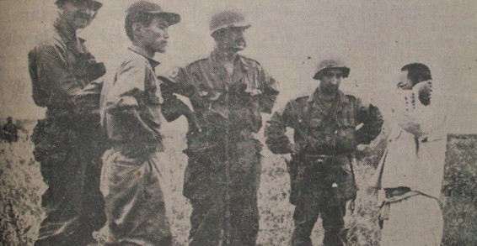
Source M: The interrogation of an enemy soldier captured by a Turkish Unit serving in Korea
(Dora, 1967, s. 328)

Source N: A translation story from the Korean War
In Korea, a Turkish officer asked a foreign correspondent (likely American or British) for help in German to interrogate a Chinese prisoner. The correspondent relayed the German question to a Korean interpreter in English. The interpreter then translated it into Korean for another Korean who is able to speak Chinese. That Korean interpreter finally directed/asked the prisoner the question in Chinese (Chang, 2020, p. 130).

Step 16: The students are asked/invited to answer the following questions based on Sources M and N.
  - What do the postures and body language of the people in the photograph in Source M convey?
  - How successful or effective do you think the method described in Source N, which the Turkish soldiers used to overcome communication problems caused by not being able to speak a foreign language, might have been? Share your thoughts.
  - In wars or in similar situations where people from different nations have to live together temporarily, what can be done to facilitate and improve communication amongst them? Research and explain.

🎯Assessment and Evaluation
- On what principles was the recruitment of soldiers for the Turkish Brigade prepared for the Korean War?
- What difficulties were encountered while forming the Turkish Brigade, and how were these problems solved?
- In your opinion, what mistakes were made in the formation of the Turkish Brigade, and what could have been done to prevent these mistakes?
- By analyzing the communication/language problems encountered during the formation of the Turkish unit sent to the Korean War, formulate authentic suggestions on how such issues could be resolved in similar international military operations.

References
Baltacıoğlu, T. (2007). Savaş içinde barış: Kore Savaşı anıları [Peace within war: Memoirs of the Korean War]. Yapı Kredi Yayınları.
Chang, D. C. (2020). The hijacked war: the story of Chinese POWs in the Korean War. Stanford: Stanford University Press.
Cumhurbaşkanlığı Devlet Arşivleri Başkanlığı Millî Savunma Bakanlığı Askerî Tarih Arşivi. ATASE [Presidency of State Archives, Ministry of National Defense, Military History Archive]. ATASE Record Group: 1–99, Place No: 99–6–7. (1950).
Cumhurbaşkanlığı Devlet Arşivleri Başkanlığı Millî Savunma Bakanlığı Askerî Tarih Arşivi. ATASE [Presidency of State Archives, Ministry of National Defense, Military History Archive]. ATASE Record Group: 1–1, Place No: 1–22–24. (1950).
Cumhurbaşkanlığı Devlet Arşivleri Başkanlığı Millî Savunma Bakanlığı Askerî Tarih Arşivi. ATASE [Presidency of State Archives, Ministry of National Defense, Military History Archive]. ATASE Record Group: 1–10, Place No: 10–1–2. (1950).
Cumhurbaşkanlığı Devlet Arşivleri Başkanlığı Millî Savunma Bakanlığı Askerî Tarih Arşivi. ATASE [Presidency of State Archives, Ministry of National Defense, Military History Archive]. ATASE Record Group: 2–21, Place No: 21–1–2. (1950).
Cumhurbaşkanlığı Devlet Arşivleri Başkanlığı Millî Savunma Bakanlığı Askerî Tarih Arşivi. ATASE [Presidency of State Archives, Ministry of National Defense, Military History Archive]. ATASE Record Group: 2–18, Place No: 18–1. (1950).
Cumhurbaşkanlığı Devlet Arşivleri Başkanlığı Millî Savunma Bakanlığı Askerî Tarih Arşivi. ATASE [Presidency of State Archives, Ministry of National Defense, Military History Archive]. ATASE Record Group: 3–130, Place No: 130–1. (1950).
Cumhurbaşkanlığı Devlet Arşivleri Başkanlığı Millî Savunma Bakanlığı Askerî Tarih Arşivi. ATASE [Presidency of State Archives, Ministry of National Defense, Military History Archive]. ATASE Record Group: 2–51, Place No: 51–2. (1950).
Cumhurbaşkanlığı Devlet Arşivleri Başkanlığı Millî Savunma Bakanlığı Askerî Tarih Arşivi. ATASE [Presidency of State Archives, Ministry of National Defense, Military History Archive]. ATASE Record Group: 3–109, Place No: 109–5. (1950).
Cumhurbaşkanlığı Devlet Arşivleri Başkanlığı Millî Savunma Bakanlığı Askerî Tarih Arşivi. ATASE [Presidency of State Archives, Ministry of National Defense, Military History Archive]. ATASE Record Group: 3–91, Place No: 91–1–2. (1950).
Dora, C. (1967). Kore Savaşında Türkler 1950–1951 [Turks in the Korean War, 1950–1951]. Akgün Matbaası. Gençel, M. (1952). Kore kahramanları [Heroes of the Korean War]. Genel Kurmay Basımevi.
Işık, A. (2009). Kore Savaşında Türk Ordusunun lojistik desteği [Logistical support of the Turkish Army during the Korean War] (Unpublished master’s thesis). Dokuz Eylül Üniversitesi, Atatürk İlkeleri ve İnkılap Tarihi Enstitüsü.
Korsavaş. (1975). Kore Savaşı Gazisi Ahmet Gökçeli ile mülakat [Interview with Korean War veteran Ahmet Gökçeli].
Korsavaş Dergisi, (5), 23.
Sipahi, S. (2007). Kore Savaşı ve Türk kamuoyu [The Korean War and Turkish public opinion] (Unpublished master’s thesis). Dokuz Eylül Üniversitesi, Atatürk İlkeleri ve İnkılap Tarihi Enstitüsü.
T.C. Millî Savunma Bakanlığı (MSB). (1998). Şehitlerimiz (C. 4) [Our martyrs] . (Turkish Republic Ministry of National Defence).

🏠
Homework
The students are asked to prepare a presentation by combining information from in-class activities with findings from independent research. These presentations will be stored in the students’ digital portfolios.

