WHAT IS IN THE RUCKSACK?
Unit 3
🎓 Grade Level:
6th, 7th and 8th Grades

⏰ Teaching Time:
40 + 40 minutes + Homework

Concepts to Digest: Equipment, Subsistence, Supply, Logistics, Typhoon, Monsoon
Skills to Improve: Historical analysis and inquiry, Historical empathy, Self-regulation

Core Values: Freedom, Responsibility

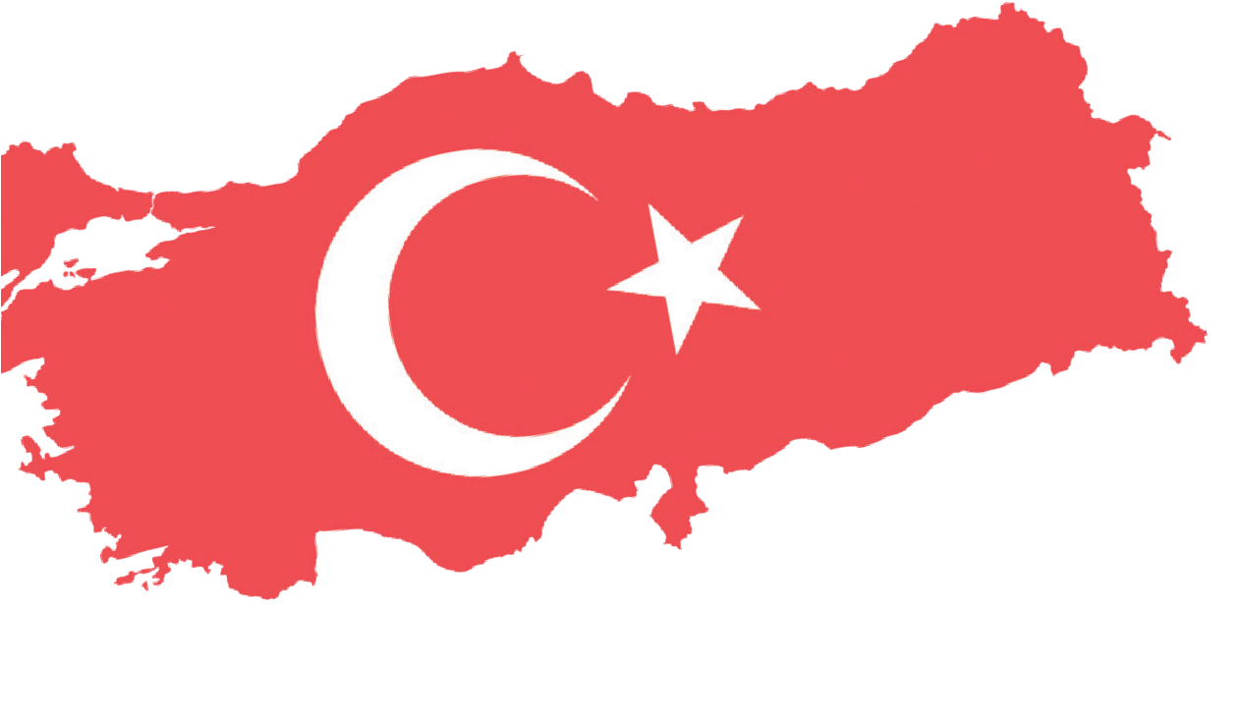
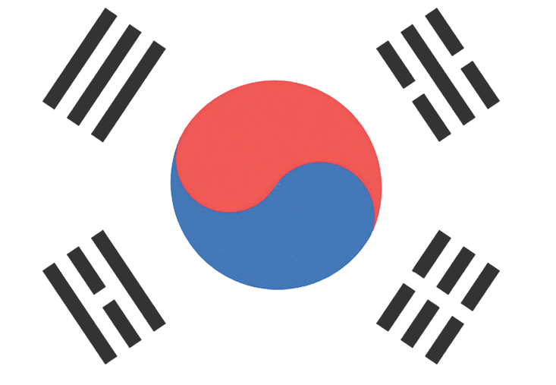

Methods-Techniques: Evidence-based learning, dramatization, case study, content analysis
Teaching-Learning Materials: Archival materials, periodicals, official websites, academic articles
Learning Aim: To introduce students to the things, belongings and daily-use items of Turkish soldiers who fought in Korea, and to raise awareness regarding frontline conditions based on these materials.
Key Question: What items did Turkish soldiers participating in the Korean War carry with them to overcome physical, psychological, and logistical challenges, and how did these items help them maintain their ability to survive and continue fighting?
Guiding Question 1

What types of clothing and equipment did Turkish soldiers participating in the Korean War use to adapt to the harsh climate conditions, and how did the design and function of these materials contribute to their survival strategies?

Objective 1

To evaluate the impact of climate conditions on the soldiers’ daily lives.
Task 1
The students are asked/invited to use Sources B, C, D, E, F, G, H, and I to answer the given questions and to complete the required tasks.
Guiding Question 2

What items did Turkish soldiers use to protect their physical and psychological well-being during the Korean War, and to what extent were these items functional and sufficient under wartime conditions?

Objective 2

To gain insight into the measures and practices undertaken to protect the soldiers’ health in a wartime environment.
Task 2

The students are asked/invited to use Sources J, K, L, and M to answer the related questions and to complete Table 1.

Teaching and Learning Plan

‼ Focus on Activity
The students are asked/invited to examine Source A, which represents the monsoon climate, and answer the related question.
5 min.

🛎 Task 1
The students are asked/invited to use Sources B, C, D, E, F, G, H, and I and to answer the given questions and to complete the required tasks.
35 min.
🛎 Task 2
The students are asked/invited to use Sources J, K, L, and M (Oral History Activity) and to answer the related questions and complete Table 1.
35 min.
The students are asked/invited to answer the open-ended questions.
5 min.
🎯 Assessment and Evaluation

🏠 Homework
The students are asked/invited to conduct research in their own time and to create the required materials table. This work is prepared electronically and will be stored in the students’ digital portfolios.

Teaching and Learning Process

25
Source B: Monsoon Climate
Monsoon comes from the Arabic-origin word ‘mausim’, meaning ‘season’. It refers to seasonal winds driven by annual temperature differences between large land masses and adjacent ocean surfaces. In the summer months, because temperatures over the continents are higher than over the oceans, monsoon winds blow from the sea toward the land. In winter, because ocean surface temperatures are higher than land temperatures, the wind reverses direction and blows from land toward the sea. The winds that blow from the oceans toward the continents in summer carry large amounts of moisture. As these warm, moist winds rise along steep coastal mountains, they cool and condense, producing incredibly intense, potentially dangerous rainfall in coastal regions.
When monsoon winds are mentioned, many people think of the destructive, damaging rains along the southern coasts of India, caused by moisture-laden southwesterly air currents. Although the same principle produces similar winds across many regions of the world, monsoons are most pronounced along the southern and eastern coasts of Asia. Monsoon winds form as a result of land and sea breezes produced by daily temperature changes, but on a much larger scale, blowing between continents and oceans in response to seasonal temperature variations. (MGM, 2024).
Focus on activity: The students are asked/invited to respond to the question, ‘If you were stranded on a deserted island, which three items would you want to have with you?’. Their answers are written on the board, and the class ranks the items from most important to least important.
Source A: A monsoon climate (An illustrative photo) (Ayandon.com.tr, 2025)
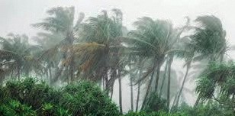

Using a smart board or projector, Source A is shown to the students, and they are asked to guess which climate the weather event in the visual belongs to.
Guiding Question 1: What types of clothing and equipment did Turkish soldiers participating in the Korean War use to adapt to the harsh climate conditions, and how did the design and function of these materials contribute to their survival strategies?
Task 1: The students are asked/invited to use Sources B, C, D, E, F, G, H, and I and to answer the given questions and to complete the required tasks.
Step 1: The students are asked/invited to read the Information Box (Source B).

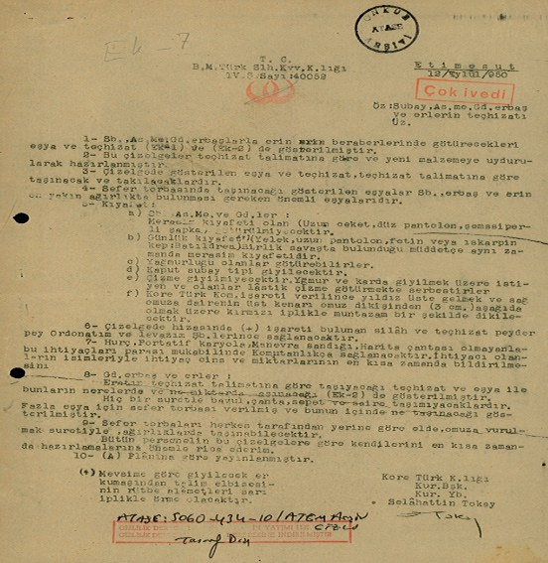
Source C: Command order containing explanations about soldiers’ clothing (ATASE, 5060-434-10)

United Nations Turkish Armed Forces Command
- The items and equipment that officers, non-commissioned officers, and enlisted men will take with them are shown in Annex-1 and Annex-2.
- These lists have been prepared in accordance with the equipment regulations and adapted to the new materials.
- The items and equipment shown in the list will be carried and worn in accordance with the equipment regulations.
- The items indicated to be carried in the deployment bag are essential belongings that officers and enlisted men must keep at the closest and most accessible weight and location.
- Clothing:
  - Officers and non-commissioned officers; ceremonial uniforms will not be taken.
  - Daily uniform (vest, long trousers, boots or shoes) serves as the ceremonial uniform as long as the unit is in combat.
  - Those personnel who have a raincoat may take it.
  - The officer-type overcoat will be worn.
  - Boots will not be worn; those who wish to may take rubber boots to be used in rain or snow.
  - Once the Korean Turkish Command insignia is issued, it will be sewn neatly with red thread so that the star is placed on top and the upper edge of the circular patch is 3 cm below the shoulder seam on the right shoulder.
- Weapons and equipment marked with a (+) sign in the list will gradually be supplied by the ordnance and logistics branches.
- For those who do not have a kit bag, portable cot, maneuver box, or map case, these needs will be provided by the command in exchange for payment. The names of those in need and the type and quantity of the required items must be reported as soon as possible.
- Enlisted men: The equipment and items that enlisted men are to carry according to the equipment regulations, and where and in what quantities they will be carried, are shown in Annex-2.
- Deployment bags will be carried by everyone either by hand or slung over the shoulder, depending on the situation.
I kindly request that all personnel prepare themselves as soon as possible in accordance with these lists. Chief of Staff of the Turkish Command in Korea" ve "Staff Captain Selahattin TOKAY

Step 2: The students are asked/invited to answer the following questions based on the content of Sources B and C.
- What differences can be identified between the climate conditions Turkish soldiers would encounter in Korea and the climate characteristics observed in Türkiye?
- According to Source C, what materials and equipment were soldiers permitted to take with them to Korea?
- Considering the materials and equipment permitted or deemed appropriate in the command order in Source C, how prepared can the Turkish army be considered for the monsoon climate in Korea?
- According to Source C, what advantages and/or disadvantages might the permitted materials and equipment provide under frontline conditions? If today’s technological possibilities had existed at the time, which of the listed items and equipment would need to be replaced, and why?

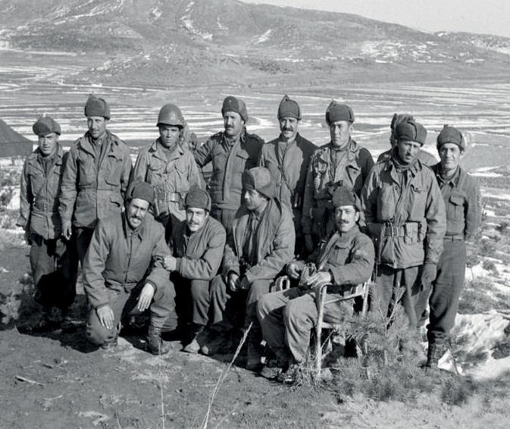
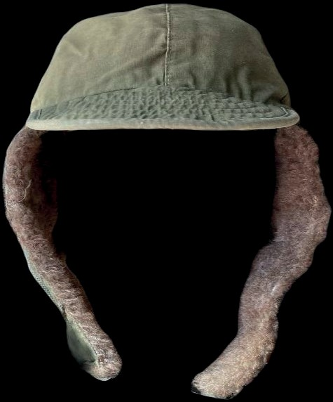
Step 3: The students are asked/invited to examine Sources D, E, and F.

Source D: Turkish soldiers on the Korean battlefield (ATASE, 2019, s. 1045)
Source E: The M1951 cap belonging to the late Korean War veteran Kemal Öztürk from Eskişehir (Prepared by the authors)

Source F: The M1951 cap
During the Korean War, the U.S. Army designed caps with fine-fiber fabric, wool lining, and ear flaps to protect soldiers from Korea’s cold, rainy weather. These caps, known as the M1951, were also used by Turkish soldiers fighting in Korea. (US Department of Defence, 2025).

Step 4: The students are asked/invited to answer the following questions based on Sources D, E, and F.
- According to Source E, what are the distinguishing features of the M1951 caps?
- Why might our soldiers be wearing a furry cap that covers their ears, as seen in Sources D and F?
- How effective might the uniforms seen on our soldiers in Source D have been in coping with the climate conditions in Korea?

Step 5: The students are asked/invited to examine Sources G, H, and I.
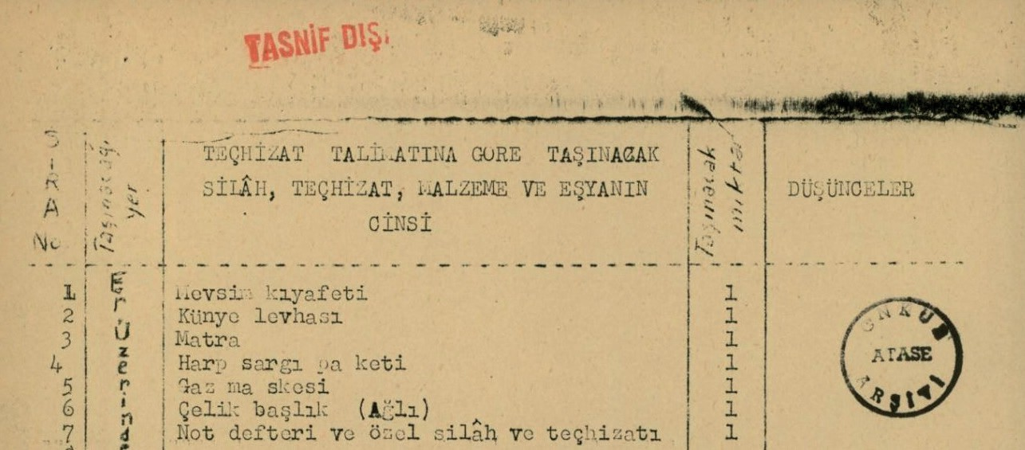
Source G: A section of the command order regarding the equipment soldiers (enlisted men) were required to carry during the Korean War (ATASE, 5060-434-10)

TYPES OF WEAPONS, EQUIPMENT, MATERIALS, AND ITEMS TO BE CARRIED ACCORDING TO THE EQUIPMENT REGULATIONS
No | Carrying Location | Type | Quantity | Remarks
1 | On the soldier | Seasonal uniforms | 1
2 |  | Identity tag | 1
3 |  | Canteen | 1
4 |  | Field dressing pack | 1
5 |  | Gaz mask | 1
6 |  | Steel helmet (Heavy) | 1
7 |  | Notebook and personal weapons/equipment | 1
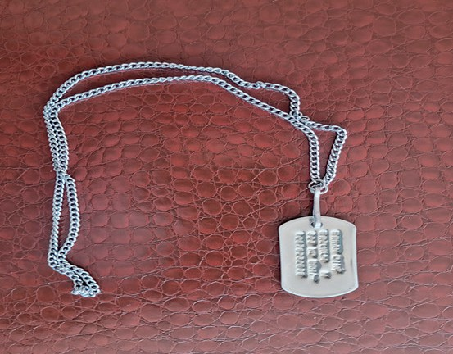
Source H: An example of a soldier’s identity tag (Prepared by the authors)
Source I: The Use of Identity Tags in the Turkish Army
The use of identity tags in the Turkish army began during the First World War. The Battle of Gallipoli had a major impact on the adoption of identity tags. The extremely high number of casualties, the difficulties in identifying soldiers who were brought to hospitals, and the delays in carrying out legal and administrative procedures related to the families of fallen soldiers made the use of identity tags a necessity (Sayılır, 2013).

Step 6: The students are asked/invited to answer the following questions based on Sources G, H, and I.
- Which item in the list provided in Source G did you find most interesting? Why?
- Categorize the items in Source G into health protection, tactical advantage, and psychological support, and analyze them. Identify the most critical item in each category and evaluate how the absence of these items might affect a soldier’s performance and chances of survival.

Health Protection | Tactical Advantage | Psychological Support

Evaluation: ..............................................................................................................................................
..................................................................................................................................................................
..................................................................................................................................................................
..................................................................................................................................................................
..................................................................................................................................................................
..................................................................................................................................................................
..................................................................................................................................................................
..................................................................................................................................................................
..................................................................................................................................................................
..................................................................................................................................................................
..................................................................................................................................................................
..................................................................................................................................................................
..................................................................................................................................................................
..................................................................................................................................................................
..................................................................................................................................................................

Guiding Question 2: What items did Turkish soldiers use to protect their physical and psychological health during the Korean War, and how functional and sufficient were these items under wartime conditions?
Task 2: The students are asked/invited to use Sources J, K, L, and M and to answer the related questions and to complete Table 1.
Step 7: The students are asked/invited to examine Sources J and K.
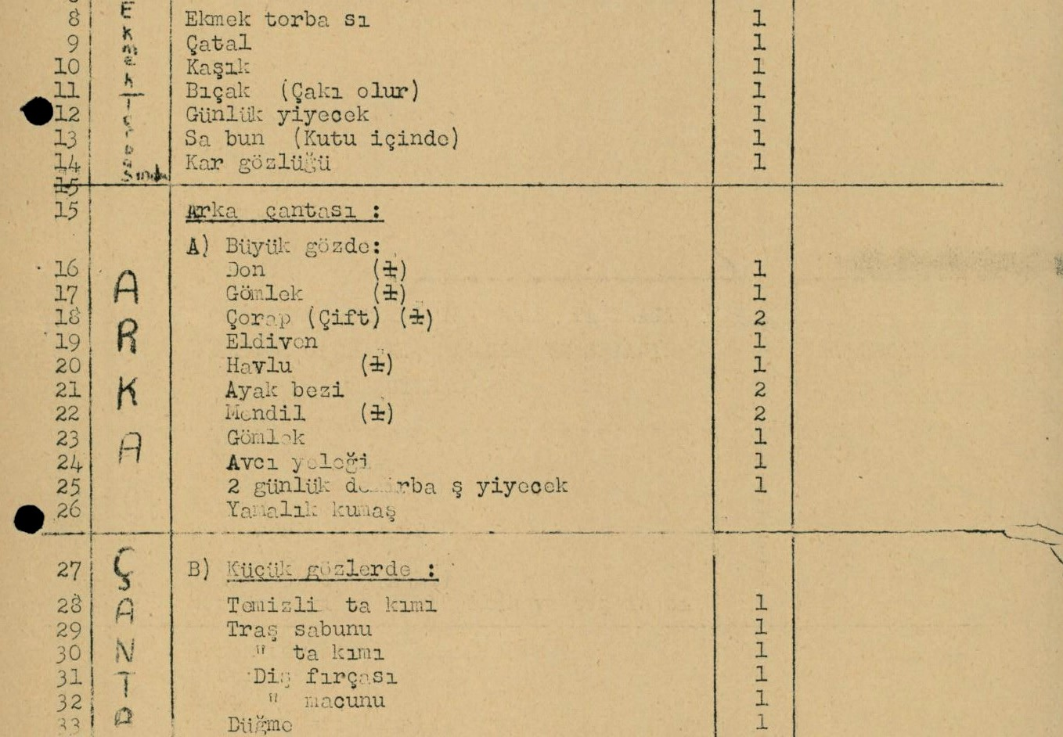
Source J: The second part of the command order regarding the equipment soldiers (enlisted men) were required to carry during the Korean War (ATASE, 5060-434-10)

No | On the soldier |  | No | Backpack (Large Compartment) |  | No | Backpack (Small Compartments)
8 | Bread bag | 1 | 16 | Undershorts | 1 | 28 | Cleaning kit | 1
9 | Fork | 1 | 17 | Shirt | 1 | 29 | Shaving soap | 1
10 | Spoon | 1 | 18 | Socks (pair) | 2 | 30 | Shaving kit | 1
11 | Knife (pocketknife acceptable) | 1 | 19 | Gloves | 1 | 31 | Toothbrush | 1
12 | Daily food ration | 1 | 20 | Towel | 1 | 32 | Toothpaste | 1
13 | Soap (in a box) | 1 | 21 | Foot cloth | 2 | 33 | Button | 1
14 | Snow goggles | 1 | 22 | Handkerchief | 2
 |  |  | 23 | Shirt | 1
 |  |  | 24 | Hunting vest | 1
 |  |  | 25 | Two-day standard ration pack | 1
 |  |  | 26 | Patch fabric | 1

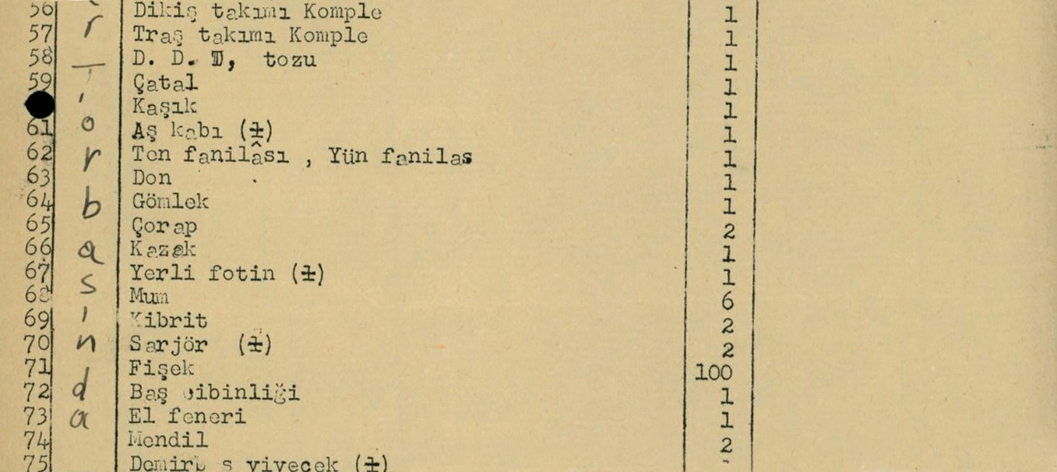
Source K: Another section of the command order regarding the equipment soldiers (enlisted men) were required to carry during the Korean War (ATASE, 5060-434-10)

No | Backpack |  | No | Backpack |  | No | Backpack
56 | Complete sewing kit | 1 | 63 | Undershorts | 1 | 70 | Cartridge clip | 2
57 | Complete shaving kit | 1 | 64 | Shirt | 1 | 71 | Roll of coins | 100
58 | DDT powder | 1 | 65 | Socks | 2 | 72 | Head net | 1
59 | Fork | 1 | 66 | Sweater | 1 | 73 | Flashlight | 1
60 | Spoon | 1 | 67 | Standard army boots | 1 | 74 | Handkerchief | 2
61 | Mess tin | 1 | 68 | Candle | 6 | 75 | Standard ration | 1
62 | Cotton | 1 | 69 | Matches | 2

Step 8: The students are asked/invited to answer the following questions based on Sources J and K.
- According to Sources J and K, which items were soldiers ordered to take with them for personal hygiene purposes?
- According to Sources J and K, which items were soldiers ordered to take with them as preventive measures to protect their health?
- Which other items listed in Sources J and K have the potential to serve the purpose of protecting soldiers’ health? Why?

Step 9: The students are asked/invited to classify the health-related items listed in Sources J and K and fill in Table 1 below.

Preventive | Curative | Psychological Support
Step 10: The students are asked/invited to examine Sources L and M.
Source L: Manchurian Fever
During the Korean War, Turkish physicians encountered another epidemic disease. In the ‘Manchurian fever’ section of Behiç Onul’s 1953 first edition of ‘Infectious Diseases’, Dr. Rıdvan Gülbaran, who became a specialist in bacteriology and infectious diseases at Gülhane Military Medical Academy in 1951, reported that during the sixteen months he served with the Turkish Brigade in the Korean War, “One officer and three enlisted men died from this disease; although the infection is not seen in our country, it is an important illness that must be examined for our units serving abroad” (Eraksoy, 2011).

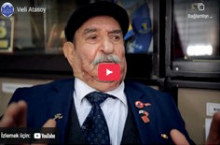
Source M: An excerpt from the oral history interview with Korean War veteran Veli Atasoy
(https://koreanwarlegacy.org/interviews/veli-atasoy/)
🕒 28:17-29:43
V. Atasoy: They captured us and took us as far as they could through the mountains. We stayed here for about three days, then
moved somewhere else for about five days; we lost track of day and night. We were hungry and thirsty. It was 1950 (he means early 1951), and around the New Year, we stayed in a place they called a cold camp. The sun only showed itself for half an hour to one hour each day. We remained there. They had also captured South Koreans; they kept them packed together like chickens. They took some out, and then we were put in, but those South Koreans had lice; an unbelievable number. They put us in there too. During that winter storm, the lice tormented us. Finally, we took off our clothes and left them outside in the cold for half an hour to one hour, froze the lice, and then put our clothes back on. That’s how we managed to get through it.

Step 11: The students are asked/invited to answer the following questions based on Sources L and M.
- According to Source L, which epidemic disease affected the Turkish soldiers fighting in Korea, and in what way?
- According to Source L, how do we know the effects of this epidemic disease on our soldiers?
- According to Korean War veteran Veli Atasoy, what health problems did captured Turkish soldiers suffer from?
- According to Source M, how did captured Turkish soldiers cope with the situation they were exposed to?
- Re-examine Source K and identify the item soldiers were required to carry for combating lice and similar parasites.

🎯Assessment and Evaluation
- How did the monsoon climate of the Korean Peninsula influence the selection of materials and equipment that Turkish soldiers needed to carry?
- How do the climate conditions of the destination affect our travel plans and the items we decide to take with us? Explain with an example.
- Why were soldiers required to keep their identity tags on them at all times?
- Based on examples such as the Manchurian fever described in Source N and the lice problem mentioned in Source M, what can be said about the effects of epidemics and parasites on the performance of military units during wartime?
- What measures are taken today to combat parasites, epidemics, and similar threats to human health? Research and explain.

References
Ayandon.com.tr. (2025). Pakistan’da muson yağmurlarında… [During the monsoon rains in Pakistan…]. https://www. ayandon.com.tr/pakistan-da-muson-yagmurlarinda-can-kaybi-299-a-yukseldi/98694/ Access Date: 24.08.2025
Cumhurbaşkanlığı Devlet Arşivleri Başkanlığı Millî Savunma Bakanlığı Askerî Tarih Arşivi. ATASE [Presidency of State Archives, Ministry of National Defense, Military History Archive]. ATASE Place No: 5060–434–10. (1950).
Eraksoy, H. (2011). Hantavirus infeksiyonları [Hantavirus infections]. Klimik Dergisi, 24(3), 139–149.
Han, J. (2018). Interview with Veli Atasoy. https://koreanwarlegacy.org/interviews/veli-atasoy/ Access Date: 04.12.2024 Meteoroloji Genel Müdürlüğü (MGM). (2024). Meteoroloji sözlüğü [Meteorology glossary]. https://www.mgm.gov.tr/
genel/meteorolojisozlugu.aspx?m=M&k=aa94 Access Date: 23.10.2024
Sayılır, B. (2013). Türk Ordusunda künye uygulanmasına ilişkin ilk girişimler ve ilk künyelerle ilgili kısa bilgiler [Early initiatives on the implementation of identification tags in the Turkish Army and brief information on the first identification tags]. Turkish Studies, 8(7), 551–561.
US Department of Defence, 2025). Common threads: army. https://www.defense.gov/Multimedia/Experience/Common-Threads/Common-Threads-Army/ Access Date: 22.03.2025

🏠
Homework
Imagine yourself as a war correspondent, reporter, or aid volunteer heading to a region experiencing ongoing conflict or war. Since you likely will not have a comfortable or stable place to stay in your mission area, list the items or objects you would choose to take with you, along with your reasons for choosing them, in the appropriate sections of the table below.

Table: Items I need to take with me

Category of Item/Object | Name of Item/Object | Seçme Gerekçesi
Personal Items | Family photos | To ease homesickness and provide psychological comfort
Cleaning / Hygiene Supplies
Contact Devices
Clothing Items
Food and Drink
Safety-Related Equipment / Gear

