NEWS FROM KOREA
Unit 4
🎓 Grade Level:
6th, 7th and 8th Grades

⏰ Teaching Time:
40 + 40 minutes + Homework

Concepts to Digest:
Communication, media
Skills to Improve: Historical analysis and inquiry, historical empathy
Core Values: Patriotism, nationalism, altruism, responsibility

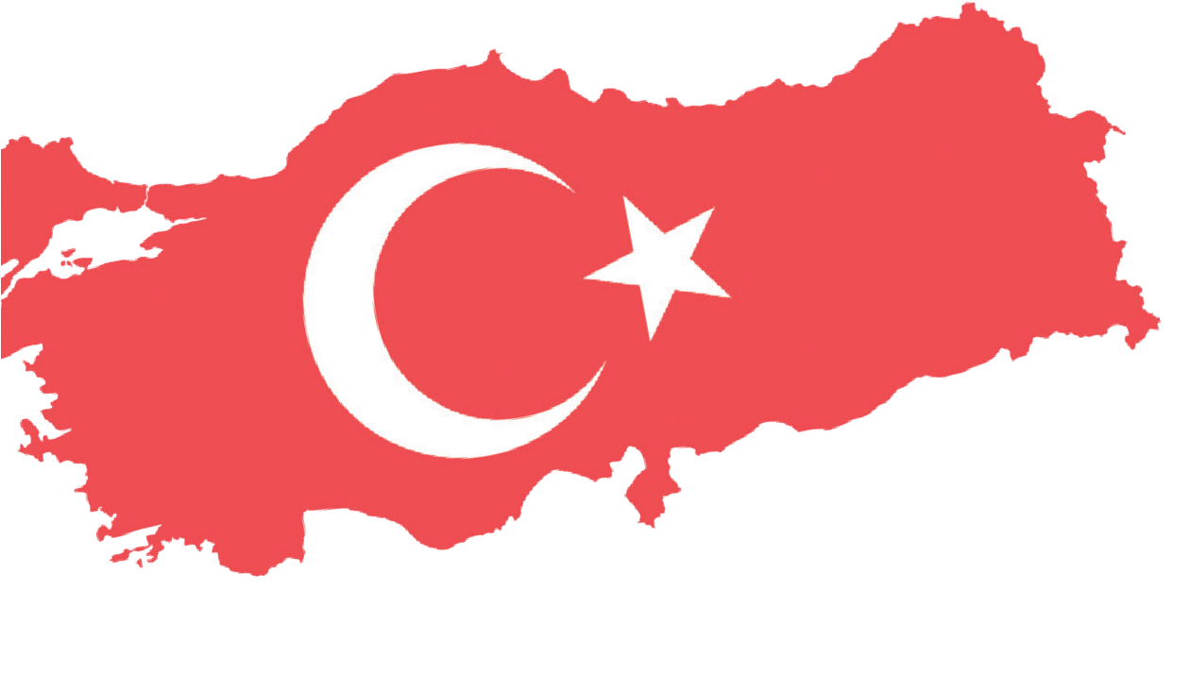


Methods-Techniques: Evidence-based historical inquiry, oral history
Teaching-Learning Materials: Archival documents, newspapers, interview/oral history recordings
Learning Goal: To understand how soldiers and their families used the main communication tools during the Korean War and what functions those tools served.
Key Question: Through what means and in what ways was communication established between soldiers and their families during wartime, and how did these exchanges affect the morale and motivation of both sides?
Guiding Question 1

How were communication tools used during the Korean War, and what limitations did these tools have?
Objective 1

By understanding which communication tools were used to maintain contact between soldiers assigned to Korea and
their families, students will analyze the emotional states of families who received no news about their children sent to Korea.

Task 1

The students are asked/invited to examine Sources B, C, D, E, F,
G, H, and I, to answer the related questions, and to complete the letter-writing activity.
Guiding Question 2

How did the various forms of communication established between soldiers and their relatives affect the morale and motivation of both sides?

Objective 2

To develop an empathetic understanding of the personal and psychological effects of communication with relatives who are in different cities or countries during war or similar extraordinary circumstances.
Task 2

The students are asked/invited to examine Sources J and K, along with Sources E, H, and I used in previous stages of the activity, and to answer the related questions.

Teaching and Learning Plan

‼ Focus on Activity
The students are asked/invited to read the short letters on the newspaper page in Source A, to answer the given questions, and to participate in a whole-group discussion.
10 min.
🛎 Task 1
The students are asked/invited to examine Sources B, C, D, E, F, G, H, and I, to answer the related questions, and to complete the letter-writing activity.
30 min.
🛎 Task 2
The students are asked/invited to examine Source J and Source K, together with Sources E, H, and I used in earlier stages of the activity, and to answer the related questions.
35 min.
The students are asked/invited to answer the open-ended questions.
5 min.
🎯 Assessment and Evaluation
🏠 Homework
The students are asked to draw a picture or write a letter about the daily lives of Turkish soldiers in Korea. This product will be stored in the electronic portfolio.

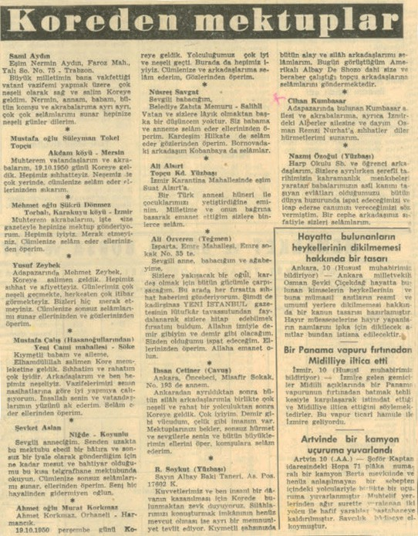
Teaching and Learning Process
Focus on activity: The students are asked/invited to read the letter summaries in Source A together and then to discuss the answer of the following question.

Source A: A page from the Yeni İstanbul newspaper dated 11 November, 1950 (Yeni İstanbul, 1950).

Letters from Korea Sami Aydın
To my wife, Nermin Aydın, Faroz District, Yalı Street No. 75 – Trabzon.
I arrived in Korea safe and sound, in excellent spirits, to fulfil the national duty entrusted to me by my great nation. Nermin, I send my greetings one by one to my mother, father, all our neighbors and relatives, and I wish joyful days to all of you.

Süleyman Tokel, son of Mustafa, Artilleryman
Akdam Village-Mersin
My dear fellow citizens and relatives, we arrived in Korea on 19 October, 1950. We are all in good health. Our spirits are also very high. I send my greetings to all of you and shake your hands.

Şükrü Dönmez, son of Mehmet
Karakuyu Village-Torbalı, İzmir
My dear relatives, I am writing to you all through the newspaper. We are all well. Do not worry about us. I send my greetings to all of you and kiss your hands.

Yusuf Zeybek
To Mehmet Zeybek, Adapazarı
We have arrived safely in Korea. We are all in good health and well-being. Our days are passing very cheerfully, and we are receiving great respect from everyone. Do not worry about us at all. I send endless greetings to all of you and kiss your hands and eyes.

Mustafa Çalış (from the Hasanoğulları family)
Yeni Cami District-Söke
My dear father and family, praise be to God, we have arrived safely in Korea. My health and comfort are excellent. My friends and I are all in good spirits. I am trying to carry out my duties well, as you advised. God willing, I will make you and my fellow citizens proud. I send my greetings and kiss your hands.

Question: How might the short letters or letter summaries in Source A have been written; in what kind of environment and with what emotions? Please, discuss your ideas as peers.
Guiding Question 1: How were communication tools used during the Korean War, and what limitations did these tools have?
Task 1: The students are asked/invited to examine Sources B, C, D, E, F, G, H, and I, to answer the related questions, and to complete the letter-writing activity.
Step 1: The students are asked/invited to examine Sources B, C, and D.
Source B: Communication during the Korean War
During the Korean War, communication technology was much more limited than it is today. Communication between soldiers and their families was mainly achieved through letters. Because of wartime conditions, letters often arrived late, making communication difficult. Besides letters, telegrams, telephones, newspapers, and radios were also used for communication. However, due to the challenges of war and limited infrastructure, staying in touch was very hard.
Practical methods were developed to make communication between soldiers and their families easier. One way was publishing summaries of soldiers’ letters in newspapers so their messages could reach their families much more quickly (Sources A, C, and E). Another way was reading short messages sent by soldiers at the front during the ‘Ankara Radio Soldier Hour’ program to relay them to their families (Source E). Additionally, certain military communication procedures were used to help soldiers who could not contact their families. In emergencies, military correspondence ensured that soldiers’ messages or conditions were delivered to their families, and family messages were sent to soldiers at the front (Sources F and G).
A number of ranked soldiers serving in the Turkish Brigade in Korea, with their commanders' permission and encouragement, started publishing the Kutup Yıldızı newspaper on August 26, 1950. Their aim was to help everyone at headquarters keep up with global news, stay informed about developments in Turkey, and receive messages from their families more quickly (Sources E and H). Depending on how the war went, Kutup Yıldızı was published either regularly or intermittently, distributed to Turkish military units in Korea, and supported with the necessary logistics so soldiers could receive and read it (Prepared by the authors).

Source C: A memory of Korean War veteran Colonel Celal Dora
“Despite searching for over a month, we hadn't been able to hear Ankara Radio, so finally finding it, and learning that a relative of mine would be addressing me, made me very happy. When I ran to the radio at Brigade Headquarters, located five hundred meters away, all the officers and soldiers there were staring at the radio, holding their breath to catch the faint sounds coming through. At that very moment, my cousin was finishing his message to me; he said that all my family members were in good health and ended his words with wishes for success. His message was followed by the voices of the families of other friends.” (Dora, 1963, pp. 69-70)

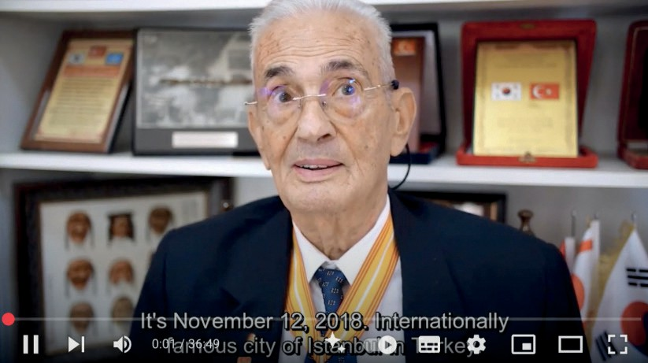
Source D: An excerpt from the oral history interview with veteran
Necdet Yazıcıoğlu, who participated in the Korean War with the Rank of Lieutenant
(https://koreanwarlegacy.org/interviews/necdet-yazicioglu/)
🕒
04:15-05:07
N. Yazıcıoğlu: In 1950, specifically on June 25, 1950, North Korea, encouraged and pressured by Russia, invaded South Korea on a Sunday and occupied Seoul within four days. A brigade of about five thousand four hundred soldiers was sent there in September and October. Among them were friends I had studied with, and I kept listening to the radio and following newspapers to hear news about the Turkish soldiers fighting there. I was constantly very sad. After North Korea pushed southward and occupied South Korea, I was deeply worried that the country would become communist. This worry stayed inside me constantly, and I decided to go to Korea. I volunteered by submitting a petition and traveled to Korea.

Step 2: The students are asked/invited to answer the following questions based on the information in Sources B, C, and D.
- Through which means did the soldiers assigned to Korea communicate with their families and relatives during the Korean War?
- According to Source B, what role did the radio play in providing communication between soldiers and their families during the Korean War?
- Through which channels did Veteran Necdet Yazıcıoğlu obtain information about the Korean War before he went to Korea?
- How did the information he obtained about the Korean War affect and influence Necdet Yazıcıoğlu, who was then a young lieutenant?

Step 3: The students are asked/invited to examine Sources E, F, G, and H.
Source E: A page from the Kutup Yıldızı (North Star) newspaper dated 28 September, 1952.
Private Gültekin Şentop receives greetings and love from his father, Colonel Hayrullah Şentop; his mother, father, sister-in-law, and aunt from Marmaris send their regards. They mention receiving his (Gültekin’s) letter dated 25 August, 1952, and their reply is on the way.
Salahattin Cengiz gets greetings from his uncle Şevki Eker in Şile, who writes that his mother Kadriye and his father Şevki are both well.

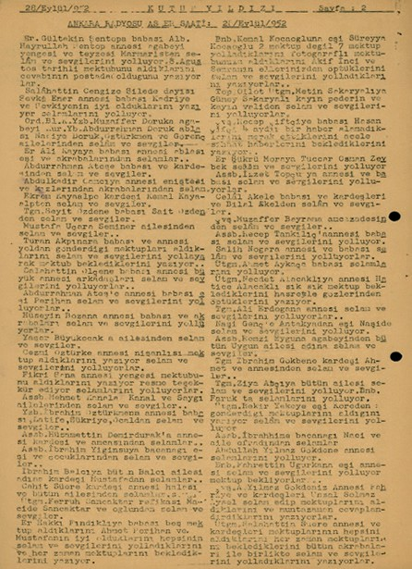
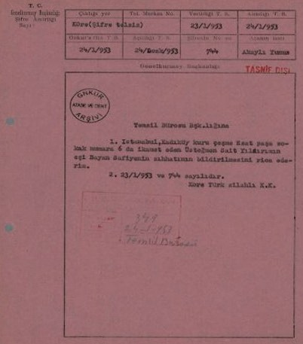
To Battalion Commander Captain Muzaffer Doruk, greetings and love from his older brother, Major Abdurrahman Doruk, his sister Nadiye Doruk, and the Öztürkmen and Görenç families.
Private Ali Kaya receives greetings from his father, mother, sister, wife, and relatives.
To Abdurrahman Ateş, greetings and love from his father and brother.
To Abdulkadir Cancı, greetings from his mother, brother-in-law, daughters, and relatives.
To Ekrem Kayaalp, greetings and love from his brother Kemal Kayaalp.
To Lieutenant Seyit Özden, greetings and love from his father, Sait Özden.
To Mustafa Uçar, greetings and love from the Seziner family.
To Turan Akpınar, greetings and love from his father and mother, who write that they had received the letters he sent while we was still travelling, and that they are awaiting his next one….

Source F: An official correspondence from the Ministry of National Defense containing the instruction to obtain information about the health of the wife of an officer serving in Korea (ATASE, 349-24-1-953).
General Staff Headquarters Unclassified (red stamp)
General Staff Archives ATASE and Inspection To the office of the Representative Bureau Chief
- I kindly request that the health condition of Mrs. Safiye, the wife of First Lieutenant Sait Yıldırım, who resides at Esat Paşa Street No. 6, Kuruçeşme, Kadıköy, Istanbul, be reported.
- Dated 23 January, 1953, and numbered 744.
Turkish Armed Forces in Korea
Ministry of National Defense, Representative Bureau Chief

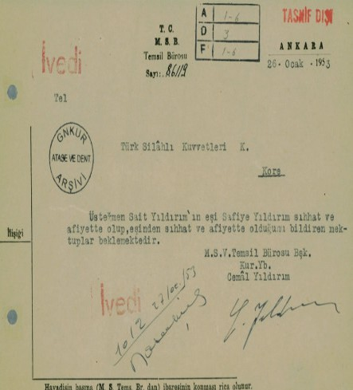
Source G: An official correspondence from the Ministry of National Defense reporting the health of the wife of an officer serving in Korea (ATASE, 1-6-3-1-16/1012-27-1-953).
Republic of Türkiye Ministry of National Defense, Representative Bureau
No: 861/2, Ankara, 26 January, 1953 To: Turkish Armed Forces Command
Kore
The wife of First Lieutenant Sait Yıldırım, Safiye Yıldırım, is in good health and well-being and is awaiting letters from her husband confirming the same.
Ministry of National Defense, Representative Bureau Chief
Staff Lieutenant Colonel
Cemâl Yıldırım

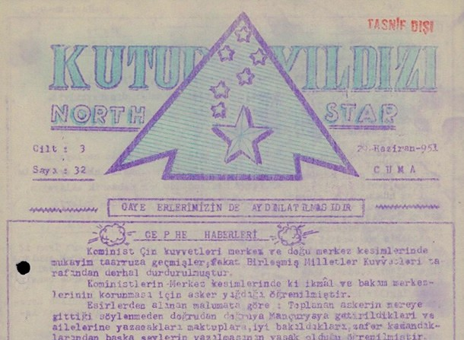
Source H: An excerpt from the Kutup Yıldızı (North Star) newspaper dated 21 June, 1951
NORTH STAR
Volume: 3 Issue: 32 29 June 1951, Friday Our goal is to keep our soldiers informed Frontline News
Communist Chinese forces launched a strong counteroffensive in the central and eastern sectors, but they were immediately halted by the United Nations Forces.
It has been learned that the Communists are
concentrating troops to protect their supply and maintenance centers in the central sectors.
According to information obtained from prisoners, the gathered soldiers were brought directly to Manchuria without being told they were being taken inland, and it was learned that in the letters they were allowed to write to their families, they were permitted to say only that they were being treated well and were forbidden to write anything other than military-related matters.

Step 4: The students are asked/invited to answer the following questions based on the information in Sources E, F, G, and H.
- How did the Kutup Yıldızı newspaper (Sources E and H) serve the soldiers in the Turkish Brigade in Korea?
- Imagine you are one of the soldiers serving in Korea during the war. If you saw your name mentioned in the Kutup Yıldızı newspaper clipping from Source E, along with a brief message from your family and relatives in Türkiye, how would you feel and what would you think?

- Based on Sources F and G, what method was used to ensure communication between soldiers and their families when they could not reach each other through the usual communication tools of that time?
- How do you view the use of an in-unit newspaper to help soldiers stay connected with their families during the Korean War? Discuss with your friends.
- In more recent wars and conflicts, what other ways might soldiers and their families communicate? Please conduct a library and/or Internet research.
Step 5: The students are asked/invited to watch/read Source I.

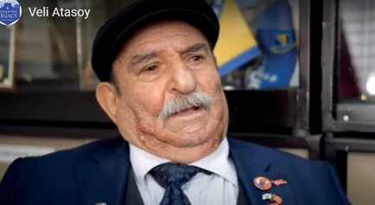
Source I: Excerpts taken from two different parts of the interview conducted with Korean War veteran Veli Atasoy. (https://koreanwarlegacy.org/ interviews/veli-atasoy/)
🕒 12:21-13:04
V. Atasoy: Even when we wrote letters while we

were still with the unit, they say someone was stealing our letters and taking the stamps, tearing up the letters. Before we were taken prisoner, there was a fake (müfrüt) sergeant, that is what they called him. He was the one doing it. Later we caught him. We never saw letters being sent or received in the unit, and we did not see any in captivity either, in the POW camp. So, there was no correspondence or letter exchange with Türkiye at all.
🕒 19:26-20:09

V. Atasoy: There was no contact at all (referring to his family) until I reached Türkiye from Korea. No communication of any kind. My father even went to the consulate asking what they had done with his son, hitting his head against stones and walls, but nothing could be done; we were prisoners. The man in the unit was tearing up the letters that came; we did not know. Then we were captured, and again, nothing from home. The Americans used to exchange letters; some of them even talked. We never received a single letter.

Step 6: The students are asked/invited to answer the following questions based on Oral History Interview 2.
- According to Source I, what was the reason given that Veteran Veli Atasoy and the soldiers in his unit were unable to communicate with their families during their time in Korea?
- Imagine for a moment that you are in the place of Veteran Veli Atasoy and his fellow soldiers, and you find out that the letters you thought you had sent to your family were torn up by another soldier just to profit from the stamp on the envelope, and that the letters your family sent to you were also destroyed instead of being delivered to you. How would you feel in such a situation, and what would you do?
- Put yourself in the place of a mother or father of a soldier who was sent abroad to war for national duty and from whom no further news has been received; like the father described by Korean War veteran Veli Atasoy when he says, “…My father even went to the consulate asking what they had done with his son, hitting his head against stones and walls, but what could be done; we were prisoners.” Write a short letter to the relevant military authorities expressing your feelings and thoughts and inquire about your son’s situation.

Source K: An excerpt from the Yeni İstanbul newspaper published on 11 November, 1950
(Yeni İstanbul Gazetesi, 1950)
Mustafa Çalış (from the Hasanoğulları family)
Yeni Cami District – Söke
To my dear father and family,
Praise be to God, we have arrived safely in the land of Korea. My health and comfort are very good. My friends and I are all in good spirits. I am trying to carry out my duties well, according to your advice. I am hoping to make you and my fellow citizens proud. I send my greetings and kiss your hands.
45

To the Commander/Command Headquarters of ,
I am the mother/father of , who was sent to Korea with the unit:
................................................................................................................................................................................
................................................................................................................................................................................
..................................................................................................................................................................
..................................................................................................................................................................
..................................................................................................................................................................
..................................................................................................................................................................
..................................................................................................................................................................
..................................................................................................................................................................
..................................................................................................................................................................
..................................................................................................................................................................

Guiding Question 2: Askerler ile yakınları arasında çeşitli şekillerde kurulan/ gerçekleşen iletişimler her iki tarafın moral ve motivasyonlarının güçlendirilmesine ne tür katkılar sağlamıştır?
Task 2: The students are asked/invited to examine Source J and Source K, together with Sources E, H, and I used in earlier stages of the activity, and to answer the related questions.
Step 7: The students are asked/invited to read Sources J and K.
Source J: An excerpt from the Yeni İstanbul newspaper published on 11 November, 1950
(Yeni İstanbul Gazetesi, 1950)
T. Fikret Vardar, Artillery Lieutenant
To my homeland and loved ones,
Far from my country, in this distant corner of the Asian continent, my heart is always filled with your love and longing. It is a great honor for me to come to Korea as a humble member of a heroic unit fighting on the side of the United Nations. We have full faith that here we will once again demonstrate that we are the children of a nation history calls ‘hero’. God is always with the Turk who declares his Creator as Truth. I thank Yeni İstanbul newspaper for giving me the opportunity to send my greetings and respects to my dear family and my beloved nation.

Step 8: The students are asked/invited to answer the following questions by taking sources E, H, I, J and K into consideration.
🏠
Homework
The students are asked to draw a picture or write a letter describing the environment, experiences, and emotions of the Turkish soldiers who participated in the Korean War, based on the information provided in the written, audio, and visual sources above.
- In Sources J and K, mark the words in the short letters that you do not know/do not understand and research their meanings.
- In the letter in Source J, what might the author be trying to emphasize with the expression, ‘Far from my country, in this far corner of the Asian continent, my heart is always filled with your love and longing’?
- Which values are emphasized in the letters in Sources J and K?
- Based on the expression of gratitude toward the Yeni İstanbul newspaper in the letter in Source J, research what different roles the media can undertake in times of war. By evaluating the functions of the media in terms of boosting morale, providing communication, creating national unity, and propaganda through the example of the Korean War, compare these with the role of the media in today’s wars and crisis situations.
- After examining sources E, H, I, J and K, what do you think about the emotional state of soldiers who are far from their homeland, and how do these feelings affect soldiers’ performance in war conditions?
- In what ways might the Kutup Yıldızı newspaper, of which two sample pages are presented in Sources E and H, have contributed to the morale and motivation of Turkish soldiers?
🎯Assessment and Evaluation
- What methods did the relatives of the Turkish soldiers use to receive news from the front during the Korean War?
- What is the name of the newspaper that began to be published within the Turkish Brigade in Korea during the Korean War? What function did this newspaper serve during the war?
- What can be said about the effect of communication between soldiers and their families during the war on their morale and motivation?
- What were the main factors that affected the morale and motivation of Turkish soldiers in the Korean War?

References
Cumhurbaşkanlığı Devlet Arşivleri Başkanlığı Millî Savunma Bakanlığı Askeri Tarih Arşivi. [Presidency of State Archives, Ministry of National Defense, Military History Archive]. ATASE Place No: 156-0-116, (1951).
Cumhurbaşkanlığı Devlet Arşivleri Başkanlığı Millî Savunma Bakanlığı Askeri Tarih Arşivi. [Presidency of State Archives, Ministry of National Defense, Military History Archive]. ATASE Place No: 158-0-17, (1952).
Cumhurbaşkanlığı Devlet Arşivleri Başkanlığı Millî Savunma Bakanlığı Askerî Tarih Arşivi. ATASE [Presidency of State Archives, Ministry of National Defense, Military History Archive]. ATASE Place No: 349–24–1–953. (1953).
Cumhurbaşkanlığı Devlet Arşivleri Başkanlığı Millî Savunma Bakanlığı Askerî Tarih Arşivi. ATASE [Presidency of State Archives, Ministry of National Defense, Military History Archive]. ATASE Record Group: 1–6–3–1–16, Place No: 1012–27–1–953. (1953).
Dora, C. (1963). Kore Savaşında Türkler [Turks in the Korean War]. İsmail Akgün Matbaası.
Han, J. (2018). Interview with Necdet Yazıcıoğlu. https://koreanwarlegacy.org/interviews/necdet-yazicioglu/ Access Date: 23.06.2024.
Han, J. (2018). Interview with Veli Atatsoy. https://koreanwarlegacy.org/interviews/veli-atasoy/ Access Date: 05.02.2024.
Yeni İstanbul Gazetesi. (1950). Kore’den mektuplar [Letters from Korea]. (11 Kasım 1950).. https://www.gastearsivi.com/ gazete/yeni_istanbul/1950-11-11/3 Access Date: 17.08.2025)

