‘AYLA. THE DAUGHTER OF TWO NATIONS’
Unit 5
🎓 Grade Level:
6th, 7th and 8th Grades

⏰ Teaching Time:
40 + 40 minutes

Concepts to Digest: War victim, orphan
Skills to Improve: Historical inquiry and analysis, historical empathy
Core Values: Altruism, compassion




Methods-Techniques: Evidence-based historical inquiry
Teaching-Learning Materials: The movie ‘Ayla’ and other documentaries, oral history, and written sources
Learning Aim: To enable students to recognize the distinction between historical reality and fictionalized reality by examining evidence about the difficulties faced by Korean children during the Korean War and the support and assistance they received from Turkish soldiers while coping with these hardships.
Key Question: How do firsthand testimonies, written and visual sources, and fictional narratives such as films and documentaries reflect historical reality?

Guiding Question 1

What kinds of support did Korean children who lost their families and relatives during the Korean War receive from the Turkish soldiers as they coped with the difficulties they faced?

Objective 1

To develop empathy for children who were victimized during the war by examining example individuals and/or events.

Task 1
Students are asked/invited to examine Sources B, C, D, and E, answer the related questions, and prepare a diary reflecting the emotions and thoughts of a war-affected child.
Guiding Question 2

To what extent might historical reality be accurately reflected in the films and documentaries produced about the Korean War?
Objective 2

To distinguish between historical reality and fiction by analyzing selected film scenes.
Task 2
Students are asked/invited to examine the selected film excerpts together with Sources F, G, and H, answer the related questions, and complete Table 1.

Teaching and Learning Plan

‼ Focus on activity
5 min.
The students are shown a stamp image and asked/invited to answer several introductory questions to begin the lesson.

🛎 Task 1
The students are asked/invited to examine Sources B, C, D, and E, answer the related
questions, and prepare a diary reflecting the emotions and thoughts of a war-affected child.
35 min.
🛎 Task 2
The students are asked/invited to examine the movie ‘Ayla’ together with Sources F, G, and H, answer the related questions, and complete Table 1.
35 min.
The students are asked/invited to answer the open-ended questions.
5 min.
🎯 Assessment and evaluation

🏠 Homework
Write a short text describing the impact the movie ‘Ayla’ had on you.

Teaching and Learning Process
Focus on activity: The students are asked/invited to examine Source A together and answer the following questions.

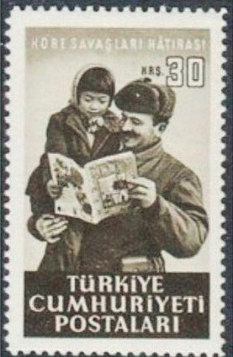
Question 1: Fotoğrafta görülenlerin kimler olabilir?
Source A: A postage stamp printed in the 1950s (Denizli, 2015, s. 105)
Question 2: What might be the reason or justification for printing this image on a postage stamp?

Guiding Question 1: What kinds of support did Korean children who lost their families and relatives during the Korean War receive from the Turkish soldiers while coping with the difficulties they faced?
Task 1: The students are asked/invited to examine Sources B, C, D, and E, answer the related questions, and prepare a diary reflecting the emotions and thoughts of a war-affected child.
Step 1: An excerpt from the diary of Korean War veteran Captain Süleyman Pulat in Source B is read.
Source B: Süleyman Pulat’s Diary
6 January 1951 – “I Had Become a Father Too.”
A little behind us, a child, her fingers buried in her hair and her head lowered, was seeking compassion from them. The child’s bare feet had turned completely purple from the cold snow on the ground and the freezing air, and her small body was trembling violently. My heart shattered into pieces. At once, my feelings of mercy for the little one surged. The small child had lost her family members and had curled up there, choosing the fire as her companion. She did not speak at all. She only wandered her meaningful eyes through the flames of the burning fire.
I immediately went back, told the battalion commander about the situation, and asked for permission to take the child. Upon receiving approval, I ran to the bridgehead together with Lieutenant Colonel Şemsi Eralp. When I arrived, the child was in the same state, standing there unaware of anything. We held her with brotherly affection. She did not object to our action and obeyed us. Now, I too have a child. Silent Müço had become not only mine but the entire battalion’s. Müço, who was hungry, was immediately fed. She ate the food placed before her with the fear that she might never find it again, and she put whatever was left into her pockets. Meanwhile, the tailor was cutting a jacket for her out of a blanket he had found. Müço, having forgotten all she had endured until then, was smiling around. At that moment, Müço was in deep sleep in the back of the jeep, easing the exhaustion of the day. Müço slept through the whole night without waking up (Habertürk, 2017).

Step 2: Based on Source B, the following questions are answered.
- What can be said about how war conditions affected children physically and psychologically, based on Source B?
- According to what is written in Source B, how were the Turkish soldiers affected by what they had witnessed regarding the children’s situation?
- According to Source B, what kinds of initiatives did the Turkish soldiers undertake for war-affected children?
- To what extent can the text in Source B be considered accurate and faithful to what truly happened during the Korean War? What can be done to verify the accuracy of what is written here?
Step 3: The students are asked/invited to examine the photographs in Source C.
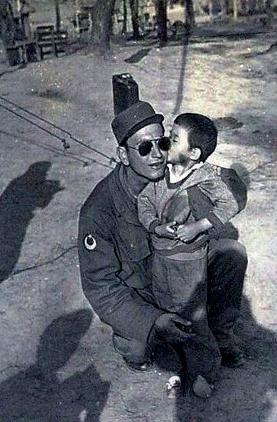
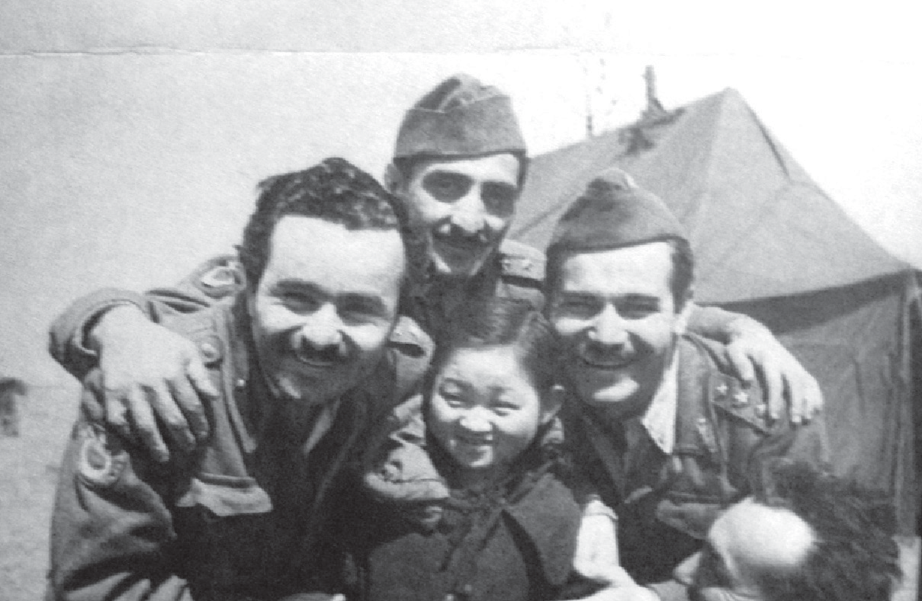
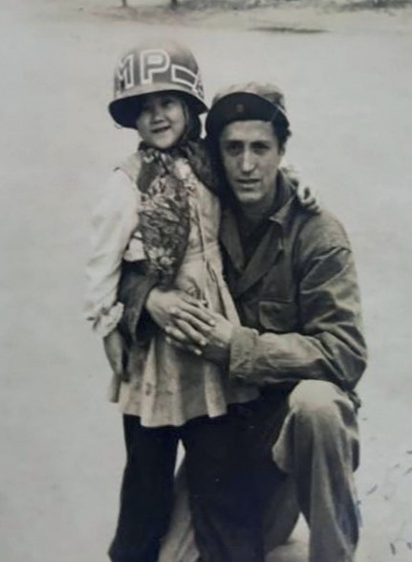
Source C: Various photographs from the time of the Korean War (Denizli, 2015, pp. 129, 132; Milli Gazete, 2017)

Step 4: The students are asked/invited to answer the following questions based on Source C.
- Who might the people seen in the photographs be?
- Are the children and soldiers seen in the photographs the same individuals, or are they different people?
- What do the photographs tell us about the attitude of the Turkish soldiers toward children?
- How many children might have been taken under protection by the Turkish Unit that participated in the Korean War? Can you make an estimate?

Step 5: The students are asked/invited to read or listen to two excerpts from the oral history interview conducted with the Korean War veteran Mehmet Aziz Erkmen.

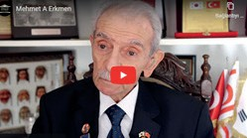
Source D: Two Excerpts from the Oral History Interview Conducted with Korean War Veteran Mehmet Aziz Erkmen (https://koreanwarlegacy.org/ interviews/mehmet-aziz-erkmen/)

🕒 36:43-37:06

M. E. Erkmen: Let me tell you, regarding our relations with the local people; you know, in our company, just like in that recently released movie ‘Ayla’, where a sergeant takes care of a little girl. We also had a little boy in our company, around four years old…
I do not know his name (I do not remember it), but we took care of him for about a month.
...
🕒 39:57-41:50

M. E. Erkmen: Let me tell you something else. We stayed in the city of Suwon for a while, and there we met a family, three or four of us together. There was a grandmother, a grandfather, a husband and wife, and their three children. The man’s arm had been severed at the elbow during the war, and the grandmother’s middle finger on one hand had become infected, swollen, yellow, and full of pus. She was twisting in pain, suffering terribly. I went to the company and brought an ointment, a medicated pomade for her, and I also gave her bandages. We had sulfonamide pills with us, they had been given to us in Türkiye before we departed, and I gave her some of those as well. The ointment burst the abscess, and the grandmother’s finger healed. They washed our laundry, and we gave them some of our rations. Once a week, we received chewing gum, cigarettes, razor blades, milk, and powdered sugar in small packs; I used to give the family some of that powdered sugar. Over time, we had become, in a way, like a family with them. When the time came to leave, to depart from the city of Suwon, they said, “Take us with you.” I told them it would not be possible. The next morning, when we were leaving, they all came as a family… and they were crying.

Step 6: The students are asked/invited to answer the following questions based on the excerpts from the oral history interview conducted with Korean War veteran Mehmet Aziz Erkmen.
- Could the child mentioned by Korean War veteran M. Aziz Erkmen be one of the children in the photographs in Source D? Why?
- What kinds of behavior did Korean War veteran M. Aziz Erkmen and his friends display toward the war-affected Korean family?
- Which values can be associated with the behavior of M. Aziz Erkmen and his friends toward the Korean family?
- How did the Korean family respond to the approach of M. Aziz Erkmen and his friends?
- What do the statements in this interview tell us about how positive attitudes and behavior between people can affect others, even during difficult situations such as war?

Step 7: The students are asked/invited to read or listen to the excerpt from the oral history interview with Korean War veteran Necdet Yazıcıoğlu in Source E.

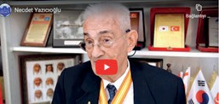
Source E: An excerpt from the oral history interview conducted with Korean War veteran Necdet Yazıcıoğlu (https://koreanwarlegacy.org/ interviews/necdet-yazicioglu/)
🕒 26.09-27.34

N. Yazıcıoğlu: Let me tell you one of the important points, a fascinating anecdote. They put us in a vehicle, twenty-four of us together. We went about 150 km to an old village reconstructed near Seoul. This village was designed to symbolize the lives of their ancestors; those who lived 100 or even 150 years ago. “They lived in a house like this, this was their kitchen, they used a lamp like this, they lit candles like this, they plowed the field this way, they shoed the horse this way,” they explained. We arrived, and the teacher was giving a lesson to primary and middle school children, showing them around. The teacher said, “Time out,” meaning break time, and he was only five meters away. The children stood up, ran toward us, held our hands, held us around the waist, and kissed our hands. One child, an older one, maybe around thirteen years old, grabbed my belt. He held my hand, kissed it, looked at me, and said, “Atatürk.” I immediately looked at the teacher, who was waving and smiling. Do you know what he said? He said: “Look, these men came here from 15,000 km away, leaving behind their mothers, fathers, wives, children, and loved ones. They died here; they shed blood. We… we won each other, we won our country. Their ancestor, their savior, Atatürk, is also your savior. Go tell him that,” he said. Moreover, he told me this. Of course, my eyes filled with tears instantly; I cried. In addition, I also cried at another time; not at the front, not during combat. However, when those children, whose parents had died and who were hungry and destitute, opened their hands toward us, asking for bread, asking for ‘chap chap’ (food), I cried a lot.

Step 8: The students are asked/invited to answer the following questions based on the excerpt from the oral history interview conducted with Korean War veteran Necdet Yazıcıoğlu.
- What might be the reason behind the idea that objects and reenactments representing ways of life in the past, witnessed by Korean War veteran Necdet Yazıcıoğlu during his visit to Korea in the 2000s, are visited by younger generations?
- What values do the behavior and attitudes displayed by the Korean students and the teacher toward the Korean War veterans visiting from Türkiye demonstrate?
- What characteristics of the Turkish soldier are reflected in Necdet Yazıcıoğlu’s statement, “I did not cry at the front or in battle. However, when those children, whose parents had died, hungry and destitute, held out their hands toward us asking for bread, asking for food, that is when I cried a lot.”

Step 9: The students are asked/invited to write a diary entry from the perspective of a child affected by the war, based on what they see and read in Sources A, B, C, D, and E.

Dear Diary;

................................................................................................................................................................................
..................................................................................................................................................................
..................................................................................................................................................................
..................................................................................................................................................................
..................................................................................................................................................................
..................................................................................................................................................................

Guiding Question 2: Kore Savaşı hakkında çekilmiş film ve belgesellerde tarihsel gerçeklik ne derece aslına uygun olarak yansıtılmış olabilir?
Task 2: The students are asked/invited to examine the movie ‘Ayla’ alongside Sources F, G, and H, answer the related questions, and complete Table 1.



Important Note: The students are asked/invited to watch the movie ‘Ayla’ with the whole class at school if suitable time and conditions are available after completing Task 1 in the first lesson. If this is not possible, students are encouraged to watch the movie ‘Ayla’ with their families.

Step 10: The students are asked/invited to read Source F, which includes the news text about Ayla and the movie ‘Ayla’.
Source F: About Ayla and the movie ‘Ayla’
During the Korean War, which broke out in 1950, Noncommissioned Officer Süleyman Dilbirliği, serving in the Turkish Armed Forces, found a five-year-old Korean girl on the battlefield who had lost her family. Having difficulty pronouncing the little girl’s real name, Süleyman gave her the name ‘Ayla’.
Süleyman took Ayla into his care and acted as her father for about fifteen months. During this time, Ayla became accustomed to living with the Turkish soldiers and learned Turkish, forming a strong bond with them.
When the war ended, Süleyman had to return to Türkiye and wanted to take Ayla with him. However, Korean law did not allow this, so Ayla was placed at the Ankara School and Orphanage established by Turkish soldiers.
In 2010, after 60 years, Süleyman Dilbirliği and Ayla (whose real name is Kim Eun-ja) were reunited in South Korea. This emotional reunion came after decades of longing, and their story inspired the 2017 movie ‘Ayla’ (Hürriyet, 2020).

Step 11: The students are asked/invited to examine an excerpt from a documentary featuring Korean War veteran NCO Süleyman Dilbirliği in Source G.
Source G: Selected Excerpts from a Documentary Featuring Korean War Veteran NCO Süleyman Dilbirliği
“We found a little girl there who had lost her way.”
“While we were withdrawing in Korea, during the withdrawal from Kunuri, I do not know exactly where; it was a place where her mother and father had been killed. She was left entirely alone, curled up in the cold… When we saw her there all by herself, we took her with us.”
Wherever they went, they were always together (Narrator).
“Now, when Ayla was eating here, just for fun, to be playful, she would take the spoon (he demonstrates by bringing his hand to his mouth) and say “aaah”, trying to tease us… Then she got used to us, and she even learned Turkish. She also acted as a translator. She had a very cheerful life. She had forgotten her past and had adapted entirely to us. She was with us all the time.” (Koreli Ayla Documentary, 2010)

Step 12: The students are asked/invited to answer the following questions based on the movie ‘Ayla’ and the information in Sources F and G.
- Did you observe any differences or inconsistencies between the sources you examined about what Ayla experienced during the war (the movie ‘Ayla’, Source F, and Source G)? If so, what might be the reason for these differences?
- Based on the footage in Source G, what can be said about how others (such as the American general) viewed the attitudes of the Turkish soldiers toward Ayla and other Korean children?
- Based on Source C and Source G, and the footage from the movie ‘Ayla’, which values can be said to have been influential or decisive in the way the Turkish soldiers approached Ayla and other Korean children? Why?
Step 13: You have learned certain information about Ayla’s real-life story and have watched the movie ‘Ayla’. Complete the following table regarding the consistency between historical facts and what is depicted in the film.
Table 1: Reality and Fiction: Are the events depicted in the movie ‘Ayla’ historically accurate or fictional?

 | Reality | Fiction
How did Ayla and Süleyman meet?
Who cared for and protected Ayla?
Did Marilyn Monroe give a concert in an environment where Turkish soldiers were also present?
Did Ayla meet Marilyn Monroe?
Do we have any information about whether Ayla and/ or Süleyman went to Japan?
Did Ayla learn Turkish well enough to translate for the Turkish soldiers?

Step 14: By evaluating the information provided by historical sources and the scenes you watched from the film comparatively, answer the following questions.
- Can the writings of those who witnessed the historical events be trusted? Why?
- Does Süleyman Dilbirliği remember correctly what he experienced during the Korean War? If he does not, what does this mean for us?
- Are filmmakers obligated to represent historical reality accurately? Why?
- After forty-two seconds of the opening of the movie ‘Ayla’, the text ‘This is the story of Süleyman Dilbirliği’ appears. Can this film be accepted as Süleyman’s real-life story or personal history? Why?
Step 15: The students are asked/invited to watch or read another excerpt from the oral history interview conducted with Korean War veteran Necdet Yazıcıoğlu presented in Source H.

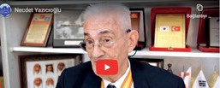
Source H: Another excerpt from the oral history interview conducted with Korean War veteran Necdet Yazıcıoğlu. (https://koreanwarlegacy.org/ interviews/necdet-yazicioglu/)
🕒 32:01-33:20

N. Yazıcıoğlu: I saw her; let me tell you something important. I saw Marilyn Monroe. She was truly stunning. Now, let me tell you the story. I was a lieutenant, and my battalion commander was a major; one meter eighty-five tall, very handsome, dressed in full combat gear. The Americans were saying, “Leave your weapons, take off the combat gear”, because he was wearing a steel vest and carrying hand grenades. They said, “Leave them and come”, “Artists have come from America, we’re going to have some entertainment.” American soldiers and generals were out front, drinking whiskey and having a good time. At that moment, I was standing at the back of the stage with the major. The major said, “Man, I want to see Marilyn Monroe up close.” I thought to myself, I was young and inexperienced, “Yes, sir, of course.” He said, “Wait a minute.” He went and stood right in front of Marilyn Monroe. Marilyn Monroe was suddenly startled. The major said, “Please… I want a piece of your hair.” Marilyn Monroe was startled again and said, “No, that is not possible.” The major said, “No, I will not let you go; that is not possible.” However, she looked at him, really looked at him, he was one meter eighty-five, very handsome… a handsome major with a mustache. She said, “Okay,” and took a small strand of hair. The major grabbed it and snipped it. He took it, put it in a piece of paper, and slipped it into his pocket. Now, that hair would be worth millions.

Step 16: The students are asked/invited to answer the following questions based on the part of the oral history interview with Korean War veteran Necdet Yazıcıoğlu given in Source H.
- How realistic do you think Korean War veteran Necdet Yazıcıoğlu’s story about meeting Marilyn Monroe is?
- How consistent is Necdet Yazıcıoğlu’s story about meeting Marilyn Monroe and the events depicted in the film?
- Imagine yourself as one of the people involved in the dialogue between the Turkish major and Marilyn Monroe described by Necdet Yazıcıoğlu. How would you feel and how would you behave?

🎯Assessment and Evaluation
- Who is Ayla?
- How did the Turkish soldiers approach Korean children during the Korean War, and what did they do for them?
- How did Korean children and adults respond to what the Turkish soldiers did for them during the war and afterward?
- Based on the sources you examined and the footage you watched, write your thoughts on how accurately historical films reflect historical reality.

References
Denizli, A. (2015). Kore Savaşı’nda Türk askerinin Kore halkına yardımları ve Ankara Okulu’nun açılması (1950–1953) [The support of Turkish soldiers to the Korean people during the Korean War and the opening of the Ankara School (1950–1953)]. Ankara.
Habertürk. (2017). Kore Savaşı’ndan ikinci Ayla hikayesi çıktı [A second Ayla story emerged from the Korean War]. https:// www.haberturk.com/kore-savasindan-ikinci-ayla-hikyesi-cikti-1723647?page=10 Access Date: 03.01.2025
Han, J. (2018a). Interview with Mehmet Aziz Erkmen. https://koreanwarlegacy.org/interviews/mehmet-aziz-erkmen/ Access Date: 27.04.2024.
Han, J. (2018b). Interview with Necdet Yazıcıoğlu. https://koreanwarlegacy.org/interviews/necdet-yazicioglu/ Access Date: 25.04.2024.
Hürriyet (2020). Süleyman Dilbirliği kimdir, ne zaman öldü? Süleyman Astsubay ve Koreli Ayla’nın gerçek hikayesi [Who was Süleyman Dilbirliği, and when did he die? The true story of Sergeant Süleyman and the Korean girl Ayla]. https://www.hurriyet.com.tr/kelebek/televizyon/suleyman-dilbirligi-kimdir-ne-zaman-oldu-suleyman-astsubay-ve-koreli-aylanin-gercek-hikayesi-41503775 Access Date: 22.03.2025
Koreli Ayla Documentary. (2010). https://www.youtube.com/watch?v=yeHBuM9kyLM&t=0s Access Date: 27.04.2024. Milli Gazete. (2017). Gazi babasının “Tugayımızın uğuru” dediği Ayla’yı Samsun’a davet etti [A veteran father invited
Ayla, whom he called “the good-luck charm of our brigade,” to Samsun]. Milli Gazete. (08.12.2017). https://www. milligazete.com.tr/haber/1434650/gazi-babasinin-tugayimizin-uguru-dedigi-aylayi-samsuna-davet-etti Access Date: 27.04.2024.

🏠
Homework
Write a short text discussing the impact that the film Ayla had on you.

