ANKARA SCHOOL
Unit 6
🎓 Grade Level:
6th, 7th and 8th Grades

⏰ Teaching Time:
40 + 40 minutes

Concepts to Digest: War, orphan, orphaned child, orphanage
Skills to Improve: Historical empathy, historical inquiry and analysis
Core Values: Friendship, altruism, helpfulness

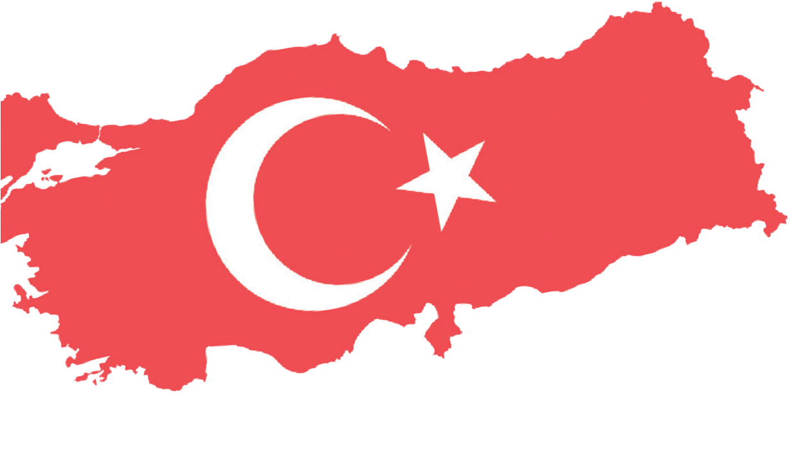
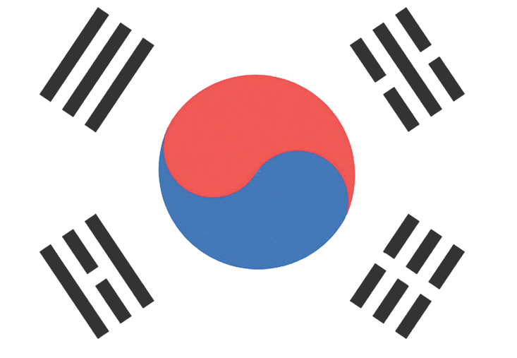

Methods-Techniques: Lecturing, historical inquiry, case study, questioning, oral history
Teaching-Learning Materials: Photographs, archival documents, interviews
Learning Aim: To demonstrate that the Turkish Armed Forces carried out a humanitarian mission beyond their military duties. This can be shown by examining the activities of the Suwon Ankara School and orphanage, which was established and supported by Turkish soldiers during the Korean War.
Key Question: How was the Suwon Ankara School and orphanage, a significant contribution of Turkish soldiers during the Korean War, established, and what functions did it serve?
Guiding Question 1

How was the Suwon Ankara School and orphanage established?
Objective 1
To understand how the Suwon Ankara School and orphanage was established by using primary sources and testimonies.
Task 1

The students are asked/invited to examine Sources A, B, C, and D, answer the related questions, and prepare a short news
text explaining who founded the Suwon Ankara School and orphanage, what resources were used, and how.
Guiding Question 2

How did the activities carried out at the Suwon Ankara School and orphanage help to create a connection between the children who lived and studied there and Türkiye?

Objective 2

To understand how the activities carried out at the Suwon Ankara School and orphanage influenced the feelings and thoughts of Korean children in regard to Türkiye, and how this shaped relations between the peoples of the two countries after then.

Task 2

The students are asked/invited to examine Sources E, F, G, H, I, and J, to answer
the related questions, to make inferences about how the activities carried out at the Suwon Ankara School and orphanage influenced Korean children’s feelings and thoughts in regard to Türkiye and how this shaped relations between the peoples of the two countries, and to prepare an informative text.

Teaching and Learning Plan

‼ Focus on activity
The prepared questions are directed to the students to draw their attention to the topic.
5 min.

🛎 Task 1
The students are asked/invited to examine Sources A, B, C, and D, answer the related
questions, and to prepare a short news text explaining who founded the Suwon Ankara School and orphanage, with what resources, and how.
35 min.

🛎 Task 2
The students are asked/invited to examine Sources B and C, Visual Sources 2, 3, 4, and 5, and Oral History Interview 2, answer the related questions, make inferences about how the activities carried out at the Suwon Ankara School and orphanage influenced Korean children's feelings and thoughts in regard to Türkiye and how this later shaped relations between the peoples of the two countries, and to prepare an informative text.
🎯 Assessment and Evaluation

35 min.

The students are asked/invited to complete an assessment composed of open-ended questions.
5 min.

🏠 Homework
The students will write three separate letters by considering the perspectives of three different individuals. Those students who prefer, may complete a task to evaluate the evidence used in the activity. This product is then stored in the electronic portfolio.

Teaching and Learning Process
Focus on activity: The students are asked/invited to answer the following questions to draw their attention to the lesson topic.
- What are the basic needs of children living in a war environment? How might the lack of these needs affect them?
- What might Turkish soldiers who participated in the Korean War have felt when leaving their families and children behind?
Guiding Question 1: How was the Suwon Ankara School and orphanage established?
Task 1: The students are asked/invited to examine Sources A, B, C, and D, answer the related questions, and prepare a short news text explaining who founded the Suwon Ankara School and orphanage, what resources were used, and how.
Step 1: The students are asked/invited to examine Source A and Source B.
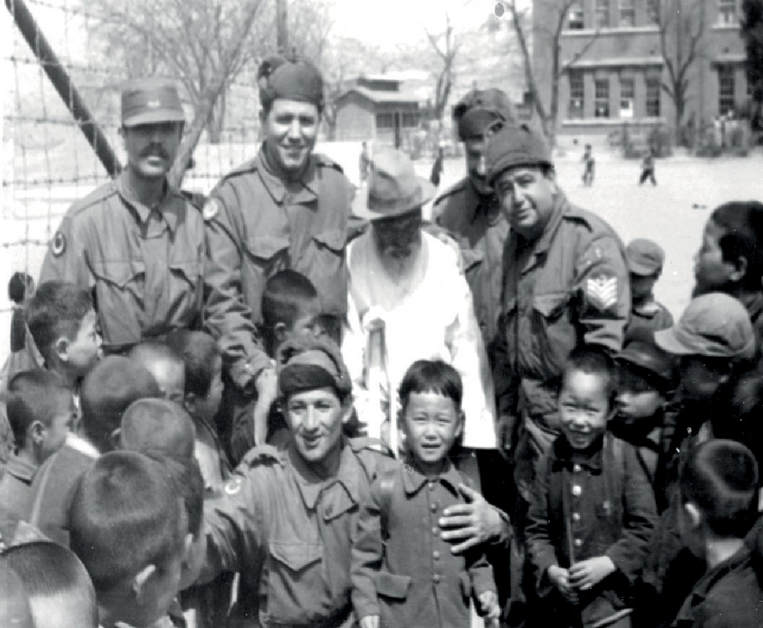
Source A: An Excerpt from the Diary of NCO Hasan Hüseyin Dinçtürk
At the headquarters where I was serving, I saw small children, clearly in need of care, collecting leftover food from the area where excess meals were discarded. Feeling sorry for them, I began helping those children who had lost their mothers and fathers in the war and had no-one left to look after them, using my own supplies. My friends joined me, and we began calling these children by Turkish names and teaching them our marches and songs. Later, we requested two teachers from the local administration and turned the area beside the depot into a school.
At first, there were only five to ten children, but over time their numbers increased, reaching around six hundred and forty. We met all their needs and embraced them with a longing as deep as that of fathers and sons. There, I served both as a teacher to these children and, for a time, as the institution's administrator (adapted from Tekin and Erdem, 2023, pp. 48-49).
Source B: A photo showing NCO Hasan Hüseyin Dinçtürk, several Turkish soldiers, and an elderly Korean man, together with the students of the Ankara School (Denizli, 2015, s. 151)
Step 2: The students are asked/invited to answer the following questions based on Source A.
1. According to Source A, what was the starting point of the developments that led to the establishment of the Suwon Ankara School?

- According to Source A, by whom
were the needs of the Suwon Ankara School met?
- According to Source A, who founded the Suwon Ankara School?
- What does Source B tell us about what Korean children experienced during the war?

Step 3: The students are asked/invited to examine Source C.
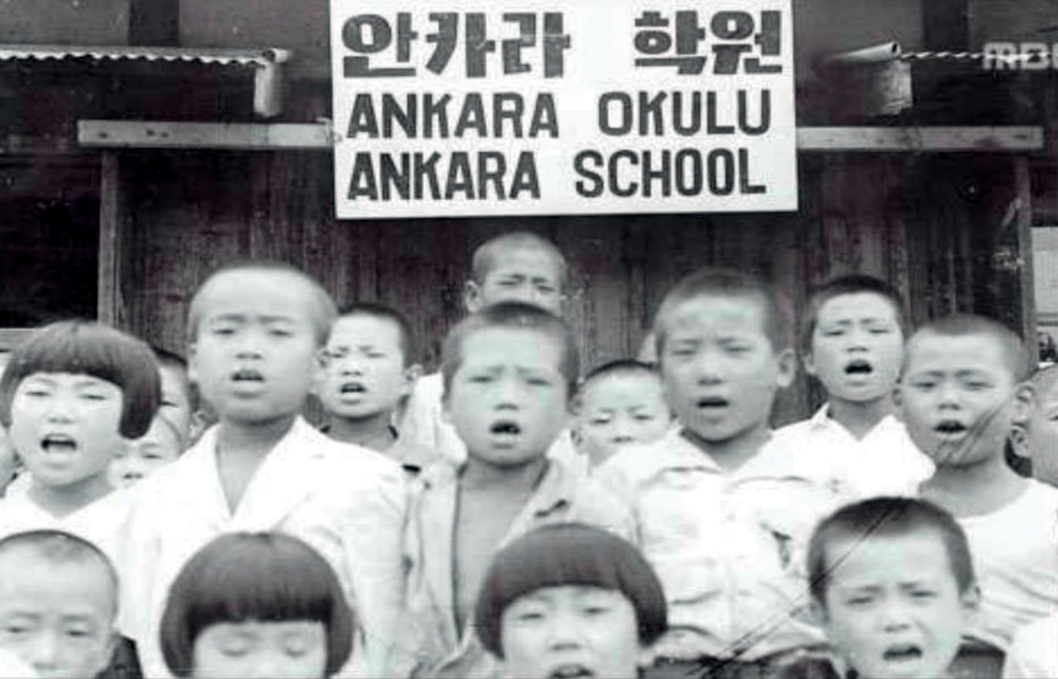
Source C: Students of the Suwon Ankara School (Denizli, 2015, p. 110)
Step 4: The students are asked/invited to answer the following questions based on Source C.
1. What can be said about the appearance of the children in the photograph (in particular their haircuts and clothing)?
  - What might the children in this
photograph be reciting (such as the Turkish National Anthem or the Ankara March)?
  - What kinds of emotions do the children in this photograph evoke in you?

Step 5: The students are asked/invited to examine the Oral History Interview Excerpt 1 in Source D.
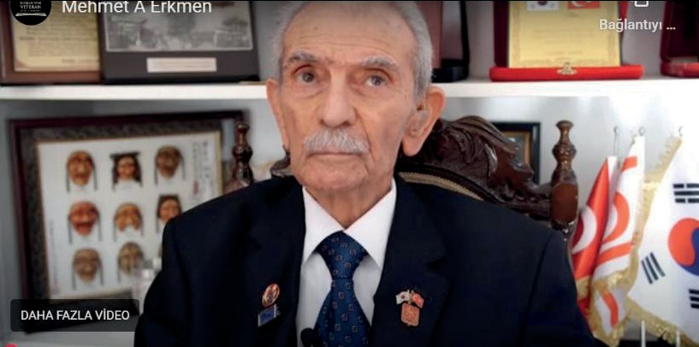
Source D: Excerpts from the interview conducted with Korean War veteran Mehmet Aziz Erkmen (https://koreanwarlegacy.org/ interviews/mehmet-aziz-erkmen/)

🕒 37:11-38:02
M.A. Erkmen: Our company commander said, “This child is very young, and the weather is freezing; it was winter. You cannot take care of him here, so take him to Suwon; you’ve heard of the Ankara School there?” He said to me, “Aziz, take a jeep and bring him to Suwon.” I then took him to the Ankara School in Suwon.
…
🕒 39:12-39:47
M.A. Erkmen: … The Medical Company Commander, Major Seyfi Aysu, had established that school. They gathered orphaned children in one building and our Brigade provided their food and clothing. The children were taught to speak and read Turkish there. The school's name was the Ankara School.

Step 6: The students are asked/invited to answer the following questions based on Source A and Source D.
- According to the Veteran M. Aziz Erkmen, what kind of function did the Suwon Ankara School serve during the Korean War?
- According to Source D, by whom were the needs of the Suwon Ankara School met?
- According to Source D, who founded the Suwon Ankara School?
- What might be the reason for the differences between Source A, Source D, and Source F below regarding who established the Suwon Ankara School?
- In your opinion, which of the statements in these sources reflects the truth regarding who established the Suwon Ankara School? Why?
Step 7: The students are asked/invited to prepare a short news text explaining who founded the Suwon Ankara School and orphanage, what resources were used, and how.

Turkish School in Korea

The Turkish Brigade that we sent to Korea on behalf of the United Nations ..........................................
..................................................................................................................................................................
..................................................................................................................................................................
..................................................................................................................................................................
..................................................................................................................................................................

Guiding Question 2: Suwon Ankara Okulu ve Yetimhanesi’nde gerçekleştirilen faaliyetler burada barınan ve eğitim alan çocuklar ile Türkiye arasında nasıl bir bağ oluşturmuştur?
Task 2: The students are then asked/invited to examine Sources E, F, G, H, I, J, and K, to answer the related questions, to make inferences about how the activities carried out at the Suwon Ankara School and orphanage influenced Korean children’s feelings and thoughts about Türkiye and how this later shaped relations between the peoples of the two countries, and to prepare an informative text.
Step 8: Students are asked/invited to examine Source E and Source F.
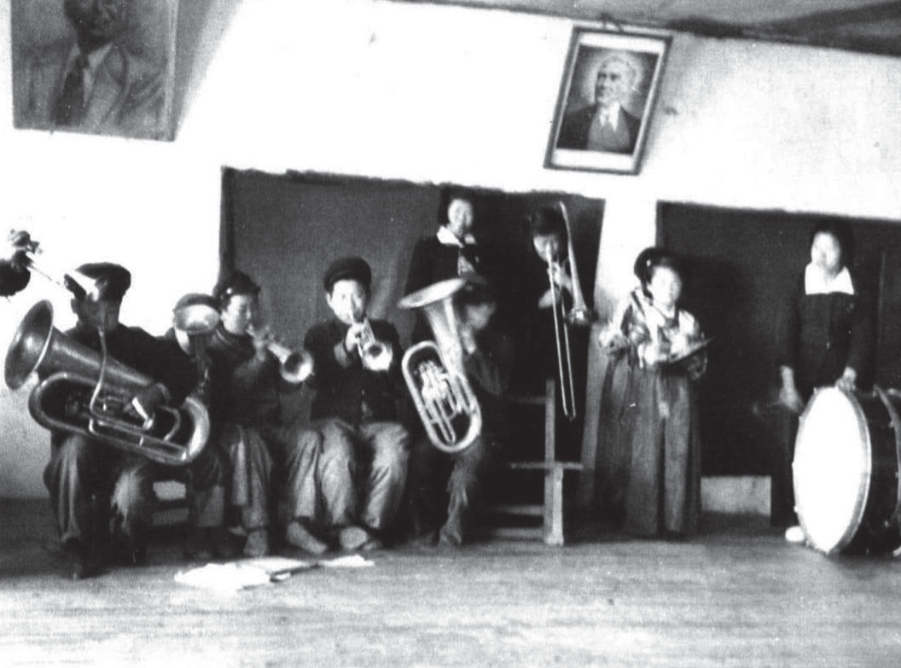
Source E: A view from a Republic Day celebration ceremony held at the Suwon Ankara School (Denizli, 2015, p. 140)

Source F: About the Ankara School
The students' educational needs were met through books and stationery sent by the Ankara Demirlibahçe Primary School, and many musical instruments brought from Türkiye were used for therapy, including a piano from Ankara.
Through these efforts, NCO Hasan Hüseyin Dinçtürk quickly earned the love and respect of the Korean people, and he was given the title ‘Father of Orphans’.
The education at the school was conducted in Turkish, English, and Korean. To ensure the children’s happiness, an overloaded curriculum was avoided. Instead, physical education and music lessons were used to help the children recover psychologically from the conditions of the war. Ballet and folk-dance performances held at the school, the October 29 Republic Day celebrations, and Korean children singing Turkish songs all helped ease the harsh impact of war on these innocent little children. They also provided morale and motivation for the Turkish soldiers who saw and loved them as their own children (summary adapted from Denizli, 2015, pp. 142-173).

Step 9: Students are asked/invited to answer the following questions based on Sources E and F.
- What do you see in Source E? Who and what are visible in the image?
- How did seeing Atatürk’s portrait on the wall of a place where children from another country were being educated or sheltered make you feel?
- According to Source F, what kind of education was provided to the students at the Suwon Ankara School? Why was this the case?
- According to Source F, what effects did the cultural activities carried out at the Suwon Ankara School have on the children studying there and on the Turkish soldiers?

Step 10: The students are asked/invited to examine Source G and Source H.
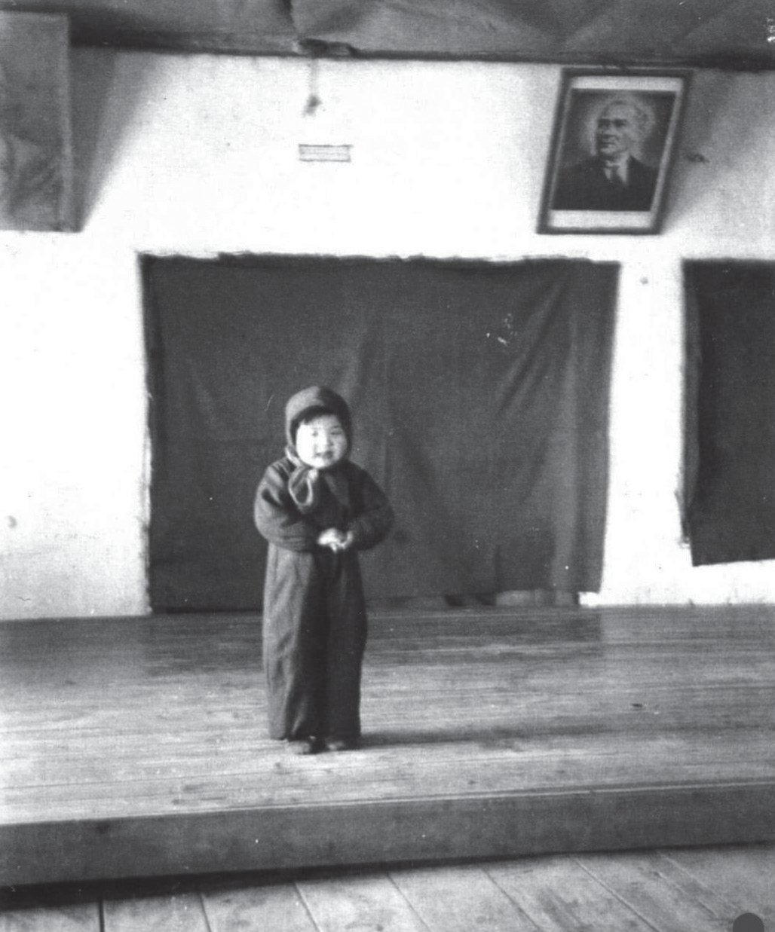
Source G: A view from a ceremony held at the Suwon Ankara School (Denizli, 2015, p. 139)

Source H: Memories of the Ankara School from two Koreans named Yoon Yeo Yeon and Lee Young
Yoon Yeo Yeon, aged 70, and Lee Young, aged 71, who studied at the Ankara School and feel deep gratitude toward the Turkish soldiers, recount those days with tears in their eyes:
“We survived on the food and drinks of the Turkish soldiers who fought for our freedom. Hüseyin Dinçtürk and his soldiers not only educated us but also acted as both mothers and fathers. There were around six hundred and forty children. For four years, they never left us alone. They made us forget that we had no mother or father. We will carry their love in our hearts until the day we die.” (Ege’de Son Söz, 2012)

Step 11: The students are asked/invited to answer the following questions based on Source G and Source H.
- What do you see in Source G?
- What kinds of emotions that you saw in Source G evoke in you?
- What feelings and thoughts do the individuals sharing their experiences about the Ankara School in Source H express regarding the Turkish soldiers?
- With which values can we associate the statements made by the individuals who shared their experiences regarding the Ankara School in Source H?
- How did the approach of Turkish soldiers work toward children during the Korean War and what did they do for them to help create a bond between the people of the two countries (Türkiye and South Korea)?
Step 12: The students are asked/invited to examine the oral history interview presented in Source I.
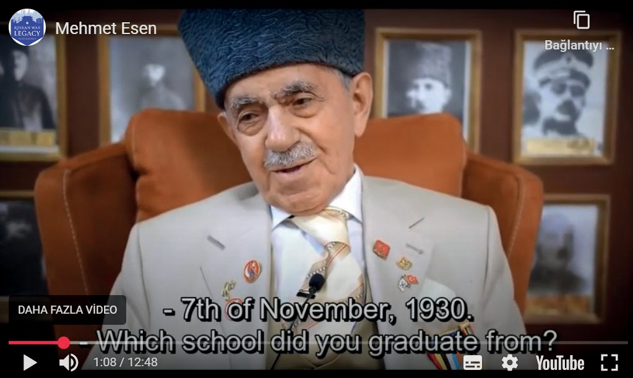
Source I: An excerpt from the interview conducted with Korean War veteran Mehmet Esen. (https://koreanwarlegacy.org/ interviews/mehmet-esen/)

🕒 04:47-05:58
M. Esen: Back then, I stayed in Seoul (at the hospital). There
was this girl, I met her at that time, my little girl… she wasn’t really my daughter, but… yes, she was one of them, the poor little thing, we took her in. I used to receive five dollars a month, and I would give that to her. I sent her to school while I was in the hospital. We also had our Kerim, Kerim… We found him somewhere. We were walking through some bushes during a reconnaissance, moving in a skirmish line. I wasn’t heavy then; I was as fit as a fiddle, thank God. I noticed something, like an eye looking out and I said, “Kaya, son, wait, what is that? There’s something there.” Then he came out. This tiny little thing, he didn’t know anything. “What will his name be?” they asked. I said, “Well, God is generous [Allah kerim],” and we named him Kerim. I have always loved my children.

Step 13: The students are asked/invited to answer the following questions based on Source I.
- With which values can we associate with the approach of Turkish soldiers toward Korean children during the war? Why is this the case?
- What clues does Veteran Mehmet Esen’s statement, “I have always loved my children”, give us about his and other Turkish soldiers’ perspectives on Korean children during and after the war?
Step 14: The students are asked/invited to watch or read the selected parts of Source J (the video featuring Sang-ki Paik, a Korean War veteran and former advisor at the Turkish Embassy in Seoul).

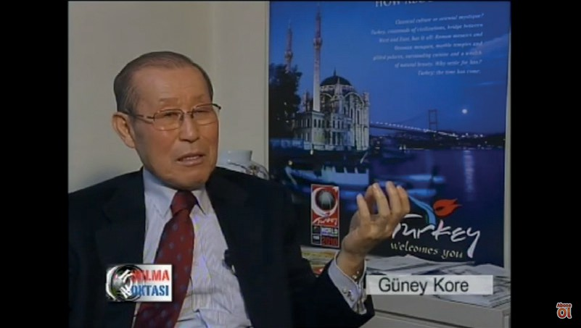
Source J: Selected excerpts from the interview with Sang-ki Paik
(Kore Savaşı – Ankara Okulu I, 2007)
🕒 08:56-11:30
Of course, during the war, a number of children were left without mothers and fathers. Their mothers had died and their fathers had died. At three or four years old, in this cold, they stood outside hungry and crying.
I always say this everywhere about the Turkish soldiers, about this nation.
This is where Turks' most excellent quality comes from. Beyond the war of course, they fought heroically, that is separate, there is humanity, and genuine humanity. Turks cannot bear to see children suffering. The Turkish soldiers feel pity for them and take one or two children with them. They bring them to the battalion or the brigade. They give them hot food, blankets, a place to sleep, food to eat, and clothes to wear. There is a city called Suwon far in the south. They took the children to the Medical Company in Suwon and set up a camp there in tents. An orphanage for orphaned children; it was named the Ankara School. Eventually, they reached about fifty children. These children grew up and later went their separate ways. Those who were five or six years old then are now around sixty or sixty-five.
Those who grew up in the orphanage and survived are now in their seventies, but when Türkiye experienced the devastating 1999 earthquake, they were among the first to rush to help. When news came that the Korean government would provide only seventy thousand dollars in aid to Türkiye, the first to react, together with civil society groups, were again these same people. They believed that such a small amount of aid was insignificant compared with what the Turks had done for the Korean people during the war, which sparked a movement of solidarity.
We launched a relief campaign, friendship, unity, and togetherness. These children came, and I was surprised, and they were surprised too. When I asked who they were, they said, “We are graduates of the Ankara School.” Which Ankara School? Because they were orphans. “The Turks helped us; we are graduates of the Ankara School in Suwon,” they said. Truly, two or three of them came. Whatever little money they had in their pockets, they brought it. “The kindness and humanity shown to us by the Turks, by the Turkish soldiers, is something we can never forget for the rest of our lives.” They stopped by the embassy and said, “Even if it is a small amount, we want to give something as a donation” (Korean War – Ankara Okulu I, 2007).

Step 15: The students are asked to answer the following questions based on the information described in Source J.
- What can be said about the physical effects of the war on Korean children based on the accounts?
- What can be said about the emotional effects of the war on Korean children based on the accounts?
- Based on the accounts, which values appear to have guided the behavior of Turkish soldiers toward civilians, especially children, during the Korean War?
- According to what is described, how were the attitudes and actions of Turkish soldiers toward civilians and children received by the Korean people during the war?

Step 16: The students are asked/invited to examine Source K.
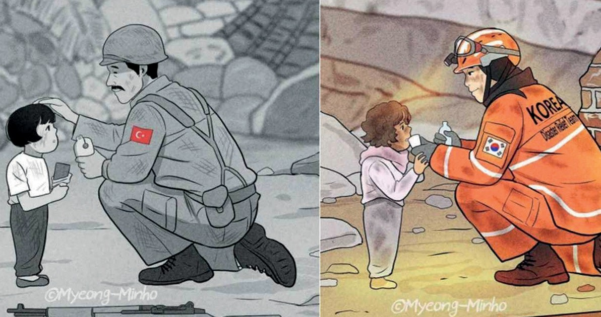
Drawings depicting a Turkish soldier helping a Korean child in need during the Korean War (1950-1953) and a Korean relief volunteer helping a Turkish child affected by the Kahramanmaraş Earthquake of 6 February 2023.
Source K: Türkiye-South Korea Solidarity (Minho, 2023; used with the written permission of the artist)

Step 17: The students are asked/invited to prepare an informative text based on Source K, using the guiding prompts provided in the box if needed.

War is .....................................................................................................................................................................
........................................................................................................................
Earthquake is..........................................................................................................................................................
........................................................................................................................
Similarities between the two concepts include .................................................................................................
.................................................................................................................................................................................. Differences between the two concepts include .................................................................................................
..................................................................................................................................................................................
In situations of war and natural disasters, international solidarity and cooperation influence and guide nations in ...............................................................................................................................................................
..................................................................................................................................................................................
. ways.

🎯Assessment and Evaluation
- What did Korean children who lost their families under wartime conditions feel, and what needs did they have?
- How did the Turkish soldiers serving in the Korean War feel when they found children who had suffered because of the war?
- What did they do to meet children’s shelter and educational needs, and to support their morale and motivation under the wartime conditions?
- What were the effects on the children of being taken in by Turkish soldiers during the Korean War, and of having their shelter, educational, and other physical, personal, and psychological needs met?
- Share your thoughts with your classmates on what children may be experiencing in today’s wars and what their shelter, educational, morale, and motivational conditions might be like.

References
Kore Savaşı – Ankara Okulu I. (2007). Kırılma Noktası. [The Breaking Point]. [documentary] https://youtu.be/ SofRo9JcZas?si=TcrbK2I1XLW1jDyM, Access Date: 15.03.2024.
Denizli, A. (2015). Kore Savaşı’nda Türk askerinin Kore halkına yardımları ve Ankara Okulu’nun açılması (1950–1953) [The assistance of Turkish soldiers to the Korean people during the Korean War and the opening of the Ankara School (1950–1953)]. Ankara.
Ege’de Son Söz, 2012). Kore’deki Türk askerlerinin insanlık dersi ortaya çıktı [The humanitarian lesson of Turkish soldiers in Korea was revealed], (25.09.2012), https://www.egedesonsoz.com/koredeki-turk-askerlerinin-insanlik-dersi-ortaya-cikti. Access Date: 13.03.2025.
Han, J. (2018a). Interview with Mehmet Aziz Erkmen. https://koreanwarlegacy.org/interviews/mehmet-aziz-erkmen/ Access Date: 27.04.2024.
Han, J. (2018b). Interview with Mehmet Esen. https://koreanwarlegacy.org/interviews/mehmet-esen/ Access Date: 25.04.2024.
Min-ho, M. (2023). Two illustrations feature a Turkish soldier (left) and a Korean Disaster Relief Team member (right) helping children who are victims of tragedies (15.02.2023). https://www.koreaherald.com/article/3063343, Access Date: 12.03.2024. (Used with the artist’s personal permission.).
Tekin, C. ve Erdem, N. (2023). Kore Savaşı’nda Türklerin açtığı bir eğitim kurumu: Ankara Okulu ve Yetimhanesi [An educational institution established by Turks during the Korean War: The Ankara School and Orphanage]. Karatay Sosyal Araştırmalar Dergisi, (10), ss. 35-62. https://doi.org/10.54557/karataysad.1253567

🏠
Homework: Empathy Exercise from Different Perspectives
Write three separate letters by thinking from the perspectives of the individuals listed below and answer the related questions.

A. As a Turkish Soldier: | B. As an Orphaned Korean Child: | C. Bir Koreli Yönetici/Öğretmen Olarak:
What did you feel when you encountered orphaned children while fighting in Korea? | How did you feel after losing your family? | How did you evaluate the Turkish soldiers’ initiative to establish an orphanage during the war?
Why did you decide to establish the Ankara School? | How did the approach of the Turkish soldiers affect you? | What did this cooperation mean to you?
What motivated you to support Korean children even though you were far from your own family and loved ones? | How did your life change at the Ankara School? | What was the role of the Ankara School in forming Turkish Korean friendship?
What challenges did you face while educating children under wartime conditions? | What did learning Turkish and becoming familiar with Turkish culture make you feel?

🏠
Homework: Evidence Evaluation Table
Evaluate the sources you examined during the activity within the framework of the table below:

Source | Type | Reliability | Information Provided | Perspective | Limitations
Source A
Source B
Source D
Source F
Source G
Source H
Source I
Source J
Source K

