TURKISH PRISONERS OF WAR IN KOREA
Unit 7
🎓 Grade Level:
6th, 7th and 8th Grades

⏰ Teaching Time:
40 + 40 minutes

Concepts to Digest: Identity, de-identification, captivity, prisoner, prisoner of war
Skills to Improve: Historical inquiry and analysis, historical empathy
Core Values: Solidarity, patience, courage, self-control

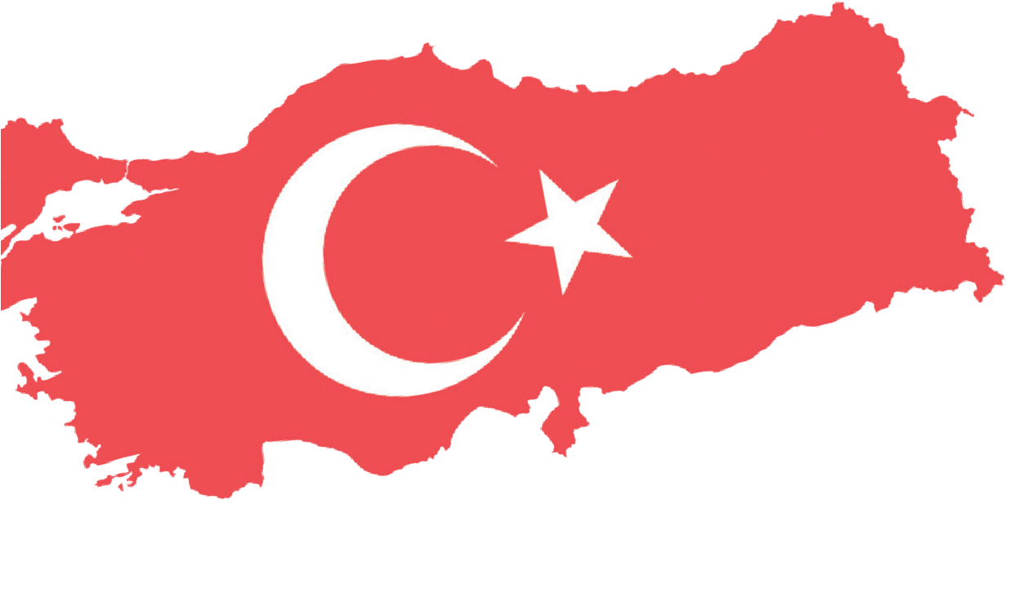


Methods-Techniques: Evidence-based historical research, historical inquiry and analysis, case study, oral history
Teaching-Learning Materials: Interviews, diaries
Learning Aim: To help students understand what Turkish soldiers captured by the enemy during the Korean War experienced as POWs.
Key Question: How does captivity affect human life physically and emotionally?

Guiding Question 1

According to the stories of Turkish soldiers captured during the Korean War, how does captivity or being a POW affect human life physically?
Objective 1

To develop historical empathy by examining the experiences of prisoners during their captivity based on the example of a selected soldier and the events he went through.
Task 1

The students are asked/invited to examine Sources B, C, D, and E and to answer the related questions.
Guiding Question 2

According to the stories of Turkish soldiers captured during the Korean War, how did the treatment of prisoners affect their spiritual and psychological well-being?

Objective 2

To evaluate propaganda and counter-propaganda
techniques through examples and to analyze their expected or possible outcomes.
Task 2

The students are asked/invited to examine Sources F, G, H, and I and to answer the related questions.
Guiding Question 3

How did Turkish soldiers cope with the adverse effects of captivity?
Objective 3

To make inferences about the military discipline and psychological resilience of Turkish prisoners of war in
comparison to others, based on personal experiences.

Task 3

The students are asked/invited to examine Sources J, K, L,
M, and N and to answer the related questions.

Teaching and Learning Plan

‼ Focus on Activity
The students are asked/invited to view Source A and to participate in a brief discussion.
5 min.

🛎 Task 1
The students are asked/invited to examine Sources B, C, D, and E and to answer the related questions.
20 min.
🛎 Task 2
The students are asked/invited to examine Sources F, G, H, and I and to answer the related questions.
25 min.
🛎 Task 3
The students are asked/invited to examine Sources J, K, L, M, and N and to answer the related questions.
25 min.
🎯 Assessment and Evaluation
The students are asked/invited to answer the open-ended questions.
5 min.

🏠 Homework
The students are asked/invited to conduct research on how the concept of the North Star emerged, and to save their final product as a presentation in their electronic portfolios.

Teaching and Learning Process
Focus on activity: The students are asked/invited to examine Source A and to share their ideas with their classmates about who the people in the photograph might be and what emotions or thoughts these individuals might have based on their appearance and facial expressions.
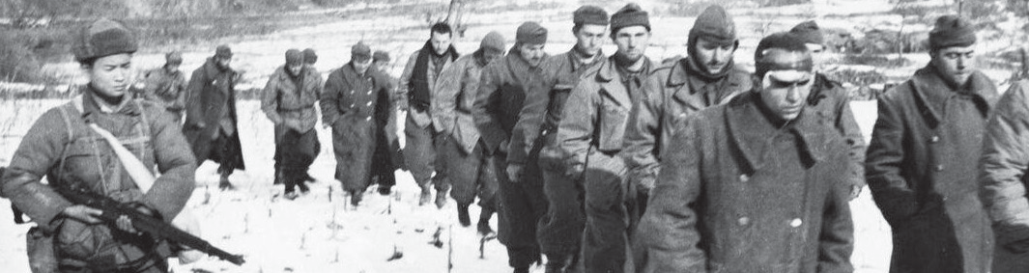
Source A: A scene from the Korean War (Türkiye Gazetesi, 2025)

Guiding Question 1: According to the stories of Turkish soldiers captured during the Korean War, how does captivity or being a POW affect human life physically?
Task 1: The students are asked/invited to examine Sources B, C, D, and E and to answer the related questions.
Step 1: The students are asked/invited to examine Sources B, C, D, and E.

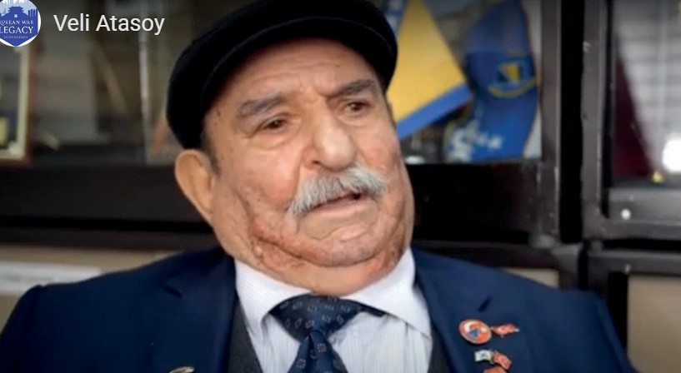
Source B: Selected excerpts from the oral history interview with Korean War veteran Veli Atasoy. (https://koreanwarlegacy.org/interviews/ veli-atasoy/)
🕒 09:34 - 12:17

V. Atasoy: My right foot… it is injured. Practically every time I walk, our memories play like a film; we recall the time we spent there like a movie reel. It kept recharging,
replaying our past experiences. We stayed there, then moved to another camp for about six months. That place was in ruins. They were doing propaganda on us there, but we could not understand anything. After that, we stayed in a city called Pyoktong on the Yalu River, where Korea, Siberia, and Manchuria meet. We stayed there for about two years. For almost a year, our days passed outside, and we were devastated. Finally, in the city of Pyoktong, we… again, we prisoners… emptied garbage bins, boiled water, then pressed dirty clothes, boiled them to get rid of lice. We began to clean the places where we slept. Slowly, slowly, we clenched our teeth and persisted. God above, earth below, there was no-one else. We were hungry and thirsty; we ate whatever they gave us and drank whatever they gave us. Captivity! I did not want to talk about it, but you insisted, so I am telling you, because when I remember those days, I lived through, smoke rises from my head to my feet; I feel hatred, we lived through life, but we lived helplessly.
🕒 13:11 - 13:30

V. Atasoy: In captivity, we were constantly under challenging situations. It is hard to describe or explain captivity. We saw many things, and we endured severe torture.

Source C: After their initial interrogations, Turkish prisoners were forced to embark on a grueling journey that would last for days as they were taken to the camps where they would stay. This journey, made entirely on foot, was a life-or-death struggle for the soldiers, most of whom were wounded, and for this reason it was called the ‘death march’. Those who became unable to walk due to exhaustion or worsening injuries were left on the roadside. When Corporal Ahmet Akdağ’s wound worsened, the Chinese guards wanted to leave him behind. Corporal Veli Atasoy, although wounded himself, carried his friend on his back until he became too weak to walk. When he could no longer walk, the guards then left him on the roadside. Atasoy became lost on Korean soil, which he did not know at all. He later encountered Koreans, was captured again, and was taken to a prisoner camp, completing his interrupted journey (Fikriyat, 2020).

Source D: I will not leave you in the House of Death
Corporal Veli Atasoy was very cautious. He noticed that the half-raw soybeans distributed once a day in the camp, and the salted fish full of worms that was rarely given, caused diarrhea among the American prisoners. In the prisoner-of-war camp, getting diarrhea meant death. He warned the Turkish prisoners not to eat such food. However, this warning also got him into trouble. When some Turkish prisoners dumped the food on the ground, the Chinese guards became furious. They investigated the incident and eventually traced it back to Corporal Atasoy. As a result, he was sentenced to one week in solitary confinement. During the time Atasoy was in the cell, some Turkish prisoners became ill. One of them was so seriously sick that he was taken to the camp hospital. Atasoy went to the hospital both to learn the fate of his fellow prisoners and to see what the camp hospital was like. However, the place was more like a ‘house of death’ than a hospital. Atasoy ensured that the Turkish prisoners in the hospital were discharged, and then he began treating his sick friends himself, so they would not be sent back to the hospital (Fikriyat, 2020).

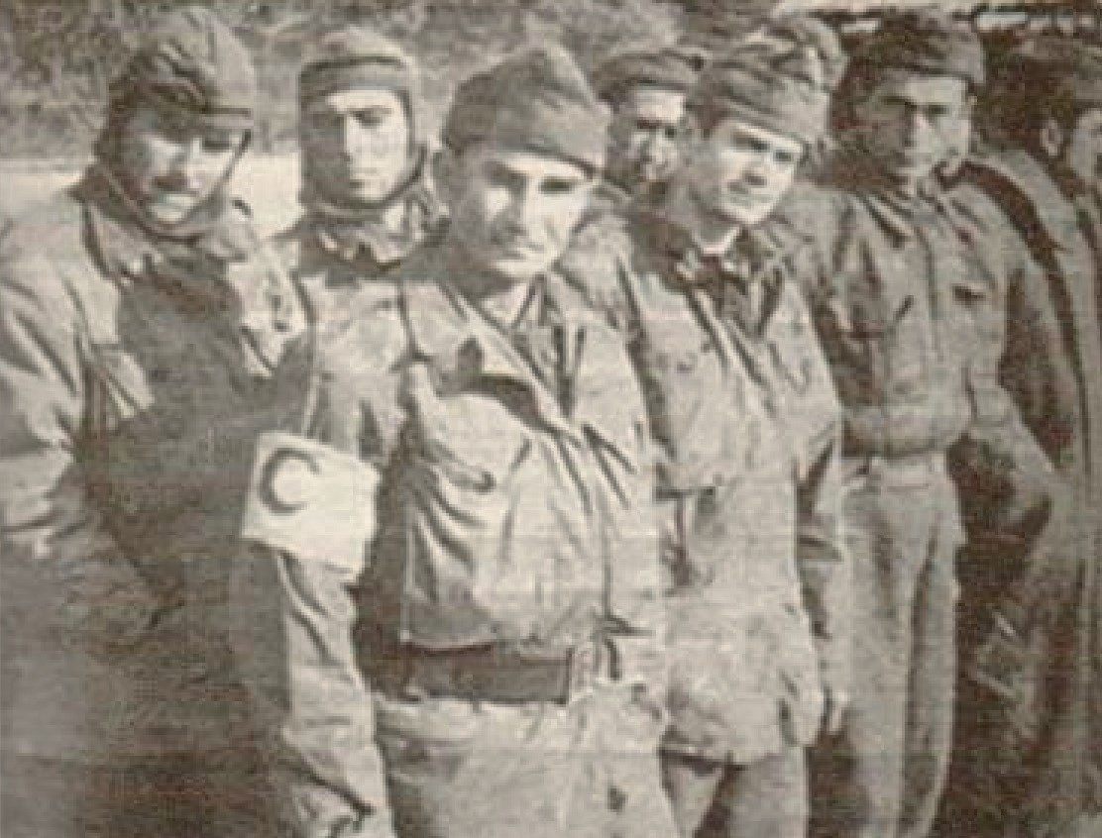
Source E: Medical Corporal Veli Atasoy and Turkish prisoners of war in the winter of 1950-1951 (Onur Çifci, 2020; p.109).

Step 2: The students are asked/invited to answer the following questions based on Sources B, C, D, and E.
- According to the account of Veteran Veli Atasoy, what kinds of difficulties did the captured Turkish soldiers experience?
- According to Source B, what method did the Turkish prisoners use to fight the lice
that threatened their health? Research what else can be done to combat lice and similar parasites.
- What difficulties faced by the prisoners are mentioned in Sources C and D?
- What is meant by the expression “But this place was more like a ‘house of death’ than a hospital”?
- What do Corporal Veli Atasoy’s actions while in captivity tell us about his personality?
- Imagine yourself in the place of Corporal Veli Atasoy in the situation described in Source D. Despite the pressure you faced and your own wound, would you risk carrying a friend on your back who was more seriously wounded than you? Why do you think this way?
- Examine carefully how the Turkish soldiers in Source E appear. How long after their capture do you think this photograph was taken? What makes you think this

Guiding Question 2: According to the stories of Turkish soldiers captured during the Korean War, how did the treatment of those under captivity affect the spiritual and psychological aspects of their lives?
Task 2: The students are asked/invited to examine Sources F, G, H, and I and to answer the related questions.
Step 3: The students are asked/invited to examine Sources F, G, H, and I.

Source F: The Condition of the Prisoners
“… I saw many wounded and sick among the prisoners. I learned that most of the injured had maggots in their wounds.”
“The prisoners' hair and beards had grown long, and their nails were like claws. Their faces, necks, hands, in short, every part of their bodies were covered with a thick layer of dirt. The smell was unbearable; they were completely infested with lice. After a while, without even looking at my own condition, I felt nauseous from what I had seen, as if I would vomit. I was also in terrible shape, but the other prisoners… Because of the filth, they did not look human, but like some other kind of creature. I wanted to leave that place.”
“If you do not like it here, you can go to another hotel,” Tahsin Sarı joked with me.
“I guess I have to stay because I do not have any money with me” I said (Rusçuklu, 2005, pp. 286-287).
Source G: Identity and De-identification
Identity strengthens the sense of belonging in an increasingly crowded and globalized world, helping individuals give meaning to life. Being able to define oneself in this regard reinforces spiritual aspects such as trust, belonging, peace, and unity, and enables individuals to act consciously. These feelings, especially in difficult times such as war, migration, or persecution, allow people to hold on to one another and develop the ability to protect themselves and to act together. The opposite of this is de-identification. De-identification has been practiced throughout history by various societies and states, using different methods to serve their own purposes. De-identification blurs a person’s beliefs, culture, values, and thoughts, and even makes them forget themselves as if they had lost their memory. In this way, it becomes easier to impose a false identity upon the individual, making them easier to manipulate (Değirmencioğlu, 2010).
Source H: Propaganda Activities Directed at Prisoners
The communists (referring to North Korea and China) removed the ranks of the soldiers in temporary camps and began the propaganda of ‘everyone is equal’. They used certain areas of the camps as classrooms and attempted to teach the prisoners their own ideology, along with songs and marches that praised this ideology. It is also known that prisoners who attended these propaganda lessons were fed better compared to other prisoners in the camps, who complained of hunger (Erlevent, 2014, pp. 132–142).
Source I: Turkish Soldiers Preserving Their Identity
A Chinese officer ordered the prisoners to remove all insignia from their uniforms, such as ranks and emblems, which would have given away who they were. Instead, each prisoner would be assigned an identification number. When the officer saw that Turkish prisoner Private Mehmet Çevlik refused to obey this order, he angrily tore the rank insignia from the Turkish soldier’s right arm. When the officer reached for the crescent-and-star emblem to remove it as well, Private Mehmet Çevlik resisted. As a result, he was imprisoned in a cave for three days, suspended from the ceiling by his wrists (Onur Çifci, 2020, pp. 102–103).

Step 4: The students are asked/invited to answer the following questions based on Sources F, G, H, and I.
- According to Source F, how did the physical appearance of the prisoners affect the psychological state of other prisoners
- What does the dialogue between the two Turkish prisoners at the end of Source F tell us about the psychological or emotional condition of our soldiers under captivity?
- Based on Source G, explain in your own words what you understand from the concept of ‘depersonalization’ and discuss with your peers what individual and societal consequences such attempts may lead to.
- According to Sources H and I, what kinds of attempts were made to depersonalize the Turkish prisoners?
- In Source I, what effects might the punishments given to Private Mehmet Çevlik and others who resisted psychological pressure have had on them? Discuss with your peers.

Guiding Question 3: Türk askerleri esaretin olumsuz etkileriyle nasıl başa çıkmışlardır?
Task 3: The students are asked/invited to examine Sources J, K, L, M, and N and answer the related questions.
Step 5: The students are asked/invited to examine Sources J and K.

Source J: Anexcerptfromtheoralhistory interview with Korean War Veteran Veli Atasoy. (https://koreanwarlegacy.org/ interviews/veli-atasoy/)
🕒 13:40 - 14:13
V. Atasoy: When I received this medal, I was a medical corporal in captivity. I treated all the United Nations
soldiers in the camp, regardless of their country of origin. Together with Chinese and Korean doctors, I dressed their wounds and helped them as much as my knowledge and ability allowed. I received this medal while I was a prisoner.

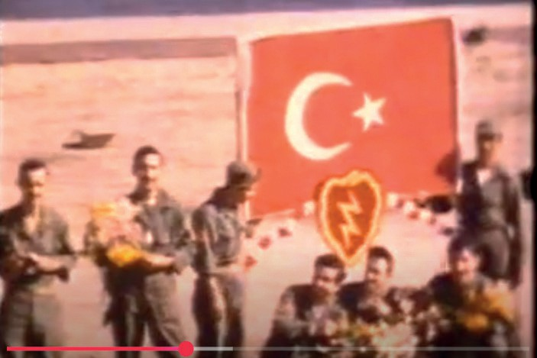
Source K: Two excerpts from a documentary: Kutup Yıldızı:
Kore Savaşı’nın 50. Yıldönümü https://www.youtube.com/ watch?v=9wiNbyhR64A&t=2808s
🕒 41:25-42.32
Let us now go back a little and look at what happened during captivity and learn the secret of survival. During the raids, the United Communist Army would march every prisoner they captured,
whatever the nationality, in long convoys toward the north. The North Korean winter in December was snowy, cold, and harsh. When a prisoner who could no longer walk collapsed to the ground, a Chinese guard would first hit him with a rifle butt or kick him, telling him to get up. If he managed one last effort to stand and walk, he saved his life. If he could not rise, the end was death. That is how it was for prisoners of other nations, but when it came to the Turks, things were different. Undoubtedly, among the Turks too, there were injured, sick, or exhausted men. However, before the Chinese guard even acted, several Turks would rush to help, lifting their comrade by the arm, and if that were not enough, one would carry him on his back, taking turns as needed. The secret of why the Turks did not lose a single man during these long death marches, lasting days and continuing north of the Yalu River into Chinese territory, lies in this.
🕒 45:27-46:30
In this matter as well, the Turkish prisoners differed from the others. Even if there were no rank insignia on their uniforms, it made no difference. A captain was still a captain, and a sergeant was still a sergeant. Food was distributed regularly and equally. No-one was left hungry or neglected. The Turks' attitude both angered and intrigued the Chinese. On a pretext, Captain Hamit Yüksel, the commander, was imprisoned. However, even after a week, nothing changed in the lives of the Turks. The first lieutenant, the next highest-ranking officer, had taken the captain’s place. During an interrogation conducted by a Chinese research committee composed of psychologists and sociologists, Captain Yüksel said the following:
“You are wasting your time! The attitude of Turkish soldiers has nothing to do with my personal character. The roots of this behavior lie in their traditional family upbringing. For them, discipline does not begin when they put on a uniform; we learn it first from our mothers.”

Step 6: The students are asked/invited to answer the following questions by considering Sources B, J, and K.
- According to the memories shared by Veteran Veli Atasoy in Sources B and J, what did the soldiers in captivity do to stay alive and maintain their physical health
- According to Source K, what actions did the captured Turkish soldiers take to ensure their own survival and the survival of their comrades?
- Based on what is described in Sources B, J, and K, which values can be said to be reflected in the behavior of the Turkish prisoners of war?

Step 7: The students are asked/invited to examine Sources L, M, and N.
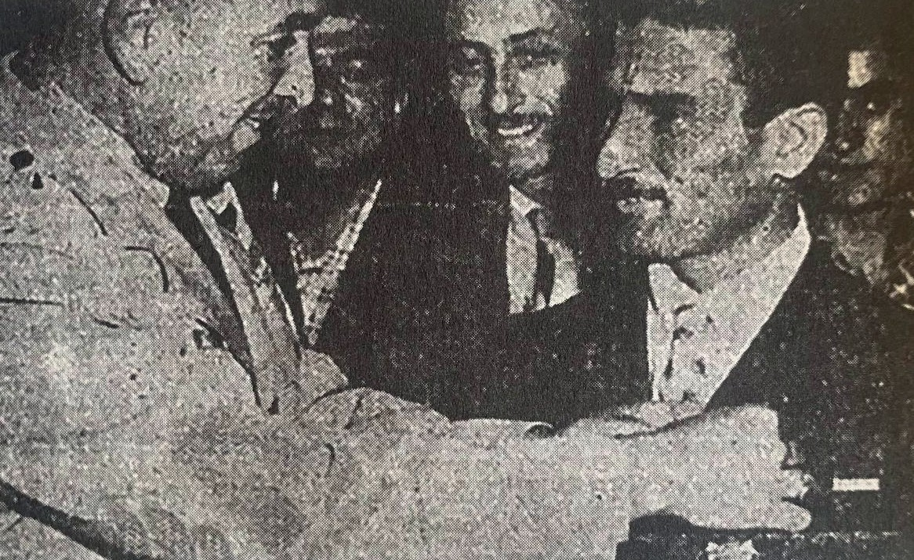
Source L: Veteran Faruk Pekerol’s Memories of the Turkish Soldiers’ Resistance to Propaganda
“…The First Lieutenant continued speaking to console us. Since the Reds could not understand him, he spoke as he wished.
‘Friends, I would like to remind you that as long as our hearts and thoughts remain united, no matter how much they try, they cannot influence us. What matters is that we hold tight to one another. They cannot break us apart, nor can they turn us from our path. Until we are freed from here, we will continue to hold each other’s hands like friends and brothers. For this reason, we ask you to give your word of honor.’
When we repeated the words friendship and brotherhood and shouted, ‘We give our word of honor!’ the entire camp and even the nearby market square seemed to shake. Civilians came to the wire fences, wondering what was happening. The Red commander and his men were disturbed by the officer’s long speech and by our shouting; their faces had changed.” (Rusçuklu, 2005, p. 292)
Source M: Collaboration with the Enemy and Defection
During the Korean War, significant differences were observed among American, British, and Turkish prisoner groups who lived in the same camps and under the same conditions regarding deaths, collaboration with the enemy, and defection cases. According to figures released by the American authorities, 38 percent of American POWs and 15 percent of British POWs died while in captivity. In contrast, none of the two hundred and forty-four Turkish POWs died in the prison camps.
Fifteen percent of American POWs and twelve percent of British POWs collaborated with the enemy during captivity. By the end of the war, twenty-one American and one British soldier had defected to the opposing side. Among the Turks, only one sergeant and one private collaborated with the enemy, but no Turkish soldier had defected by the end of the war (Onur Çifci, 2020; pp. 19-20 and 29).
Source N: Medical Corporal Veli Atasoy Receiving the Distinguished Service Medal Awarded by the United States Army (Onur Çifci, 2020, p. 338)

Step 8: The students are asked/invited to answer the following questions based on the information given in Sources K, L, M, and N.
- According to Source K, how did the Turkish soldiers respond to the psychological pressures such as the removal of ranks, which the Chinese commanders in the prisoner-of-war camp applied as a means of de-identification?
- According to Source L, how did all the Turkish soldiers, both those with rank and those without, behave in the face of the propaganda activities of the Chinese camp authorities?
- What values do the accounts in Sources K and L show that the Turkish prisoners of war adopted and reflected in their behavior? Why was this?
- According to Source M, what differences were there between American, British, and Turkish prisoners of war in terms of deaths, collaboration with the enemy, and defections while under captivity?
- When Sources K, L, and M are evaluated together, how can the reasons for Turkish soldiers surviving the period of their captivity and returning to their country be explained?
- In Source N, there is a photograph showing Veteran Veli Atasoy being awarded a distinguished service medal by the United States Army. Why might the United States Army have deemed a Turkish soldier worthy of such an award? Research and explain

🎯Assessment and Evaluation
- By doing Internet research, find the meanings of the concepts of propaganda and psychological warfare.
- Based on the sources examined, what can be said about the physical and spiritual or emotional effects of captivity on human life?
- How should enemy soldiers treat the prisoners in their hands? Research and explain.
- How can the fact that, during the Korean War, not a single Turkish prisoner defected despite the many pressures and acts of violence they had experienced in captivity be explained in terms of moral or spiritual values? Why is this?

References
Değirmencioğlu, S. M. (2010). Kimlik gelişimi ve toplumsal bağlam: Gençliği anlamak [Identity development and social context: Understanding youth]. İstanbul Bilgi Üniversitesi Yayınları.
Erlevent, B. (2014). 1950–1953 Kore Savaşı’nda esir kamplarındaki Türkler [Turks in prisoner-of-war camps during the Korean War, 1950–1953]. İstanbul Üniversitesi, Atatürk İlkeleri ve İnkılap Tarihi Enstitüsü Yüksek Lisans Tezi.
Fikriyat. (2020). Esaret altında kahramanlık [Heroism under captivity]. https://www.fikriyat.com/tarih/2020/01/19/ esaret-altinda-kahramanlik Access Date: 12.05.2025.
Han, J. (2018). Interview with Veli Atasoy. https://koreanwarlegacy.org/interviews/veli-atasoy/ Access Date: 20.08.2025. Kutup Yıldızı “Kore Savaşının 50. Yıldönümü” belgeseli [North Star “50th anniversary of the Korean War” documentary].
(2000). https://www.youtube.com/watch?v=9wiNbyhR64A&t=2808s Access Date: 20.08.2025
Onur Çiftci, A. (2020). Ben Türk: Kore Savaşı’nda Türk esirler [Me Turk: Turkish prisoners in the Korean War], (2. baskı).
İstanbul: Timaş Yayınları.
Rusçuklu, B. (2005). Kore Savaşı: Unutulan savaş ve Gazi Faruk Pekerol’un anıları [The Korean War: The forgotten war and the memoirs of veteran Faruk Pekerol]. İstanbul: Arvo Yayınları.
Türkiye Gazetesi. (2025). Çin esaretinden kurtulmuştu! Mardinli Kore gazisine Los Angeles’ta “barış madalyası” verildi [He had escaped Chinese captivity! A “peace medal” was awarded to a Korean War veteran from Mardin in Los Angeles]. Çin esaretinden kurtulmuştu! Mardinli Kore gazisine Los Angeles'ta "barış madalyası" verildi | Türkiye Gazetesi Access Date: 08.09.2025.

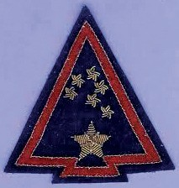
🏠
Homework
The students are asked/invited to research what the emblem on the left arm of Private Mehmet Çevlik and other Turkish soldiers represented for the Turkish troops in Korea, who gave the Turkish soldiers the name ‘North Star’, and what this emblem symbolized, as mentioned in Source I, and to prepare their findings as a presentation.

