DEVELOPING BONDS AFTER THE WAR
Unit 8
🎓 Grade Level:
7th and 8th Grades

⏰ Teaching Time:
40 + 40 minutes

Concepts to Digest: International relations, ambassador, diplomacy, economic relations, humanitarian, social, and cultural relations
Skills to Improve: Historical inquiry and analysis, historical empathy, and interrogating evidence

Core Values: Friendship, solidarity, and loyalty

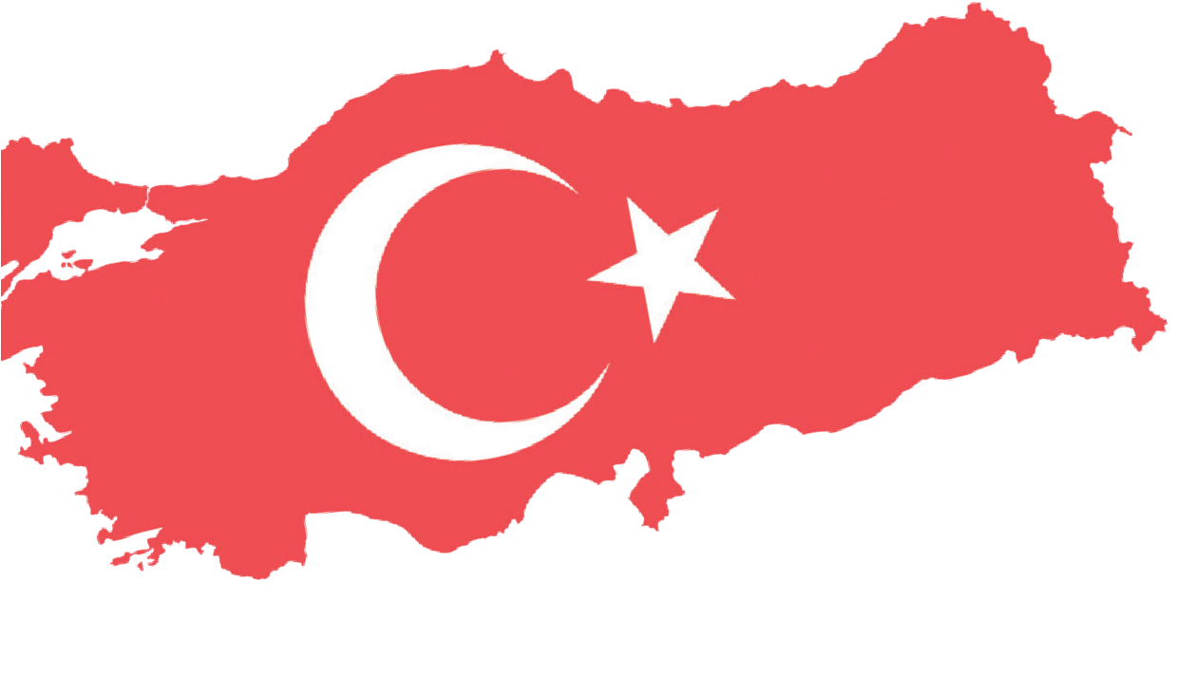
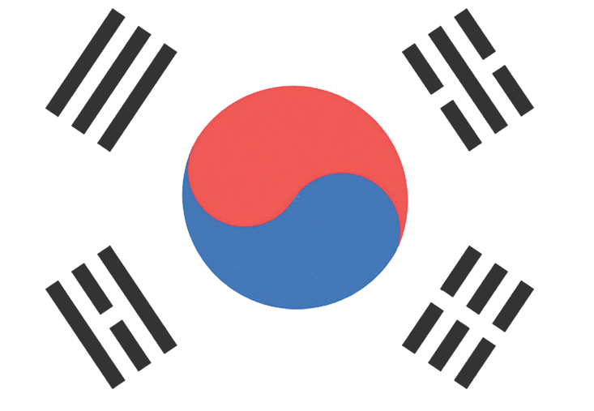

Methods–Techniques: Evidence-based historical inquiry and oral
Teaching-Learning Materials: Archival documents, secondary sources, newspaper articles, oral history interview recordings, and infographics
Learning Aim: To enhance the students’ knowledge and awareness of how political, diplomatic, economic, humanitarian, social, and cultural relations between Türkiye and South Korea developed in the post-Korean War period.
Key Question: How did Türkiye’s participation in the Korean War influence the development of relationships between Türkiye and South Korea in the postwar period?
Guiding Question 1

How have the political and diplomatic relations between the two countries developed?
Objective 1

To analyze the impact of the Korean War on the political and diplomatic relations between Türkiye and South Korea.
Task 1

The students are asked/invited to examine Sources B, C, D, E, and F and answer the related questions.
Guiding Question 2

What is the current state of economic relations between the two countries?
Objective 2

To understand the reflections of the post-Korean War period on the economic relations between Türkiye and the Republic of Korea.
Task 2

The students are asked/invited to examine Sources G, H, I, and J and answer the related questions.
Guiding Question 3

Which institutions and organizations contribute to the development of humanitarian, social, and cultural ties between the two countries, and in what ways?
Objective 3

To understand in which fields and through what activities the leading institutions and organizations contribute to the development of humanitarian, social, and cultural relations between Türkiye and the Republic of Korea.

Task 3

The students are asked/invited to examine Sources K, L, M, and N, answer the related questions, and prepare the required text.

Teaching and Learning Plan

‼ Focus on Activity
The students are asked/invited to discuss the given questions in groups, and then to examine the infographic in Source A.
5 min.
🛎 Task 1
The students are asked/invited to examine Sources B, C, D, E, and F and to answer the related questions.
20 min.
🛎 Task 2
The students are asked/invited to examine Sources G, H, I, and J and to answer the related questions.
20 min.
🛎 Task 3
The students are asked/invited to examine Sources K, L, M, and N, answer the related questions, and to prepare the required text.
30 min.
🎯 Assessment and evaluation
The students are asked/invited to respond to the prepared open-ended questions.
5 min.

🏠 Homework
The students are asked/invited to complete the related chart using the provided information set, and to save their product in their electronic portfolio.

Teaching and Learning Process
Focus on activity: The students are asked/invited to discuss the following questions in groups, and then to examine the infographic in Source A.
- What would you do if you lost your passport while traveling abroad?
- How do Turkish citizens who get married abroad complete their official procedures?
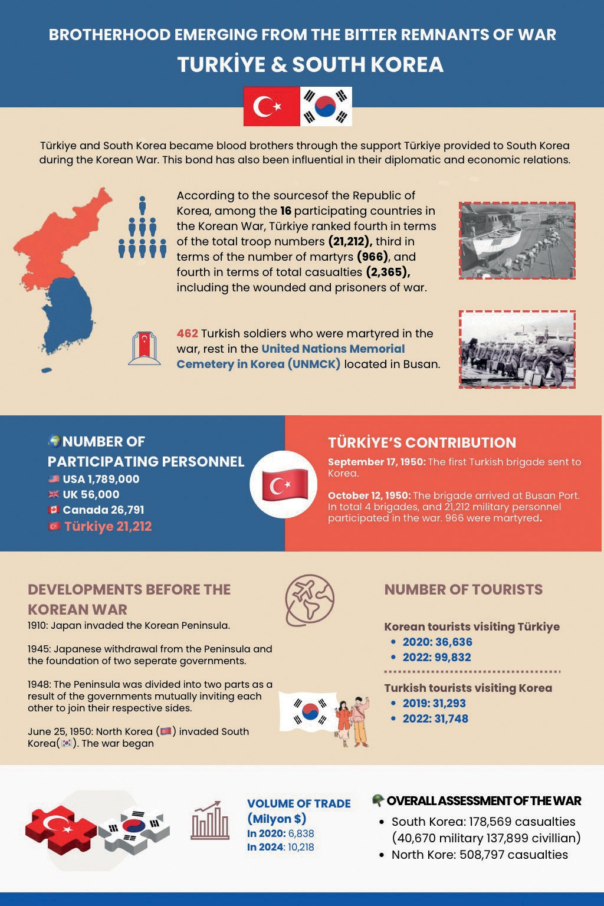
Source A: Infographic containing various information about the Korean War and the relations between Turkey and South Korea (prepared by the authors).

Guiding Question 1: How have the political and diplomatic relations between the two countries developed? Task 1: The students are asked/invited to examine Sources B, C, D, E, and F and to answer the related questions. Step 1: The students are asked/invited to examine Sources B, C, and D.
Source B: The Council of Ministers decision regarding the opening of a Turkish Embassy in Korea
(ATASE: 030-18-01 / 141-118- 07)
Republic of Türkiye-Office of the Prime Minister Laws and Decrees
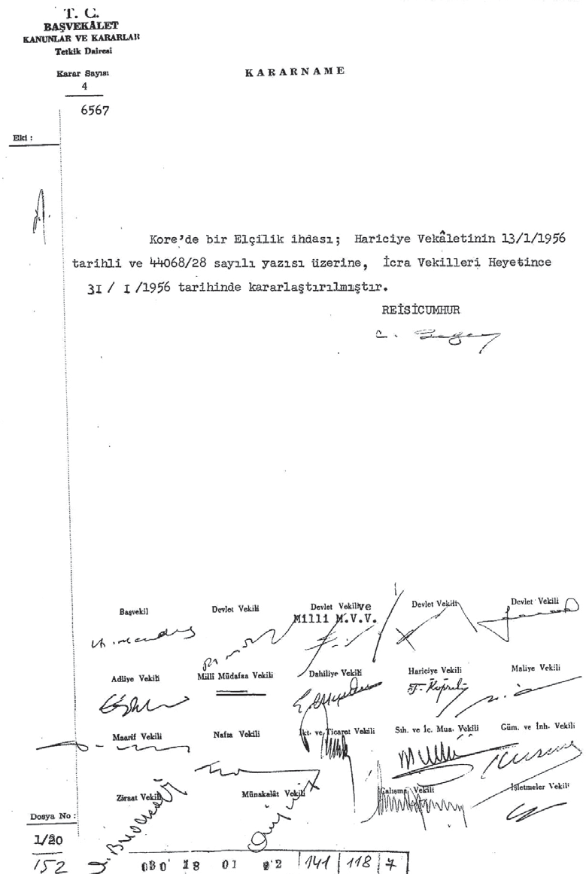
Review Department Decision No: 4/6567

DECREE
The establishment (opening) of an embassy in Korea was decided by the Council of Ministers on 31 January 1956, based on a letter from the Ministry of Foreign Affairs dated 13 January 1956, numbered 44068/28.
President (Signature)
Prime Minister and other ministers (Signatures)

Source C: An Ambassador
An ambassador is a person who represents her/his country politically and legally in another country. Ambassadors represent the head of state of their own country in the state where they are appointed.
They are established under Public International Law. They communicate diplomatically with other countries. On behalf of their country, they carry out high-level activities in another state. Ambassadors have unlimited diplomatic immunity (Wikipedia, 2025).

Source D: The Duties and Authorities of Ambassadors in Current Times
- To represent the Republic of Türkiye before the state in which they are established and accredited, and to protect the rights and interests of the Republic of Türkiye, its citizens, and legal entities under its jurisdiction..
- To conduct necessary contacts and negotiations with the governments and relevant institutions of the states in which they are established and accredited.
- To work toward establishing friendly relations and enhancing political, military, economic, cultural, scientific, and other forms of cooperation between the Republic of Türkiye and the state in which they are established and accredited.
- To monitor developments in the countries in which they are established and accredited, and to convey relevant information and assessments related to their duties to the appropriate units within the central and foreign missions (Republic of Türkiye Ministry of Foreign Affairs, 2024).

Step 2: The students are asked/invited to answer the following questions based on Sources B, C, and D.
- Why might Türkiye have felt the need to open an embassy in South Korea?
- The decision of the Government of the Republic of Türkiye to open an embassy in South Korea in early 1956 points to which developments? Why?
- According to the information provided in Source C and Source D, what qualifications is the Turkish Ambassador to Seoul expected to have?
- According to the information provided in Source C and Source D, what duties and/or responsibilities is the Turkish Ambassador to Seoul expected to undertake?

Step 3: Students are asked/invited to examine Sources E and F.
Source E: Developing Bonds
Korea and Türkiye are known as brother countries. It is known that the Göktürk State, considered the origin of the Turkish people, was a neighboring state to Goguryeo in Asia and that the two share ancient historical ties. The foundation of today’s strong bilateral relations was undoubtedly Türkiye’s participation in the Korean War. Türkiye became the fourth country sending the highest number of soldiers after the United States, the United Kingdom, and Canada, and the third country with the highest number of casualties after fighting heroically in the Battle of Geumyangjang-ri. Based on these ties, in 1957, Türkiye became the third country in the world with which Korea established diplomatic relations (Embassy of the Republic of Korea in Ankara, 2025).
Source F: Political Relations Between Turkey and North Korea
Türkiye’s relations with the Democratic People’s Republic of Korea (North Korea) are limited. The basis of the diplomatic relations between these two countries is the Memorandum of Understanding signed in Beijing on 15 January 2001. Following completion of the necessary legal procedures in both Türkiye and North Korea, a joint statement was issued on 27 June 2001, announcing that the two countries had established diplomatic relations at the ambassadorial level, effective from 15 January 2001. The Turkish Embassy in Seoul is accredited to North Korea, while North Korea’s Embassy in Sofia is accredited to Türkiye (Republic of Türkiye Ministry of Foreign Affairs, 2024).

Step 4: The students are asked/invited to answer the following questions based on Sources E and F.
- Considering the information given in Source E, what can be said about the perspective of the people and government of the Republic of Korea (South Korea) toward Türkiye and the Turkish Nation?
- According to Source E, what historical event forms the basis of the political and diplomatic relations between Türkiye and the Republic of Korea (South Korea)?
- According to Source F, Türkiye does not have an official representation in the Democratic People’s Republic of Korea (North Korea), nor does North Korea have one in Türkiye. Based on this information:
  - What can be said about the reasons for this situation?
  - What solution has been established to maintain relations between the two sides?

Guiding Question 2: What is the state of economic relations between Türkiye and South Korea?
Task 2: The students are asked/invited to examine Sources G, H, I, and J and answer the related questions.
Step 5: The students are asked/invited to examine Sources G, H, and I.
Source G: Türkiye-South Korea Economic Relations
According to data from December 2018, trade between Türkiye and South Korea totaled 6.340 billion USD, with most of it consisting of industrial products imported from South Korea.
Türkiye’s main imports from South Korea are the following: mobile phones; electronic devices; computer chips; LCD, LED and OLED display panels/screens; motor vehicles; vehicle parts and components; boilers; machinery and mechanical devices; plastic products; ships; iron-steel; optical instruments and devices; railway vehicles and their parts; rubber and rubber goods; as well as artificial and synthetic fibers suitable for weaving.
Türkiye’s main exports to South Korea are the following: liquefied hydrocarbon gas (raw rubber material); vehicle components; pharmaceutical products; electrical machinery and devices; clothing items; boron and other metal ores; food products (hazelnuts, seafood, confectionery, pasta, fruit juice, spices); and leather industry products (Republic of Türkiye Embassy in Seoul, 2024).
Source H: Import
Import, or external purchasing, can be defined in the simplest terms as the act of buying goods from another country and bringing them into the country (Republic of Türkiye Ministry of Trade, 2025b).
Source I: Export
Export can be defined, in its simplest form, as the sale and shipment of a good from one country to another (Republic of Türkiye Ministry of Trade, 2025a).

Step 6: The students are asked/invited to answer the following questions based on Sources A, G, H, and I.
- When the data presented in Source A and Source G regarding the trade volume between Türkiye and South Korea are evaluated together, what can be said about the economic relations between the two countries?
- When the goods and products imported (purchased) from South Korea and the goods and products exported (sold) to them are compared, which side appears to benefit more from the economic relations between the two countries? Why?
- Considering your immediate environment (yourself, your family, and your friends), identify which products imported from South Korea are commonly used in Türkiye.

Step 7: The students are asked/invited to examine Source J.
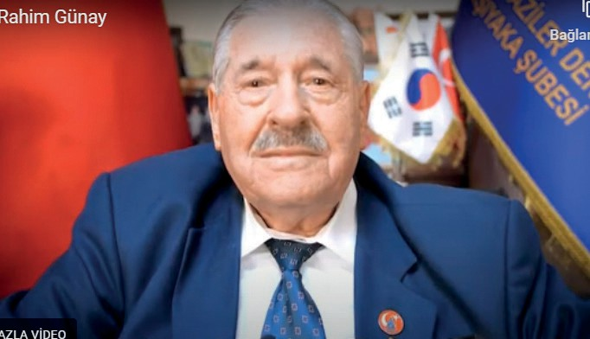
Source J: An Excerpt from an Interview with Korean War Veteran Rahim Günay (https://koreanwarlegacy.org/interviews/ rahim-gunay/)
🕒 12:54-14:04
R. Günay: … I said I was astonished; I told them this.
I said, ‘Buildings of 30-40 floors!’ But no, there were no
bricks, no cement; everything was made entirely of steel. I said, ‘These cars, these avenues, these people… this place has become like paradise’. I told them about how it used to be and what I saw. They asked, ‘How is this possible? What is the situation here?’ So, we explained it to them. Then of course, we were touring around. At that time, a little student said, ‘If the Turkish soldiers had not been here, we would not be alive today.’ You could never imagine that Korea would develop this much when we left. Yes, that it would develop like this… Later, their Ministry of Education even included details about the heroism of Turkish soldiers in their textbooks. And they taught it to the children. So, the child says, ‘If the Turkish soldiers had not been here, we would not be alive today. They saved us’.

Step 8: The students are asked/invited to answer the following questions based on Source J..
- Based on the statements of Veteran Rahim Günay, what inferences can be made about the South Korean economy in the post-Korean War period?
- What emotions did Veteran Rahim Günay feel when he saw Korea years later?
- Considering the attitudes and expressions shown toward Turkish soldiers years after the war, what can be said about the South Korean perspective on Türkiye and the Turkish people?
Guiding Question 3: Which institutions and organizations contribute to the development of humanitarian, social, and cultural relations between the two countries, and in what ways?
Task 3: Sources K, L, M, and N are examined, the related questions are answered, and the required text is prepared.
Step 9: The students are asked/invited to examine Sources K, L, and M.

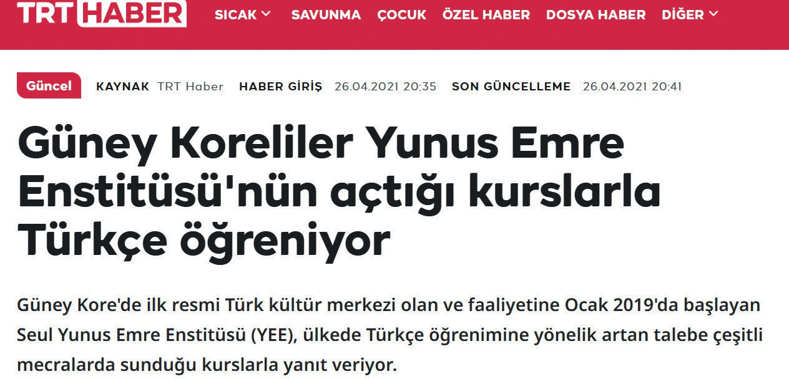
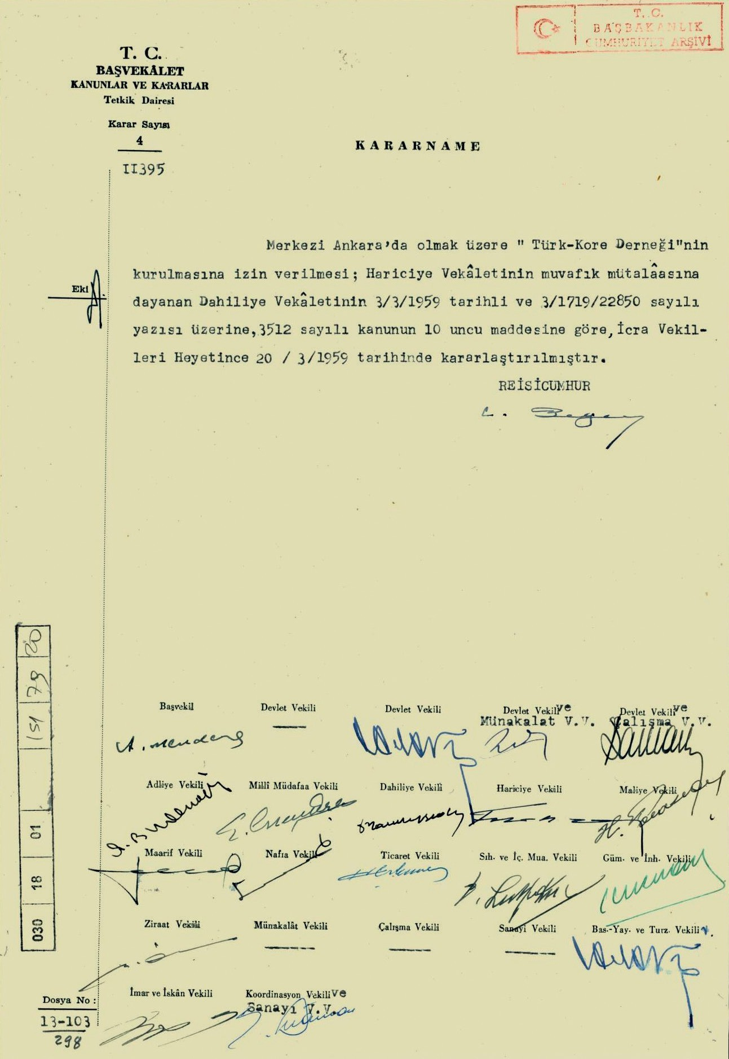
Source K: Decree on the Establishment of a Turkish Korean Association Based in Ankara (ATASE: 030-18-01, 151-79-20)
T.R. OFFICE OF THE PRIME MINISTER LAWS AND DECREES
Review Department
Decision No: 4/11395

DECREE
Permission for the establishment of the “Turkish Korean Association,” with its headquarters in Ankara, has been granted based on the letter of the Ministry of the Interior dated 3 March, 1959, numbered 3/1719/22850, which was prepared in accordance with the favorable opinion of the Ministry of Foreign Affairs, and pursuant to Article 10 of Law No. 3512. The Council of Ministers took this decision on 20 March, 1959.
President (Signature)

Prime Minister and other ministers (Signatures)
Source L: The Korean Cultural Center
The Korean Cultural Center, located in Ankara, the capital of Türkiye, has been working since its foundation on 13 October, 2011, to expand cultural cooperation and exchange between South Korea and Türkiye through various cultural activities that encompass both tradition and modernity. At the center, in addition to the Korean language and Korean cuisine courses, exhibitions, film and documentary screenings, and many other cultural events, are organized to promote Korean culture to Turkish citizens (Korean Cultural Center, 2025).
Source M: Regarding the Activities of the Yunus Emre Institute in Seoul (TRT Haber, 2021).

South Koreans Learn Turkish at the Curses Offered by the Yunus Emre Institute

The first official Turkish cultural center in South Korea, which started its operation in January 2019, the Seoul Yunus Emre Institute (YEI), meets the growing demand for learning Turkish in the country by providing courses on various media channels.

Step 10: Students are asked/invited to answer the following questions based on Sources K, L, and M..
- What might be the purpose or purposes of establishing a Turkish Korean Association in Ankara in 1959? Discuss with your classmates.
- According to Source L, what services does the Korean Cultural Center offer to Turkish citizens who are interested in Korea and Korean culture?
- According to Source M, what service does the Yunus Emre Institute provide for Koreans?
- In line to develop humanitarian, social, and cultural relations between Türkiye and South Korea, what other activities could the institutions and organizations mentioned in Sources K, L, and M, as well as similar organizations, carry out? Research this question.
Step 11: The students are asked/invited to examine Source N.
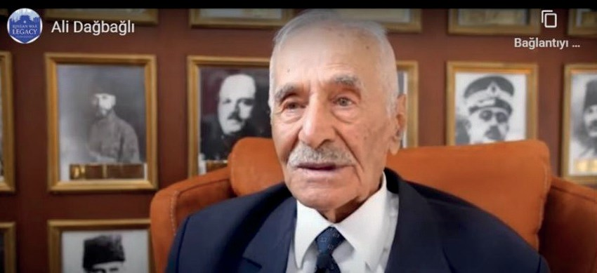
Source N: An Excerpt from an Interview with Korean War Veteran Ali Dağbağlı (https://koreanwarlegacy.org/interviews/ali-dagbagli/)
🕒 12:33 - 13:37
A. Dağbağlı: ... At that time, I was there during the World
Cup. During the World Cup, the Koreans applauded our team more than their own. They applauded a lot, and they supported us even more. When it comes to the Turks, I could say they recognize no-one other than the Turks; that’s how devoted they were. They would bow in respect. You must have seen it on television as well. They would even visit the homes of Turkish Korean War veterans to ask about their well-being, bowing in respect. The commanders who came here would say, ‘If it weren’t for you, we wouldn’t be here’.

Step 12: The students are asked/invited to answer the following questions based on Source N.
- What impressions did Korean War Veteran Ali Dağbağlı get during his visit to Korea in 2002?
- According to what Veteran Ali Dağbağlı describes what feelings and thoughts do Koreans have about Türkiye and the Turkish people?
- The attitudes of Koreans toward Turkey and Turks indicate that they possess which values? Why?
Step 13: The students are asked/invited to form groups of three or four and to prepare a text presenting their thoughts and suggestions on what additional activities organizations such as the Korean Cultural Association and the Yunus Emre Institute, both of which continue to operate actively today, could carry out to improve relations between the two countries further. The prepared text may follow the format provided below.

Proposed Activities for the Korean Cultural Association and the Yunus Emre Institute
Korean Cultural Association | Yunus Emre Institute

🎯Assessment and Evaluation
- What are the main factors that have guided the development of relations between Turkey and the Republic of Korea?
- When the economic relations between Turkey and the Republic of Korea are examined, which side can be said to benefit more from these relations? Why?
- How do tourist visits, especially cultural trips to areas with historical and natural attractions, influence the development of relations between countries? Research this question.

References
Cumhurbaşkanlığı Devlet Arşivleri Başkanlığı Millî Savunma Bakanlığı Askerî Tarih Arşivi. ATASE [Presidency of State Archives, Ministry of National Defense, Military History Archive]. ATASE Record Group: 030–18–01, Place No: 141–118–07. (1956).
Cumhurbaşkanlığı Devlet Arşivleri Başkanlığı Millî Savunma Bakanlığı Askerî Tarih Arşivi. ATASE [Presidency of State Archives, Ministry of National Defense, Military History Archive]. ATASE Record Group: 030–18–01, Place No: 151–79–20. (1959).
Han, J. (2018). Interview with Ali Dağbağlı. https://koreanwarlegacy.org/interviews/ali-dagbagli/ Access Date: 25.04.2024.
Han, J. (2018). Interview with Rahim Günay. https://koreanwarlegacy.org/interviews/rahim-gunay/ Access Date: 25.04.2024.
Embassy of the Republic of Korea in Ankara. (2025). Büyükelçinin mesajı [Message from the ambassador]. https://overseas.mofa.go.kr/tr-tr/wpge/m_9146/contents.do Access Date: 23.08.2025
Korean Cultural Center. (2025). Kültür merkezi hakkında [About the cultural center]. https://tr.korean-culture.org/tr/7/contents/330 Access Date: 23.08.2025
Republic of Türkiye Ministry of Foreign Affairs. (2024). Büyükelçinin görev ve yetkileri [Duties and powers of the ambassador]. https://www.mfa.gov.tr/teskilat-yapisi_.tr.mfa Access Date: 10.06.2024.
Republic of Türkiye Embassy in Seoul. (2024). Kore Hakkında Genel Bilgiler [General information about Korea]. https://seul-be.mfa.gov.tr/Mission/ShowInfoNote/356130 Access Date: 29.05.2024
Republic of Türkiye Ministry of Trade. (2025a). Gümrük rehberi [Customs guide]. https://gumrukrehberi.gov.tr/kategori/ticari-slemler/hracat-rehberi Access Date: 25.04.2024.
Republic of Türkiye Ministry of Trade. (2025b). Gümrük rehberi [Customs guide]. https://gumrukrehberi.gov.tr/kategori/ticari-slemler/thalat-rehberi Access Date: 25.04.2024.
TRT Haber. (2021). Koreliler Yunus Emre Enstitüsü’nün açtığı kurslarla Türkçe öğreniyor [Koreans learn Turkish through courses opened by the Yunus Emre Institute]. https://www.trthaber.com/haber/guncel/guney-koreliler-yunus-emre-enstitusunun-actigi-kurslarla-turkce-ogreniyor-575954.html Access Date: 23.08.2025
Wikipedia. (2025). Büyükelçi [Ambassador]. https://tr.wikipedia.org/wiki/ B%C3%BCy%C3%BCkel%C3%A7i#:~:text=B%C3%BCy%C3%BCkel%C3%A7i%20veya%20sefir%2C%20 ba%C5%9Fka%20bir,%C3%BClkenin%20devlet%20ba%C5%9Fkan%C4%B1n%C4%B1%20temsil%20eder. Access Date: 23.08.2025

🏠
Homework
The students are first asked/invited to examine the visitor statistics provided in the lower right corner of Source A. After this, they are required to research the places Korean tourists visit in Türkiye and the types of activities they engage in, as well as the places Turkish tourists visit in South Korea and the activities they participate in. Lastly, the students are instructed to organize the information they obtain in the form of a newspaper article in the box below.

