COMMEMORATING THE KOREAN WAR
Unit 9
🎓 Grade Level:
6th, 7th and 8th Grades

⏰ Teaching Time:
40 + 40 minutes

Concepts to Digest: Monument, ceremony, association
Skills to Improve: Historical inquiry and analysis, historical empathy, interrogating evidence
Core Values: Friendship, helpfulness, solidarity, altruism

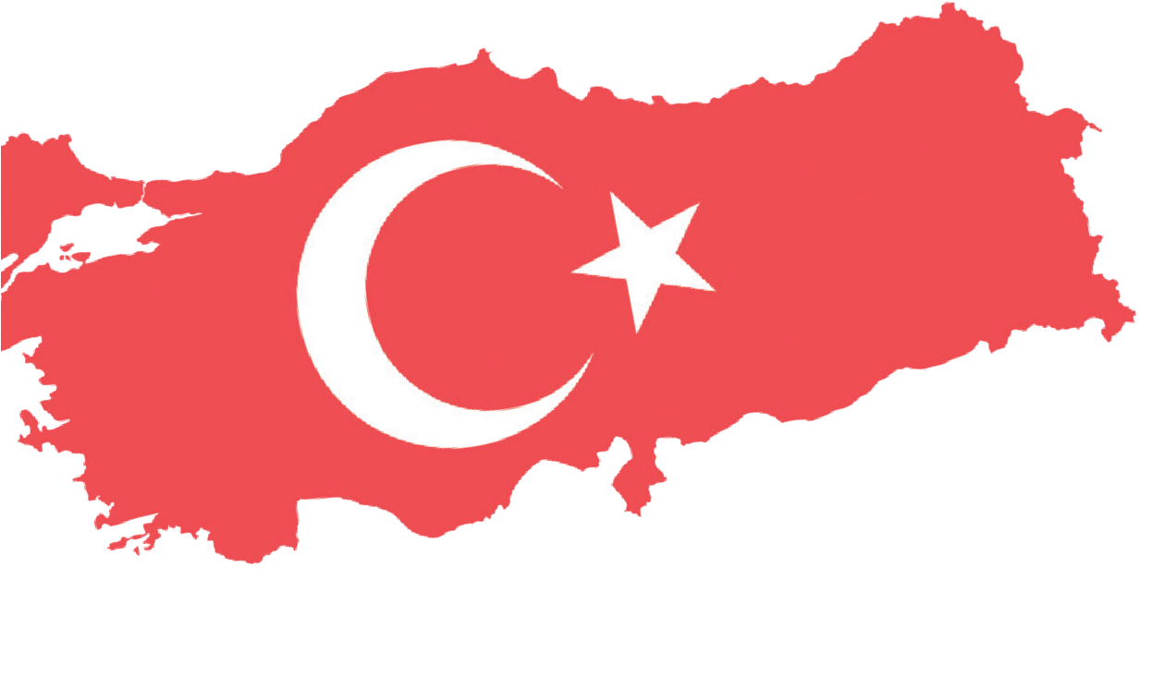
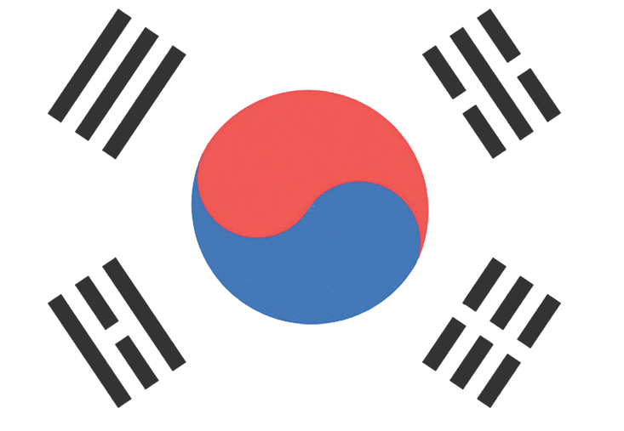

Methods-Techniques: Direct instruction, evidence-based historical inquiry, oral history case study, questioning, oral history
Teaching-Learning Materials: Photographs, secondary sources, official documents, oral history interview records
Learning Aim: This activity aims to enable the students to comprehend the historical significance of the Korean War and to make them analyze how this war is remembered, commemorated, and transmitted through monuments, ceremonies, and associations. Another goal is to help students evaluate the role of historical memory and shared values in Türkiye-South Korea relations.
Key Question: How do societies remember, preserve, and hand challenging historical experiences and acts of heroism, such as wars, down to next generations?
Guiding Question 1

How do monuments and memorial cemeteries function in remembering historical events and acts of heroism and in shaping collective memory?
Objective 1

To analyze the role and symbolic significance of monuments and memorial cemeteries in the formation of historical memory.
Task 1

Analyzing the symbolic significance of monuments and memorial cemeteries and their function in collective memory, the students are asked/invited to examine Sources B, C, and D and to answer the questions.
Guiding Question 2

How have the monuments and commemorative events that honor the heroism of Turkish soldiers in the Korean War contributed to strengthening the friendship between the two countries?
Objective 2

To evaluate the impact of monuments and commemorative activities honoring Turkish soldiers’ heroism in the Korean War on the development of Türkiye-South Korea relations.
Task 2

The students are asked/invited to examine Sources E, F, G, and H, to answer the questions related to the historical significance of the Battle of Kumyangjang-ni, and
to complete an activity in which they write a letter to a martyr’s family from the perspective of a Korean interpreter.
Guiding Question 3

In the process of remembering and transmitting historical events, what complementary roles are played by different structures and methods, such as oral history studies, ceremonies, and associations?
Objective 3

To understand the complementary roles of various methods (oral history, ceremonies, associations) in remembering and transmitting historical events.
Task 3

Students are asked/invited to examine Sources I, J, K, L, M,
N, O, and P, to respond to the related questions, and to evaluate the role of commemorations, ceremonies, and associations in strengthening relations between the two countries.

Teaching and Learning Plan

‼ Focus on Activity
The students are asked/invited to examine a photograph of the United Nations Memorial
Cemetery in Korea, to answer the related open-ended questions, and to transition this into the lesson.
5 min.
🛎 Task 1
Analyzing the symbolic significance of monuments and memorial cemeteries and their
function in collective memory, the students are asked/invited to examine Sources B, C, and D and to answer the questions.
25 min.

🛎 Task 2
The students are asked/invited to examine Sources E, F, G, and H, to answer the questions regarding the historical significance of the Battle of Kumyangjang-ni and to complete an activity in which they write a letter to a martyr’s family from the perspective of a Korean interpreter.
🛎 Task 3
The students are asked/invited to examine Sources I, J, K, L, M, N, O, and P, to answer

25 min.

the related questions, and to evaluate the role of commemorations, ceremonies, and associations in strengthening relations between the two countries.
20 min.
🎯 Assessment
The students are asked/invited to complete the assessment using open-ended questions.
5 min.

🏠 Homework
The students are asked/invited to watch the 1954 film ‘Şimal Yıldızı’ with their families and to share their ideas and feelings about the film’s topic and content.

Teaching and Learning Process
Focus on Activity: After examining Source A, the students are asked to share their thoughts with their peers about how people and countries remember, commemorate, and pass down wars to new generations.
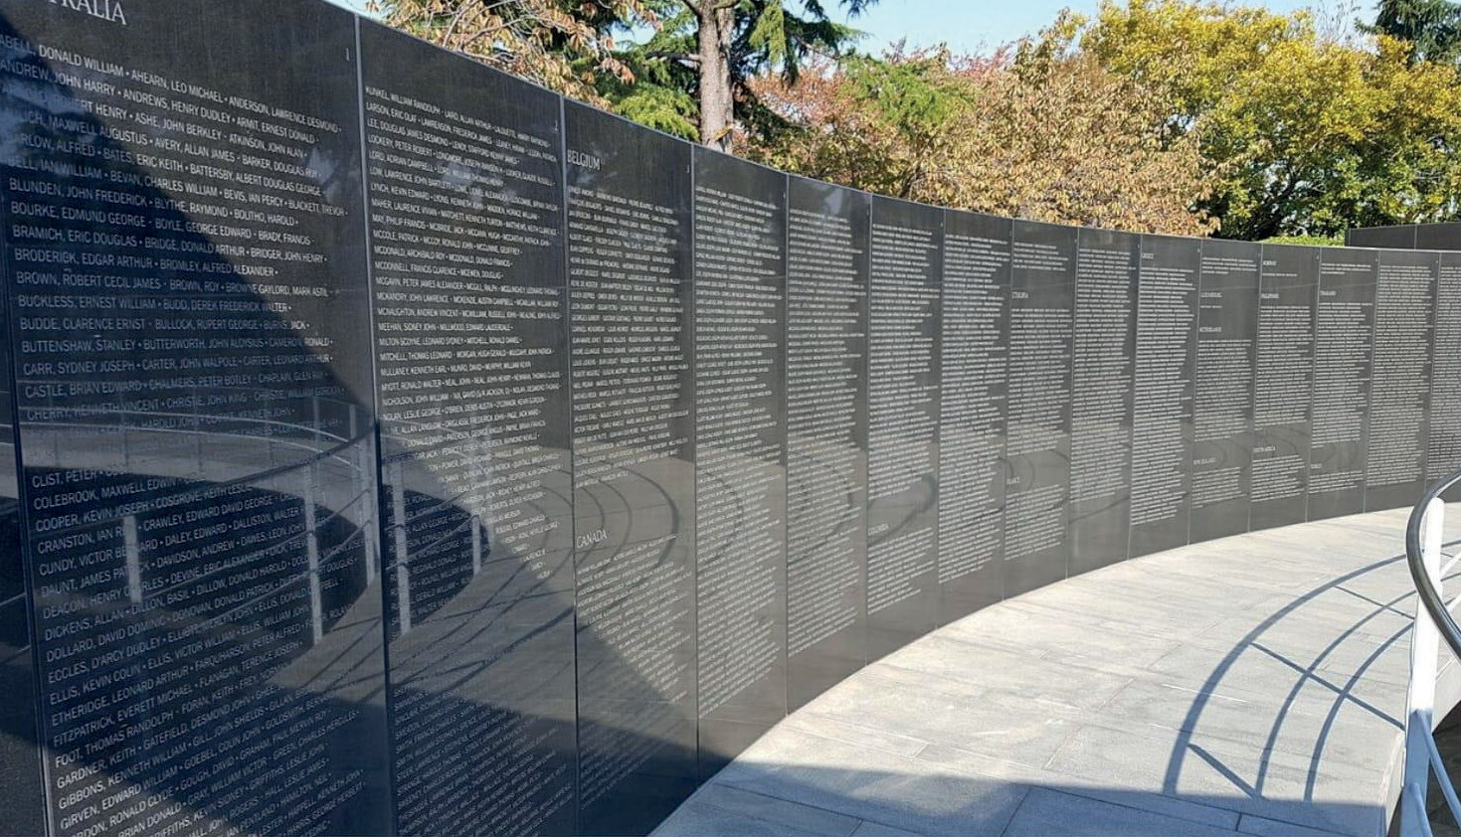
Source A: United Nations Memorial Cemetery (Wikipedia, 2024)

Guiding Question 1: How do monuments and memorial cemeteries function in remembering historical events and acts of heroism and in shaping collective memory?
Task 1: Analyzing the symbolic significance of monuments and memorial cemeteries and their function in collective memory, the students are asked/invited to examine Sources B, C, and D and answer the questions.
Step 1: The students are asked/invited to read Sources B and C.
Source B: The Korean War
In 1950, North Korea, supported by the Soviet Union and China, started a war against South Korea. In response to the United Nations’ call, Turkish troops sent by the Government of the Republic of Türkiye supported South Korea in the war, which lasted until July 1953, along with units from several other countries. The Turkish brigades sent to Korea, each made up of about 5,000 soldiers, were mostly replaced by new forces sent from Türkiye in 1951, 1952, and 1953. During the war, over 21,000 Turkish soldiers defended South Korea as if it were their own land, and although the exact number is unknown, about 750 soldiers were martyred or went missing. After the armistice, Türkiye continued sending troops to Korea for some time. The courage and heroism shown by Turkish soldiers in the Korean War helped Korea gain freedom and promote world peace, and they are deeply honored by soldiers from other participating countries and the people of South Korea (Türkiye Muharip Gaziler Derneği, 2025).

Source C: The United Nations Memorial Cemetery
Starting on January 18, 1951, it was decided that soldiers who lost their lives fighting under the United Nations command would be buried in a designated location. A site chosen in Busan (Pusan), South Korea, was later established as the United Nations Memorial Cemetery, where soldiers from different countries who died fighting under the UN command in the Korean War are laid to rest. The part of the cemetery where Turkish soldiers are buried is called the ‘Pusan Turkish Memorial Cemetery’.
At the United Nations Memorial Cemetery, burials include 462 Turkish martyrs, 36 Americans, 117 Dutch, 34 New Zealanders, 281 Australians, 378 Canadians, 44 French, 1 Norwegian, 36 South Koreans, 11 South Africans, 885 British, and 15 soldiers of unknown nationality. Each soldier has a headstone indicating their name and nationality. (Wikipedia, 2024).

Step 2: The students are asked/invited to answer the following questions based on Sources B and C.
- Could you share your thoughts and feelings about the fact that the courage and heroism shown by Turkish soldiers in the Korean War are appreciated not only by South Koreans but also by soldiers from other countries?
- What contributions might the establishment of a Memorial Cemetery in the city of Busan by the United Nations provide to the remembrance of the Korean War and the commemoration of those who sacrificed their lives?
- Imagine yourself as a South Korean national visiting the United Nations Memorial Cemetery. During your visit, you learn that the 462 Turkish soldiers buried there sacrificed their lives for your country’s freedom and independence. What would you think and feel about the Turkish people and Türkiye?
- What clues does the fact that Turkish martyrs rest in the same memorial cemetery alongside soldiers from other countries who died in Korea give us about what it takes to achieve world peace and friendship?
Step 3: The students are asked/invited to watch/read Source D.
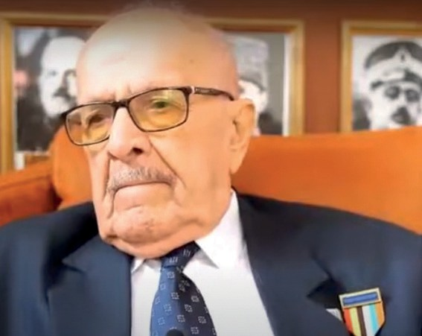
Source D: Selected excerpts from the oral history interview conducted with Korean War veteran Mehmet Çöpten (https://koreanwarlegacy.org/interviews/mehmet-copten/)
🕒 20:06-20:10
M. Çöpten: It was terrific, and there is also this, at three different places, I
saw the one in Seoul too. They erected monuments in all three places. We were very proud. We liked it very much. They built them in three places; we were really pleased with them.
🕒 20:36-20:43
M. Çöpten: … when we saw how warmly they treated us, that kindness, we felt proud. We said that everything we had done was absolutely worth it, completely justified…
🕒 21:09-21:56
M. Çöpten: … I am leaving, we are going to Korea. My late mother was very religious and deeply loved her country. Others were crying, but my mother was not. They asked her, “Mehmet is going to Korea, why aren’t you crying?” She said, “I raised him for this. For this country, for my homeland. The state is sending them there to save people,” she did not know the details, of course. She said, “If my son dies there, I will proudly hold my head high as the mother of a martyr. Moreover, if he returns as a veteran, I will hold my head high as the mother of a veteran.” What a blessing it is to have such a mother, she said.

Step 4: The students are asked/invited to answer the following questions based on Source D.
- What emotions did the monuments built in Korea for the Turkish martyrs and the warm attitudes of Koreans evoke in Korean War veteran Mehmet Çöpten and his comrades?
- With which values can the words and behavior of Mehmet Çöpten’s mother, as she sent her son to Korea, be associated? Why?
- How might the attitudes and actions of the South Korean government and people toward Türkiye and Turkish Korean War veterans have influenced or shaped the relations between the two countries?
Guiding Question 2: How have the monuments and commemorative events that honor the heroism of Turkish soldiers in the Korean War contributed to the development of friendship between the two countries?
Task 2: The students are asked/invited to examine Sources E, F, G, and H, to answer questions about the historical significance of the Battle of Kumyangjang-ni and to complete an activity in which they write a letter to a martyr’s family from the perspective of a Korean interpreter.
Step 5: The students are asked/invited to examine Sources E and F.

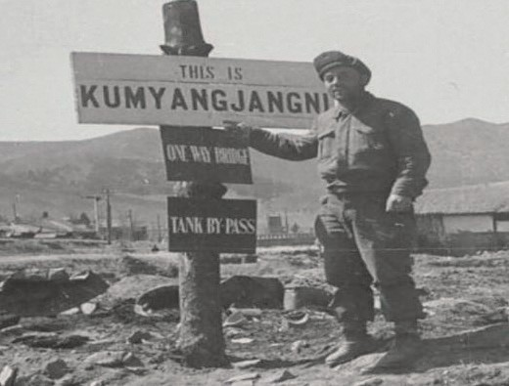
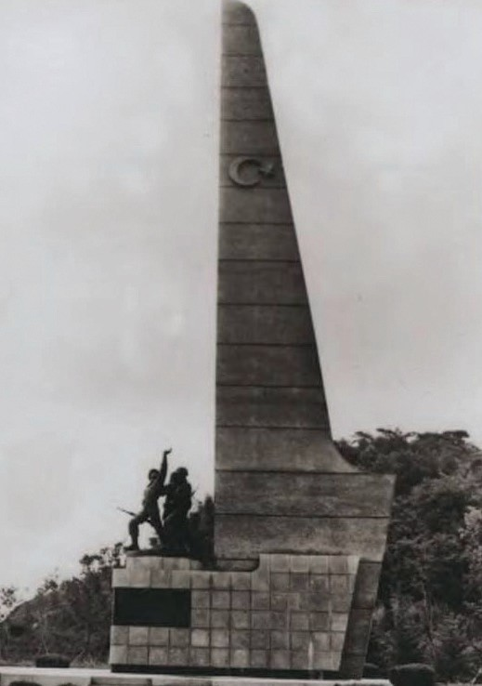
Source E: A Photograph Taken During the Korean War (Denizli, 2009, p. 1)
Source F: The Kumyangjang-ni Victory Monument, Korea (Kore Savaşı ve İzleri, 2025)

Step 6: The students are asked/invited to answer the following questions based on Sources E and F.
- What kind of scene is observed in Source E?
- What does the scene in Source E tell us about Korea at the time of the war?
- To which nation might the soldiers represented in Source F belong? Why do you think this?
- What does the monument seen in Source F show about the perspective of the Korean people and the Korean Government toward the actions carried out by Turkish soldiers during the Korean War?

Step 7: The students are asked/invited to read Source G.
Source G: The Battle of Kumyangjang-ni and its Legacy
Thousands of kilometers away from our country, during the Korean War between 1950 and 1953, Turkish soldiers joined South Korea’s call for help under the United Nations flag and successfully fought not only against North Korea but also against Chinese and Russian forces. In the Battle of Kumyangjang-ni, a turning point of the Korean War, Turkish soldiers achieved a remarkable victory through bayonet combat against a Chinese army three times larger than their own, changing the course of the war. By shattering the myth of the ‘invincible’ Chinese army, the Turkish soldier inspired worldwide admiration and joy. This battle is remembered in Korean War history as the ‘extraordinary victory of the allied Turks’.
Due to their achievements in this battle, Turkish soldiers were awarded the Distinguished Unit Citation by the governments of Korea and the United States. The South Korean Ministry of Patriots and Veterans Affairs declared this region the ‘Türkiye Road’. To commemorate the successful fight waged by Turkish soldiers against the Chinese forces between 25 and 27 January 1951 in many parts of the region, the monument seen in Source F was erected in the city of Kumyangjang-ni in memory of 3,064 Turkish martyrs and veterans (summarized from Başoğlu, 2012; Denizli, 2009; and Türkiye Muharip Gaziler Derneği, 2025).

Step 8: The students are asked/invited to answer the following questions based on Source G.
  - According to Source G, how did the success of the Turkish units in the Battle of Kumyangjang-ni influence the course of the Korean War?
  - According to Source G, how did the Turkish units display heroism in the Battle of Kumyangjang-ni receiving recognition from other countries?
  - According to Source G, what actions did the Korean Government take to express its gratitude for the heroism displayed by Turkish units in the Battle of Kumyangjang-ni?
Step 9: Students are asked/invited to examine Source H.
Source H: Notes from the Korean War
During the Battle of Kunuri, Captain Kaya Aldoğan was shot while trying to carry a wounded soldier on his back to a safe area. Despite being severely wounded himself, he insisted that his soldier be treated first. During a clash, First Lieutenant Mehmet Gönenç volunteered to distract the enemy alone so his comrades could retreat. He directed all artillery fire onto the hill where he was located and was martyred under friendly fire, saving the lives of thousands of allied soldiers. Noncommissioned Officer Süleyman Dilbirliği shared his food with hungry Korean children and gave his own blanket to a family shivering in the cold. He cared for a little Korean girl as if she were his own daughter (Başoğlu, 2012; Denizli, 2009; Denizli, 2011; Denizli, 2015).

Step 10: The students are asked/invited to answer the following questions based on Source H.
- Which value or values can the behavior of the Turkish soldiers mentioned in the text be associated with? Why?
- Why might a person choose to make sacrifices for the well-being of others instead of thinking of their own interests?
- What functions does the value of altruism serve in social life? Research and explain.

Step 11: The students are asked/invited to complete the following letter-writing activity.
Imagine yourself as a Korean interpreter assigned to one of the Turkish units that actively participated in the Battle of Kumyangjang-ni. Assume that you have been tasked with writing a letter to the family of one of the Turkish soldiers who was martyred in this battle to deliver the news of their son’s martyrdom. What would you include in your letter?

Dear Family,
My name is ........................... I serve as an interpreter for your son. who was assigned
to the unit of the Turkish Brigade in Korea.
(Here you may explain why you are writing this letter) ...................................................................................
..................................................................................................................................................................................
..................................................................................................................................................................................
(Here you may write what you know about the martyred Turkish soldier) ..................................................
..................................................................................................................................................................................
..................................................................................................................................................................................
(Here you may share the feelings and thoughts you wish to express to the family members)....................
..................................................................................................................................................................................
..................................................................................................................................................................................

Guiding Question 3: In the process of remembering and transmitting historical events, what complementary roles are played by different structures and methods, such as oral history studies, ceremonies, and associations?
Task 3: The students are asked/invited to examine Sources I, J, K, L, M, N, O, and P, to answer the related questions, and to evaluate the role of commemorations, ceremonies, and associations in strengthening relations between the two countries.
Step 12: The students are asked/invited to read/examine Sources I, J, K, and L.

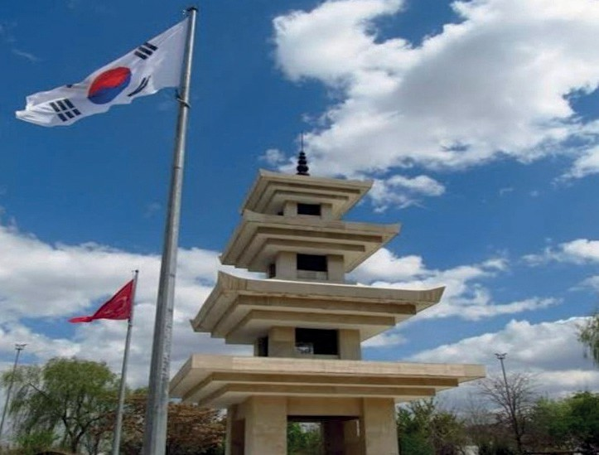
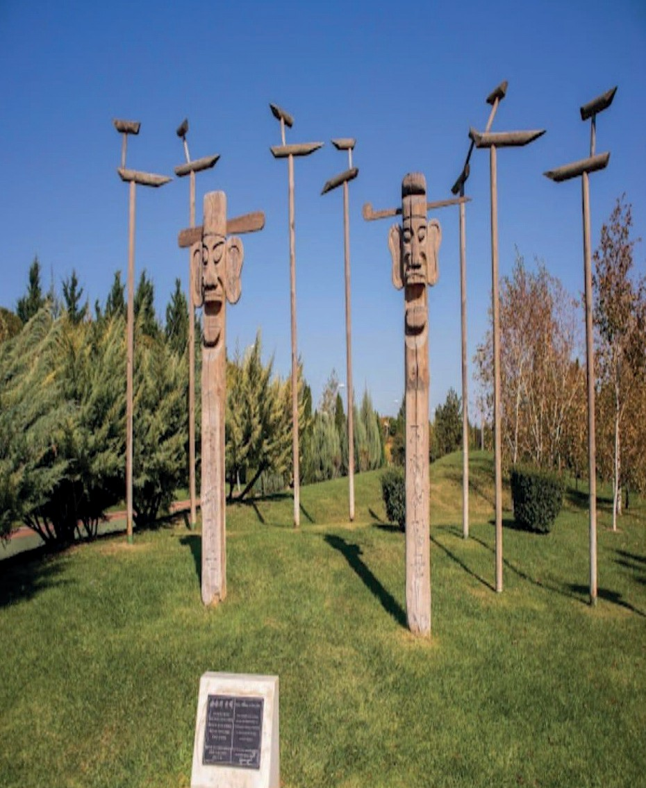
Source I: Turkish Fighters in Korea Monument, Ankara (Photographed by the authors)
Source J: ‘Korea Friendship Monument’ located in Eskişehir Kent Park (Photographed by the authors)

Source K: Turkish Fighters in Korea Monument
After the Korean War, two monuments were erected, one in Korea and one in Türkiye. These two monuments were built in memory of the soldiers who fought in the Korean War and as an expression of gratitude to them. The Turkish Fighters in the Korea Monument, located in Türkiye, was presented as a gift by the Republic of Korea to the Republic of Türkiye on Türkiye's fiftieth anniversary, as a gesture of thanks for Türkiye’s contribution to the war. Since the monument incorporates both Turkish and Korean cultural motifs, it has facilitated cultural exchange. The Turkish Fighters in the Korea Monument, which holds significant spiritual value for the Turkish martyrs and veterans who sacrificed their lives in Korea, functions as an important site of memory that ensures the war is remembered and commemorated. The monument is also a fundamental symbol of friendship between the two countries (Wikipedia, 2025).

Source L: Another Monument from Korea to Eskişehir
Eskişehir has welcomed another monument created by sculptors from its sister city, Paju. As is well known, the Korea Friendship Monument, built in 2007 by artists from Paju, was the first artwork to symbolize the friendship and sisterhood between the two cities. After this monument, which includes various figures symbolizing the protection of people from evil according to Korean belief, two additional monuments named Jang Seung and Sot Dae were erected in the same location, Kent Park, and inaugurated with the participation of many guests; this included Korean War veterans from Eskişehir and a delegation from South Korea. In Korea, the Jang Seung and Sot Dae monuments are placed at village entrances and symbolize abundance and prosperity.
Before the opening ceremony, Metropolitan Mayor Prof. Dr. Yılmaz Büyükerşen reminded the audience that Eskişehir and Paju had become sister cities under a memorandum of understanding signed about two years earlier. He said, “Our sister city, Paju, is gifting another monument to Eskişehir. These monuments we are inaugurating today are a step toward strengthening the ties between the two sister cities. The figures on the monuments symbolize protection from evil in Korean belief. I hope that the people of both countries will always be protected from harm, and I thank everyone who contributed to the creation of this monument.”
After Mayor Büyükerşen, Kim Myung Jun, General Director of Paju Municipality, expressed his happiness in contributing another monument reflecting Korean culture to Eskişehir Kent Park. He stated that visitors to Kent Park will remember the friendship between the two countries through these monuments (EBB, 2024).

Step 13: The students are asked/invited to answer the following questions based on Sources I, J, K, and L.
- What do the architectural features of the monument seen in Source I evoke?
- According to Source I, by whom and for what purpose was the Turkish Fighters in Korea Monument built?
- According to Source K, what does the Turkish Fighters in Korea Monument represent?
- What significance does the construction of the Turkish Fighters in Korea Monument in Ankara, the capital of the Republic of Türkiye, hold for remembering, commemorating, and transmitting the Korean War?
- According to Source L, what are the purposes behind the creation of various monuments in Eskişehir by artists from the South Korean city of Paju?
- How might the Korea Friendship Monument have influenced the feelings and thoughts of the Turkish public, especially the people of Eskişehir, toward South Korea?
- What meaning might the participation of Korean War veterans from Eskişehir in the opening ceremony of the Jang Seung and Sot Dae monuments in Kent Park carry?
- According to the General Director of Paju Municipality, what function will the monuments built in Kent Park serve for?

Step 14: The students are asked/invited to examine Sources M, N, and O.
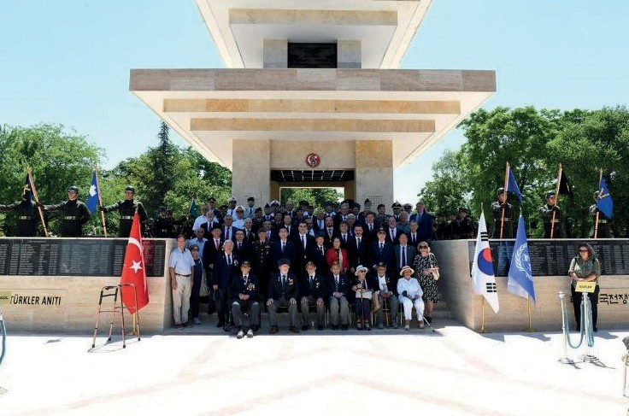
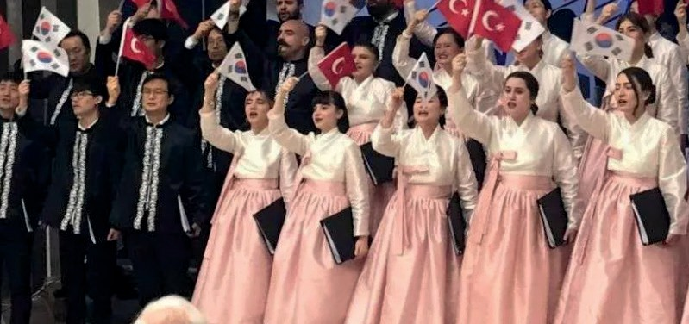
Source M: A Photograph Taken in Front of the Turkish Fighters in Korea Monument
(Embassy of the Republic of Korea, 2025)
Source N: Another Scene from the Korean War Commemoration Events (TEMAD, 2023)

Source O: The Korean War Veterans’ Associations
Veterans who returned from the Korean War established various associations to preserve their wartime experiences, defend their rights, and maintain solidarity among themselves. The foremost of these was the Korean War Veterans Association, founded at the end of 1972, which later came under the umbrella of the Turkish War Veterans Association. This association serves as an umbrella organization that includes not only Korean War veterans but also veterans of other wars. The associations fulfill the following functions:
- Ensuring solidarity and mutual support among veterans
- Preserving the memories of those who were martyred in the Korean War
- Organizing commemorative ceremonies and events
- Strengthening the friendship between Türkiye and South Korea
- Working to protect and improve veterans’ rights
- Educating new generations regarding the Korean War and Türkiye’s contributions (Türkiye Muharip Gaziler Derneği, 2025)

Step 15: The students are asked/invited to answer the following questions based on Sources M, N, and O.
- Who might the people seen in Source M be?
- During what type of event might this photograph have been taken?
- Why might the individuals in Source N be carrying Turkish and South Korean flags?
- During what type of event might the photograph in Source N have been taken?
- Who or which institutions or organizations might have organized the events in these two visuals? Why?
- Based on these visuals, what can be said about the importance of commemorative ceremonies in remembering and transmitting various events or phenomena? Why?
- What situations might arise if commemorative ceremonies are not held or are insufficient?
- According to Source O, what functions do the civil society organizations established by veterans or serving veterans fulfill?

🎯Assessment and Evaluation
- Give examples of the efforts made by the countries that participated in the Korean War to remember, commemorate, and transmit the war.
- What might someone who attended a commemorative ceremony related to the Korean War have thought or felt?
- What might have been done to strengthen relations between Türkiye and South Korea after the war?

References
Başoğlu, K. (Ed.). (2012). Kore’de Türk muharebeleri [Turkish battles in Korea]. Genelkurmay Başkanlığı ATASE Yayınları.
Denizli, A. (2009). Kore Savaşındaki Kumyangjang-ni kahramanları [The heroes of Kumyangjang-ni in the Korean War]. Denizli, A. (2011). Kore kahramanı Bandırmalı şehit Topçu Üsteğmen Mehmet Günenç [Korean War hero: Martyr Artillery
First Lieutenant Mehmet Günenç of Bandırma]. Turhan Kitabevi.
Denizli, A. (2015). Kore Savaşı’nda Türk askerinin Kore halkına yardımları ve Ankara Okulu’nun açılması (1950–1953) [The assistance of Turkish soldiers to the Korean people during the Korean War and the opening of the Ankara School (1950–1953)].
Eskişehir Büyükşehir Belediyesi (EBB). (2024). Eskişehir’e Kore’den bir anıt daha [Another monument from Korea for Eskişehir]. https://www.eskisehir.bel.tr/icerik-detay.php?icerik_id=33&cat_icerik=1&menu_id=24 Access Date: 07.09.2024.
Han, J. (2018). Interview with Mehmet Çöpten. https://koreanwarlegacy.org/interviews/mehmet-copten/ Access Date: 15.06.2024.
Embassy of the Republic of Korea. (2025). https://overseas.mofa.go.kr/tr-tr/brd/m_9154/view.do?seq=754776&page=1 Access Date: 22.08.2025.
TEMAD. (2023). Kumyangjang-ni Muharebesi’nin 73. Yıldönümünde Kore şehitlerimizi andık [We commemorated our Korean War martyrs on the 73rd anniversary of the Battle of Kumyangjang-ni]. https://temad.org.tr/kumyangjang-ni-muharebesinin-73-yildonumunde-kore-sehitlerimizi-andik/ Access Date: 08.09.2024.
Türkiye Muharip Gaziler Derneği. (2025). Kore Savaşı: Türk Tugaylarının muharebeleri (1950–1953) [The Korean War: Battles of the Turkish Brigades (1950–1953)]. https://www.muharipgaziler.org.tr/kore-savasi Access Date: 19.03.2025.
Wikipedia. (2025). Kore’de Savaşan Türk Askerleri Anıtı [Monument to Turkish Soldiers Who Fought in Korea]. https:// tr.wikipedia.org/wiki/Kore%27de_Sava%C5%9Fan_T%C3%BCrk_Askerleri_An%C4%B1t%C4%B1 Access Date: 17.06.2025.
Wikipedia. (2024). https://tr.wikipedia.org/wiki/Birle%C5%9Fmi%C5%9F_Milletler_An%C4%B1t_ Mezarl%C4%B1%C4%9F%C4%B1#/media/Dosya:Wall_of_Remembrance,_UN_Memorial_Cemetery,_view_1.jpg Access Date: 08.09.2024
Kore Savaşı ve İzleri. (2024). https://koresavasiveizleri.com Access Date: 06.09.2024

🏠
Homework
Watch the 1954 film ‘Şimal Yıldızı’ with your family and share your thoughts and feelings about the film’s topic and content.

