THE LEGACY OF THE SECOND WORLD WAR
Unit 1
🎓 Grade Level:
10th, 11th, and 12th Grades

⏰ Teaching Time:
40 + 40 minutes+Homework

Concepts to Digest: Cold War, Capitalism, Communism, Anachronism
Skills to Improve: Historical comprehension, historical inquiry and analysis, map literacy

Core Values: Patriotism

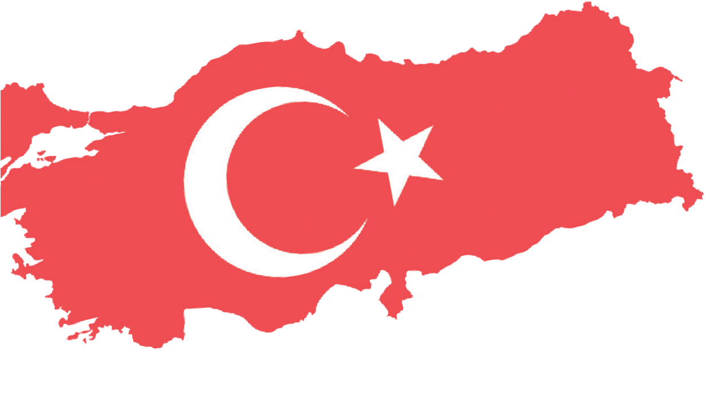
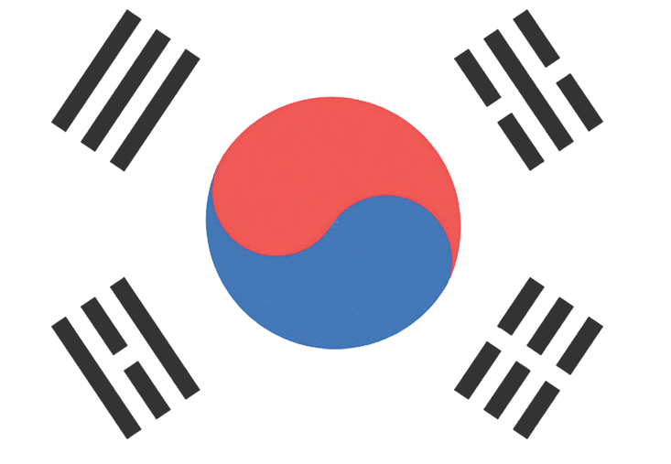

Methods-Techniques: Large-group discussion, oral history
Teaching-Learning Materials: Blank world map, digital map, interview recordings
Learning Aim: This activity aims to help the students understand why the states that fought on the same side and emerged victorious in the Second World War later became divided into opposing blocs, how the Cold War developed in the following period, and how these dynamics influenced the outbreak and progression of the Korean War.
Key Question: How was the bipolar world shaped after the Second World War, and how did this polarization reflect on the Korean War?
Guiding Question 1

What were the significant developments that shaped global politics in the post-Second World War period?
Objective 1
To analyze the causes of the tensions that emerged among the victorious countries in the post-Second World War period.
Task 1

The students are asked/invited to examine Sources B, C, and D and to analyze the causes of the political tensions that arose in the post-Second World War period.
Guiding Question 2

How did capitalist and communist ideologies influence global power balances and international relations in the post-Second World War period?
Objective 2
To understand the ideological and political ideas behind
the bipolar world order that emerged during the Cold War, along with the symbols associated with these ideas.
Task 2

The students are asked/invited to examine Sources E, F, G, H, and I, to complete the required steps in the related stages, to prepare a concept map, and
to carry out the flag-design activity. In addition, the news-writing activity is assigned as homework
Guiding Question 3

How did the Turkish soldiers who participated in the Korean War perceive the formation of the bipolar world order?
Objective 3
To analyze the general observations of the Turkish soldiers who took part in the Korean War regarding the countries involved in the conflict.
Task 3

The students are asked/invited to examine Sources J, K, L, and M and to answer the related questions.

Teaching and Learning Plan

102

‼ Focus on Activity
The tasks of map study, prediction, and explanation of key concepts are carried out.
5 min.

🛎 Task 1
The students are asked/invited to examine Sources B, C, and D and to analyze the causes of the political tension that emerged in the post-World War II period.
25 min.
🛎 Task 2
The students are asked/invited to examine Sources E, F, G, H, and I, to complete the steps
in the related sections, to prepare a concept map, and to carry out the flag-design activity. In addition, the news-writing assignment is given as homework.
25 min.
🛎 Task 3
The students are asked/invited to examine Sources J, K, L, and M and to answer the related
questions. 20 min.
🎯 Assessment and Evaluation
The students are asked/invited to prepare a newspaper article as homework based on
interviews they conduct with their older family members, and to share it on the classroom bulletin board
5 min.

🏠 Homework
The students are asked to share the flags, maps, and photographs they have (dated before 1991) related to the Soviet Union and the United States with an older family member who lived during the Cold War. They then write a short news report describing that family member’s reactions, feelings, and thoughts upon seeing these materials. It is emphasized that a visual may also be added to the news report.

Teaching and Learning Process
Focus on Activity: Students are asked/invited to examine the color-coded blank world map below, to predict what the colors might represent, and to explore the concept of bloc formation that emerged in the post-World War II period.
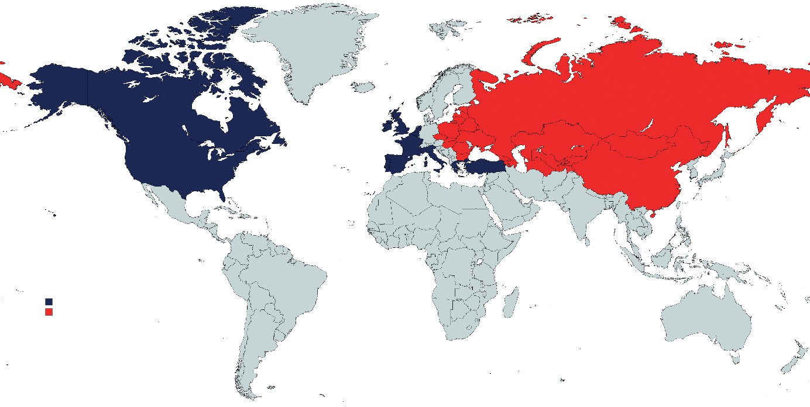
Source A: Blank World Map (Prepared by the authors)

Guiding Question 1: What were the significant developments that shaped global politics in the post-World War II period?
Task 1: The students are asked/invited to examine Sources B, C, and D and to analyze the causes of the political tension that emerged in the post-World War II period.
Step 1: The students are asked/invited to first read the information provided in Sources B, C, and D below.
Source B: The Concept of the Cold War and the Developments that led to its Emergence
The Cold War refers to a state of political and military tension in international relations that did not escalate into armed conflict. The Cold War was a period of global political and military rivalry between the Soviet Bloc (also called the Eastern Bloc or Warsaw Pact countries) and the Western powers, lasting from 1945 to 1989.
Developments that shaped global politics after World War II
- The devastation experienced by Europe and European states; traditionally the central and most significant element of the global balance of power
- The emergence of the United States and the Soviet Union as superpowers after the war
- The development of nuclear weapons
- The rise of national independence movements against colonial powers in various parts of the world

Developments that led states into conflict and which triggered the Cold War
- The Percentages Agreement: An agreement made between Churchill and Stalin in October 1944, aiming to clearly determine the spheres of influence in Eastern Europe.
- Berlin Crisis: This emerged when the U.S., the U.K., and France established the Federal Republic of Germany in their occupation zones, while the USSR founded the German Democratic Republic in its own zone.
- Disagreement over nuclear arms control: This further escalated the tension between the Soviet Union and the United States.
- The USSR’s efforts to spread communism: In eight countries within the Soviet sphere of influence (East Germany, Poland, Czechoslovakia, Hungary, Romania, Bulgaria, Albania, and Yugoslavia), Marxist-Leninist parties seized political power (Koyuncu Lorasdağı, 2023).
Source C: The Percentages Agreement (1944)
The Percentages Agreement was a secret accord made in October 1944 between the British Prime Minister Winston Churchill and the Soviet leader Joseph Stalin toward the end of World War II. The purpose of the agreement was to determine the spheres of influence over Eastern European countries in the postwar period. It became known by this name because the influence over each country was expressed in percentages.
Toward the end of the war, the Soviet Union was rapidly advancing through Eastern Europe, which alarmed Britain. Churchill sought to limit Soviet influence and protect Britain’s interests in the Mediterranean area. Ensuring that Greece and Italy remained under Western influence was particularly important to him. However, when the United States shifted its wartime focus toward Western Europe, Churchill chose to negotiate directly with the Soviets.
For this purpose, Churchill traveled to Moscow in October 1944 to meet with Stalin. During the meetings, spheres of influence were assigned for countries such as Bulgaria, Romania, Hungary, Yugoslavia, and Greece. For example, 90% Soviet influence in Romania and 90% British influence in Greece were agreed upon. These percentages represented the expected political and military influence in each country.
The discussions also addressed issues beyond the division of territories, including the Straits and Türkiye's position. Stalin demanded revisions to the Montreux Convention and sought a greater Soviet role over the Straits. While Churchill approached this cautiously, he stated that he was not wholly opposed to Soviet access to warm seas.
As a result of the agreement, the Soviets gained dominance in Eastern Europe, while Britain secured its influence in Greece. Churchill took action against the Greek socialist National Liberation Front, and the Soviets did not intervene. Similarly, when the Soviets established a communist administration in Romania and Britain remained silent.
The Percentages Agreement became publicly known in 1953, when Churchill published his memoirs. The Soviets, however, continued to deny the existence of the agreement for many years. Since the accord involved dividing countries without regard for the will of their peoples, it was criticized both in the West and in the East. Over time, similar negotiations by other states led to a broader historical reassessment of such power-sharing arrangements (Erdoğan, 2022).
Source D: The Cold War (1945-1989)
The Cold War was a bipolar conflict between the United States and the Soviet Union that shaped international relations. During this period, war and security policies came to the forefront, and the tension that had begun with the division of Germany and the establishment of Soviet-style governments in Eastern Europe brought the two superpowers into confrontation over global power distribution. Because no direct armed conflict occurred between them, this process came to be known as the ‘Cold War’.
104

The capitalist Western Bloc, led by the United States, consisted of the industrialized European countries; the Eastern Bloc, by contrast, comprised the Soviet satellite states and China. The North Atlantic Treaty Organization (NATO) and the Warsaw Pact formed the military foundations of these blocs. The Cold War ended with the fall of the Berlin Wall in 1989, the collapse of communist regimes in Eastern Europe, and the dissolution of the Soviet Union in 1991.
The most defining feature of this period was the nuclear arms race and the doctrine of mutual nuclear deterrence, known as the ‘Balance of Terror’. In addition, ideological conflicts and competition among the core capitalist states led to numerous conflicts and transformations in many Third World countries, from Africa to Latin America. While weak or failed states emerged in the post-Soviet period, countries such as Korea, China, and Taiwan became sources of tension. In the 2020s, the technological rivalry between the United States and China has revived discussions of a new Cold War (Koyuncu Lorasdağı, 2023).

Step 2: After reading Sources B, C, and D, the students are asked/invited to answer the following questions in order:
- According to the sources you examined, which states became superpowers after World War II?
- What does the term the ‘Cold War’ mean? Explain briefly.
- In your opinion, which development in the post-World War II period was most influential in shaping global politics and/or triggering the Cold War? Can you give an example of how this historical development affects the world today?
- How might the Percentages Agreement have contributed to the formation of a bipolar world order? Explain.
- According to the sources you examined, what were the reasons that the states that fought together against Nazi Germany and its allies during World War II came to take opposite sides in the postwar period?
Guiding Question 2: How did capitalist and communist ideologies influence global power balances and international relations in the post-World War II era?
Task 2: The students are asked/invited to examine Sources E, F, G, H, and I, to complete the steps in the related sections, to prepare a concept map, and to carry out the flag-design activity. In addition, the news-writing activity is assigned as homework.
Step 3: The question, ‘Why were the victorious countries of World War II unable to act together in the postwar period?’ is posed to the students, and a classroom discussion is thereby initiated.
Step 4: The students are asked/invited to read Sources E and F below.
Source E: Capitalism
Derived from the Latin word ‘capitale’, meaning capital, capitalism is an economic system in which the private sector and entrepreneurs control the economy. Individuals operate the means of production for profit and may pass them on as an inheritance. Individuals’ rights to property and inheritance are guaranteed by law. People have the freedom to engage in enterprise and may accumulate capital by producing in any field they choose. In capitalist countries, state intervention in the economy is minimal. The United States and the United Kingdom are among the leading capitalist countries (Aydoğuş, 2018).

Source F: Communism
Derived from the word ‘common’, communism is the idea that the means of production and consumption should be collectively owned by society. In communist countries, the economy is under the absolute control of the ruling communist party. According to communist ideology, private property does not exist; consequently, citizens in these countries do not possess inheritance rights. Communism also aims to eliminate social classes. The ideological foundations of communism were established in the nineteenth century by Karl Marx. The implementation of communism as a state ideology began in Russia after World War I, with the Bolshevik Revolution and the establishment of the Union of Soviet Socialist Republics (USSR) (Kaynak, 2020).

Step 5: The students are asked/invited to predict which states, apart from the United States and the Soviet Union, may have been influenced by capitalist and communist ideologies based on the information they obtained from the sources above.
Step 6: The map provided in Source G below is shown to the students, and they are asked/invited to compare their previous predictions with the information in Source G. Afterwards, they are asked to make inferences about how the bipolar world order shaped by capitalist and communist ideologies was reflected geographically.
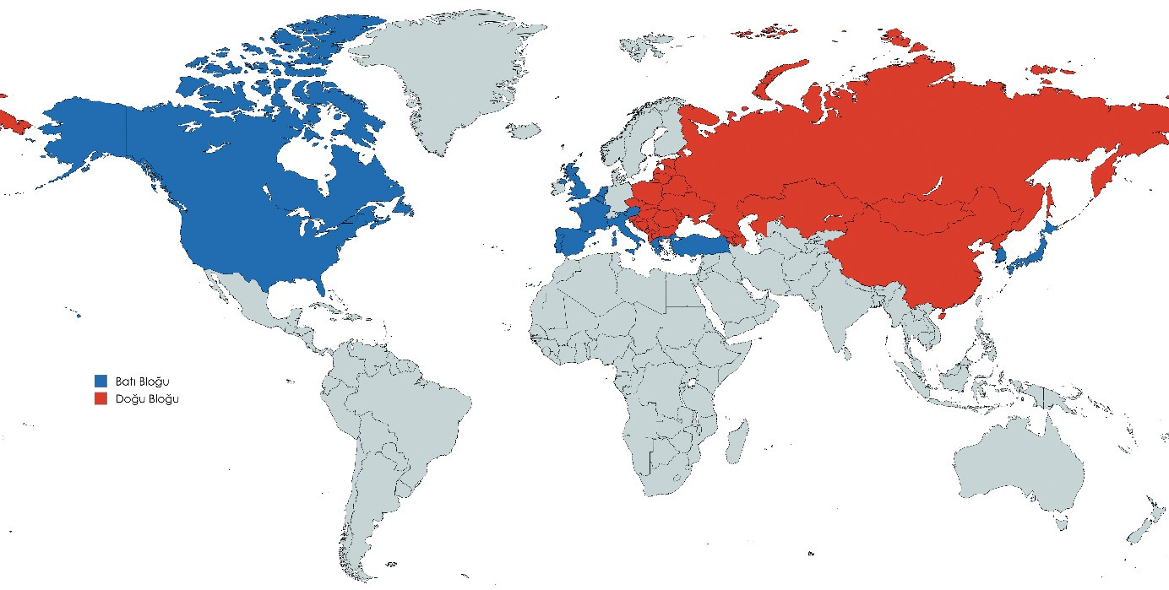
Source G: A Blank World Map Highlighting Bloc Formation During the Cold War
(Prepared by the authors)

Step 7: The students are asked/invited to read the information in Sources H and I about the flags of the United States and the Soviet Union, and to examine the visuals.

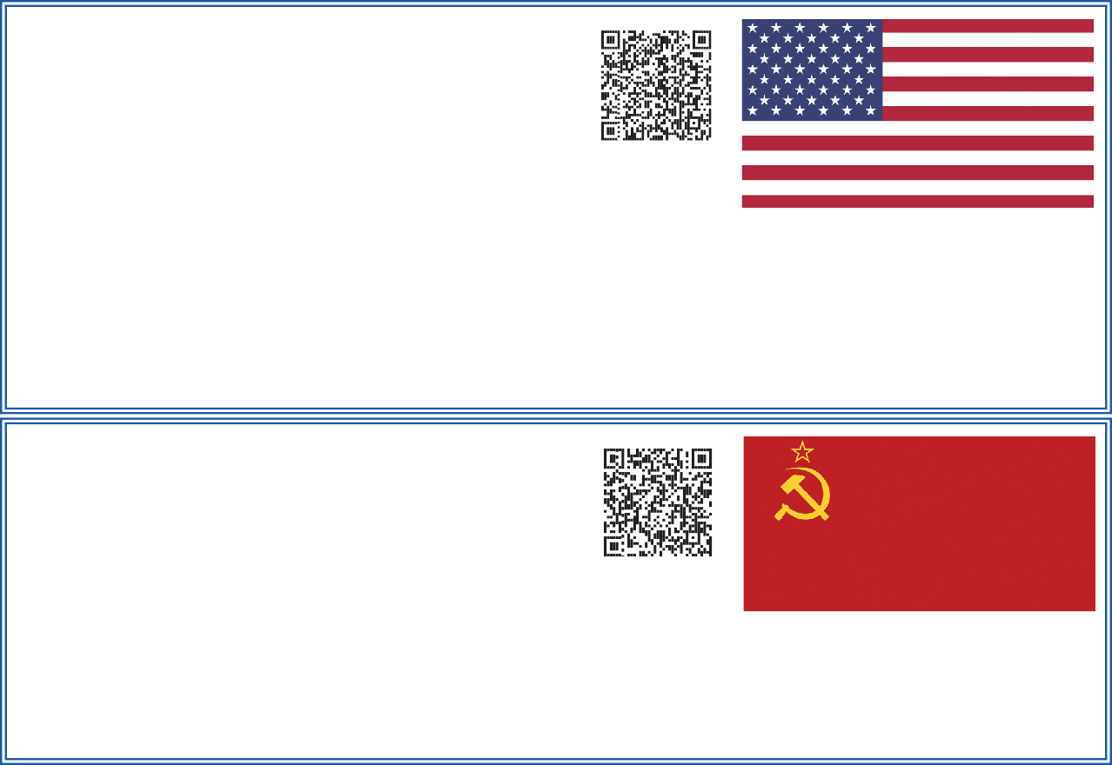
Source H: The Flag of the United States
(usa.gov, 2025)
The thirteen red and white stripes of the flag represent the thirteen colonies that revolted against England in the eighteenth century (each
of which became a U.S. state after independence). The fifty
stars in the upper-left corner of the flag symbolize the U.S. system of government. The fifty states that make up the United States, which is governed by a federal system, are represented by fifty stars on the flag. The red color represents bravery and courage, white symbolizes purity and innocence, and blue stands for vigilance, perseverance, and justice

Source I: The Flag of the Soviet Union
(Britannica.com, 2025)
It came into use after the Bolshevik Revolution of 1917. The hammer on the flag represents industry and the working class, while the sickle symbolizes
agriculture and the peasantry. The five-pointed star above the
hammer and sickle represents the ultimate goal of communism; a communist revolution that would take place across the five continents.

Step 8: The students are asked/invited to answer the following questions based on Sources G, H, and I, as well as their prior learning:
- What do the shapes, symbols, and colors on the flags represent?
- How were the ideologies of the United States and the Soviet Union reflected in their national flags?
- Re-examine Source G and investigate which other countries’ flags may also reflect elements of capitalist or communist ideology.
- What are the fundamental differences between capitalism and communism?
- Why might the rivalry between these two ideologies have continued as the Cold War as opposed to turning into a direct armed conflict? Share your views with your classmates.

Step 9: The students are asked/invited to create a concept map, with the entire class participating, that shows the shared and differing characteristics of the Cold War, Capitalism, and Communism.

Concept Map
Capitalism and Communism
Step 10: The students are asked/invited to create, with the entire class, a table comparing the political, economic, and social characteristics of the ideologies of Capitalism and Communism.

 | Political | Social | Economic
Capitalism
Communism
Step 11: Flag Design
The students are asked/invited to design a flag that depicts the bipolar world of the Cold War period. They are informed that they may use the information they gathered from Sources E, F, G, H, and I while creating their design. The flag they create should represent one side of the Cold War.

Guiding Question 3: KoHow did the Turkish soldiers who participated in the Korean War perceive the emergence of the bipolar world order?
Task 3: The students are asked/invited to examine Sources J, K, L, and M and answer the related questions.
Step 12: The students are asked/invited to listen to/read the oral history interviews conducted with Turkish veterans Mehmet Aziz Erkmen, Osman Yaşar Eken, and Rahim Günay, who fought in the Korean War.

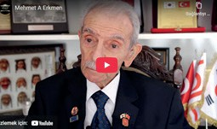

Source J: An Excerpt from the Oral History Interview with Veteran M. Aziz Erkmen (https://koreanwarlegacy.org/interviews/ mehmet-aziz-erkmen/)
🕒 05:24-05:52
M. A. Erkmen: First, let me say that we disembarked at the
Port of Busan. We waited there for one day. I counted the ships in the harbor from the deck of our vessel; thirty-six ships were flying the American flag in the Port of Busan, thirty-six in total. After leaving Busan, we went to Daegu.
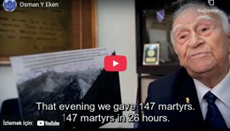

Source K: Selected Excerpts from the Oral History Interview with Veteran O. Yaşar Eken (https://koreanwarlegacy.org/interviews/ osman-yasar-eken/)
🕒 4:34-04:47
O. Y. Eken: The Vegas Battles… In the Korean War, regarding Korea’s destiny… Kunuri is separate, that is true but look at the Vegas Battles.
🕒 04:55-05:22
O. Y. Eken: This hill here, the place marked as my company’s position, look, the area marked in blue is where my company was located, yes. Moreover, the red lines show where the Chinese were positioned; look, the Chinese. We fought there against the Chinese, not against North Korea. That night, we lost one hundred and forty-seven soldiers; one hundred and forty-seven martyrs in twenty-six hours. This did not happen in Kunuri. However, do you know how many Chinese soldiers died that night? Three thousand five hundred of them.
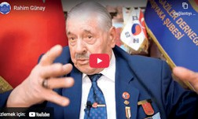

Source L: An Excerpt from the Oral History Interview with Veteran Rahim Günay
(https://koreanwarlegacy.org/interviews/rahim-gunay/)
🕒 15:46-16:15
R. Günay: … There are North Korean soldiers. There are South Korean soldiers. Moreover, of course, the Americans are there
as well. They are brothers and relatives; how did they end up fighting each other like this? Well, in 1950, the world was divided into two. The eastern part, Russia and China, became communist countries. This side represented democracy, meaning NATO; fifteen states joined NATO.

Step 13: The students are asked/invited to answer the following questions based on the oral history interviews:
- Veteran M. Aziz Erkmen and a number of other soldiers state in their memories that Turkish troops first encountered American ships at the Port of Busan, the first place they reached in Korea. What might be the reason that Turkish soldiers first encountered American ships off the Korean coast?
- What might be the reason that the Korean War veteran Osman Yaşar Eken says, “We fought there against the Chinese?”
- To what extent do the words of the Korean War veteran Rahim Günay, “In 1950 the world was divided into two. The eastern region, Russia and China, became communist countries. This side represented democracy, meaning NATO; fifteen states became part of NATO …” accurately reflect the historical reality of the period described?
- How reliable are the above testimonies of our Korean veterans as historical sources regarding the time in which they lived? Discuss them in terms of the opportunities they offer and their limitations.
- What might be the reasons why the interests of countries differ even when they are located in the same geographical region?
Step 14: The students are asked/invited to examine Source M.
Source M: Anachronism
Anachronism refers to evaluating historical events through the value judgments and accumulated knowledge of the present day. Considering events or concepts that did not exist in a given historical period as if they did, based on today’s perspective, leads to misconceptions in historical research. Historical events must be interpreted in accordance with the context or the conditions of the period in which they occurred (Öztürk, 2011).

Step 15: The students are asked/invited to review the content of Sources J, K, L, and M and to determine whether any anachronistic statements appear in these sources.
🎯Assessment and Evaluation
- What do the concepts of the Cold War and the bipolar world order mean? Research and explain.
- Explain the concepts of Capitalism and Communism.
- What are your thoughts on how the Cold War period has influenced today’s world?

References
Aydoğuş, İ. (2018). Kapitalizm.[Capitalism]. https://ansiklopedi.tubitak.gov.tr/ansiklopedi/kapitalizm Access Date: 16.02.2024.
Erdoğan, M.C. (2022). Yüzdeler Antlaşması [Percentages Agreement]. https://ataturkansiklopedisi.gov.tr/bilgi/yuzdeler-antlasmasi/ Access Date: 16.02.2024.
Han, J. (2018). Interview with Mehmet Aziz Erkmen. https://koreanwarlegacy.org/interviews/mehmet-aziz-erkmen/ Access Date: 19.02.2024
Han, J. (2018a). Interview with Osman Yaşar Eken. https://koreanwarlegacy.org/interviews/osman-yasar-eken/ Access Date: 19.02.2024
Han, J. (2018b). Interview with Rahim Günay. https://koreanwarlegacy.org/interviews/rahim-gunay/ Access Date: 19.02.2024
Kaynak, B. (2020).Komünizm [Communism]. https://ansiklopedi.tubitak.gov.tr/ansiklopedi/komunizm Access Date: 16.02.2024.
Koyuncu Lorasdağı, B. (2023). Soğuk Savaş [Cold War]. https://ansiklopedi.tubitak.gov.tr/ansiklopedi/soguk_savas.
Access Date: 16.02.2024.
Öztürk, İ. H. (2011). Tarih öğretiminde anakronizm sorunu: Sosyal bilgiler ve tarih ders kitaplarındaki kurgusal metinler üzerine bir inceleme [The problem of anachronism in history teaching: An analysis of fictional texts in social studies and history textbooks]. Sosyal Bilgiler Eğitimi Araştırmaları Dergisi, 2(1), 37–58.

Visual References
USA. (2025). The American Flag and other national symbols. https://www.usa.gov/flag#:~:text=The%20flag%20of%20the%20United,background%20represent%20the%2050%20
states. Access Date: 16.02.2024
Britannica. (2025). Flag of Union of Soviet Socialist Republics. https://www.britannica.com/topic/flag-of-Union-of-Soviet-Socialist-Republics Access Date: 16.02.2024

🏠
Homework
The students are asked to share the flags, maps, and photographs they have (dated before 1991) related to the Soviet Union and the United States with an older family member who lived during the Cold War. They then write a short news report describing that family member’s reactions, feelings, and thoughts upon seeing these materials. It is emphasized that a visual may also be added to the news report

In My Grandfather’s Memories: The Cold War Era

..................................................................................................................................................................
..................................................................................................................................................................
..................................................................................................................................................................
..................................................................................................................................................................
..................................................................................................................................................................
..................................................................................................................................................................
..................................................................................................................................................................

