MEDIA AND POLITICS
Unit 2
🎓 Grade Level:
10th, 11th, and 12th Grades

⏰ Teaching Time:
40 + 40 minutes+Homework

Concepts to Digest: Media, Public Opinion, Political Party, Non-Governmental Organization, Columnist
Skills to Improve: Historical Empathy, Historical Analysis and Inquiry, Creative Writing

Core Values: Respect, Sensitivity, Patriotism

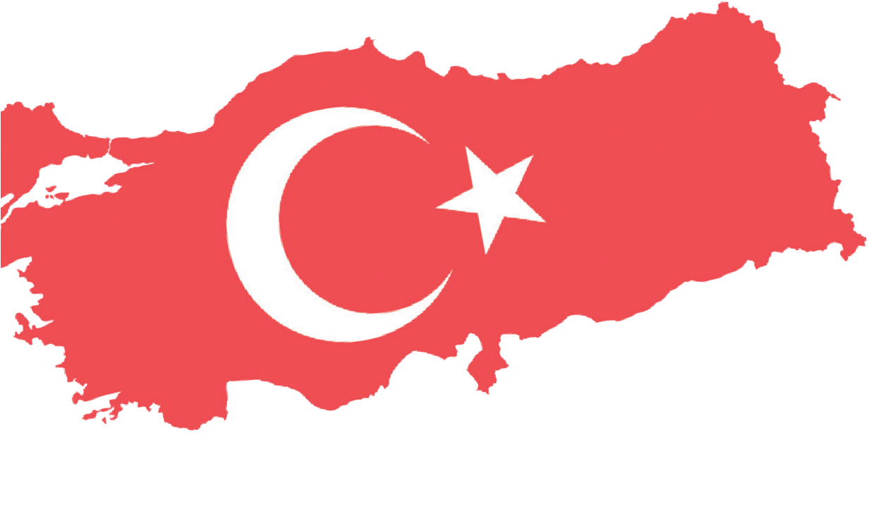


Methods-Techniques: Lecture, Discourse Analysis, Oral History Study
Teaching-Learning Materials: Newspaper clippings, oral history interview recordings
Learning Aim: This activity aims to help students understand the role of the Turkish press in shaping public opinion and political perspectives regarding the Turkish government’s decision to send military forces to Korea.
Key Question: How were competing social and political viewpoints concerning the Turkish government’s decision to send military forces to Korea represented in the Turkish media?
Guiding Question 1

How did the columnists writing for different newspapers evaluate the government’s decision to send military forces to Korea?
Objective 1
To analyze the writings of the columnists of the time and to make inferences about how Turkish public opinion was shaped.
Task 1

The students are asked/invited to work in groups to examine Sources B, C, and D, to answer the given questions, and to write a newspaper column about Türkiye’s decision to send troops to Korea.
Guiding Question 2

How did the statements of the politicians and political
parties featured in the Turkish press influence public opinion regarding Türkiye’s decision to send military forces to Korea?
Objective 2
To analyze the statements of the political parties and their leaders of the time and draw inferences about the roles these institutions and individuals played in shaping Turkish public opinion.
Task 2

The students are asked/invited to examine Sources E, F, and G, to answer the related questions, and to prepare a speech text
for a political party leader concerning Türkiye’s decision to send troops to Korea.
Guiding Question 3

How did the views of intellectuals and non-governmental organizations, as reflected in the Turkish press, influence the formation of public opinion regarding Türkiye’s decision to send military forces to Korea?
Objective 3
To analyze the statements of intellectuals and NGOs, along with oral history interviews, and to understand the
roles these individuals and institutions played in shaping public opinion.
Task 3

The students are asked/invited to examine Sources H, I, J, and K, to answer the related questions, and to prepare a slogan or poster.

Teaching and Learning Plan

‼ Focus on Activity
At the beginning of the lesson, a newspaper clipping (Source A) is shown, and the students’ attention is drawn through questions about the visual it contains.
5 min.

🛎 Task 1
The students are asked/invited to work in groups to examine Sources B, C, and D, to answer the related questions, and to write a newspaper column regarding Türkiye’s decision to send troops to Korea. (The column-writing activity may begin in class and be completed as homework)
🛎 Task 2
The students are asked/invited to examine Sources E, F, and G, to answer the related questions, and to prepare a speech text for a political party leader concerning Türkiye’s decision to send troops to Korea. (The column-writing activity may begin in class and be completed as homework)
🛎 Task 3

25 min.

25 min.

The students are asked/invited to examine Sources H, I, J, and K, to answer the related questions, and to prepare a slogan or poster.
20 min.
🎯 Assessment and Evaluation
Open-ended questions prepared for this lesson are asked of the students.
5 min.

🏠 Homework
The column writing activities that were started but not completed in class are assigned as homework. The students’ are instructed to store their completed works in their digital portfolios.

Teaching and Learning Process
Focus on Activity: The students are asked/invited to examine the photograph on the right side of the newspaper clipping in Source A, which depicts two soldiers resembling a father and son, and to answer the following questions:
Question 1: What might the father and son depicted here be thinking and feeling at the moment this photograph was taken?
Question 2: Imagine that you are with your father on a battlefield or another similarly dangerous place.
What would you think and how would you feel?
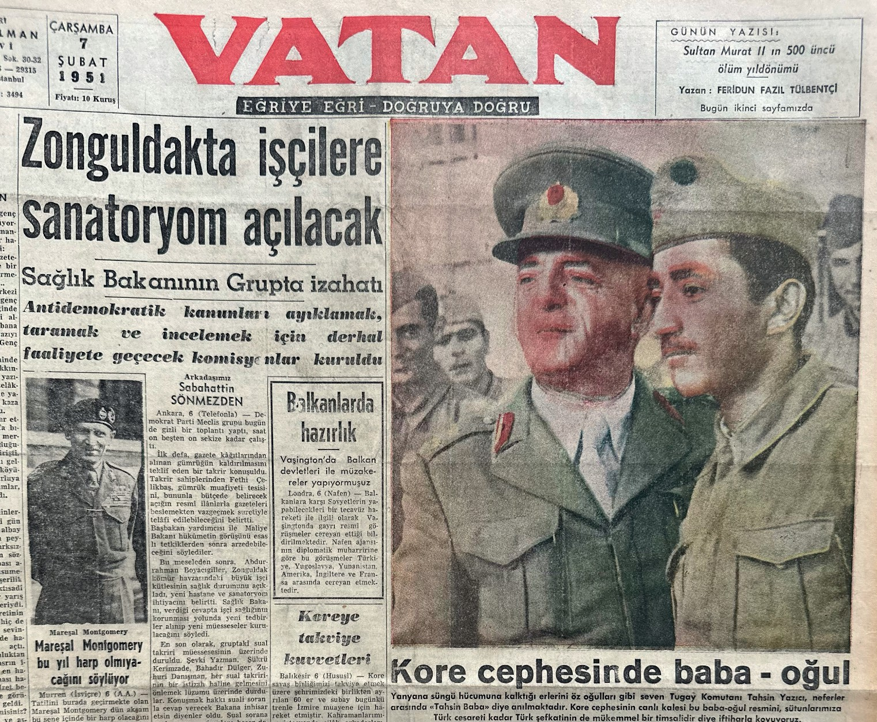
Source A: Headline: Father and son at Korean Front, 7 February 1951 (Vatan, 1951)

Guiding Question 1: How did the columnists of the time writing for different newspapers evaluate the government’s decision to send military forces to Korea?
Task 1: The students are asked/invited to work in groups to examine Sources B, C, and D, to answer the related questions, and to write a newspaper column regarding Türkiye’s decision to send troops to Korea.
Step 1: The students are asked/invited to examine the newspaper columns presented in Sources B, C, and D.

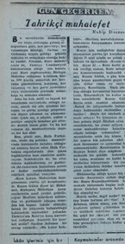
Source B: The Original Version and Summary of Muhip Dranas’s Column ‘Gün Geçerken’, Published in the Zafer Newspaper on 28 July, 1950 (Dranas, 1950)

Provocative Opposition
In this country, since we have adopted a democratic system of government, every issue may be evaluated and debated by any citizen in whatever way aligns with their own thoughts and conscience. Accordingly, regarding the Korea issue as well, every citizen and every political party may discuss and evaluate the recent decision of the Government of the Republic of Türkiye; that is, the decision to send an armed force of four thousand five hundred soldiers to join the United Nations army on the Korean front, as either appropriate or inappropriate.
However, when a national and vital matter is at stake, this right cannot and should not go beyond the framework of a discussion or disagreement within a family. The government’s decision is in no way contrary to the Constitution. Is it a mistake or not? Sit down and debate it, gentlemen! However, do not engage in harmful and dangerous provocations such as ‘Acheson remained silent’ or ‘Stalin frowned’.

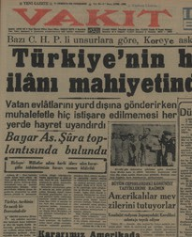
Source C: The Original Version and Summary of Asım Us’s Column Published in the Vakit Newspaper on 27 July, 1950 (Us, 1950)

Türkiye Is in One of the Most Delicate Periods of its History
The government’s decision to send a force of four thousand five hundred soldiers to join the United Nations troops fighting in Korea leaves no need for further words to express the gravity of our current circumstances. The Turkish nation has bound its own existence to the existence of the United Nations.
In principle, this decision cannot be opposed. However, announcing such decisions definitively, before their approval by the Grand National Assembly, is contrary to the constitution. Even if that were not the case, it would still have been appropriate, for the sake of national unity, to give the decision weight and legitimacy at a national level.
In other words, had the government sought consultative contact and secured the opposition party's participation instead of merely expecting its acceptance of the decision, nothing would have been taken away from the government's authority. On the contrary, a consensus could have been reached on setting a timeframe for implementing the decision in a way that would be more beneficial, or at least less harmful, for both the United Nations and the country.

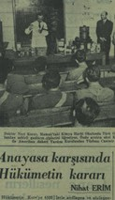
Source D: The Original Version and Summary of Nihat Erim’s Column Published in the Ulus Newspaper on 28 July 1950 (Erim, 1950)
The Government’s Decision in Relation to the Constitution
Article 26 of the Constitution lists the powers that must be exercised directly by the Grand National Assembly. The authority to make agreements and treaties with other states, as well as the authority to declare peace and war on behalf of the Turkish nation, belongs exclusively to the Grand National Assembly. Therefore, unless the Assembly makes such a decision, the government cannot wage war. Sending four thousand five hundred soldiers to Korea and placing them on the line of fire is undeniably an act of war. However, the Korean War is not a bilateral conflict between two states; rather, it is a collective punitive and disciplinary action taken by the United Nations against North Korea, which violated international law.
The current government’s initiative involves sending four thousand five hundred Turkish youths into a situation that demands the sacrifice of their blood. The Turkish soldier is patriotic. He has always fulfilled his military duty with dignity and courage. Wherever the State assigns him, he will once again carry out this duty in a manner befitting the honor
of our nation. However, from a constitutional standpoint, the government has placed itself in a dire position of responsibility. How it has done so is difficult to understand. Should not the opinions of the State’s principal legal institutions have been sought before making such an important decision?

Step 2: The students are asked/invited to answer the following questions based on these sources.
- How does each columnist view the idea of Türkiye sending troops to Korea?
- What are the reasons or evidence underlying the perspectives expressed in the columnists’ writings?
- How many competing or differing viewpoints appear in these columns?
- What might be the causes of these differing viewpoints (political affiliations, personal worldviews, humanitarian concerns, and so on.)?
- Which of the views expressed by the columnists seems more reasonable to you, and why?
Step 3: The students are asked/invited to form groups of four to five, re-examine the columns in Sources B, C and D, and then write their own newspaper column expressing their group’s shared view on the Turkish Government’s decision to send troops to Korea. In this two or three-paragraph column, the students may address how they evaluate the government’s decision in light of existing legal regulations, the advantages and disadvantages of this decision for the country, the nation, and the soldiers who would be sent to Korea, and whether they support this decision along with the reasoning behind their stance. (The column-writing activity may begin in class and be completed as homework)
Title .................................................................................
..................................................................................................................................................................................
..................................................................................................................................................................................
..................................................................................................................................................................................
..................................................................................................................................................................................
..................................................................................................................................................................................

Guiding Question 2: How did the statements of the politicians and political parties of the time published in the Turkish press influence public opinion regarding Türkiye’s decision to send military forces to Korea?
Task 2: The students are asked/invited to examine Sources E, F, and G, answer the related questions, and to prepare a speech text for a political party leader concerning Türkiye’s decision to send troops to Korea
Step 4: The students are asked/invited to read the newspaper articles in Sources E, F, and G.
Source E: The original version and summary of the front-page news from the Ulus newspaper dated 30 July, 1950 (Ulus, 1950)

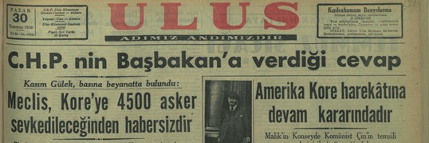
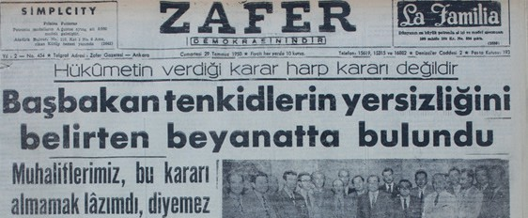
Kasım Gülek made a statement to the press: The Parliament is unaware that four thousand five hundred soldiers will be deployed to Korea.
If the danger and security situation has not changed since the time we were in power, we can clearly state that by sending four thousand five hundred soldiers, Türkiye will be reducing its security.
We carefully read Prime Minister Adnan Menderes’s statement given to journalists. We do not know whether the public, who expected a detailed explanation from the Prime Minister regarding the government’s decision to assist in the Korean War, will be satisfied with this speech.
The Parliament is unaware that four thousand five hundred soldiers will be deployed to Korea. The fact that consultation with the United Nations was deemed unnecessary concerning military assistance is also a matter that requires criticism. Rather than explaining the government's decision, Prime Minister Menderes placed greater emphasis on criticizing those who opposed it from various perspectives.

Source F: The original version and summary of the front-page news from the Zafer newspaper dated 29 July, 1950 (Zafer, 1950)

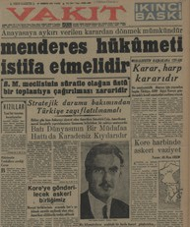
The Government's decision is not a declaration of war.
The Prime Minister emphasized that the criticisms were unfounded.
Our opponents cannot say that this decision should not have been made.
First of all, let us state that the decision taken by our government is not a declaration of war; it is an initiative and decision to preserve peace. In our opinion, aggression can be prevented and world peace protected only through decisions of this nature, taken by freedom-loving nations, as ours has done. It was the belief that peace could be maintained through the efforts of each state acting independently, and that nations could save themselves from disasters threatening others by seeking their own solutions, that led to the unprecedented calamities and tragedies of the Second World War.
Our government has made this decision with full awareness and conviction. So much so that, even if we were faced with the same situation a thousand times, the decision we would take each time would again be this one. The experiences of the two great wars the world have lived through, and those of the last few years, have made it clear that the independence and existence of countries cannot always be defended strictly within their own geographical borders. It is undeniable that we live in an era when the world has reached a shared destiny, both in peace and in war.
In Korea, the waving of our flag will reflect both the most idealistic and the most realistic aims and perspectives. Indeed, sincerely embracing the United Nations ideal also means believing in this principle. They want to cite the hesitant and indecisive actions of certain states regarding the Korean War as examples to us. However, to act hesitantly and indecisively, driven by narrow sentiments and vague hopes, and to believe that the disasters threatening the world can be avoided in this way, would be an inconceivable act of negligence after all the experiences and catastrophes the world has endured.
There is no need for lengthy calculations or extensive information to determine whether assigning a force of four thousand soldiers from our army will represent a deficiency or weakness for us. Are those who, for the past ten years, have claimed to have kept armies of a million or half a million under arms not the very same people? The ratio of four thousand to four hundred thousand is not even a matter for calculation.
We have joined the United Nations Charter. The provisions of this Charter have been ratified and approved by our laws. The consequences of this ratification and approval, and the obligations arising from it, were preemptively mandated to the government by the Grand National Assembly. If communist aggression is not confronted in Korea and spreads, the Turkish public will certainly not misunderstand the implications of similar provocations within our own country, and it will make its judgment accordingly.

Source G: The original version and summary of the front-page headline from the Vakit newspaper dated 30 July, 1950 (Vakit, 1950)
It Is Possible to Reverse the Decision Made in Violation of the Constitution
The Menderes Government Must Resign
It Is Necessary to Convene the Grand National Assembly for an Extraordinary Session Urgently
Türkiye must not be weakened in terms of its strategic position. First of all, it must be acknowledged that the Korean War is connected to the fate of Formosa, Japan, and the Philippines, and that it is an American war. How can Mr Cain, who serves on the Armed Forces Committee of the U.S. Senate, forget that one of the defense lines of the Western world is the Black Sea coast? Türkiye, which for years has maintained a large and strong army, enduring burdens far beyond its financial means and suffering hardships, has been safeguarding world peace.
Mr Cain, who stresses the need for America not to be weakened out
of fear of a potential Third World War, seems to overlook Türkiye’s extremely delicate strategic position. The coincidence of our decision to send troops to the Korean War with the visit of an American senator to Ankara, together with Mr Cain’s recent statements, gives the matter a particular significance and meaning.
According to the American senator, who is also a member of the Senate Armed Forces Committee, the Korean War is not an American war; it is a United Nations’ war. America must be strong in the face of the signs of a possible Third World War appearing on the horizon.

Step 5: The students are asked/invited to answer the following questions based on an examination of Sources E, F, and G.
- What are the perspectives of the politicians and political parties whose views appear in the newspaper headlines regarding Türkiye’s decision to send troops to Korea?
- In Source E, what message might be intended with the statement written from the perspective of Kasım Gülek, the CHP Secretary General at the time: “If the danger and security situation has not changed since the time we were in power, we can clearly state that, by sending four thousand five hundred soldiers, Türkiye will be reducing its own security?”. Do you find this message and its viewpoint convincing? Why?
- In Source F, what is meant by the statement addressed to Prime Minister Adnan Menderes: “First of all, let us state that the decision taken by our government is not a declaration of war; it is an initiative and decision to preserve peace.” Discuss.
- What are the reasons or grounds behind the views of the Democrat Party and the Republican People’s Party regarding Türkiye’s decision to send troops to Korea?
- How reasonable or convincing do you find the arguments put forward by the Democrat Party and the Republican People’s Party concerning Türkiye’s decision to send troops to Korea, as well as the evidence or grounds they use to support these arguments? Why do you think this way?
- What does the way political parties are viewed in these newspapers tell us about the relationship between politics and the media?
Step 6: The students are asked/invited to write a speech text, from the perspective of a political party leader, about Türkiye’s decision to send troops to the Korean War, based on the sources examined in Steps 1 and 2, and what they have learned. (The speech text-writing activity may begin in class and be completed as homework)

My Dear Citizens,

..................................................................................................................................................................................
..................................................................................................................................................................................
..................................................................................................................................................................................
..................................................................................................................................................................................
..................................................................................................................................................................................
..................................................................................................................................................................................
..................................................................................................................................................................................
..................................................................................................................................................................................
..................................................................................................................................................................................
..................................................................................................................................................................................
..................................................................................................................................................................................
..................................................................................................................................................................................

Guiding Question 3: Aydınların ve sivil toplum kuruluşlarının Türk basınına yansıyan görüşleri, Türkiye’nin Kore’ye askeri güç göndermesi konusundaki kamuoyunun oluşmasında nasıl bir rol oynamıştır?
Task 3: The students are asked/invited to examine Sources H, I, J, and K, to answer the related questions, and then to prepare a slogan or poster.
Step 7: The students are asked/invited to examine Sources H, I, and J.

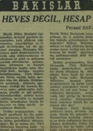
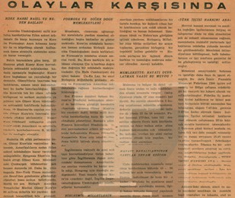
Source H: Peyami Safa’s column titled ‘Bakışlar’, published in the Ulus newspaper on 30 July, 1950 (Safa, 1950)

Not Excitement but Calculation Peyami SAFA
“Without convening the Grand National Assembly, without consulting the opposition parties, without gauging public opinion, without receiving any guarantees from America or the relevant states… For the government to hastily and abruptly decide to send soldiers to Korea on a matter that concerns the very existence of the Turkish Nation… has caused great astonishment and even greater concern among citizens.”
Government propaganda claims that the opposition parties are turning a foreign policy issue into a domestic political matter. What a nonsense! Does discussing a foreign policy issue, one that is directly tied to the life and vital interests of the Turkish Nation, in the Grand National Assembly mean degrading it into a domestic political dispute?
The Korean War is not a matter of excitement but of calculation.
The reluctance of most United Nations member states to
participate in this war is based on many political and military calculations and concerns. Would it not be childish to hope that they might see us among them and be inspired by enthusiasm like children?

Source I: The original text, summary, and related cartoons from a news article in the July, 1950 issue of the Barış Magazine (Barış Dergisi, 1950)

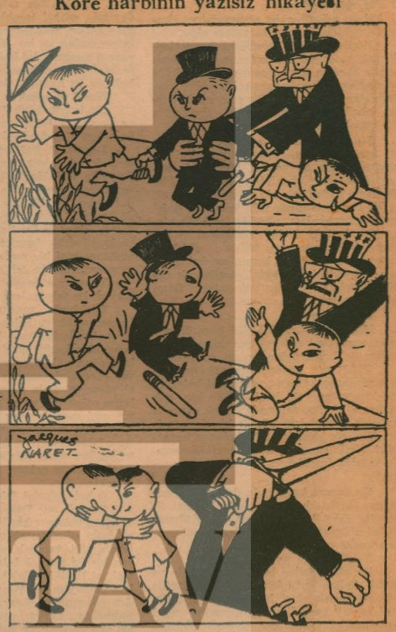
In the Face of Events
America has decided to oppose the national liberation movements in the Far East through direct military intervention and to incorporate Korea and Formosa into its strategic system as bases and bridgeheads against the Asian continent. The South Korean government, led by Syngman Rhee, was in a situation very similar to that of the former Chiang Kai-shek government. At one point, the United States House of Representatives even considered rejecting a $60 million aid package for South Korea.
Immediately after the decision to intervene in Korea, the United States ordered its naval forces in the Far East to defend Formosa. This constitutes a direct intervention in the Chinese civil war, which has nothing to do with the Korean conflict. France, by participating directly in the Security Council’s call for a defensive action in Korea, has joined the intervention. Britain's hesitation to place its fleet in Japanese waters under American command stems entirely from its concerns about Hong Kong. In other words, the issue is not ‘helping South Korea’ but protecting the British Empire's interests in the Far East.

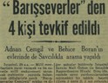
Source J: A news report from the Ulus newspaper dated 30 July, 1950 (Ulus, 1950)

Four Members of the ‘Peace-Lovers’ Detained
The investigation being carried out by a committee of assistant prosecutors, under the supervision of Istanbul Prosecutor Nail Özkan and Deputy Chief Prosecutor Hicabi Dinç, regarding allegations that the ‘Peace-Lovers Association’ executives and other individuals published materials that could harm national interests and thereby undermine national resistance continued today.
Following the initial investigation, the interrogations of Behice Boran, Associate Professor and President of the Peace-Lovers
Association, Adnan Cemgil, the Association’s Secretary General; lawyer Vahdettin Barut, and printer Kemal Anıl, who printed the statement in question, were conducted at the Duty Magistrate’s Court. As a result of the interrogation, all four suspects were detained.
In addition, the prosecutor’s office conducted searches at the homes of Adnan Cemgil and Behice Boran, and the documents obtained were submitted to the judge, who ordered their confiscation. The prosecutor’s investigation committee continues its work.

Telegram from the Student Union
Following the statements made regarding the Turkish Peace-Lovers Association, the National Turkish Student Union sent the following telegram to Prime Minister Menderes:
“The nationalist youth gratefully acknowledge your reaffirmed decision to fight with determination against those who seek to violate freedom. Should there be any duties you assign to us in this matter, we respectfully declare that we will strive to fulfill them with all our strength and devotion.”

Step 8: The students are asked/invited to answer the following questions based on Sources H, I, and J.
- What viewpoint does Peyami Safa express in the column presented in Source H regarding the government’s decision to send troops to Korea?
- What does Peyami Safa intend to convey to his readers with the sentence, “Does discussing a foreign policy issue, one that is directly tied to the life and vital interests of the Turkish Nation, in the Grand National Assembly mean degrading it into a domestic political dispute?”
- According to the text in Source I, what is the perspective of the Barış Magazine and the Peace-Lovers Association (which publishes the magazine) regarding the Korean War?
- In the cartoon included in Source I, how are the countries participating in the Korean War depicted?
- According to Source J, what are the leaders of the Peace-Lovers Association, and the printer who printed the statement prepared by the Association, accused of?
- What does the telegram from the National Turkish Student Union, provided in the continuation of Source J, tell us about this civil society organization’s stance toward the Peace-Lovers Association?
- Based on the telegram from the National Turkish Student Union, what can we infer about the reaction of Prime Minister Adnan Menderes toward the dissenting NGOs and intellectuals?
- How do Sources H, I, and J indicate that the views of the intellectuals and NGOs diverged regarding Türkiye’s decision to send troops to Korea? What might the reasons be behind these differences (for example, political affiliations, public or broader worldviews, humanitarian concerns)?
Step 9: The students are asked/invited to imagine themselves as members of a civil society organization active in the mid-1950s and to prepare a slogan or poster reflecting the perspective of the organization they have chosen or imagined regarding Türkiye’s participation in the Korean War.
The students are asked/invited to place their slogan or poster in this box.

Step 10: The students are asked/invited to listen to/read the relevant sections of the oral history interview presented in Source K.

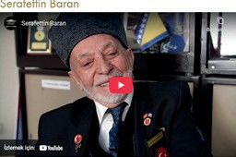
Source K: An excerpt from the oral history interview conducted with Korean War veteran Şerafettin Baran (https://koreanwarlegacy.org/ interviews/serafettin-baran)
🕒 03:39-06:40
Ş. Baran: We used to hear it on the news or on the radio in the village; we listened to it there. They said Korea advanced
five kilometers beyond the thirty-eighth parallel, then retreated three meters, and that is how we followed what was happening. We listened to the radio. We knew nothing about Korea at first. Yes, when the war broke out, the Korean War, we started listening to it on the radio. Later, I became a soldier; I was doing my military service here, in Ankara. We drew lots here. After completing basic training and the oath ceremony, we drew lots, and Korea came out for us. We went to Korea; we drew lots to decide who would go. We received three months of training in Izmir. There was war; we were already thinking about the war. We set out for Korea and went to the war, but then an agreement was made. We entered the oceans. We spent seventeen days at sea. It took twenty-four days in total, but around the seventeenth day, they said, “The ceasefire has been declared today.” They said it was at about 10:10. We did not believe it at first, but newspapers were always being printed on the ship. We read them and still did not believe it. Later, it turned out that the ceasefire had indeed fully taken effect.

Step 11: The students are asked/invited to answer the following questions based on Source K and the other sources examined above.
- What can be said about what Şerafettin Baran knew about Korea before joining the military and before being sent there?
- How was the decision made for veteran Şerafettin Baran to go or be sent to Korea?
- Where and how did veteran Şerafettin Baran and his friends learn about the ceasefire? How might this information have affected them psychologically?
- To what extent do Şerafettin Baran’s views on the Korean War overlap with the information, ideas, and interpretations presented in the news reports, commentaries, and opinion columns examined above? What evidence can you use to support your thinking?

🎯Assessment and Evaluation
- According to the opinion columns you examined, how did the views of the political parties differ regarding Türkiye’s participation in the Korean War?
- According to the opinion columns you have examined, what views did the civil society organizations express concerning Türkiye’s participation in the Korean War?
- How, and to what extent, might media organizations such as the newspapers and magazines of the time have influenced the general views of the Turkish public regarding Türkiye’s participation in the Korean War in the 1950s?

References
Barış Dergisi. (1950, Temmuz). Temmuz 1950 sayısından bir sayfa [A page from the July 1950 issue]. https://tustav.org/ yayinlar/sureli_yayinlar/baris/b_007.pdf. Access Date: 25.12.2023
Dranas, M. (1950). Gün geçerken: Tahrikçi muhalefet [As the days pass: Provocative opposition]. Zafer Gazetesi. (28.07.1950). https://dspace.ankara.edu.tr/xmlui/handle/20.500.12575/4596 Access Date: 25.12.2023.
Erim, N. (1950). Anayasa karşısında hükümetin kararı [The government’s decision in the face of the Constitution]. Ulus Gazetesi. (28.07.1950). https://dijital-kutuphane.mkutup.gov.tr/tr/Periodicals/Catalog/Issue/?IssueId=136283.
Access Date: 25.12.2023.
Han, J. (2018). Interview with Şerafettin Baran. https://koreanwarlegacy.org/interviews/serafettin-baran/ Access Date: 13.10.2024.
Safa, P. (1950). Heves değil, hesap [Not enthusiasm, but estimation]. Ulus Gazetesi. (30.07.1950). https://dijital-kutuphane. mkutup.gov.tr/tr/Periodicals/Catalog/Issue/?IssueId=136285. Access Date: 25.12.2023.
Ulus Gazetesi. (1950). Manşet: Kasım Gülek, basına beyanatta bulundu: Meclis, Kore’ye 4500 asker sevk edileceğinden habersizdir [Headline: Kasım Gülek stated to the press that the Parliament was unaware that 4,500 troops would be sent to Korea]. Ulus Gazetesi. (30.07.1950). https://dijital-kutuphane.mkutup.gov.tr/tr/Periodicals/Catalog/ Issue/?IssueId=136285. Access Date: 25.12.2023.
Us, A. (1950). Türkiye tarihin en nazik bir devresindedir [Turkey is in one of the most delicate periods of its history]. Vakit Gazetesi. (27.07.1950). https://dijital-kutuphane.mkutup.gov.tr/tr/Periodicals/Catalog/Issue/?IssueId=166094. Access Date: 25.12.2023.
Vakit Gazetesi. (1950). Manşet: Anayasaya aykırı verilen karardan dönmek mümkündür, Menderes Hükûmeti istifa etmelidir [Headline: It is possible to reverse the unconstitutional decision; the Menderes Government should resign]. Vakit Gazetesi. (30.07.1950). https://dijital-kutuphane.mkutup.gov.tr/tr/Periodicals/Catalog/Issue/?IssueId=166100. Access Date: 25.12.2023.ba
Vatan Gazetesi. (1951). Manşet: Kore cephesinde baba-oğul [Headline: Father and son at Korean Front]. Vatan Gazetesi. (07.02.1951). https://www.kitantik.com/product/VATAN-gazetesi-7-subat-1951-Kore-savasi_1br9qfyl4mkqfgi122b. Access Date: 27.12.2023
Zafer Gazetesi. (1950). Manşet: Hükûmetin verdiği karar harp kararı değildir, Başbakan tenkidlerin yersizliğini belirten beyânatta bulundu, Muhaliflerimiz, bu kararı almamak lâzımdı, diyemez [Headline: The decision taken by the government is not a declaration of war; the Prime Minister stated that the criticisms are unfounded; our opponents cannot say that this decision should not have been taken]. Zafer Gazetesi. (29.07.1950). https://dspace.ankara.edu. tr/xmlui/handle/20.500.12575/4595. Access Date: 25.12.2023.

🏠
Homework
The students are asked to complete the activities of writing newspaper columns and the speech text as homework, which they had begun during class.

