FAREWELL FROM İSKENDERUN
Unit 3
🎓 Grade Level:
9th, 10th, and 11th Grades
⏰ Teaching Time:
40 + 40 minutes+Homework

Concepts to Digest: Brigade, Supplies, Equipment, Staging, Propaganda
Skills to Improve: Historical Analysis and Inquiry, Historical Empathy
Core Values: Courage, Sensitivity, Benevolence

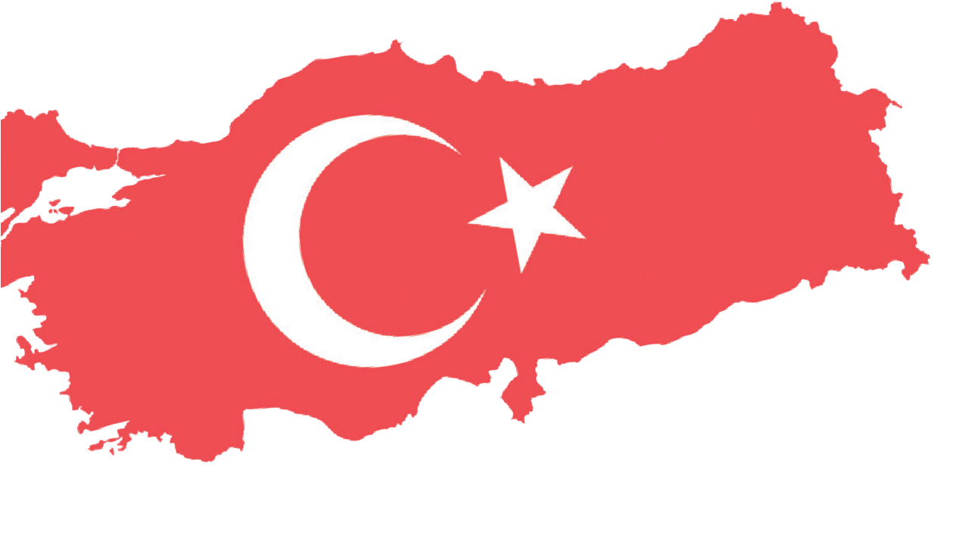


Methods-Technique: Direct Instruction, Questioning, Oral History
Teaching-Learning Materials: Memory journal, period photographs and videos, case studies
Learning Aim: This activity aims to help the students recognize the relationship between political institutions and public opinion on a controversial issue, and to empathize with the experiences and feelings of soldiers of the First Turkish Brigade during their journey from Türkiye to Korea and up to the battlefield.
Key Question: How was the relationship between political institutions and public opinion shaped in a controversial context such as the Korean War, and how was it reflected in the experiences of the soldiers?

Guiding Question 1

During the Korean War, what kind of relationship emerged between political institutions and public opinion in the context of a controversial issue?

Objective 1

To make inquiry-based inferences about the relationship between political institutions and public opinion during the Korean War by drawing on oral history interviews and period videos.
Task 1

The students are asked/invited to examine Sources E, F, and G and to answer the questions in Step 2.
Guiding Question 2

What did the soldiers of the First Turkish Brigade experience and feel during their journey from Türkiye to Korea, and throughout the process leading to the battlefield?

Objective 2

To understand and make sense of what the soldiers of the First Turkish Brigade experienced and felt during their journey from Türkiye to Korea, and throughout the process leading to the battlefield.
Task 2
The students are asked/invited to examine Sources H, I, J, K, and L and to answer the given questions.

Teaching and Learning Plan

‼ Focus on Activity
Sources A, B, C and D are shown, and the relevant questions are asked.
5 min.

🛎 Task 1
The students are asked/invited to examine Sources E, F, and G and to answer the questions in Step 2.
25 min.
🛎 Task 2
The students are asked/invited to examine Sources H, I, J, K, and L and to answer the related questions.
45 min.
🎯 Assessment and Evaluation
The open-ended questions provided are answered.
5 min.

🏠 Homework
The students are asked/invited to write a letter to their family from the eyes of a soldier or someone else who experienced a sea journey from Türkiye to Korea like the Turkish soldiers at the time of the Korean War. The completed work is stored in their electronic portfolio.

Teaching and Learning Process
Focus on Activity: The students are asked/invited to examine the photographs in Sources A, B, C, and D after being informed that these images were taken during the journey preparations and training period of the Turkish Brigade that would participate in the Korean War.

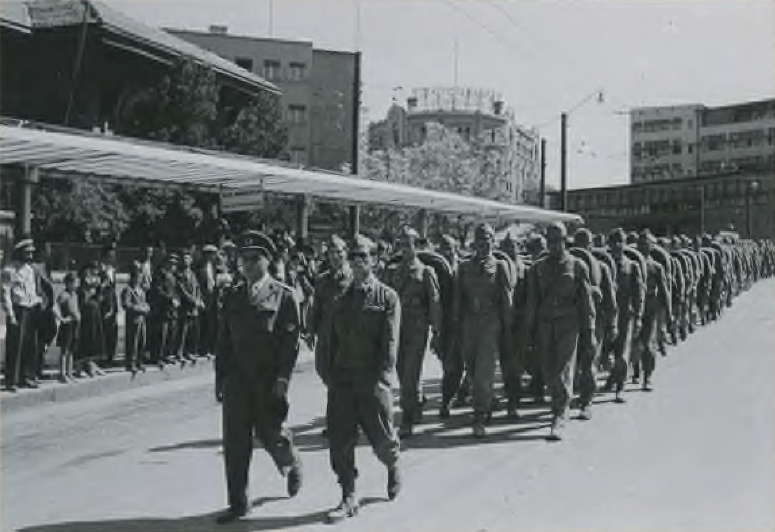
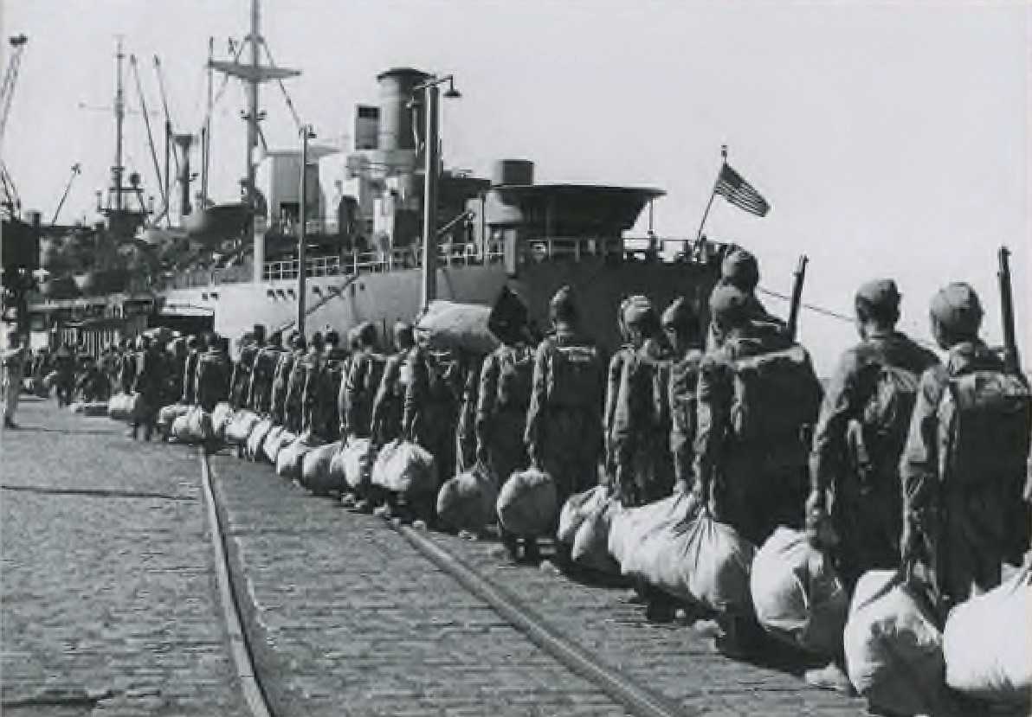
Source A: The Passage of Units belonging to the Korean Brigade through Ulus Square during their march in Ankara (AsMvKSK, 2019, p. 22)
Source B: Turkish soldiers boarding the ship to depart for Korea (AsMvKSK, 2019, p. 43)

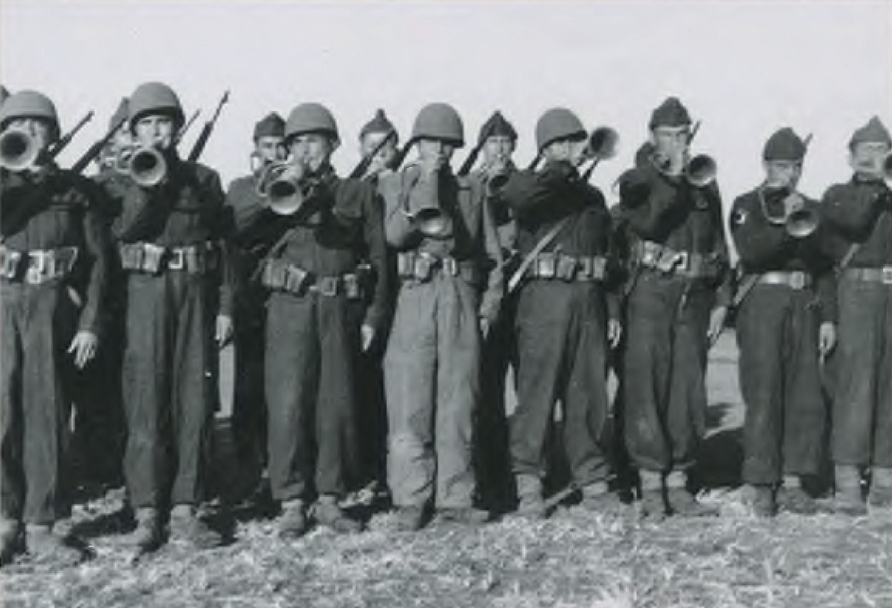
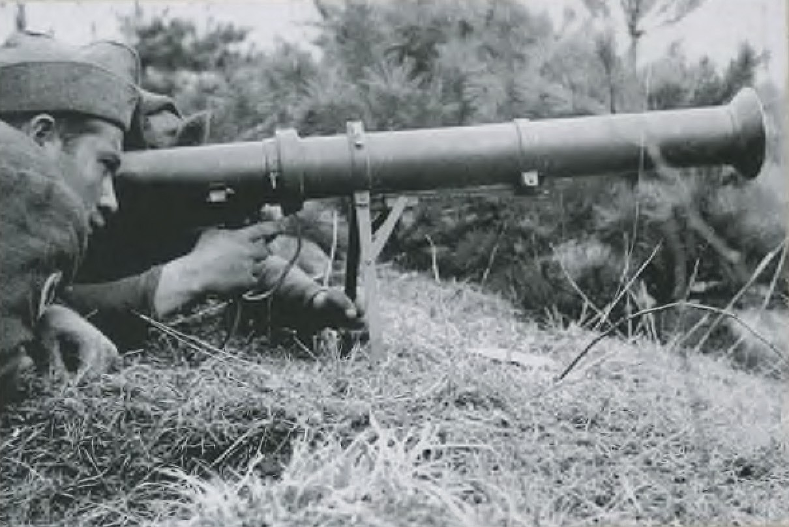
Source C: The Brigade Band practicing the National Anthems of other countries sending soldiers to Korea (AsMvKSK, 2019, p. 74)
Source D: Two Turkish soldiers receiving training with a bazooka, a modern weapon of the period (AsMvKSK, 2019, p. 68)

Afterward, the students are informed that although the Turkish Brigade, which had gathered in August 1950 at Sarıkışla in Ankara, had planned to participate in the Korean War, it did not engage in its first combat until November 1950. They are asked/invited to make predictions about what might have been done during the approximately three-month interval

Guiding Question 1: In the context of this controversial issue, such as the idea of Türkiye sending troops to Korea, what kind of relationship existed between the political institutions and public opinion at the time of the Korean War?
Task 1: The students are asked/invited to examine Sources E, F, and G and to answer the questions in Step 2.
Step 1: The students are asked/invited to watch the oral history interview (Source E) and the additional videos (Sources F and G).

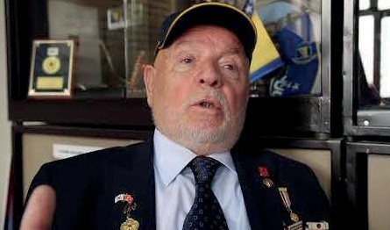
Source E: An excerpt from the oral history interview with Veteran Ali Rıza Yurtnaç (https://www.youtube. com/watch?v=hE1hU1mF1S4)
🕒 12:44-15:37
A. R. Yurtnaç: After Merzifon, we came to Ankara. In the 28th Division in Ayaş, the 241st Infantry Regiment was called up; our regiment was assigned to Korea.
Before going to Korea, I was living in Ordu. When I first join the military, we were in Ayaş where we were in sergeant training. When the Korea issue arose, our 241st Infantry Regiment was selected. Then we underwent medical examinations at the Gülhane Hospital; every soldier, the entire regiment. About half were deemed unfit for service. As a result, reinforcements came from other places, Izmir, Erzurum, and so on, to support our 241st Infantry Regiment. Then the brigade was formed. After that, we moved from Ayaş to the Armored Brigade in Etimesgut. We received American training there; one month, day and night. After one month, we boarded a train and traveled to Iskenderun. The ships had not arrived in Iskenderun when we arrived there so we set up tents on the Belen Plateau. We waited there for the boats for fifteen days. On the Belen Plateau… then we departed from Iskenderun. Around the twentieth of September, after about twenty-five days, we arrived there. In October, we reached Busan. We were at the Port of Busan.
🕒 16:10-17:11
A. R. Yurtnaç: Once we arrived in Korea, we disembarked in Busan… From there, we took our backpacks on our shoulders and boarded a train to Daegu. There were buildings there, built by the Japanese at the time. We were placed in those buildings. The buildings were three to four stories high. Our entire regiment settled there and there were ample facilities, like a barracks. We trained there for twenty-one to twenty-five days. Day and night, we prepared ourselves; preparing for war. The Korean people treated us with great warmth in Daegu. After twenty-five days of training in Daegu, we boarded military trucks. After the training, we moved to Kunuri.

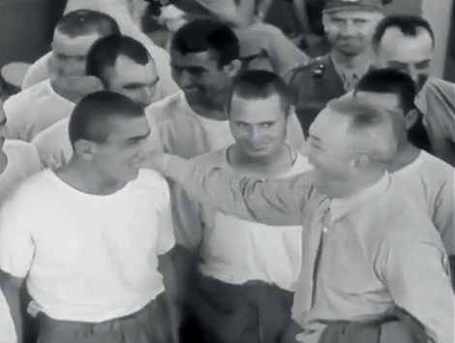
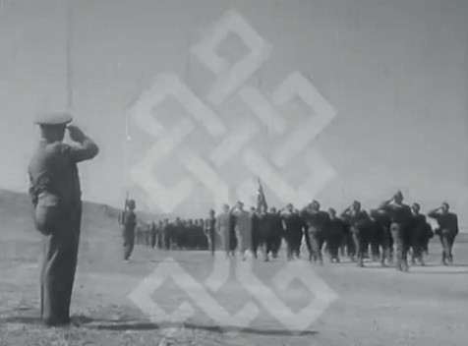

Source F: The Turkish Military Unit participating in the United Nations Forces on the way to Korea (TCKTBa, no date)
🕒 00:22-01:14
Orator: As our heroic unit, preparing to go to Korea to safeguard world peace on behalf of the United Nations, gets ready for a ceremonial parade; they stand with their Regimental Flag, which will always wave proudly at their side. Our brave soldiers, each
one an example of courage from our valiant army, wait for their commander, who will arrive shortly for inspection. Now, Brigadier General Yazıcı, the commander who was loved and respected by the soldiers as if he was a father, begins inspecting the unit. As always, our flag, which has flown victoriously everywhere, rises proudly in the hands of a hero, as if…
🕒 03:35-04:47
Orator: One day, our Korean Unit arrived at Ankara Station by train. Truly, they came with the joy and excitement of people like going to a wedding; laughing, singing folk songs. Nearly the entire city had gathered at Ankara Station. Officials, the soldiers’ acquaintances, and hundreds of citizens flocked there, surrounding the heroes and offering them flowers, sweets, various gifts, and above all, their warm smiles and wishes for a safe journey. People gazed with admiration at the commander and his soldiers, who were loved by all. Before the unit departed from Ankara Station, everyone joined in singing the National Anthem, filling the atmosphere with a deep sense of reverence. Finally, the journey…

Source G: Turkish forces on the way to Korea (TCKTBb, no date)
🕒 02:23-03:36
Orator: Oh! Enjoy your meal. Of course, one should not forget to write a few lines of congratulations to the family back home. How beautiful it is to worship God together in this open-air mosque on the morning of the Eid (religious holiday)! May God be with them. Here they are, all rising with clear foreheads from the prostration in which they have collectively bowed before the
Merciful. After the unit’s imam offers a heartfelt prayer, the commander will celebrate the holiday with the soldiers. A number of soldiers carry their heavy weapons and drive their vehicles along with them and this equipment is loaded onto the ships. The time has now come to depart for Korea.
🕒 06:05-08:05
Orator: Sometimes you see the Brigadier General stepping onto a ship, joining his soldiers, and, as always, asking after their well-being. Here is the unit’s Chief of Staff, Lieutenant Colonel Tokay, stepping aboard as well, never losing the smile on his face. Our courageous, intelligent, resilient, and valiant soldiers, from the highest-ranking officer to the lowest-ranking private, are thoroughly united, and their morale is beyond any description or praise. They will join the heroic efforts undertaken under the United Nations banner to protect world peace and here is the glorious Regimental Flag. The unit's sacred symbol is being brought aboard the ship. Meanwhile, the cranes lift and lower equipment; now the time to set sail is near.

Step 2: The students are asked/invited to analyze and to evaluate the audiovisual sources they examined (and/ or their transcriptions) using the questions below.
Mise-en-scène Analysis (Analysis):
- What might be the reasons for employing ‘mise-en-scène’ in the videos you watched?
- When the ‘mise-en-scène’ and visual compositions used in the videos are examined, how might they be said to shape public perception? Why?
Propaganda Analysis (Synthesis):
- Were any propaganda techniques used in the videos you watched? If you believe they were, please identify them.
- For what purposes might these techniques have served within the political and social context of the period? Why is this?
- Do you think similar propaganda techniques are used by the media today? If so, can you give examples?
Reality and Representation Comparison (Evaluation):
- When the feelings and thoughts expressed in soldiers’ diaries, such as in Source I below, are compared with those conveyed in the videos, what similarities and differences can be identified?
- What might the reasons be for the differences between the soldiers’ actual feelings and thoughts and the emotions portrayed in the videos?
- How might the relationship between the political institutions and public opinion be characterized in the context of this controversial issue? Interpret your thoughts.
Guiding Question 2: What did the soldiers of the First Turkish Brigade experience and feel during their journey from Türkiye to Korea and throughout the process leading to the battlefield?
Task 2: The students are asked/invited to examine Sources H, I, J, K, and L and answer the related questions.
Step 3: The students are asked/invited to examine the map in Source H.
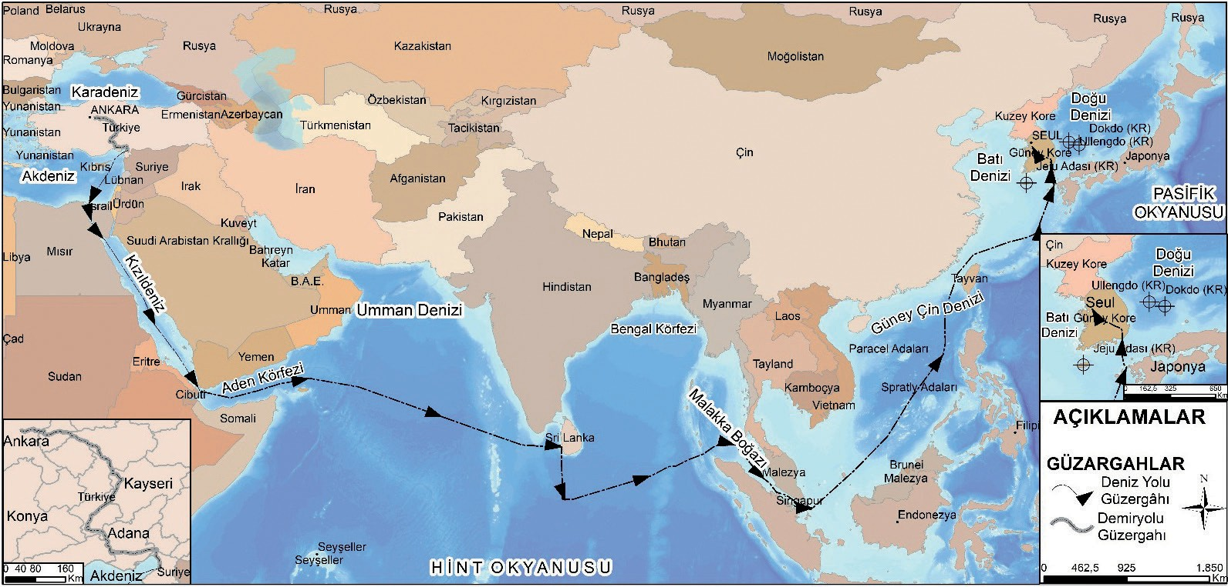
Source H: Map showing the route of the Turkish Brigade’s journey to Korea
(Prepared by the authors).

Step 4: The students are asked/invited to examine Source I and then to read the diary excerpts of martyr First Lieutenant Mehmet Gönenç presented in Source J.
Source I: A photograph of Martyr First Lieutenant Mehmet Gönenç (Denizli, 2011, p. 117)
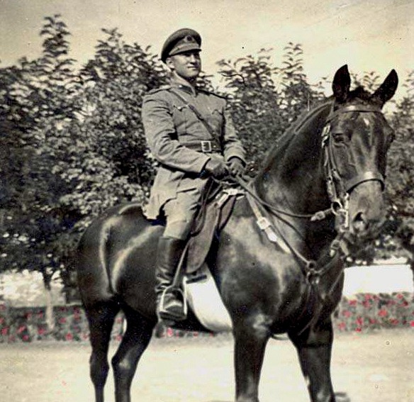

Source J: Selected excerpts from the diary of martyr First Lieutenant Mehmet Gönenç 2 October 1950, Monday
I woke up at 05:45. I went up to the deck and did some physical exercises. The sun is just rising, but the weather is quite hot. I do not know where we are at the moment. The sea surrounds us. We are waiting for Jeddah with great impatience. The ship is rocking lightly. Now I will take my bath and go to breakfast.
Today our work begins.
Every morning, we receive the news from the ship’s radio in English. We translate it into Turkish and learn about world affairs day by day. Since there is no radio in either the lounge or the dining hall, this is the only deficiency. It seems I was mistaken, do not misunderstand, not about the radio, but about the distance. As I am writing these lines, we are apparently passing off the coast of Jeddah.
The captain announced the news. The morning after tomorrow, we will arrive in the Gulf of Aden. This evening at 19:00, we will watch an open-air movie on the ship’s deck. They prepared the screen during the day. Let’s see what films they have.

4 October 1950, Wednesday
Then we studied English for about an hour. Around 13:00 we reached the waters off Hadhramaut. Today, we also conducted an alarm drill. The battalion imam gave a sermon to the soldiers and recited the Qur’an.
There were two pairs of boxing gloves on the ship. At first, none of the Americans wanted to box with me. Then one volunteer appeared. We put on the gloves and boxed two rounds of two minutes each. It was something like a cockfight. The referee was a forty-two-year-old black man, a former boxer. He invited me to train every evening, and I accepted.

134

Thursday, 5 October 1950
Today I was on duty. I was present in the kitchen during the distribution of dinner. There was supposed to be a movie tonight, but because it seemed like it might rain, it was canceled. After then, while the others were searching for radio stations in the lounge, they found the Turkish broadcast from London. We all gathered around the radio. The sound affected us deeply.
Now, I understand what it truly means to long for home. Yet it had only been one week since we left but with every passing second, we moved a little farther away.
Today again, the Americans helped us with language learning. I tried to communicate, half in English and half through gestures, with the black boxer for about half an hour. He wrote his name and address in my notebook. Honestly, I am very pleased with the ship's crew; they are very friendly.
At 21:30, we listened to Perihan Sözeri’s record ‘Last night, in despair, I lost myself ’, during the Turkish broadcast of Voice of America.

6 October 1950, Friday
Not knowing the language is terrible, especially when traveling to distant lands among strangers; true, we communicate with gestures and such, but it is not enough. I can manage broken German with a German man named William. I wonder what we will do in Korea. I definitely want to learn English.
Tonight, we will move our clocks one hour forward again. We continued the film we had to stop yesterday because of the rain. The film is titled ‘The Enchanted Garden’ and stars Pat O’Brien and Herbert Marshall.

7 November 1950, Tuesday
Today, for the first time since coming to Korea, I took a bath. This evening was quite exciting. Rumors began to spread that we would depart for the front in two days and that the situation there was worrying. After listening to the evening radio news, all the personnel at the training site gathered, as the lieutenant colonel was going to give a speech. He could not come because he was occupied so we returned to our rooms. (Summarized from Denizli, 2011, pp. 61-105.)

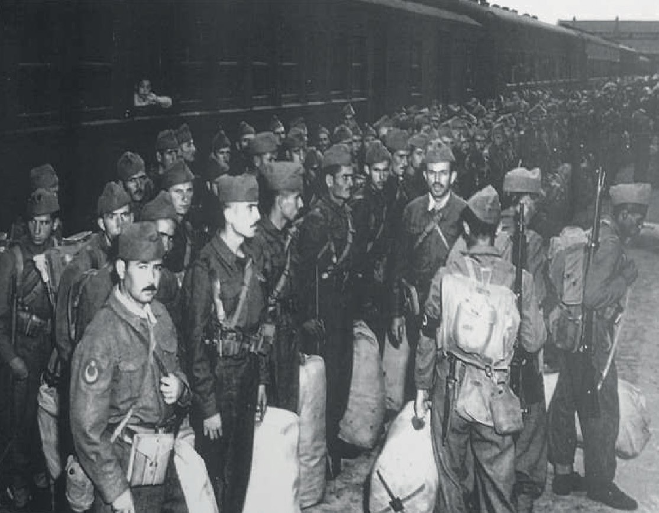
Step 5: The students are asked/invited to examine Source K and to read the excerpts summarized from the memoirs of Veteran Faruk Pekerol presented in Source L.
Source K: A photograph of Turkish soldiers arriving at the Iskenderun train station (Denizli, 2011, p. 86)

Source L: An excerpt from the memoirs of Korean War Veteran Faruk Pekerol, Written by Bülent Rusçuklu
“On Tuesday, 17 October 1950, before dawn, the loudspeaker of the American military transport ship McRea announced the wake-up time for all officers and enlisted men.
Throughout the voyage, the Turkish soldiers on board were responsible for maintaining order and cleanliness in their assigned areas, cabins, dining halls, and the deck, and after handing them over to the American crew, they assembled fully equipped on the deck at 05:30.
All the personnel were experiencing the excitement of the war they were about to join, along with the anxiety and impatience of setting foot in a country they did not know.
After a twenty-one-day sea journey, the American military ship slowly entered the Port of Pusan in South Korea with the first light of morning. The city’s lights had not yet gone out.
The port was full of military vehicles and warships. It was, frankly, like a fairground.
Because another military ship that had docked earlier was still unloading, the Turkish soldiers on the McRea were ordered back to their cabins to unload their equipment.
They had to wait one more day before setting foot in South Korea.
On Wednesday morning, 18 October 1950, we set foot on Korean soil.
After the assembly below, we began marching in firm and proper steps toward the Pusan train station.
The people lined up along both sides of the road were shouting joyfully from the heart. Their enthusiastic cheers continued all the way to the station.
At 11:30, we began boarding the trains. Since it was lunchtime, they had distributed canned food. Having eaten breakfast very early in the morning, we were hungry and because we could not read the labels on the cans, we were curious about their contents. So, we began trying to open them.
The train had not yet departed. Holding a can and its key opener, I got off and approached an American military policeman walking nearby. With the help of the English, I had learned at school and some hand gestures, I asked him how to open the can.
Inside the cans were meals, fruit compotes, and desserts.
By the time our train left the port city for Taegu in the north, it was 12:00.
Late at night, our train entered the station at Taegu, and we disembarked in order; company, platoon, and squad.
After twenty-three days of training, At 08.30 on Friday, 10 November, 1950, we left Taegu for the front to fight the Reds.
As we moved northwest, we began to encounter the tragic and painful scenes of villages and towns destroyed by bombs. Along the roadsides and in the fields, we also saw the wrecks of tanks, artillery, trucks, and jeeps.
According to our commanders, these areas had been invaded by the enemy before we arrived. From the very first days, we began to understand the devastation the war had inflicted on this country.
After three days and nights of travel by military trucks, we reached Seoul, the prewar capital of South Korea. We pitched our tents in the areas designated for us.

136
During this journey, we suffered our first loss, a martyr, due to an accident.
Because the roads were rough, our senior supply sergeant in the logistics vehicle died when the vehicle overturned after being unable to brake on a sudden curve.
This unexpected accident saddened us all.
Early the next morning, we continued northward in trucks.
After passing through towns of various sizes for two days, we arrived in the city of Changdan on the evening of 17 November, 1950.
On 21 November, 1950, toward evening, we reached Pyongyang, the capital of North Korea, located northwest of Kaesong. Without stopping, we continued our journey. Some nights we camped by rivers. When passing through villages and towns, Korean children and adults shouted, “Okay, chop chop, eat eat!” We gave them food from our rations.
Then, on 24 November 1950, our supply company settled south-east of Kunuri (Kunmori), north of Pyongyang.” (Ruscuklu, 2012, pp. 24–32).

Step 6: The students are asked/invited to answer the following questions based on Sources H, I, J, K, and L.
- According to the sources, what difficulties did the Turkish soldiers encounter during their journey to Korea?
- What might the Turkish soldiers have felt in response to the events they witnessed and experienced as they moved from Taegu toward the battlefield?
- If you had seen and/or experienced similar situations, what would you think and feel?
- Compare the feelings and thoughts of the soldiers before participating in the war, as shown in the videos, with their emotions and thoughts during active involvement in the war. Do you observe any changes? If so, what are they?

🎯Assessment and Evaluation
- Summarize the types of preparation, tasks, and procedures that took place from the initial decisions about which units would participate in the war to the selection process and the soldiers’ arrival at the battlefield.
- To what extent can it be said that the videos prepared by the Ministry of Culture accurately reflected the emotions and thoughts of the soldiers preparing to depart for Korea? Why is this?
- According to the sources you have examined, what kind of situation did Turkish soldiers encounter upon arriving in Korea?

References
Denizli, A. (2011). Kore Savaşı kahramanı Bandırmalı Şehit Topçu Üsteğmen Mehmet Günenç [Korean War hero: Martyr Artillery First Lieutenant Mehmet Günenç from Bandırma]. Turhan Kitabevi.
Askeri Müze ve Kültür Sitesi Komutanlığı (AsMvKSK). (2019). Fotoğraflarla Kore Savaşı’nda Türk Askeri [The Turkish soldier in the Korean War in photographs]. Askeri Müze ve Kültür Sitesi Komutanlığı.
Han, J. (2018). Interview with Ali Rıza Yurtnaç. https://koreanwarlegacy.org/interviews/ali-riza-yurtnac/ Access Date: 19.04.2024.
Rusçuklu, B. (2012). Kore Savaşı: Unutulan savaş ve Gazi Faruk Pekerol’un anıları [The Korean War: The forgotten war and the memoirs of Veteran Faruk Pekerol]. Arvo Yayınları.
T.C. Kültür ve Turizm Bakanlığı. (TCKTBa). (n.d.). Birleşmiş Milletler Kuvvetlerine Katılan Türk Askerî Birliği Kore Yolunda [The Turkish Military Unit Joining the United Nations Forces on the Road to Korea] [Documentary]. https://filmmirasim.ktb.gov.tr/tr/film/birlesmis-milletler-kuvvetlerine-katilan-turk-askeri-birligi-kore-yolunda Access Date: 27.08.2025
T.C. Kültür ve Turizm Bakanlığı. (TCKTBb). (n.d.). Türk Kuvvetleri Kore Yolunda [Turkish Forces on the Road to Korea] [Documentary]. https://filmmirasim.ktb.gov.tr/tr/film/turk-kuvvetleri-kore-yolunda Access Date: 27.08.2025.

🏠
Homework
Writing a Letter to My Family
The students are asked/invited to write a letter to their family from the eyes of a soldier or someone else who experienced a sea journey from Türkiye to Korea like the Turkish soldiers at the time of the Korean War. They are required to take into consideration the experiences described in the diaries of the two soldiers they read in this activity. In their letter, they may include one, several, or all of the following topics:
- Daily life during the journey to Korea and in Taegu
- Conditions of the journey to Korea
- Communication with soldiers from other countries on the ship
- Efforts to adapt to a different culture
- The soldiers’ training on the ship and in Taegu
- Longing for home, based on the expressions of the martyr First Lieutenant Mehmet Günenç

