WAGES AND ALLOWANCES AS PART OF THE COST OF WAR
Unit 4
🎓 Grade Level:
9th, 10th, and 11th Grades
⏰ Teaching Time:
40 + 40 minutes+Homework

Concepts to Digest: Economy, daily wage, purchasing power, budget
Skills to Improve: Using historical evidence, historical inquiry and analysis
Core Values: Patriotism, Cooperation, Solidarity, Self-sacrifice




Methods-Techniques: Historical inquiry, research, direct instruction, questioning
Teaching-Learning Materials: Photographs of banknotes, dictionary
Learning Aim: This activity aims to help the students gain general knowledge regarding Türkiye’s economy during the period and, by comparing salaries, daily wages, and other payments to those assigned to Korea or elsewhere, draw inferences about the cost of war based on payments to individuals in different professions.
Key Question: Based on the example of the Korean War, what can be said about the economic, social, and human costs of war for a country?
Guiding Question 1

What was Türkiye’s economic situation in the post-World War II period?
Objective 1

To make inferences about Türkiye’s economic situation in the post-World War II period.
Task 1

The students are asked/invited to read Sources A, B, C, and D, to answer the given questions, and to prepare an informative text.
Guiding Question 2

How did the payments made during the Korean War differ according to the personnel’s training and qualifications?
Objective 2

To make inferences about how a person’s education and
acquired qualifications for their profession or job are two main factors that determine their income.
Task 2

The students are asked/invited to examine and analyze source documents E, F, G, H, I, and J, to answer the related questions, and to fill in Table 1.
Guiding Question 3

In extraordinary situations such as the Korean War, what other financial burdens besides personnel payments does war place on a country’s economy (equipment, logistics, medical support, and so on), and what are the long-term economic effects of these burdens?
Objective 3

To make inferences about the economic costs of payments made to specific military
and civilian personnel in extraordinary situations, such as wartime.
Task 3

The students are asked/invited to fill in Table 2, to answer the related questions in groups, and to write a newspaper column.

Teaching and Learning Plan

‼ Focus on Activity
Various banknotes are shown to the students, who are then asked to guess which countries they belong to and what their currency units are called.
5 min.
🛎 Task 1
The students are asked/invited to read Sources A, B, C, and D, to answer the given questions, and to prepare an informative text.
25 min.
🛎 Task 2
The students are asked/invited to examine and analyze source documents E, F, G, H, I, and J, to answer the related questions, and to fill in Table 1.
25 min.
🛎 Task 3
The students are asked/invited to fill in Table 2, to answer the related questions in groups, and to write a newspaper column.
20 min.
🎯 Assessment and Evaluation
Open-ended questions are answered.
5 min.

🏠 Homework
The students are asked/invited to conduct an online and AI-assisted inquiry into a country’s capacity to wage and sustain war. The resulting product is stored in their electronic portfolio.

Teaching and Learning Process
Focus on Activity: Photographs of various national currencies are projected on the screen. The students examine the banknote images in Table 1 and predict which countries they belong to. The teacher then shares the correct information about which countries these currencies belong to.
Visual 1: Sample Banknotes from Various Countries (Allnumis.com, 2025; Kitantik.com, 2025; Notafilia-kp.com, 2025; Numista.com, 2025).
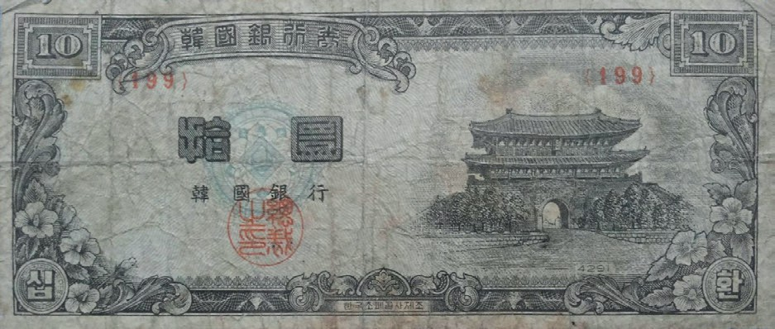
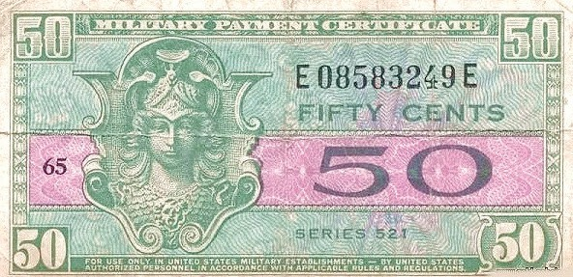
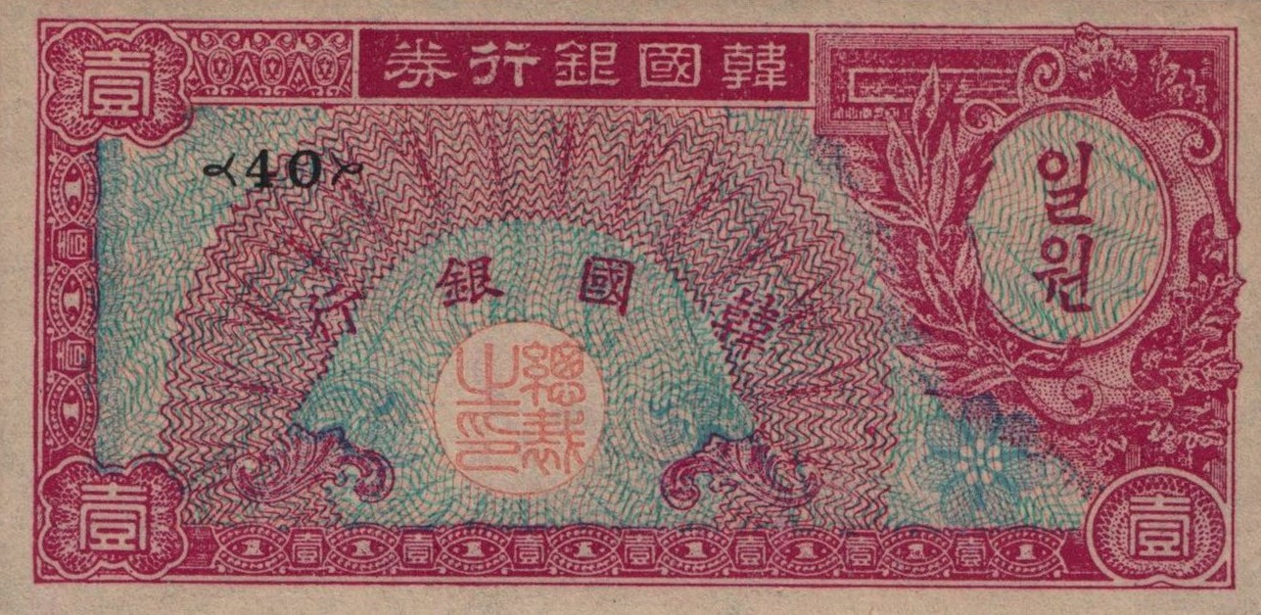
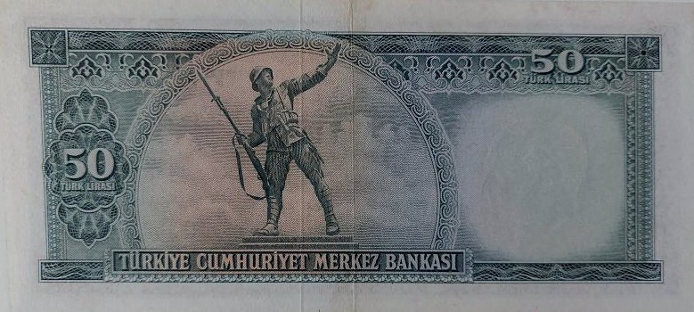

Guiding Question 1: What was Türkiye’s economic situation in the post-World War II period?
Task 1: The students are asked/invited to read Sources A, B, C, and D, to answer the given questions, and to prepare an informative text.
Step 1: The students are asked/invited to read Source A and Source B.
Source A: Fundamental Economic Concepts
Economy: A social science that regulates production, distribution, and consumption activities to meet people’s unlimited needs with limited resources. The wartime economy examines how countries mobilize their resources under extraordinary conditions or circumstances.
Daily Wage: The payment given to an individual for one day of work. During the Korean War, daily payments to military and civilian personnel varied depending on rank and duty location.
Purchasing Power: The amount of goods and services that a given amount of money can buy. It changes with the value of the currency and inflation rates. When compared using the value of gold, the difference in purchasing power between the 1950s and today becomes clearly visible.
Budget: The total planned income and expenditures of a state, institution, or individual for a specific period. During wartime, extraordinary expenses impose additional burdens on the budget (Prepared by the authors).

Source B: The Use of Money in Trade
Meeting human needs requires a division of labor within society. As a result of this division of labor, the exchange of different goods and services requires an accurate measure of value. The difficulties of the barter system created the need for a commonly accepted standard of value and, as its tangible representation, an instrument for exchanging goods and services. This instrument, first invented approximately 2,700 years ago on Anatolian soil, made it possible to measure the value of an item or service and to exchange it for another item or service easily and quickly (Prepared by the authors).

Step 2: The students are asked/invited to answer the following questions based on Sources A and B.
- According to the information in Source A, what kind of relationship can be identified among the concepts of purchasing power, budget, and economy?
- What might the medium of exchange be as mentioned in Source B?
- If the instrument mentioned in the text did not exist, how would the exchange of goods and services be carried out?
- In economic systems where production, distribution, and consumption activities are regulated, what functions does the instrument of money serve?

Step 3: The students are asked/invited to read Source C.
Source C: What is Money?
Money, the most widely used medium of exchange for goods and services, generally refers to coins and banknotes. It functions as a unit of value, a means of exchange, and a store of value. The use, value, and circulation of money are regulated and supervised by states, which are recognized as political structures responsible for ensuring security and justice in political, legal, and economic spheres. Today, almost every developed state or union of states determines its monetary policy and issues money through an institution with autonomous status. Many countries have their own national currency. The funds issued carry different denominations, facilitating commercial transactions. Countries also take various security measures to prevent counterfeiting; that is, the production of fake money (Prepared by the authors).

Step 4: The students are asked/invited to answer the following questions based on Source C
- According to Source C, what is the most fundamental function of money?
- What is the name of the institution responsible for determining monetary policy and issuing money in many countries, including the Republic of Türkiye?

Step 5: The students are asked/invited to match the economic terms below with the numbered explanations.

Income | Expenditure | Budget |  | Inflation
……….. | ……….. | ……….. |  | ………..
Current Account Deficit | Liberalism |  | Disinflation
……….. | ……….. |  | ………..

1. Price increases accompanied by a decrease in purchasing power
2. A situation that arises when a country’s imports exceed its exports
3. The calculation of income and expenditure
4. Money received from somewhere or earnings obtained
5. A decrease in the rate of price increases
6. Spending or expenditure
7. A reduction in government intervention in the economy
Step 6: The students are asked/invited to read Source D.
Source D: Türkiye’s Economy Before and During the Korean War
Although Türkiye did not actively participate in World War II, it was affected by the war's adverse economic conditions. However, after years of inflation, there was no significant increase in prices between 1941 and 1951. During these years, an emphasis was placed on ensuring that public expenditure did not exceed budget revenues. Although prices began to rise again in 1951, the economic policies implemented by the Democrat Party led to the years between 1950 and 1954 being remembered, albeit briefly, as a period of economic prosperity. With the Democrat Party’s rise to power, public intervention did not decrease, but policies prioritizing liberal, private enterprise policies, were pursued.
In the early years, the expansion of cultivated lands, the increase in agricultural production due to favorable weather conditions, and the growing global demand, especially for wheat during the Korean War, opened the way for greater agrarian exports. Additionally, U.S. economic and military aid, along with the use of the treasury’s foreign currency and gold reserves, supported economic development.
Although the rate of growth in agriculture did not match that of other sectors, growth was also observed in mining, sugar, cement, and textile production, driven by public support. Although the roots of the inflation experienced after 1954 lie in earlier years, the period from 1946 to 1953 can be considered a time of economic growth. Linked to this, income levels and living standards also rose during this period. However, due to the effects of the liberal import regime, the external deficits of 1952 and the inflation that resumed in 1951 became felt significantly after 1954 (Adapted from Boratav, 1985; Pamuk, 2012).

Step 7: The students are asked/invited to answer the following questions.
- According to Source D, what is the reason that no significant price increases occurred between 1941 and 1951?
- According to Source D, in which sectors did production increase after 1950?
- Prepare a brief informative text about Türkiye’s economy in the post-World War II period.

Economy: Türkiye’s Economy in the Post-World War II Period .........................................................
..................................................................................................................................................................
..................................................................................................................................................................
..................................................................................................................................................................
..................................................................................................................................................................
..................................................................................................................................................................
..................................................................................................................................................................

Guiding Question 2: How did the payments made during the Korean War differ according to the personnel’s training and qualifications?
Task 2: The students are asked/invited to examine and analyze source documents E, F, G, H, I, and J, to answer the related questions, and to fill in Table 1.
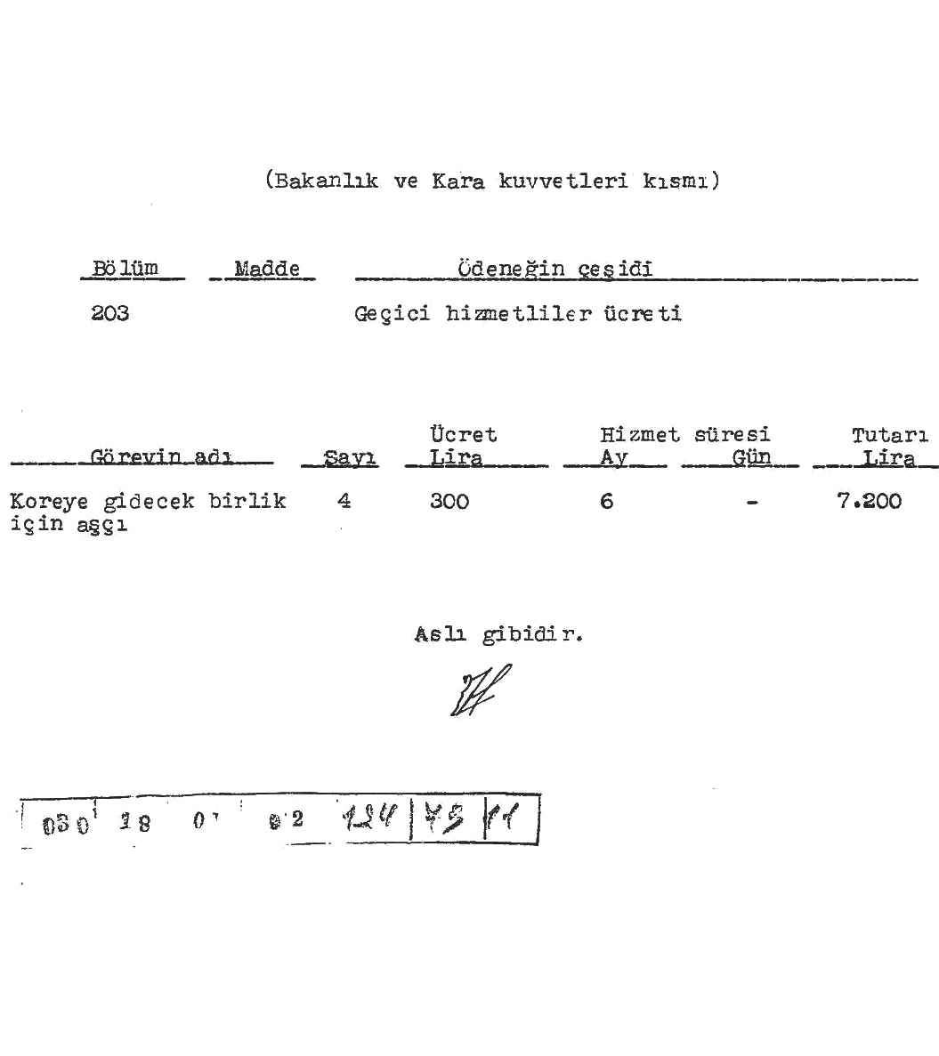
Step 8: The students are asked/invited to examine Sources E, F, G, H, and I.
Source E: Decision on the wages to be paid to cooks to be sent to Korea
(ATASE: 30-18-1-2 / 124 - 79 – 11)
(Ministry and Land Forces section)
Section
203 Wages for temporary personnel
Article Type of Allowance
Certified true copy.
050 18 0 82 121/2511

Duty Title | No | Wage in Liras | Length of Service |  | Lira
Duty Title | No | Wage in Liras | Months | Days | Lira
Cooks assigned to the unit are to be sent to Korea | 4 | 300 | 6 | - | 7.200

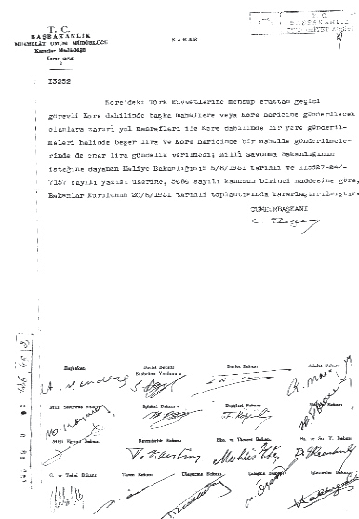
T.R. PRIME MINISTRY GENERAL DIRECTORATE OF ADMINISTRATIVE
Source F: Decision on the Temporary Duty Allowances to be paid to Soldiers serving in Korea
(ATASE: 30-18-1-2 / 126 - 49 – 2)
Department of Decisions Decision No: 3
Decision (13252)
It has been decided that conscripted soldiers belonging to the Turkish forces in Korea who are assigned on temporary duty to other locations within Korea or outside Korea shall be paid necessary travel expenses, and, if they are sent to a location within Korea, a daily allowance of five lira, and if they are sent to a location outside Korea, a daily allowance of ten lira. This decision was taken at the meeting of the Council of Ministers on 20/6/1951, based on the Ministry of Finance’s written request dated 5/6/1951 and numbered 115527-24/7157, which was itself based on the request of the Ministry of National Defense, in accordance with Article 1 of Law No. 5686.
President of the Republic
C. Bayar
Prime Minister
A. Menderes
The signatures of the Deputy Prime Minister and the other ministers are also present.

Source G: Decision on the Travel Allowances and Daily Wages to be paid to Nurses assigned to duty in Tokyo (ATASE: 30-18-1-2 / 124 - 100 – 9)

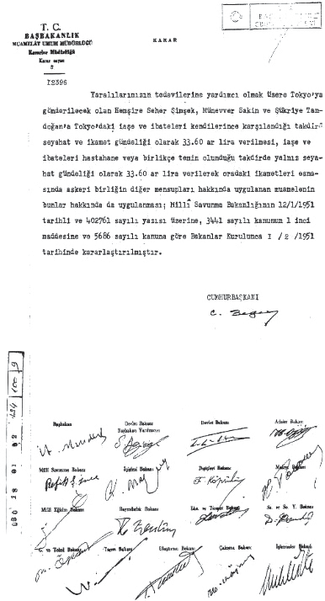
T.R. PRIME MINISTRY GENERAL DIRECTORATE OF ADMINISTRATIVE AFFAIRS
Department of Decisions Decision No: 3
Decision (13296)
It has been decided that Nurses Seher Şimşek, Münevver Sakin, and Şükriye Tandoğan, who are to be sent to Tokyo to assist in the treatment of our wounded soldiers, shall each be paid 33.60 lira as travel and accommodation allowance, provided that they cover their own subsistence and lodging expenses in Tokyo. If the hospital or the military unit provides subsistence and lodging, they shall each be paid only the travel allowance of 33.60 lira. During their stay there, the same procedures applied to other members of the military unit shall also apply to them. This decision was adopted by the Council of Ministers on 1/2/1951 in accordance with Article 1 of Law No. 3441 and Law No. 5686, based on the request of the Ministry of National Defense dated 12/1/1951 and numbered 402761.
President of the Republic
C. Bayar
Prime Minister
A. Menderes
The signatures of the Deputy Prime Minister and the other ministers are also present.

Source H: Decision on the Temporary Duty Allowances to be paid to Air Force Pilot Officers assigned to Korea and other locations during the Korean War (ATASE: 30-18-1-2 / 132 - 49 – 9)

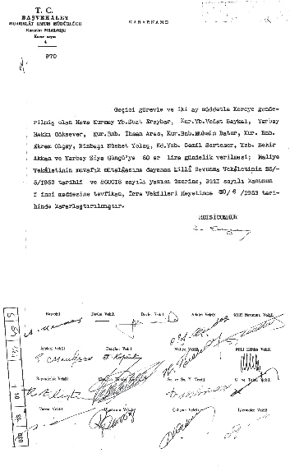
T.R. PRIME MINISTRY GENERAL DIRECTORATE OF ADMINISTRATIVE AFFAIRS
Department of Decisions Decision No: 4
Decree (970)
It has been decided that Air Staff Lieutenant Colonel Suat Eraybar, Staff Lieutenant Colonel Vedat Baykal, Lieutenant Colonel Hakkı Göksever, Staff Major İhsan Aras, Staff Major Muhsin Batur, Staff Major Ekrem Olçay, Major Nüshet Yolaç, Senior Captain Cemil Serteser, Captain Bekir Akkan, and Lieutenant Colonel Ziya Günçü, who were sent to Korea on temporary duty for a period of two months, shall each be paid a daily allowance of 60 lira. This decision was adopted by the Council of Ministers on 20/6/1953, pursuant to Article 1 of Law No. 3441, based on the letter of the Ministry of National Defense dated 25/5/1953 and numbered 860018, which was itself prepared in accordance with the favorable opinion of the Ministry of Finance.
President of the Republic
C. Bayar
Prime Minister
A. Menderes
The ministers' signatures are also present.

Source I: Decision on Temporary Duty Allowances to be paid to Senior Officers assigned to Korea and other locations during the Korean War (ATASE: 30-18-1-2 / 123 - 75 – 19)

T.R. PRIME MINISTRY GENERAL DIRECTORATE OF ADMINISTRATIVE AFFAIRS
Department of Decisions Decision No: 3
Decision (11902)
It has been decided that General Staff Operations Chief Lieutenant General Yusuf Adil Egeli, who is to be sent to Japan, Korea, and the United States to conduct discussions at General MacArthur’s headquarters in Tokyo regarding the employment and related matters of the Turkish combat unit deployed to Korea, to carry out inspections in the Pacific assembly area and the Korean combat zone, and subsequently to travel to Washington for consultations with the American General Staff, shall be paid a daily allowance of 75 lira for thirty days. Staff Colonel Cemal Aydınalp and Staff Lieutenant Colonel Niyazi Çelik shall each be paid a daily allowance of 60 lira for thirty days. This decision was adopted by the Council of Ministers on 29/9/1950, in accordance with Article 1 of Law No. 3441, based on the letter from the Ministry of National Defense dated 29/9/1950, numbered 335810.
President of the Republic
C. Bayar
Prime Minister
A. Menderes
The signatures of the Deputy Prime Minister and the other ministers are also present.

Step 9: The students are asked/invited complete Table 1 based on the information provided in Sources E, F, G, H, and I regarding the travel allowances and daily payments made to military or civilian personnel assigned to Korea or other locations (such as Japan or the United States) during the war.
Table 2: Payments made to Military and Civilian Personnel assigned to Korea or other locations during the War

Personnel Assigned | Daily payments received (per person) | According to the average value of a Republic gold coin between 1951 and  1953 (35 TL) | According to the average value of a Republic gold coin on the day this activity is conducted  (check online) | Average monthly income (30 days)
Cook
Soldier assigned to Korea.
Soldier assigned outside Korea.
Nurse
Pilot officers
Chief of the General Staff of Operations

Step 10: The students are asked/invited to answer the following questions based on Sources E, F, G, H, and I and Table 1.
- What types of documents do Sources E, F, G, H, and I contain? Why is this so?
- Considering the institutions that prepared these documents and the individuals whose signatures appear on them, what can be said about their reliability?
- According to Table 1, who receives the highest and lowest daily wages?
- What might be the reasons for the differences in payments among personnel with different duties? What do these differences allow you to infer about Türkiye’s social and economic structure at the given time?
- Considering the gold prices of the early 1950s and of today, what can be said about the appropriateness or adequacy of the payments made to those assigned abroad during the Korean War?
- The information in Sources E, F, G, H, and I show that decisions regarding assignments abroad and the payments to be made to such personnel during the Korean War were taken by the Council of Ministers. Considering this, what can be said about the importance the government of the time attached to the Korean War?

Step 11: The students are asked/invited to listen to/read the oral history interview conducted with Korean War Veteran Mehmet Cemil Yaşar, presented in Source J. They are then asked/invited to examine Source K.
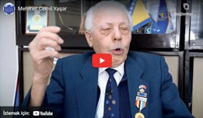
Source J: An Excerpt from the Oral History Interview conducted with Korean War Veteran M. Cemil Yaşar (https://koreanwarlegacy.org/interviews/ mehmet-cemil-yasar/)
🕒 26:09-26:35
M. C. Yaşar: While fighting, fighting in the places where we
fought, and while we were fighting in Korea, we fought as if we were fighting an enemy in our own homeland. If we had not thought this way, Korea would not have gained its freedom today. In other words, we fought by treating the enemy before us as if they were enemies in our own country.

Step 12: The students are asked/invited to answer the following questions based on Source J.
  - Based on the statement by Veteran M.C. Yaşar, what characteristics of our soldiers fighting in Korea are reflected here? Why is this?
  - When the payments made to soldiers and other professionals assigned to Korea in the sources above are compared with the statement by Veteran M.C. Yaşar in Source J, what values can be identified as motivating Turkish soldiers during the Korean War?
Guiding Question 3: In extraordinary situations such as the Korean War, what other financial burdens, besides personnel payments, does war place on a country’s economy (equipment, logistics, medical support, and so on), and what are the long-term economic effects of these burdens?
Task 3: The students are asked/invited to fill in Table 2, to answer the related questions in groups, and to write a newspaper column.
Step 13: The students are asked/invited to use the information provided in Table 2 and, taking into account that four Turkish brigades were sent to Korea during the war, that each brigade had approximately 250-300 officers, and that these officers served for an average of one year, calculate the approximate total payments made to the officers and fill in Table 3.
Table 3: Payments Made to Officers Serving in Korea During the War

Personnel Assigned | Estimated/Average Payments Made Between 1950-1953 | Estimated Current Value of Payments*
The estimated total payment made to a single officer in one year.
The estimated total payment made to all officers in one year.
The estimated total payment made to all officers over four years.
*Calculations are made by taking into account that the average value of a Republic gold coin between 1950 and 1953 was 35 TL, and that its current value is … TL (students are asked/invited to look up the current gold value online).

Step 14: The students are asked/invited to answer the following questions.
- Considering that the cost of the Korean War to Türkiye includes not only the payments made to personnel but also military equipment, logistical support, medical services, and payments made to the families of martyrs, what can be said about the total cost of participation in the war?
- Taking into account the approximate current equivalents of the payments made to military personnel during the Korean War, what can be said about how participation in a war might affect a country’s economy?
Step 15: It is evident that Türkiye’s participation in the Korean War, in addition to the estimated economic and human costs, brought financial and political gains, including NATO membership and U.S. financial aid. Based on this information, the students are asked/invited to write a newspaper column that either supports or opposes Türkiye’s decision to send troops to Korea. In this column, the students may use the concrete information provided in the sources above as evidence. They may also discuss the possible short-term and long-term effects of the war’s human, social, military, economic, and political dimensions.

The Cost of Fighting in Korea ................................................................................................................
..................................................................................................................................................................
..................................................................................................................................................................
..................................................................................................................................................................
..................................................................................................................................................................
..................................................................................................................................................................
..................................................................................................................................................................

🎯Assessment and Evaluation
- What can be said about Türkiye’s economic situation between 1950 and 1954?
- Wars have the costs of machinery, equipment, and most importantly human beings. From the labor and time invested in an individual from birth to adulthood to the significance of each life in giving rise to and raising new individuals, that is in bringing forth future generations, every life has value. In this regard, write your thoughts on the cost of war to a country.
- Based on the payments and allowances made to those assigned to the Korean War, as shown in Table 2, and also taking into account the human cost, what can be said about the cost to the Turkish economy of sending soldiers to the Korean War?
- The Korean War affected Türkiye not only financially, but also in terms of military experience, international prestige, and political gains. Considering these effects, evaluate the costs and the gains of the war.

References
Allnumis.com. (2025). 10 Hwan Banknote dated 1958. https://www.allnumis.com/banknotes-catalog/south-korea/1953-1958-issue/10-hwan-1958-4291-6018 Access Date: 22.08.2025
Boratav, K. (1985). Türkiye iktisat tarihi 1908–1980 [Economic history of Turkey 1908–1980]. In S. Akşin (Ed.), Türkiye Tarihi: 4 Çağdaş Türkiye 1908–1980 [History of Turkey: Vol. 4 Contemporary Turkey 1908–1980] (ss. 311–319). Cem Yayınevi.
Cumhurbaşkanlığı Devlet Arşivleri Başkanlığı Millî Savunma Bakanlığı Askerî Tarih Arşivi. ATASE [Presidency of State Archives, Ministry of National Defense, Military History Archive]. ATASE Record Group: 30–18–1–2, Place No: 124–79–11. (1951).
Cumhurbaşkanlığı Devlet Arşivleri Başkanlığı Millî Savunma Bakanlığı Askerî Tarih Arşivi. ATASE [Presidency of State Archives, Ministry of National Defense, Military History Archive]. ATASE Record Group: 30–18–1–2, Place No: 126–49–2. (1951).
Cumhurbaşkanlığı Devlet Arşivleri Başkanlığı Millî Savunma Bakanlığı Askerî Tarih Arşivi. ATASE [Presidency of State Archives, Ministry of National Defense, Military History Archive]. ATASE Record Group: 30–18–1–2, Place No: 124–100–9. (1951).
Cumhurbaşkanlığı Devlet Arşivleri Başkanlığı Millî Savunma Bakanlığı Askerî Tarih Arşivi. ATASE [Presidency of State Archives, Ministry of National Defense, Military History Archive]. ATASE Record Group: 30–18–1–2, Place No: 132–49–9. (1951).
Cumhurbaşkanlığı Devlet Arşivleri Başkanlığı Millî Savunma Bakanlığı Askerî Tarih Arşivi. ATASE [Presidency of State Archives, Ministry of National Defense, Military History Archive]. ATASE Record Group: 30–18–1–2, Place No: 123–75–19. (1951).
Han, J. (2018). Interview with Mehmet Cemil Yaşar. https://koreanwarlegacy.org/interviews/mehmet-cemil-yasar/ Access Date: 30.09.2024.
Kitantik.com. (2025). 50 Türk Lirası Banknot 1950 tarihli. https://www.kitantik.com/product/5-EMISYON-4-TERTIP-50-TURK-LIRASI-KAGIT-PARA-CILALTI-NATUREL-SERI-U2-044683-COK-NADIRDIR_1b
r9qfwlfc633t711u6?srsltid=AfmBOori1ok3sk94PC_0EqjItHME7ILVf7D61DiEaK2I-OMYi8f0IC0R Access Date: 22.08.2025
Notafilia-kp.com. (2025). 1 Won Banknote dated 1953. https://notafilia-kp.com/1-won-1953-lang_ee-p-94006. html Access Date: 22.08.2025
Numista.com. (2025). 50 Cents Banknote dated 1954. https://en.numista.com/catalogue/exonumia214089. html Access Date: 22.08.2025
Pamuk, Ş. (2012). Economic change in 20th-century Turkey: Is the glass more than half full? In R. Kasaba (Ed.), History of Türkiye in the modern world 1839–2010 (Vol. 4, pp. 275–311). Kitap Yayınevi.

🏠
Homework
The students are asked/invited to investigate the most critical factors that affect the value of a country’s currency. They are also asked/invited to examine how currency value and a country’s other forms of wealth (such as human resources, underground and above ground resources, and the level of development of its arms industry) influence that country’s capacity to wage and sustain war. The students are asked/invited to train an artificial intelligence application with at least five scholarly articles written on this topic and based on this to write a report describing the answers they reached to the questions above.

