KOREAN WAR THROUGH THE EYES OF A SOLDIER
Unit 5
🎓 Grade Level:
9th, 10th, and 11th Grades

⏰ Teaching Time:
40 + 40 minutes+Homework

Concepts to Digest: Diary, Volunteering
Skills to Improve: Using Evidence, Historical Inquiry, Historical Empathy
Core Values: Courage, Patriotism, Altruism

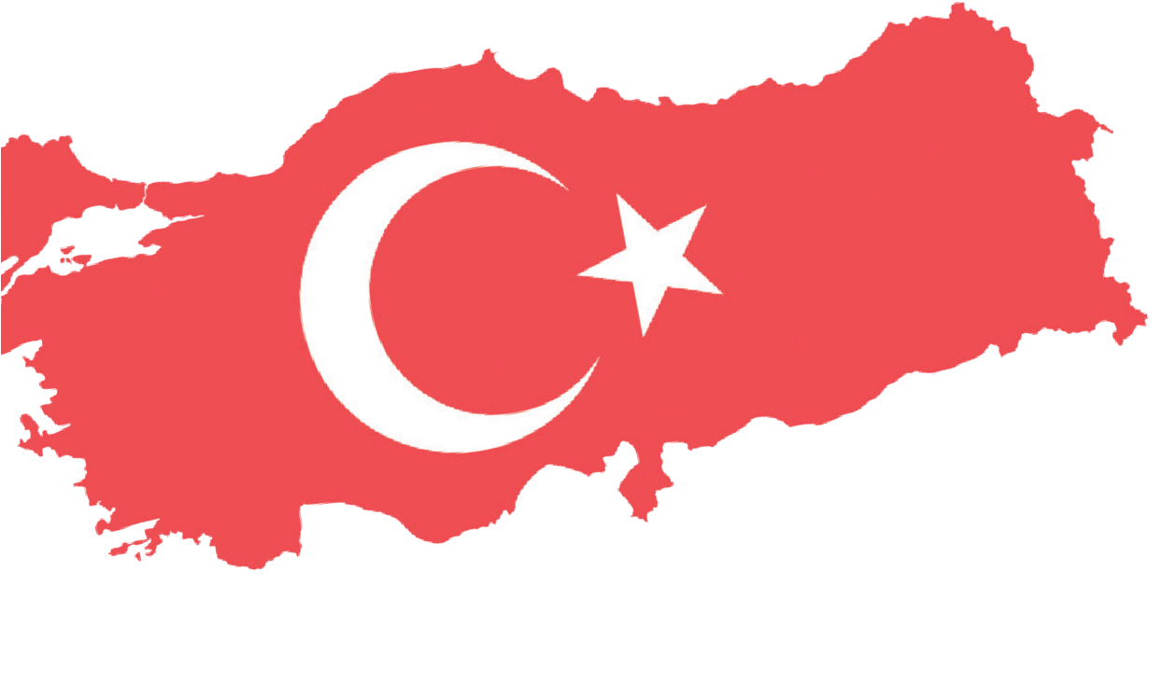
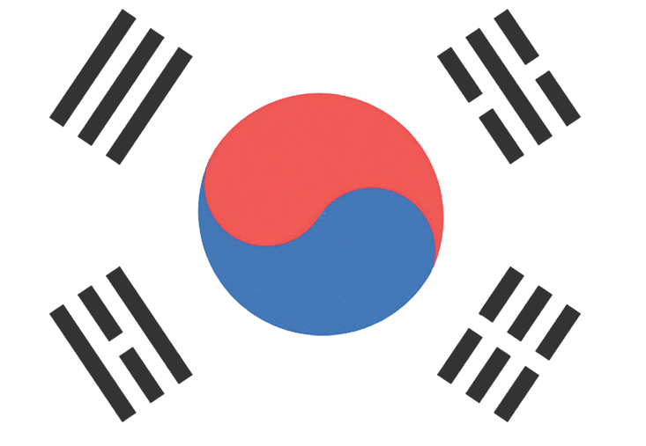

Methods-Techniques: Evidence-Based Historical Inquiry, Oral History, Role-Playing
Teaching-Learning Materials: Personal diaries, newspaper clippings from the period
Learning Aim: This activity aims to help students analyze the physical and psychological effects of war on individuals, specifically Turkish soldiers who participated in the Korean War, through primary sources.
Key Question: How do wars affect the physical, psychological, and social lives of individuals and societies?
Guiding Question 1

What personal, social, and political factors influence individuals’ decisions to participate in or avoid participating in a war?
Objective 1

To make inferences about what people consider when making a significant decision, such as joining a war.
Task 1

The students are asked/invited to examine Sources A, B, and C, to answer the questions about the factors that shape a soldier’s decision to participate in or not to participate in a war and to consider how the challenges in these decision-
making processes are overcome. They are then asked to complete Table 1 based on their analysis.
Guiding Question 2

What physical and psychological experiences did the soldiers who participated in the Korean War live through, and how did these experiences affect them?
Objective 2

To interpret how the journey to and from the war influenced
soldiers’ daily routines and their perceptions of other cultures.
Task 2

Students are asked/invited to examine Sources D, E, F, G, and H, to answer the questions related to the situations, events, phenomena, and processes
a soldier witnessed and experienced during the journey to and from Korea, to list key moments from these travel experiences, and to complete the partially written diary entry.
Guiding Question 3

Based on the information found in a soldier’s diary, what can be inferred about the psychological effects of being in a war environment on soldiers and civilians (Koreans)?
Objective 3

To make inferences about how the news received during the war and the situations encountered affected soldiers.
Task 3

Students are asked/invited to read Source I and carry out a dramatization activity (historical empathy through
role-playing). Afterwards, they are asked/invited to examine Source J and to prepare a news text expressing their thoughts on how the war restricted people’s lives.

Teaching and Learning Plan

‼ Focus on Activity
Source A is projected, and the students are asked/invited to respond to the open-ended questions.
5 min.
🛎 Task 1
The students are asked/invited to examine Sources A, B, and C, to answer the questions
about the factors influencing a soldier’s decision to participate in or withdraw from war, to consider how challenges in these processes were overcome, and to create Table 1.
20 min.

🛎 Task 2
The students are asked/invited to examine Sources D, E, F, G, and H, to answer the questions related to the situations, events, phenomena, and processes a soldier witnessed and experienced during the journey to and from Korea, to list the travel experiences, and to complete the unfinished diary entry.
🛎 Task 3
The students are asked/invited to read Source I and to carry out a dramatization activity

25 min.

(historical empathy through role-playing). Afterwards, they are asked/invited to examine Source J and to prepare a news text expressing how the war restricted people’s lives.
25 min.
🎯 Assessment and Evaluation
Open-ended questions are answered.
5 min.

🏠 Homework
The students are asked/invited to write a diary page describing the experiences of a soldier who participated in the Korean War.

Learning and Teaching Process
Focus on Activity: The students are asked/invited to examine the newspaper clipping provided in Source A and to answer the questions below.

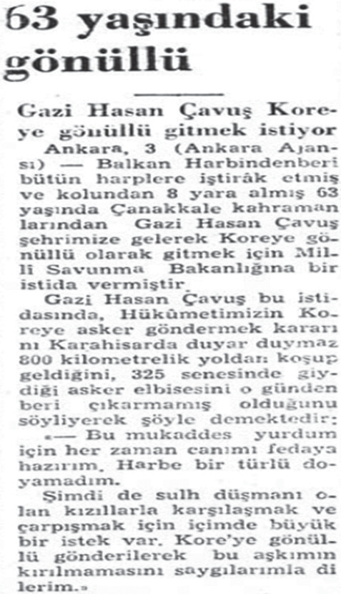
Source A: The 63-year-old volunteer (Milliyet, 1950a)

The 63-year-old volunteer
Veteran Sergeant Hasan wants to volunteer for Korea
Ankara, 3 (Ankara Agency): Veteran Sergeant Hasan, a 63-year-old hero of the War of Gallipoli who has participated in every war since the Balkan Wars and has received eight wounds to his arm, came to our city and applied to the Ministry of National Defense requesting to volunteer for service in Korea.
In his application, Veteran Sergeant Hasan states that as soon as he heard in Karahisar about Turkish Government’s decision to send troops to Korea, he ran 800 kilometers to come here, and that he has not taken off the military uniform he wore in the year 325 (referring to the Hijri year 1325, corresponding to 1907-1908 in the Gregorian calendar). He adds:
“For this sacred homeland of mine, I am always ready to sacrifice my life. I have never grown weary of war.
Now, I have a deep desire to confront and fight the Reds, the enemies of peace. I respectfully request to be sent to Korea as a volunteer so that this passion of mine will not be broken.”

Question 1. What makes this text interesting?
Question 2. Why might this news have been published?

Guiding Question 1: What personal, social, and political factors influence individuals’ decisions to participate in or avoid participating in a war?
Task 1: The students are asked/invited to examine Sources A, B, and C, to answer the questions about the factors influencing a soldier’s decision to participate in or refrain from participating in war, to consider how challenges in these processes were overcome, and to create Table 1.
Step 1: The students are asked/invited to examine Sources A, B, and C.

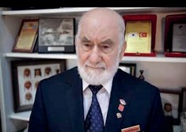
Source B: An excerpt from an interview with Ali Muzaffer Kocabalkan, a Korean War Veteran (https://koreanwarlegacy.org/ interviews/ali-muzaffer-kocabalkan/)
🕒 03:44-05:05
Ali M. Kocabalkan: My enlistment… I had actually applied earlier. My older brother was in the First Korean Contingent; he went while he was a sixteen-month soldier. When he was
wounded there, I also wanted to join the military. I insisted a bit, but they did not take me because my other brother was also serving at the time, so they refused. I eventually went in 1953. I went directly to Sivas. From there, we departed for Korea. Well, the commander… I used to play football, you know? I was also an electrician and spoke a number of languages. Because of these things, the commander sent me on the selection day, telling me, ‘Go, have a look around’, and he even gave me money. I went, but it rained that day, and I returned after receiving the order to come back. My brother and I both volunteered to go. In fact, when the deployment orders came from there, the commander hid my file. He did not want to send me. So, I went to the battalion commander and explained the situation. He said, ‘You go’. He told me to get on a jeep. That is where I understood that my file would turn up eventually.

Source C: An excerpt from the diary of Korean War Veteran M. Aziz Erkmen-Part 1
28 August (1950): …After lunch, with a certain amount of hesitation, we went to see our school commander along with our sick friend. I knocked on the door, and we entered. My friend stood to my left, saluted, and assumed the position of attention. Our school commander was walking around the room. There were two American captains present, one sitting on the edge of the desk and the other standing. (These two captains later came with us to Korea.)
…Major, we are going to Korea to fight. Among the selected soldiers, some are married and do not want to go, and some are ill. A number of friends wish to volunteer. Since we are going to war, it is not reasonable to expect those to be effective there, who do not want to go to Korea while their minds remain here (Erkmen and Erkmen, 2011, p. 13).
Step 2: The students are asked/invited to answer the following questions based on the information provided in Sources A, B, and C.
- With which core values can the statements and actions of Veteran Sergeant Hasan in Source A be associated? Why?
- According to Source B, what motivated Korean War Veteran Ali Muzaffer Kocabalkan to volunteer for service in Korea?
- What challenges did Ali Muzaffer Kocabalkan face in his effort to go to Korea, and what did he do to overcome them? What do his ways of dealing with these challenges suggest about his personality and values?
- According to Source C, what reasons did the soldiers who did not want to go to Korea have? How do you evaluate these reasons as a human condition? Do you think refusing to go to Korea contradicts the value of patriotism? Why or why not?

Step 3: The students are asked/invited to classify the soldiers’ reasons for participating in the war and complete Table 1.
Table 1: Reasons for Soldiers’ Participation in the War.

Personal | Social | Political

Guiding Question 2: What physical and psychological experiences did the soldiers who participated in the Korean War live through, and how did these experiences affect them?
Task 2: The students are asked/invited to examine Sources D, E, F, G, and H, to answer the questions related to the situations, events, phenomena, and processes a soldier witnessed and experienced during the journey to and from Korea, to list the travel experiences, and to complete the unfinished diary entry.
Step 4: The students are asked/invited to examine Sources D, E, F, G, H, and I.
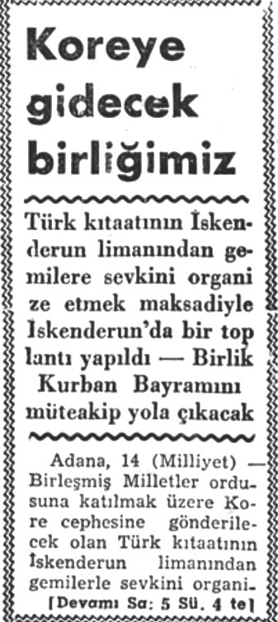
Source D: An excerpt from the Diary of Korean War Veteran M. Aziz Erkmen-Part 2
From Ankara-21 September, Thursday (1950): Today we departed from Ankara by train, heading toward Iskenderun. At many train stations, people who had come to see us off were giving the soldiers various gifts such as grapes, sherbet, sugar, and similar treats. A few could not hold back their tears and cried, while others recited prayers. A number said, “May God protect you, go safely, return in peace.” Since the radio and newspapers had been reporting news about the Turkish unit that would go to Korea, people gathered at the stations along the route to bid farewell to the soldiers.
Iskenderun-22 September, Friday (1950): We arrived in Iskenderun at 16:30. Film cameras arrived as well. Those who were going to Korea were filmed (Erkmen and Erkmen, 2011, p. 17).

Source E: Turkish unit departing for Korea (Milliyet, 1950b)
Adana, 14 (Milliyet) – A meeting was held today under the chairmanship of the Governor of Hatay to organize the embarkation of Turkish units to be sent to the Korean front to join the United Nations forces. The Garrison Commander, as well as the District Governor and Mayor of Iskenderun, also attended the meeting. During the meeting, the main outlines of the farewell ceremony for our soldiers were established as a formal program. According to this program, our unit, which will arrive in Iskenderun by various trains, will board the ships from there and be sent off with a large ceremony jointly held by military and civilian authorities, civil society organizations, and the public. Religious rites will also be performed during this ceremony. The entire country will be represented through delegations arriving from all provinces. It is estimated that the embassies of friendly nations will also participate in the ceremony.
According to the information provided to us, our unit will set out after the Feast of Sacrifice.

Source F: An Excerpt from the Diary of Korean War Veteran M. Aziz Erkmen-Part 3
3 October, Tuesday: The clocks were set two hours forward. I am feeling unwell today. The flying fish have disappeared; they are no longer seen off the coast of India. Through an announcement made over the loudspeaker, it was reported that the ship would not move until the brigade’s surgeon captain completed an operation, as the ship’s captain was suffering from severe kidney pain. After the operation was completed, the ship continued its course. During the surgery, the ship remained motionless on the open sea for a while (Erkmen and Erkmen, 2011, p. 18).

Source G: An Excerpt from the Diary of Korean War Veteran M. Aziz Erkmen-Part 4
6 October, Friday (1950): “At 8:00 in the morning, we entered Colombo Port (Sri Lanka). The weather was rainy. The soldiers were given five dollars as pay, sergeants ten dollars, and it was said that officers were given twenty-five dollars each. The weather cleared up, the rain stopped, and the ground dried immediately.
Women were walking barefoot, wearing bright silk dresses with one end draped over their shoulders, and carrying silk umbrellas. Tugboat and ship captains working in the harbor were performing their duties barefoot, wearing ties, formal uniforms, and caps. Thirty-five percent of the island’s inhabitants are Muslim, sixty percent Christian, and five percent Buddhist. Officers were granted permission to go into the city. Various souvenirs were sold at the port, including ebony elephant and tiger figurines, sewing and shaving kits, and jewelry for women. Officers who were allowed to disembark bought many souvenirs. Even though we were going to war, it was impossible not to be captivated by the charm of those beautiful pieces of art.
We bought coconuts and pineapples, which we had never seen in Turkey. I enjoyed the pineapple's taste very much. In the heat, it refreshes you like a sweet, cold sherbet.” (Erkmen and Erkmen, 2011, p. 19)

Source H: An Excerpt from the Diary of Korean War Veteran M. Aziz Erkmen-Part 5
8 June (1951): All the company gathered inside one of the large, enlisted men’s tents. A table and a typewriter were brought in. The company clerk, Sadık Asimgil from Mersin, sat at the typewriter. The reason for these preparations was that a drawing of lots would be held to determine the first group to return home; they would exchange places with the replacement unit arriving from Turkey.
Senior noncommissioned officer İbrahim Göktaş held slips of paper in his hand, each bearing a soldier’s name, along with slips marked ‘full’ or ‘empty’. First, the lots for the two depot sergeants who would return home were to be drawn. The names of Necati and me were written down, and slips marked ‘full’ and ‘empty’ were prepared. Two sugar sacks were brought in and Lieutenant Sahir placed our name slips in one bag and the full/empty slips in the other. Another draw would determine which one of the two corporals, Şinasi or Gıyasettin would go home and who would stay.
There was complete silence in the tent. At that moment, if a fly had passed by, one could have heard the sound of its wings. Everyone was filled with tension. In the dim light of the tent, it was impossible to discern the color of anyone’s face. Surely, everyone looked pale. I could feel my face turning yellow with excitement; my heart was pounding as if it would burst through my chest and leap out and the longing for our homeland burned like a fire. The tiny slip of paper to be drawn from the sack felt as though it would determine the destiny of our entire future… (Erkmen and Erkmen, 2011, p. 50).

Step 5: The students are asked/invited to answer the following questions based on Sources D, E, F, G, and H.
- If you were one of the soldiers participating in the Korean War, how would you feel when seeing the people who came to bid you farewell and witnessing their emotional reactions?
- In Source C, it is noted that the soldiers who arrived in Iskenderun were filmed. Why might the soldiers departing for Korea have been recorded on film?
- In Source E, it is mentioned that clocks were set two hours forward during the journey to Korea. What might be the reason for this practice?
- What kind of information does the ability to perform surgery on the ship tell us about the ship?
- In Source F, the expression “Even though we were going to war, it was impossible not to be captivated by the charm of those beautiful pieces of art” is used. What does this statement suggest about human nature?
- In Source H, the soldiers preparing for the draw that will determine who returns to Turkey are described. According to this source, what expectations do the soldiers seem to have?
Step 6: The students are asked/invited to re-examine Sources D, E, F, G, and H, to create a list of the experiences and observations encountered by Korean War Veteran M. Aziz Erkmen during his journey to and from Korea and then to complete the diary-writing activity following the instructions provided in Box 1.

Box 1: Travel Experiences.

- ...............................................................................................................................................................
- ..............................................................................................................................................................
- ..............................................................................................................................................................
- ..............................................................................................................................................................
- ..............................................................................................................................................................
- ..............................................................................................................................................................
- ..............................................................................................................................................................
How might these experiences have affected the war veterans? Write a short diary entry in your own words from the perspective of a soldier, describing these experiences.
..................................................................................................................................................................
..................................................................................................................................................................

Guiding Question 3: Based on the information found in a soldier’s diary, what can be inferred about the psychological effects of being in a war environment on soldiers and civilians (Koreans)?
Task 3: The students are asked/invited to read Source I and to carry out a dramatization activity (historical empathy through role-playing). Afterwards, they are asked/invited to examine Source J and to prepare a news text expressing how the war restricted people’s lives.
Step 7: The students are asked/invited to examine the diary excerpts provided in Source I.

Source I: An Excerpt from the Diary of Korean War Veteran M. Aziz Erkmen-Part 7
30 November, Thursday (1950): I received three letters, two of them from Sedat Başar. Sedat is a friend of ours from Silivri and is someone we know as a family.
1 December, Friday (1950): Sedat Başar of Silivri also arrived. I gave him the two letters that had been sent to him. The letters brought news that his wife had given birth to a baby boy (Erkmen and Erkmen, 2011, p. 28-32).

Step 8: The teacher selects two volunteer students and asks them to dramatize the event described in Source
I. After the dramatization, the students are asked/invited to share with their classmates how they felt during the activity.
Step 9: The students are asked/invited to examine the following excerpts from the oral history interview conducted with M. Aziz Erkmen.

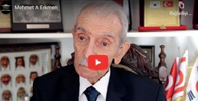
Source J: Two Excerpts from the Interview with Korean War Veteran M. Aziz Erkmen (https://koreanwarlegacy.org/interviews/ mehmet-aziz-erkmen/)
🕒 06:27-07:22
M. A. Erkmen: …Everywhere was in ruins. There were not

even paved roads in Korea. At the entrances of some villages and towns, the ground was nothing but piles of earth and ash. At the entrances, signs would say, ‘this is such and such place’, meaning that this used to be a village or a town. When we went to seoul, it was like a ghost city. Seoul was a wreck. In my book, there are some photographs of this. There are also photos i took in Seoul. The buildings in the city had no windows, no frames, no doors; nothing.
🕒 08:49-10:05

M. A. Erkmen: The people were living in extreme misery. Children came out barefoot, wearing nothing. Let me describe a later scene: as we were withdrawing from the kunuri front, the civilians were fleeing with us from the chinese forces. Women had their babies tied on their backs, and a bag of rice balanced on their heads. Ten-to-twelve-year-old children carried their younger siblings on their backs, along with a bag of rice. The elderly and the sick had been abandoned along the roads. Tens of thousands of people were running from the chinese troops. A few had tied two tree branches together to make a sled-like structure, placed a few belongings on it, and were dragging it along as they walked. It was utter misery. Children who had lost their families were crying out and running in every direction. It is impossible to describe such devastation. Moreover, we tried to help them however we could, even giving away our rations or any extra shirts or clothing we had.

Step 10: The students are asked/invited to complete the following tasks:
- The students are asked/invited to place themselves in the position of one of the individuals mentioned in the oral history interview in Source J (a Turkish soldier witnessing the hardships faced by the Korean people, or a Korean child, woman, or older adult) and share with their classmates what they might have felt and thought while experiencing the events described.
- The students are asked/invited to prepare a news article describing how the war affected people’s lives, writing from the perspective of one of the individuals mentioned in the oral history interview. In the news article, they should include their observations regarding concrete events and situations as well as their personal impressions. They may use the headline given in the box below or create a similar one.
The Human Tragedy That Happened in Korea
..................................................................................................................................................................
..................................................................................................................................................................
..................................................................................................................................................................
..................................................................................................................................................................
..................................................................................................................................................................
..................................................................................................................................................................
..................................................................................................................................................................
..................................................................................................................................................................
..................................................................................................................................................................
..................................................................................................................................................................
..................................................................................................................................................................
..................................................................................................................................................................

🎯Assessment and Evaluation
- Why might Mehmet Aziz Erkmen have felt the need to keep a diary during the war?
- In an extraordinary situation such as war, what benefits might keeping a record of one’s experiences have for the individual?
- What is the importance of primary sources such as diaries for understanding historical events? Explain by giving examples from Mehmet Aziz Erkmen’s diary.
- What are the physical and psychological effects of the war experience on soldiers? Explain by giving examples from the sources you have examined.
- Classify the motivations of Turkish soldiers who participated in the Korean War and explain which motivations were more effective, providing your reasons.

References
Erkmen, M. A., & Erkmen, M. M. (2011). Bir Kore gazisinin günlüğünden askerlik ve Kore anıları [Diary of a Korean War Veteran]. http://www.korehatiralari.com/2011-04-12-bir-kore-gazisi-anilari.pdf Access Date: 16.05.2024
Han, J. (2018a). Interview with Ali Muzaffer Kocabalkan. https://koreanwarlegacy.org/interviews/ali-muzaffer-kocabalkan/ Access Date: 14.10.2024.
Han, J. (2018b). Interview with Mehmet Aziz Erkmen. https://koreanwarlegacy.org/interviews/mehmet-aziz-erkmen/ Ac-cess Date: 19.04.2024.
Milliyet. (1950a). 63 yaşındaki gönüllü: Gazi Hasan Çavuş Kore’ye gönüllü gitmek istiyor [A 63-year-old volunteer: Veteran Hasan Çavuş wants to go to Korea voluntarily]. Milliyet. (04.09.1950). https://gazetearsivi.milliyet.com.tr/liste?filtreler={%22containWords%22:%22gazi%20hasan%20
%C3%A7avu%C5%9F%22,%22nearWords%22:%22%22,%22sameOneWord%22:%22%22,%22anyOf-Words%22:%22%22,%22exceptTheseWords%22:%22%22,%22additionalBroadcastingId%22:%22%22,%22first-Date%22:%221950.05.03%22,%22lastDate%22:%221953.12.01%22,%22sortBy%22:%22MostRelevant%22,%22de-
scending%22:false,%22page%22:1,%22pageSize%22:10,%22pageNo%22:%22%22,%22getPageCount%22:true} Access Date: 18.07.2025.
Milliyet. (1950b). Kore’ye gidecek birliğimiz [Our unit that will go to Korea]. Milliyet. (19.09.1950). https://gazetearsivi.milliyet.com.tr/liste?tarih=1950.09.15 Access Date: 18.07.2025.

🏠
Homework
The students are asked/invited to write a diary entry describing the experiences of the soldiers who participated in the Korean War. They are informed that reflecting on their personal answers to the questions below will be helpful and reminded to pay attention to conveying the events and emotions in the sources they had examined.
- With which historical figure did you empathize the most during this activity? Why was this?
- What similarities and differences can you identify between this person’s experiences and those of individuals living through wars in today’s world?

