CHILDREN IN WAR
Concepts to Digest: Children’s
Unit 6
🎓 Grade Level:
9th, 10th, and 11th Grades
⏰ Teaching Time: 40 + 40 minutes

rights, violation of rights, war, orphan, psychological trauma, stress disorder, orphanhood, orphanage
Skills to Improve: Historical inquiry and analysis, historical empathy
Core Values: Friendship, altruism, helpfulness

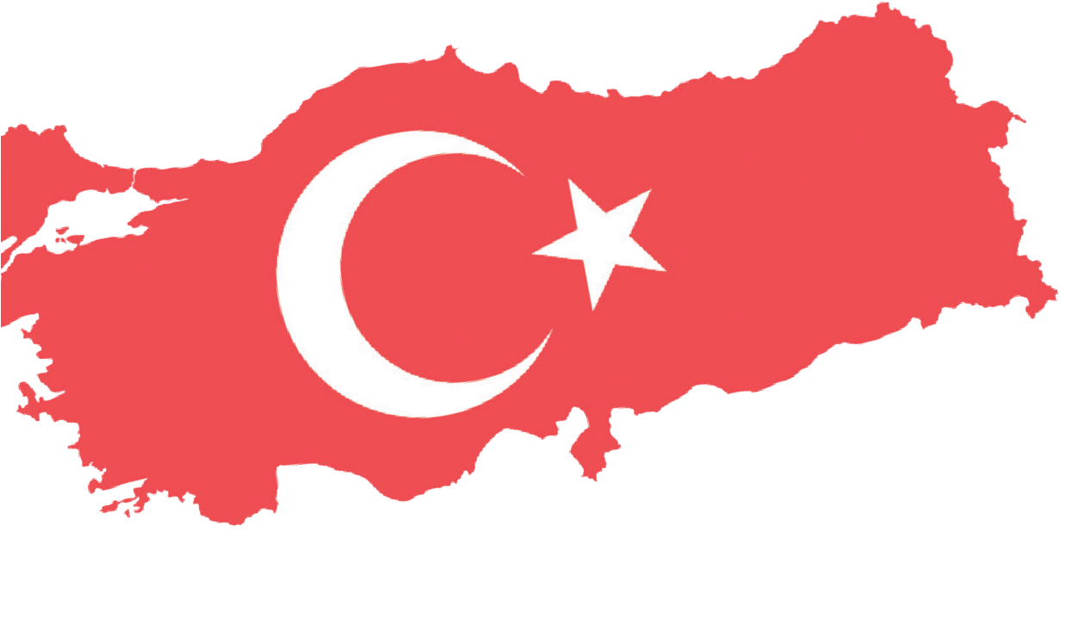
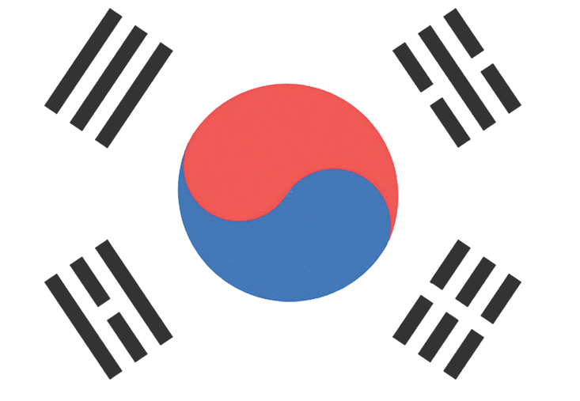

Methods-Techniques: Direct instruction, historical inquiry, case study analysis, questioning, oral history
Teaching-Learning Materials: Paper, pencils, and as many printouts of Table 1 as there are students in the class.
Learning Aim: Öğrencilerin çocuk haklarını temel alan bir bakış açısıyla savaşın devam ettiği farklı ortamlarda, çocukların neler yaşadıkları ve neler hissettikleri konusunda bilgiye dayalı bir farkındalık geliştirmelerini sağlamak.
Key Question: How do wars affect the lives of children?

Guiding Question 1

According to memories of the Korean War and other sources, how do wars affect the lives of children?
Objective 1

To develop historical empathy by analyzing what war-affected children experienced and felt, based on real-life stories.
Task 1

The students are asked/invited to examine Sources C, D, E,
F, G, H, I, and J, to answer the related questions, and to carry out the news-writing activity provided in Step 3.
Guiding Question 2

During the Korean War, what did Turkish soldiers do for children?
Objective 2

To understand which values Turkish soldiers embraced in their approach to Korean
children and what they did for them, based on case examples.

Task 2

The students are asked/invited to examine Sources K, L, M, N, O, and R, to answer the related questions, and to carry out the letter-writing activity.
Guiding Question 3

What are the similarities and differences between the
problems children experience in today’s wars and conflicts and those experienced during the Korean War?

Objective 3

To comparatively analyze the effects of past and present wars on children within
the framework of universal children’s rights.

Task 3

The students are asked/invited to examine Source S and Source T, complete Table 1, and then
to take part in the discussion activity provided in Step 16.

Teaching and Learning Plan

‼ Focus on Activity
The students are shown Source A (a photograph of Seoul and Captain Süleyman Pulat)
and Source B (Korean children at the Ankara School), and they are asked/invited to respond to the related questions.
10 min.
🛎 Task 1
The students are asked/invited to examine Sources C, D, E, F, G, H, I, and J, to answer the related questions, and to carry out the news-writing activity provided in Step 3.
35 min.
🛎 Task 2
The students are asked/invited to examine Sources K, L, M, N, O, and R, to answer the related questions, and to carry out the letter-writing activity.
20 min.
🛎 Task 3
The students are asked/invited to examine Source S and Source T, to complete Table 1, and
then to take part in the discussion activity provided in Step 16. 20 min.
An assessment consisting of open-ended questions is conducted.
5 min.
🎯 Assessment and Evaluation

🏠 Homework
Preparing a speech text. This product will be stored in the electronic product portfolio.

Teaching and Learning Process
Focus on Activity: The students are asked/invited to examine the photographs provided in Source A and Source B and then to answer the following questions.

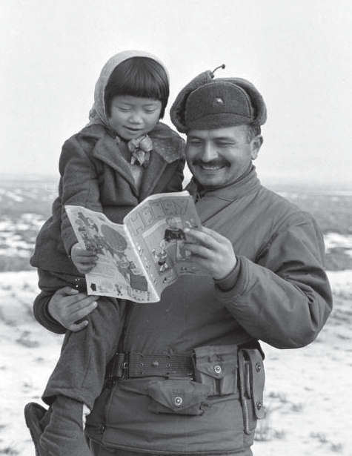
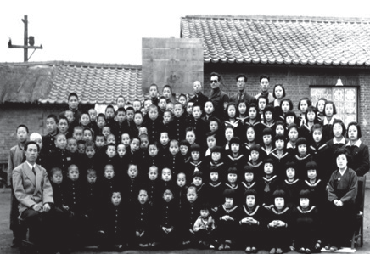
Source A: A photo from the time of the Korean War
(Denizli, 2015, p. 124)

Source B: Korean children receiving education and shelter at the Ankara School and orphanage (Denizli, 2015, p. VII)

- Based on facial expressions and body language, what emotions might the child and the soldier in the photograph in Source A be experiencing? Why?
- What can be said about the physical and psychological conditions of the children shown in the photograph in Source B?
- To what extent might the children shown in both photographs have had access to rights such as living, education, shelter, and health under war conditions? To what extent might they have benefited from these rights?

Guiding Question 1: According to memories of the Korean War and other sources, how do wars affect the lives of children?
Task 1: The students are asked/invited to examine Sources C, D, E, F, G, H, I, and J, to answer the related questions, and to carry out the news-writing activity provided in Step 3.
Step 1: The students are asked/invited to examine Sources C, D, E, and F.

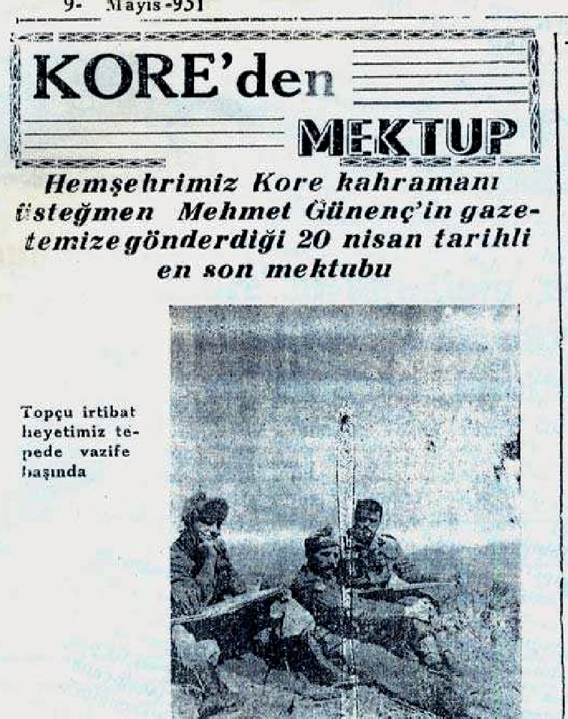
Source C: A letter sent from Korea to a local newspaper in Bandırma
“War shows what it can do to a country. You can witness this in Korea. Magnificent cities have been reduced almost entirely to piles of brick and concrete rubble. One would think that a devastating earthquake wave had passed through here.
And the Koreans… Ah, this is truly heartbreaking. These poor people are like ghosts wandering among the ruins. The roads are filled with women and children. Fearing that the Reds are coming, they abandon their homes and villages and head south, toward an unknown destination. The men have gone to war, mothers have lost their children, everyone is struggling to survive, and no one is able to see or be aware of anyone else.
It is winter. The ground is covered with snow, and the air is bitterly cold. On the roads, you come across those who have frozen to death. Do not even look at those tiny children. A three-year-old child is holding the handle of a small cart, trying to move it together with his four-year-old older brother.
On 6 January, we were retreating from Seoul. It was two o’clock in the morning. We had passed Suwon by about ten kilometers. On the road, I saw a five-year-old boy. He was walking alone. There was no one else around, not a soul in sight. With just a few examples like these, I have tried to convey the misery here (Denizli, 2011b, pp. 157–159).”

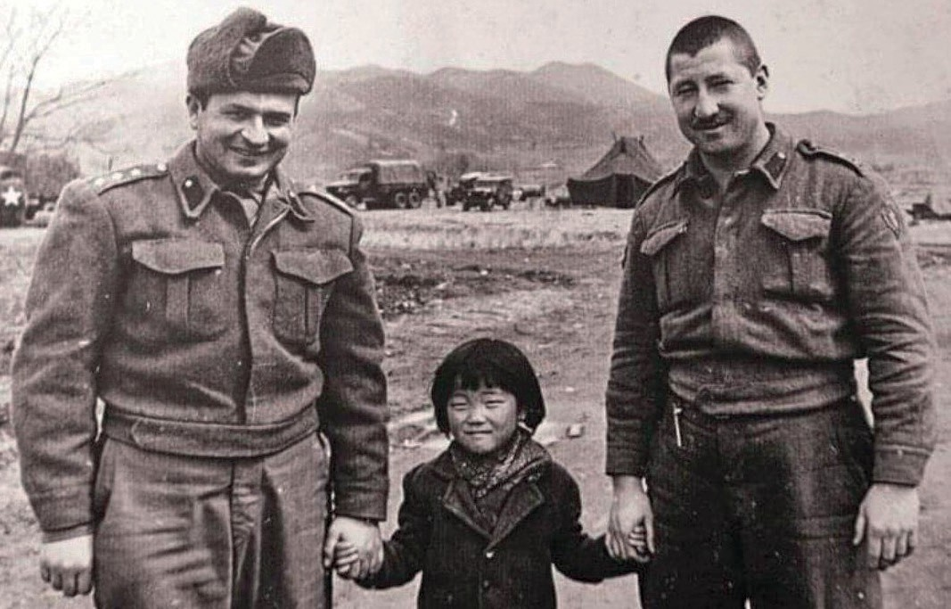
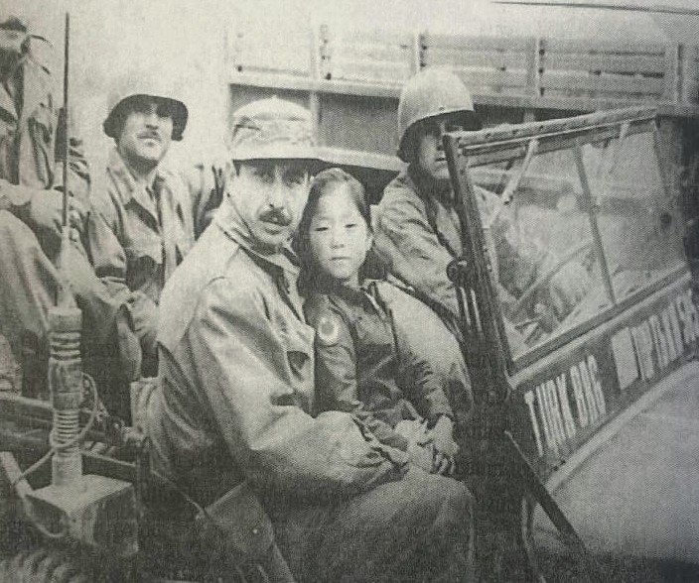
Source D: Captain Süleyman Pulat and First Lieutenant Mehmet Günenç with a Korean girl they named Seoul (Denizli, 2011, p. 91)
Source E: Turkish Soldiers and Seoul
(Denizli, 2015, p. 104)

What I Witnessed in Korea
..................................................................................................................................................................
..................................................................................................................................................................
..................................................................................................................................................................
..................................................................................................................................................................

Source F: Two Pages from the Diary of Captain Süleyman Pulat

6 September 1951-I had become a parent too
Farther back, a child stood with her fingers tangled in her hair, her head lowered, silently begging for compassion. The child’s bare feet had turned deep purple from the cold of the snow-covered ground and the freezing air, and her small body was trembling violently. My heart broke into pieces. I was immediately overcome with feelings of mercy for the little one. Having lost her family, the child had curled up there, choosing the fire as her only companion. She did not speak at all. She merely moved her expressive eyes among the flames of the burning fire. I immediately went back, informed the battalion commander of the situation, and asked for permission to take the child with us. Upon receiving approval, I ran toward the bridgehead together with Lieutenant Colonel Şemsi Eralp. When I returned, the child was still there in the same position, unaware of everything. We embraced her with the affection of a brother. She did not find our action strange and obeyed us calmly. I had now become a parent as well. Quiet Müço was no longer only mine but belonged to the entire battalion. Müço, who was hungry, was immediately fed. She ate what was placed in front of her, fearing she might never find food again, and put the leftovers in her pockets. Meanwhile, the tailor was making her a jacket from a blanket he had found. Müço, on the other hand, was smiling around as if she had forgotten all the suffering she had endured. At this moment, Müço is fast asleep in the back of the jeep, recovering from the exhaustion of many days. Müço slept through the night without waking.

7 September, 1951-We accepted Müço’s name as Seoul
We are now in Chonom. Together with all my comrades, we decided to name Müço ‘Seoul’. Seoul is content with her life. She had a haircut, dressed, and properly clothed. The unmarried soldiers began to see her as their sister, and the married ones as their child. Thus, Seoul became the beloved child of the entire brigade (Habertürk, 2017).

Step 2: The students are asked/invited to answer the following questions based on Sources C, D, E, and F.
- How are Korea and Korean civilians, especially women and children, portrayed during the war in Source C?
- In the sentence ‘The roads are filled with women and children; fearing that the Reds are coming, they abandon their homes and villages and head south, toward an unknown destination’, what is meant by the expression ‘an unknown destination’? Research and explain.
- Place yourself in the position of Müço or Seoul as described in Source F at the moment of encountering Turkish soldiers. In such a situation, what would you feel and think, and what would you do? Why?
- In the photographs in Source D and Source E, how does Seoul appear alongside the Turkish soldiers?
- What clues do the photographs in Source D and Source E provide about Turkish soldiers’ approach to Korean children?
Step 3: The students are asked/invited to prepare a short news article using the visuals and texts provided in Sources C, D, E, and F. In the article, they may address the children’s physical and psychological appearance and characteristics as shown in the visuals, the hardships and difficulties they experienced, the soldiers’ attitudes and behavior toward them, and, finally, the relationships formed between the children and the soldiers.

Step 4: The students are asked/invited to examine Sources G and H.
Source G: War and Children
Documenting the psychological effects of war is very difficult, and its impact on children is often subtle. The psychological effects are felt more deeply by children than the physical effects, and they are more difficult and limited to treat. Children display symptoms of post-traumatic stress disorder through recurring, detailed, and distressing thoughts and images. These children relive traumatic events repeatedly through dreams, storytelling, or play. Depression and anxiety disorders are commonly observed among children who have experienced war.
In war zones, children are deprived of educational opportunities due to the destruction of schools, lack of educational materials, and shortages of teachers. This situation leads children to view the future with hopelessness and prevents them from developing their abilities. Growing up in a society whose norms and values have been overturned by war causes symptoms that manifest in many ways. Attitudes and values are also affected by the moral collapse brought about by war. In children affected by fear, aggressive behavior may emerge through various forms of conduct (summarized from Hatun, Çağlayan, & Gönüllü, 2003).
Source H: Psychological Trauma
Psychological trauma refers to the effects caused by events that create extreme fear, leave a person in terror, produce a sense of helplessness, and are often extraordinary and unexpected (Türkiye Psikiyatri Derneği, 2025).

Step 5: The students are asked/invited to answer the following questions by taking Sources G and H into account.
  - According to Source G, what are the possible adverse effects of wars on children?
  - Classify these effects under the headings of the short-term and long-term effects, and the physical and psychological effects.
  - Which of the possible effects mentioned here can be defined as psychological trauma as described in Source H? Why?
Step 6: The students are asked/invited to examine Sources I and J.
Source I: A Memory of Korean War Veteran Nazım Dündar Sayılan
I will never forget it. In a secluded part of the forest, I encountered a boy about nine years old, trembling with fear, his eyes and mouth wide open. Believing that he was about to be killed, the child had crouched down, covering his face with both hands. When he realized that I was a rescuer, he threw his arms around my neck and clung to me with all his strength, almost taking my breath away. He could not believe that he was still alive and kept embracing me again and again. He swallowed the food I gave him without chewing, and even the affection I showed could not stop his trembling.
I learned that the child’s name was Kim. He could barely walk with the help of two crutches. His family had migrated south. Kim had run away from home and taken refuge in the forest so as not to be a burden on his family. I carried him on my back to the jeep and sent him to the medical station behind the lines to see a doctor (Denizli, 2015, pp. 105–109).

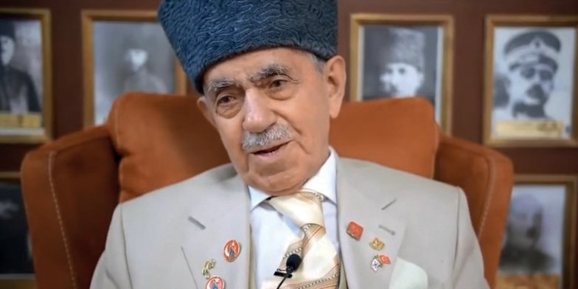
Source J: An excerpt from an oral history interview with Korean War veteran Mehmet Esen https://koreanwarlegacy.org/interviews/ mehmet-esen/#clip-1
🕒 4:47 – 6:07
M. Esen: Well, at that time, I was staying in Seoul. There was
that little girl, we called her ‘Chin Chon’ back then. She was about my younger daughter's age. She was not my daughter, of course, but she was one of them, the poor child. We took her in as well. I used to earn five dollars a month, and I gave that money to her. I sent her to school while I was in the hospital. And then there was our Kerim. We saw him, Mehmet was like a father to him, while we were moving along. We noticed something among the bushes, like a figure. I said, “Kaya son, stop, what is that?” Moreover, out he came. He was this tiny person, and I did not even know his name. I asked him, and he said, “Mehmet, what will happen?” I said, “God knows best, let his name be Kerim”, and that is what we named him. I have always loved children. We didn’t take Chin Chon with us, but Kerim stayed with us. Wherever we went, Kerim went too, I said that myself. They told us his mother and father were far away.

Step 7: The students are asked/invited to answer the following questions based on Sources I and J.
- Can the behavior and conditions of the Korean children named Kim in Source I and Kerim in Source J, after being found by Turkish soldiers, be evaluated as signs of psychological trauma? Why?
- What is meant by the statement ‘Kim took refuge in the forest so as not to be a burden on his family’?
- If you were in Kim’s position, do you think you would have acted in the same way? Why or why not?
- What might have happened to Kim and Kerim if they had not encountered Turkish soldiers and had not been taken under their protection?
Guiding Question 2: During the Korean War, what did Turkish soldiers do for children?
Task 2: The students are asked/invited to examine Sources K, L, M, N, O, and R, to answer the related questions, and to carry out the letter-writing activity.
Step 8: The students are asked/invited to examine Sources K, L, and M.

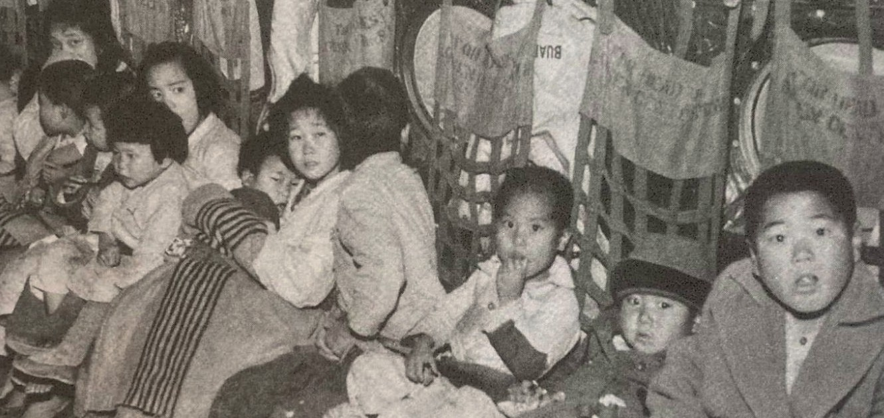
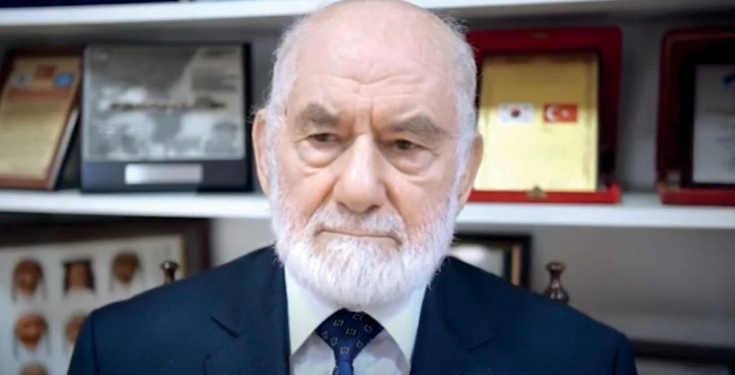

Source K: Two excerpts from an oral history interview with Korean War veteran
A. Muzaffer Kocabalkan (https://koreanwarlegacy.org/interviews/ali-muzaffer-kocabalkan/)
🕒 23:49 – 25:06
A. M. Kocabalkan: Children from the village used to come, boys and girls together, aged about six to twelve or thirteen. I would throw food to them from the other side of the wire fence at our position and give them whatever surplus I had. I gave one, three, and five portions whenever I could. The commander, our captain, eventually forbade it, and he was right. He said, “You cannot give it,” and ordered that the children not be allowed inside. They did not let them in, but I was distraught. They were hungry, truly hungry. I say this sincerely. It may not be right to say this, but a twelve-year-old would say, “Take me with you, just give me food.” Unfortunately, there was nothing left, not even cats or dogs. Hunger was very severe at that time. Nothing remained. May God never let anyone fall into such a situation. Because of this, near our unit, there was a bridge and a stream, and a large pipe ran underneath. I used to put the food into that pipe so they could come from the other side and take it. I was caught doing this and was sentenced to fifteen days in detention.
🕒 25:43 - 26:39
A. M. Kocabalkan: We had a child, like a son to us. I named him Ahmet. There was no-one around him; he wandered about, and there are photographs of him. He is not with me today, but I still remember him. I used to put him to bed, wake him up, feed him, and give him water. He was everyone’s favorite. Later on, our captain noticed. He said, “You cannot keep him here; you cannot do this.” Through the communications company, we sent him to the Brigade. We had grown very attached to him. The child was very intelligent, around six or seven years old. He picked up words quickly, whether in English or Turkish.

Source L: A group of Korean children brought to the Ankara School to be taken under the protection of Turkish Soldiers (ATASE, 2016, p. 153).

Source M: A Turkish soldier with Korean children caring for them (ATASE, 2016, p. 151).

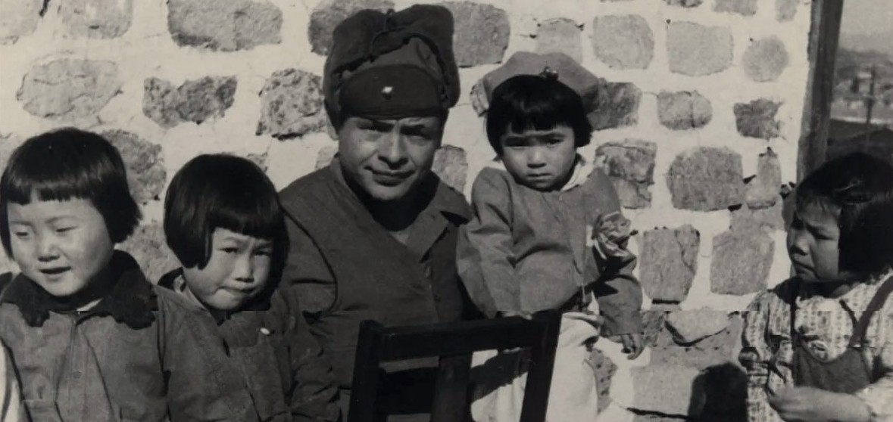
Step 9: The students are asked/invited to answer the following questions based on Sources K, L, and M.
- According to the statements of Veteran Ali Muzaffer Kocabalkan in Source K, what kind of approach did Turkish soldiers display toward Korean children?
- According to Ali Muzaffer Kocabalkan’s account, what risks did Turkish soldiers take in order to help Korean children?
- What can be said about the physical and psychological conditions of the children shown in the photograph in Source L?
- What can be said about the physical and psychological conditions of the children shown in the photograph in Source M?
- What might be the reasons for the differences between the physical and psychological conditions of the children depicted in Source L and Source M? Discuss.
Step 10: The students are asked/invited to examine Sources N, O, and P.
Source N: An excerpt from the diary of Non-Commissioned Officer Hasan Hüseyin Dinçtürk
At the headquarters where I was on duty, I saw little children, clearly in need of care in every respect, collecting leftover food from the place where surplus meals were discarded. With deep sorrow, I began to help those children, whose parents had been killed in the war and who had no-one left to care for them, using my own supplies. My comrades joined me, and we began addressing these children in Turkish and teaching them our National Anthem and the Ankara March. Later, we requested two teachers from the local authorities and turned the area next to our depot into a school. At first, the number of children was only five or ten, but over time it increased to about six hundred and forty. We met all their needs and embraced them with the longing of a father for a child. There, I served both as a teacher for those children and, for a while, as the facility's administrator (adapted from Tekin & Erdem, 2023, pp. 48–49).

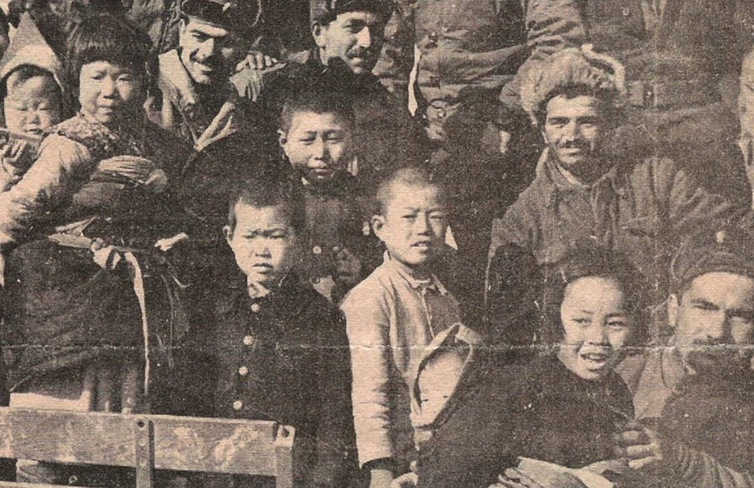

Source O: Korean children and Turkish soldiers brought to the Ankara School for shelter and education (Erkmen ve Erkmen, 2011, p. 67)
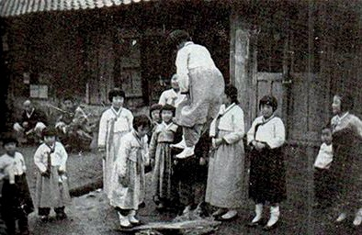
Source P: Children in the Garden of the Suwon Ankara School (Arkitera, 2019)

Step 11: The students are asked/invited to answer the following questions based on Sources N, O, and P.
- According to Source N, to meet which needs of Korean children did Turkish soldiers take action?
- According to Source N, what kinds of education did Turkish soldiers provide for Korean children?
- According to Source N, how did Turkish soldiers approach Korean children?
- What can be said about the physical and psychological conditions of the children shown in Source O and Source P?
Step 12: The students are asked/invited to examine Source R, which summarizes the assistance provided by Turkish soldiers for Korean children.
Source R: Humanitarian Aid Activities of Turkish soldiers in Korea
The presence of Turkish soldiers in Korea was not limited to a military mission; it was also evident in humanitarian aid activities. Within this scope, Turkish soldiers carried out the following services:
- Ankara School and Educational Support: The orphanage and school established by Turkish soldiers in the city of Suwon in 1952 provided education and shelter for more than one hundred orphaned children. In other locations where they were stationed, Turkish soldiers also made efforts to support children’s education and provided food and financial assistance to another school.
- Health Services: Turkish military medical personnel provided regular health services to the local population, especially to children. Vaccination campaigns and basic health check-ups were carried out.
- Food Aid: By setting aside portions of their own rations, Turkish soldiers regularly provided meals for Korean children suffering from hunger.
- Distribution of Clothing and Blankets: Clothing and blankets sent from Türkiye and those obtained through the soldiers’ own means were distributed to Korean children.
- Psychological Support: Turkish soldiers took a close interest in children affected by war trauma, taught them games, and provided emotional support and encouragement (prepared by the authors)..

Step 13: The students are asked/invited to place themselves in the position of one of the children who benefited from one or more of the humanitarian aid activities summarized in Source R and provided by Turkish soldiers, and to write a short letter expressing their feelings and thoughts regarding the Turkish soldiers who offered them these opportunities and support.

..................................................................................................................................................................
..................................................................................................................................................................
..................................................................................................................................................................
..................................................................................................................................................................
..................................................................................................................................................................
..................................................................................................................................................................
..................................................................................................................................................................

Guiding Question 3: What are the similarities and differences between the problems children experience in today’s wars and conflicts and those experienced during the Korean War?
Task 3: The students are asked/invited to examine Source S and Source T, complete Table 1, and then to take part in the discussion activity provided in Step 16.
Step 14: The students are asked/invited to examine Source S.

Source S: Children in contemporary wars
According to data provided by UNICEF, approximately four hundred and fifty million children worldwide are currently living in conflict zones. This means that one in every six children globally is affected by conflict. Ongoing conflicts in regions such as Syria, Yemen, Gaza, Sudan, Myanmar, and Ukraine are profoundly impacting the lives of millions of children. Within this context, it can be stated that children face the following risks:
- Physical harm: Wars and armed conflicts may result in burns and blast injuries, orthopedic injuries leading to loss of function, traumatic brain injuries, and other forms of abuse directed at children.
- Nutrition-related problems: Wars and prolonged armed conflicts expose societies, and especially children, to food insecurity, hunger, and malnutrition.
- Infectious diseases: Conditions created by armed conflicts endanger basic public health functions such as vaccine distribution, health surveillance, and the investigation of disease outbreaks. In addition, people displaced by war are often forced to live in crowded camps, which encourages the spread of infections.
- Psychological trauma: Exposure to armed conflict and the loss of parents or other close relatives during or after conflict may lead children and adolescents to experience feelings of threat, fear, and loss, resulting in post-traumatic stress disorder.
- Other health problems: The destruction of health infrastructure, disruption to vaccination programs, and a lack of access to basic health services put children’s health at serious risk.
- Disruption of education: Insecurity caused by war or conflict conditions directly restricts access to education. The use of school buildings for military purposes turns them into direct targets, endangering the lives of students and teachers and leading to partial or complete destruction of these facilities.
- Use of children as soldiers or laborers: In some regions, children under the age of twelve are forcibly recruited by armed groups. During wartime, children may also be used as cooks, porters, messengers, or spies.
- Displacement or refugee and migrant status: Wars force millions of children and families to flee their familiar environments in search of safer places, compelling them to live under demanding conditions in camps or informal settlements in urban areas.
- Digital threats: In modern wars, children face additional risks such as exposure to propaganda, theft of personal data, and manipulation in digital environments (Irmak & Piyal, 2023; UNICEF, 2022).

Step 15: The students are asked/invited to complete Table 1 by comparing the effects of the Korean War on children with the effects of contemporary wars and conflicts on children, drawing on the information provided in Source S and the knowledge they have gained throughout this activity.

Table 1:
🎯Assessment and Evaluation
- What effects did the Korean War have on Korean children? Create a list.
- What did Turkish soldiers do for Korean children?
- With which values can the actions of Turkish soldiers for Korean children be associated? Why?
- Wars and conflicts restrict or completely prevent the exercise of which children’s rights as articulated in the United Nations Convention on the rights of the Child?
- From a children’s rights perspective, what can be done to reduce the impact of wars on children?

Risks | Children During the Korean War | Children in Contemporary Wars | Similarities | Differences
Physical harm
Nutrition-related problems
Infectious diseases
Psychological trauma
Other health problems
Disruption of education
Use as soldiers or laborers.
Displacement
Digital threats
Step 16: The students are asked/invited to examine Sources S and T together and to discuss which article or articles of the United Nations Convention on the Rights of the Child are related to each of the risks defined in Source S.
Source T: Selected articles of the United Nations Convention on the rights of the child Article 6: Every child has the inherent right to life.
Article 19: Children must be protected from all forms of violence, abuse, and neglect.
Article 22: Refugee children have the right to special protection and assistance.
Article 24: Children have the right to benefit from health services.
Article 28: Every child has the right to education.
Article 38: All necessary measures must be taken to protect children affected by armed conflicts. Children under fifteen may not be recruited into the armed forces.
Article 39: All appropriate measures must be taken to promote the physical and psychological recovery and social reintegration of children who are victims of armed conflict (UNICEF, 2025).

References
Arkitera. (2019). Türk askerlerinin çabalarıyla kurulan Ankara Okulu'nda eğitim gören Koreli yetim çocuklar [Korean orphans educated at the Ankara School established through the efforts of Turkish soldiers]. https://www.arkitera. com/proje/katilimci-kore-savasi-anma-alani-ve-ziyaretci-merkezi-mimari-proje-yarismasi-21/ Access Date: 02.06.2025
ATASE. (2016). Ateşkesin 60’ıncı yıldönümünde Kore Savaşı [The Korean War on the 60th anniversary of the Armistice].
Genelkurmay Personel Başkanlığı Askerî Tarih ve Stratejik Etüt (ATASE) Başkanlığı Yayınları.
Denizli, A. (2011). Kore Savaşı kahramanı Bandırmalı Şehit Topçu Üsteğmen Mehmet Günenç [Korean War hero: Martyr Artillery First Lieutenant Mehmet Günenç of Bandırma]. Turhan Kitabevi.
Denizli, A. (2014). Kore Savaşı’nda Türk askerinin Kore halkına yardımları ve Ankara Okulu’nun açılması (1950–1953) [The assistance of Turkish soldiers to the Korean people during the Korean War and the opening of the Ankara School (1950–1953)]. Pelikan Kitabevi.
Habertürk. (2017). Kore Savaşı’ndan ikinci Ayla hikayesi çıktı [A second Ayla story emerged from the Korean War]. Habertürk. https://www.haberturk.com/kore-savasindan-ikinci-ayla-hikyesi-cikti-1723647?page=10 Access Date: 03.01.2025
Han, J. (2018a). Interview with Ali Muzaffer Kocabalkan. https://koreanwarlegacy.org/interviews/ali-muzaffer-kocabalkan/ Access Date: 20.08.2025
Han, J. (2018b). Interview with Mehmet Esen. https://koreanwarlegacy.org/interviews/mehmet-esen/#clip-1 Access Date: 20.08.2025
Hatun, Ş., Çağlayan, Ç., & Gönüllü, E. (2003). Savaş ve çocuklar [War and children]. https://www.ttb.org.tr/eweb/yeni_ yayin/savas_cocuklar/1.htm Access Date: 24.08.2025
Irmak, Z., & Piyal, B. (2023). Savaş ve silahlı çatışmalarda çocuk sağlığı [Child health in war and armed conflicts]. Sağlık Akademisyenleri Dergisi, 10(4), 689–695.
Tekin, C., & Erdem, N. (2023). Kore Savaşı’nda Türklerin açtığı bir eğitim kurumu: Ankara Okulu ve Yetimhanesi [An educational institution established by Turks during the Korean War: The Ankara School and Orphanage]. Karatay Sosyal Araştırmalar Dergisi, (10). https://doi.org/10.54557/karataysad.1253567 Access Date: 19.03.2025
Türkiye Psikiyatri Derneği. (2025). Travmasonrasıstresbozukluğu [Post-traumatic stress disorder]. https://psikiyatri.org.tr/ halka-yonelik/28/travma-sonrasi-stres-bozuklugu#:~:text=Ruhsal%20Travma%20Nedir%3F,bunlar%C4%B1n%20 t%C3%BCm%C3%BC%20ruhsal%20travma%20yaratmaz.&text=ruhsal%20travma%20olarak%20 adland%C4%B1r%C4%B1l%C4%B1r. Access Date: 20.08.2025
UNICEF. (2022). Children’s Fund. Six grave violations against children in times of war. www.unicef.org/stories/children-under-attack-six-graveviolations-against-children-times-war Access Date: 13.04.2025
Çocuk haklarına dair sözleşme [Convention on the Rights of the Child]. https://www.unicef.org/turkiye/%C3%A7ocuk-haklar%C4%B1na-dair-s%C3%B6zle%C5%9Fme Access Date: 12.06.2025
🏠
Homework
The students are invited to prepare a speech on the theme ‘War and Children’s Rights’ to be presented at an event on 20 November, World Children’s Rights Day. It is emphasized that the following points should be taken into consideration while preparing the speech:
- Providing examples of the effects of wars on children from the Korean War to the present day
- Explaining similarities and differences through a comparative approach
- Offering suggestions for the protection of children’s rights
- Emphasizing the promotion and dissemination of a culture of peace

