TURKISH TROOPS IN THE KOREAN WAR
Unit 7
🎓 Grade Level:
9th, 10th, and 11th Grades

⏰ Teaching Time:
40 + 40 + 40 minutes

Concepts to Digest: Defense, Offensive
Skills to Improve: Historical inquiry and analysis, historical empathy, map reading
Core Values: Heroism, self-sacrifice, courage, altruism

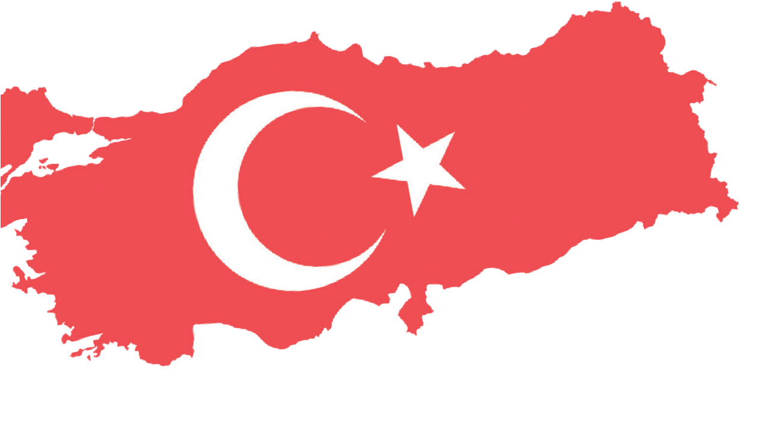
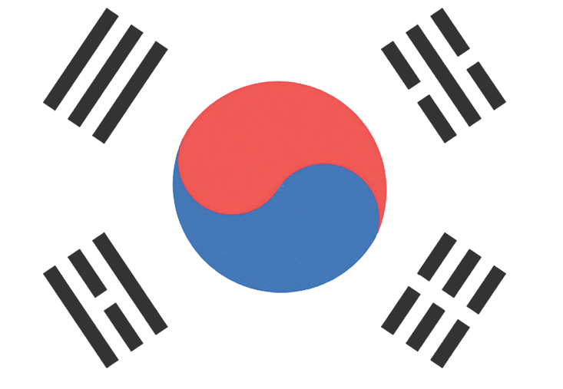

Methods-Techniques: Tarihsel sorgulama, sözlü tarih çalışması
Teaching-Learning Materials: Oral history interviews, newspaper reports, secondary sources, maps
Learning Aim: To develop an awareness of and an appreciation for the heroism of Turkish soldiers in Korea by closely examining two key engagements involving Turkish units, one defensive and one offensive, and the critical roles they played.
Key Question: How did the performance of Turkish units in the battles of Kunuri and Kumyangjang-ni affect the overall course of the Korean War, and what kinds of repercussions did it generate?
Guiding Question 1

How did the Battle of Kunuri (defensive), in which the Turkish Brigade played an active role during the Korean War, take place, and what kinds of effects and outcomes did it produce?

Objective 1

To explain how the battles and engagements in which the Turkish Brigade participated during the Korean War were carried out.
Task 1

Students are asked/invited to examine Sources B, C, D, E, F, G, and H, to answer the related questions, and to prepare the news text requested in Step 3.
Guiding Question 2

How did the Battle of Kumyangjang-ni (offensive), in which the Turkish Brigade played an active role during the Korean War, take place, and what kinds of effects and outcomes did it produce?

Objective 2

To analyze in detail the Battle of Kunuri (defensive) and the Battle of Kumyangjang-ni (offensive), in which Turkish soldiers took part during the Korean War, by examining them closely in the light of available evidence.

Task 2

Students are asked/invited to examine Sources I, J, K, L, M, and N and to answer the related questions.
Guiding Question 3

What kinds of effects did the performance displayed by Turkish units in the battles of Kunuri and Kumyangjang-ni generate in Türkiye and abroad?
Objective 3

To raise students’ awareness of the heroism demonstrated by Turkish soldiers who
participated in the Korean War.
Task 3

Students are asked/invited to examine Sources O, P, R, S,
T, U, V, and Y, to answer the related questions and to carry out the medal-design activity requested in Step 15.

Teaching and Learning Plan

‼ Focus on Activity
The students are asked/invited to examine the photograph provided in Source A and to
make predictions about where and when it was taken, who the people in the photograph are, and what they are trying to do.
5 min.
🛎 Task 1
The students are asked/invited to examine Sources B, C, D, E, F, G, and H, to answer the related questions, and to prepare the news text requested in Step 3.
35 min.
🛎 Task 2
The students are asked/invited to examine Sources I, J, K, L, M, and N and to answer the related questions.
40 min.
🛎 Task 3
The students are asked/invited to examine Sources O, P, R, S, T, U, V, and Y, to answer the related questions, and to carry out the medal-design activity requested in Step 15.
30 min.
The students are asked/invited to answer open-ended questions.
10 min.
🎯 Assessment and Evaluation

🏠 Homework
The students are asked/invited to access, by way of the Internet, newspaper issues dated 26 November-4 December 1950 and 25-29 January 1951 that were used in this activity, and to analyze news reports, commentaries, and opinion columns related to the Korean War, particularly the battles of Kunuri and Kumyangjang-ni, using ChatGPT or a similar artificial intelligence tool. Based on this analysis, they then prepare a text explaining the impact of Turkish units on the overall course of the war and their concrete contributions to the United Nations forces. The product is stored in students’ electronic portfolios.

Teaching and Learning Process
Focus on Activity: The students are asked/invited to examine the photograph below (Source A) and to make predictions about where and when it was taken, who the people are, and what they are trying to do.
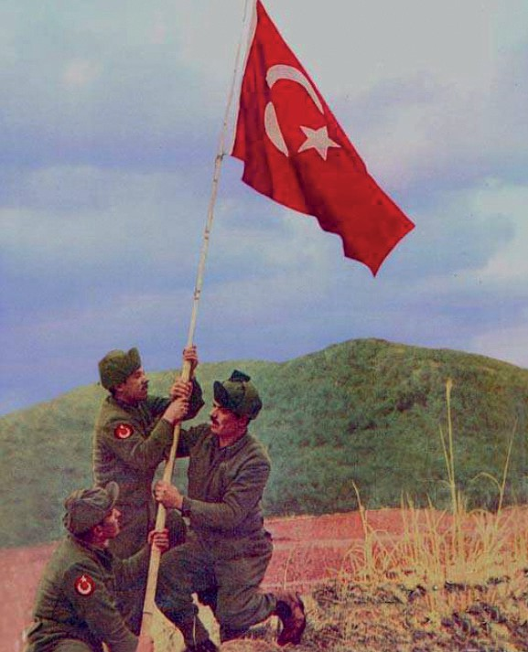
Source A: Soldiers and a Flag (Denizli, 2011, p. 152)
Note I:
The Turkish Brigade, which arrived at the Port of Pusan on 18 October, 1950, reached the city of Daegu two days later and began its preparations for war. Assigned to the command of the 25th Division of the U.S. Eighth Army, the Turkish Brigade’s initial duties included combating guerrilla forces and ensuring the security of roads and bridges. When the United Nations forces began to retreat after being disrupted by the enemy offensive that started on 26 November, 1950, the Turkish Brigade was tasked with covering this withdrawal and ensuring its security (Denizli, 2010; Kore Savaşı ve İzleri, 2025).

Guiding Question 1: How did the Battle of Kunuri (defensive), in which the Turkish Brigade played an active role during the Korean War, take place, and what kinds of effects and outcomes did it lead to?
Task 1: The students are asked/invited to examine Sources B, C, D, E, F, G, and H, to answer the related questions, and to prepare the news text requested in Step 3.
Step 1: Students are asked/invited to examine Sources B, C, and D.
Source B: The Battles of Kunuri (26-30 November, 1950)
The Turkish Brigade was assigned the mission of ensuring the safe withdrawal of United Nations forces, delaying the enemy’s advance by engaging and harassing it, and thereby gaining time. As United Nations units, primarily American forces, were retreating, the Turkish Brigade was deployed against the enemy on the evening of 26 November, moving east from Kunuri toward Tokchon. The first contact with the Chinese army occurred on the morning of 28 November in the Wawon area during the advance toward Tokchon. Despite heavy casualties, the Turkish Brigade delayed the Chinese army's advance at Wawon, later at Sinnimni, Kaechon, and the Kunuri Pass. Attempts by the Chinese army to encircle and destroy Turkish troops were repelled each time by the heroic acts of Turkish soldiers. The bravery of the Turkish Brigade in the battles of Kunuri enabled a large portion of the United Nations forces to withdraw without being destroyed. The losses suffered by the Turkish brigade in the Kunuri battles totaled 767, including 218 martyrs, 94 missing, and 455 wounded (Denizli, 2010; Kore Savaşı ve İzleri, 2025).

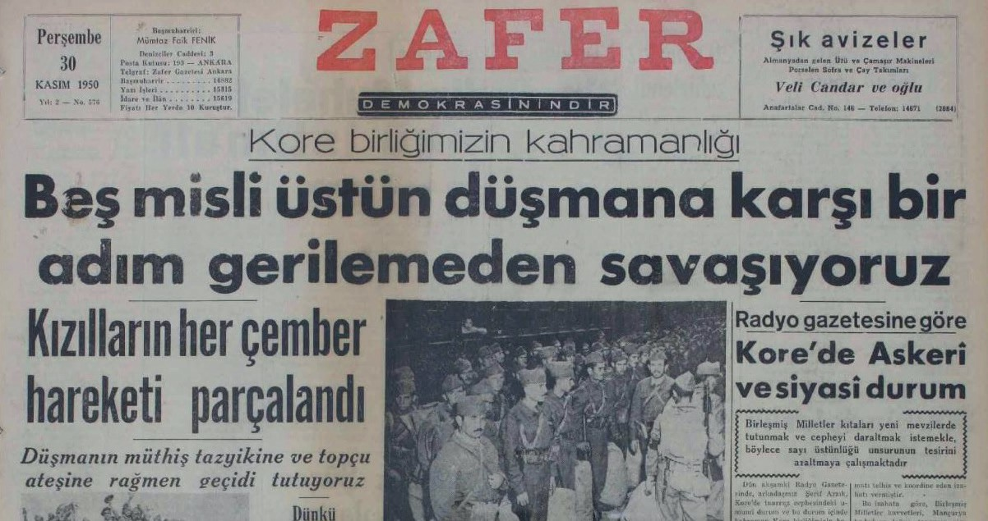
Source C: The headline of the Zafer Newspaper, dated 30 November, 1950 (Zafer, 1950) (The front page and the continuation of the news article)
The Heroism of our Korean Unit

We are fighting without retreating a single step against an enemy five times stronger.
Every encirclement maneuver by the Reds has been broken.
Despite the enemy’s tremendous pressure and artillery fire, we are holding the pass.
While the United Nations forces are retreating along the entire front, the Turkish forces continue their heroic resistance against the fierce attacks of the Chinese units. A Turkish battalion on the Sunchon road at Kunuri is currently surrounded. Meanwhile, the battalion commander sent a radio message stating that he had dispatched a tank and a company to assist them and that the soldiers had the situation under control. This message was met with great astonishment by the Turkish unit's command.

One Against Five
According to reports from correspondents in Korea, the Turkish Brigade, which holds a highly strategic pass between Tokchon and Kunuri, situated between two steep mountains, and which protects the Eighth U.S. Army from encirclement, has not retreated so far despite being under tremendous pressure. It is reported that units of the U.S. Army have moved into action tonight to support the Turkish forces. Turkish units are fighting enemy forces at a ratio of one to five.
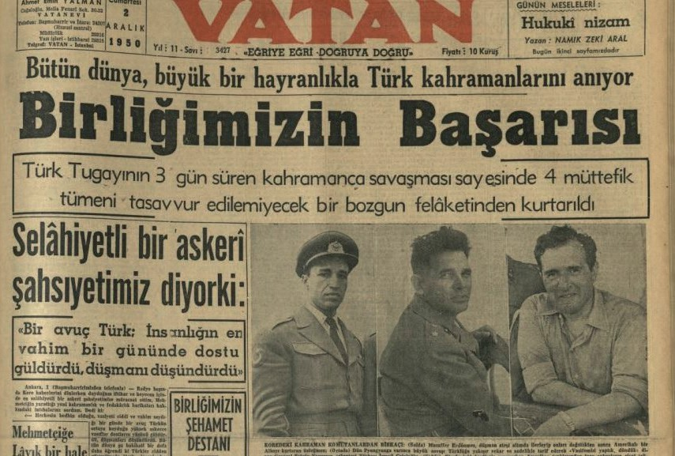
Source D: The Vatan Newspaper dated 2 December, 1950 (Vatan, 1950a) (The front page and the continuation of the news article)
Thanks to the Turkish Brigade’s three-day-long heroic resistance, four Allied divisions were saved from an unimaginable disaster of defeat.
During the Battle of Kunuri, the Turkish Brigade displayed extraordinary heroism by holding the front line at the most critical moments for the United Nations forces. In the face of sudden raids and intense attacks by Chinese forces, Turkish soldiers maintained their positions, enabling the withdrawal of American
divisions. Despite being encircled at times, the Turkish Brigade repelled enemy assaults through bayonet charges and did not abandon its positions under extremely harsh conditions. In particular, between 27 and 29 November, the Turkish soldiers' resistance halted the enemy advance and allowed most UN forces to escape encirclement. During this heroic defense, although the Turkish Brigade suffered heavy casualties against the numerically superior Chinese forces, it successfully fulfilled its mission.

Step 2: The students are asked/invited to answer the following questions based on Sources B, C, and D.
- According to the information presented in Source B, what tasks were assigned to the Turkish units during the Battle of Kunuri?
- According to Sources B, C, and D, what did the Turkish units manage to achieve during the Battle of Kunuri?

- In Source C, what is meant by the expressions ‘the soldiers had control of the situation’ and ‘fighting enemy forces at a ratio of one to five’? Explain this.
- In Source D, what difficulties faced by the Turkish units during the course of the war are intended to be conveyed by the sentence, ‘Although the Turkish Brigade was encircled from time to time, it repelled enemy attacks with bayonet charges and did not abandon its positions under harsh conditions’?
- By comparatively evaluating the information presented in Sources B, C, and D, explain what the Turkish units did or did not succeed in accomplishing during the Battle of Kunuri.
Step 3: The students are asked/invited to use the Internet and AI tools to investigate who the individuals shown in the photographs in Source D are? In addition, why did a national newspaper feature these individuals on its front page? After this, the students are asked/invited to prepare a news report focusing on the actions and roles of these individuals during the Battle of Kunuri.

Three Heroes at Kunuri
..................................................................................................................................................................
..................................................................................................................................................................
..................................................................................................................................................................
..................................................................................................................................................................
..................................................................................................................................................................

Step 4: The students are asked/invited to examine the following Sources E and F.

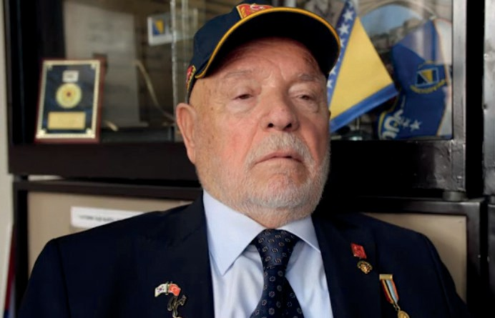
Source E: An excerpt from an oral history interview conducted with Korean War Veteran Ali Rıza Yurtnaç (https://koreanwarlegacy.org/ interviews/ali-riza-yurtnac/)
🕒 19:21-22:22

A. R. Yurtnaç: After Taegu, we boarded the troop transport vehicles in the evening and arrived in Kunuri by morning. At
the time, I knew nothing about Kunuri; I learned about it later. We got off the military transport vehicles and walked along a very narrow, steep road for approximately 15-20 kilometers, going up and down continuously until evening. Toward the evening, news arrived that we had approached Manchuria. From there, we walked back another twenty kilometers on foot and took positions there at night. There were actually no proper trenches; we took cover among the rocks. There was a bridge, and a number of soldiers were positioned farther ahead on it. The fighting began in the morning. The Chinese had surrounded us there, and many of our soldiers were martyred. They had positioned themselves among the pine trees, set up machine guns, and opened fire. They advanced to within fifty meters of us; we fired at them, they fell, but more kept coming. In my squad, our corporal was wounded. The medics arrived and evacuated him. We continued fighting there until evening. There were houses across from us, and the houses began to burn. There was no food; nothing at all. United Nations aircraft arrived, but they could not fire at close range; they fired at distant targets because there were also United Nations soldiers in the area. Behind us was the U.S. 8th Corps, which carried out a withdrawal. We held the Chinese forces

at the front to delay the American withdrawal. The next day, we pulled back a little and fought again. During the withdrawal attack, I was wounded on the last day. When I was wounded, I rolled down the slope. One of our machine gunners caught me. One of our anti-aircraft units was passing by, with a trailer attached behind it. They placed me inside the trailer. The anti-aircraft unit continued firing as it moved and broke out of the encirclement.
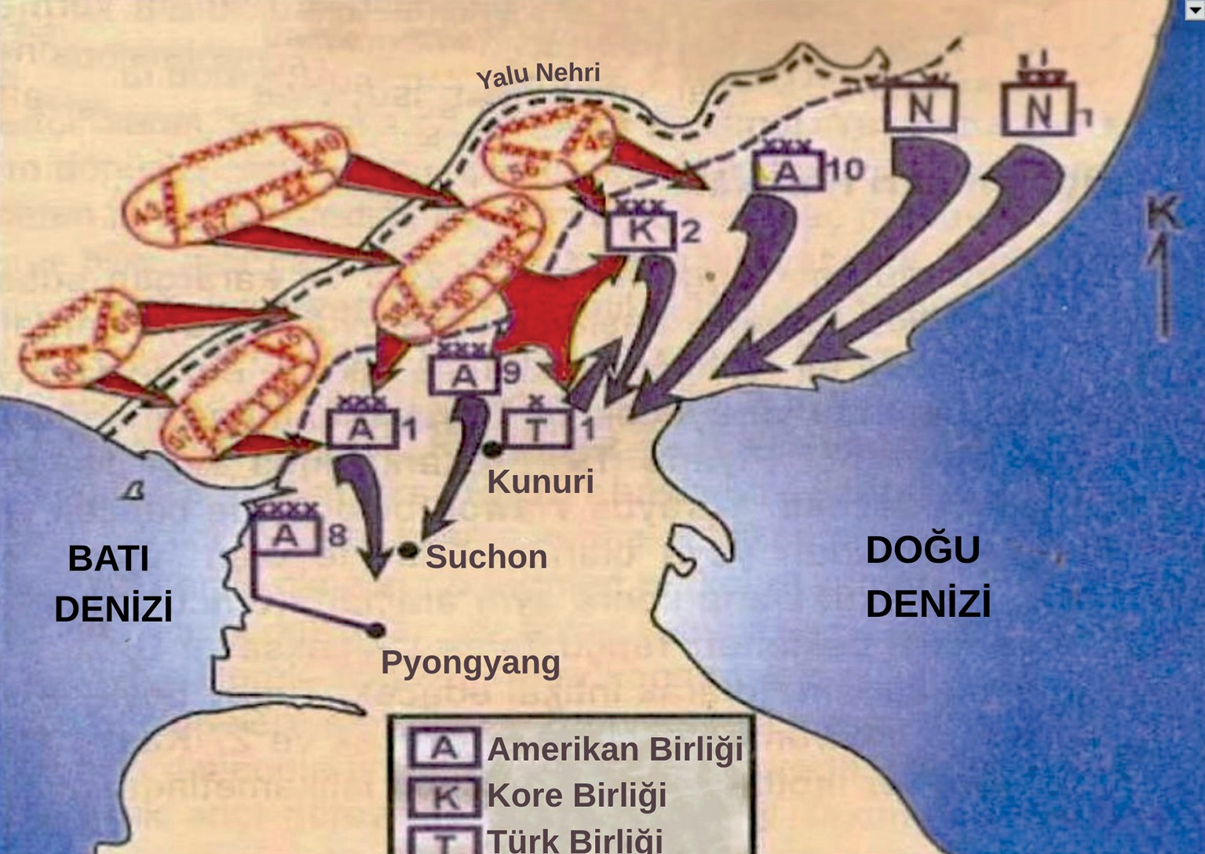

Source F: A sketch illustrating the tactical movements of United Nations Forces and enemy units during the Battles of Kunuri (Denizli, 2010, p. 33)
Step 5: The students are asked/invited to answer the following questions based on Source E and Source F.
- In the sentence ‘Toward the evening, news arrived that we had approached Manchuria’, what does Manchuria refer to? The students are asked/invited to research this region and indicate it on the sketch provided in Source F.
- How does veteran Ali Rıza Yurtnaç describe the role undertaken by the Turkish units during the Battles of Kunuri? What kind of consistency or contradiction exists between his account and the information presented in Sources B, C, and D?
- According to Source E, why could the United Nations air power not be used effectively against the enemy?
- What do the details presented in Source F reveal about the difficulties experienced by the Turkish units during the Battles of Kunuri? Explain this.
- What do Veteran Ali Rıza Yurtnaç’s statements,“When I was wounded, I rolled down the slope. One of our machine gunners caught me. Our anti-aircraft unit was passing by. There was a trailer behind it. They put me in the trailer. The anti-aircraft unit fired continuously and broke out of the encirclement.” Tell us about the effects of war and armed conflict on human life.

Step 6: The students are asked/invited to examine Source G and Source H.

Source G: A Turkish officer and his unit martyred during the Battle of Kunuri
During the Battle of Kunuri (on the night of 28-29 November 1950), Infantry Senior Captain Esat Öztüzün, the Company Commander of the Headquarters Company of the 3rd Infantry Battalion, gathered the remaining members of his company, which had suffered heavy losses (three officers, one non-commissioned officer, and eighteen enlisted soldiers), and set out to search for their battalion. Unable to locate the battalion throughout the night, they halted at the foot of a hill. Shortly after leaving this position at daybreak, they encountered enemy forces. Under intense fire from both sides, they managed to escape the dangerous situation by moving through the shrubland. After passing through a cornfield, they ate raw corn to satisfy their hunger and continued marching for a while. In a village ahead, they noticed approximately fifty to sixty soldiers warming themselves by a fire. By the time they realized these soldiers were enemy troops, it was already too late. Surrounded, they were captured following clashes that continued until 10:30 a.m. Captain Öztüzün and his soldiers were then forced to march northward behind a Chinese company under armed guard.
During the march, the officers informed the soldiers that the enemy would eventually kill them and that they should attempt to escape together at the first opportunity. While they were marching, an American truck that was approaching from the opposite direction failed to take a bend and overturned. Taking advantage of the confusion, First Lieutenant Ömer Köklü threw the Chinese guard carrying a machine gun into a stream and encouraged the others to flee. As the soldiers ran together toward the southwest, they were subjected to prolonged and intense enemy fire from behind. Only one officer and four enlisted soldiers survived this escape attempt. Those who survived stated that the remaining soldiers were shot and martyred. As Captain Esat Öztüzün’s name does not appear on the list of Turkish prisoners submitted to the Armistice Commission, it is believed that he was martyred during this incident (Cited in by Ülgen, 2007, pp. 208-209).
Source H: The situation of Turkish soldiers captured during the Battles of Kunuri
…Among the prisoners, I saw many who were wounded and ill. I learned that most of the wounded had maggots in their injuries. The captive soldiers’ hair and beards had grown long, and their fingernails were like hoes. Their faces, necks, hands, in short, their entire bodies, were covered with a thick layer of dirt. The smell was unbearable; one could hardly stand near them. They were completely infested with lice. After a while, without even considering my own condition, I felt nauseated by what I saw and almost vomited. I myself was in a deplorable condition, but the captive soldiers… (Rusçuklu, 2005, pp. 286–287).

Step 7: The students are asked/invited to answer the following questions based on Source G and Source H.
- According to Source G, what kinds of difficulties did Turkish soldiers struggle with in Korea, and what risks did they face?
- Do the details provided in Source G conclusively state that Captain Esat Öztüzün was martyred during the Battles of Kunuri? Why or why not?
- What does the fact that the Turkish soldiers were willing to risk death rather than remain in captivity tell us about their morale, motivation, and their views on the possible consequences of captivity?
- According to the information presented in Source H, how and to what extent does captivity affect human life?
Guiding Question 2: How did the Battle of Kumyangjang-ni (offensive), in which the 2nd Turkish Brigade played an active role during the Korean War, take place, and what kinds of effects/outcomes did it produce?
Task 2: The students are asked/invited to examine Sources I, J, K, L, M, and N and answer the related questions.

Step 8: The students are asked/invited to examine Sources I, J, K, and L.
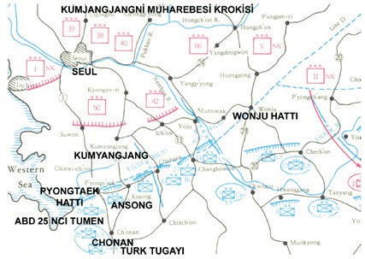
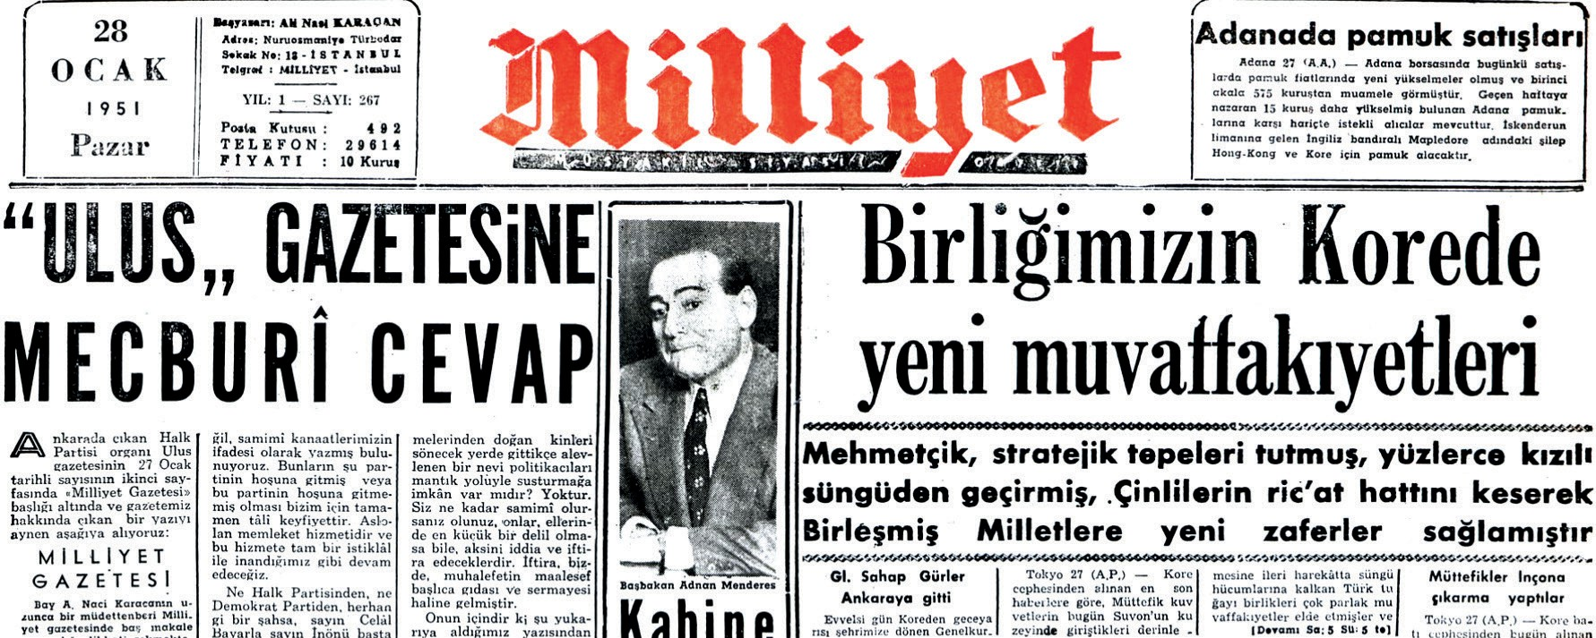
Source I: The Battle of Kumyangjang-ni (27 January, 1951)
Despite continued offensives reinforced by additional troops, the North Chinese army could not be stopped. This situation negatively affected the morale of the United Nations forces, which had withdrawn approximately four hundred kilometers, and significantly weakened their will to fight. Within the United Nations forces, the belief that the war would be lost had become widespread, and plans were therefore prepared to abandon Korea.
The Turkish Brigade was assigned a mission of forced reconnaissance in order to locate the enemy and reveal its position and strength. The brigade began its offensive on 25 January, 1951. All the enemy objectives and the town of Kumyangjang-ni were captured. As a result of this offensive the United Nations forces also launched counter attacks, and the Chinese army was defeated. This long-anticipated victory was achieved at Kumyangjang-ni. The Battle of Kumyangjang-ni also demonstrated that the North Chinese armies could be defeated. This victory caused the United Nations forces, whose morale and determination to fight had been severely shaken by Chinese attacks and who had been planning to withdraw from Korea, to abandon these plans, allowing the war to continue in favor of the United Nations. Seoul was liberated once again (Kore Savaşı ve İzleri, 2025).
Source K: A news report from the Milliyet Newspaper dated 28 January, 1951 (Milliyet, 1951)
Source J: A sketch illustrating the tactical movements of United Nations forces and enemy units during the Battles of Kumyangjang-ni (Denizli, 2009, p. 4)

New Successes of our Units in Korea
Mehmetçik (the title historically representing Turkish warriors fighting for Islam) secured strategic hills, bayoneted hundreds of communist troops, and cut the Chinese retreat lines, thereby achieving new victories for the United Nations
Tokyo, 27 (A.P.): According to the latest reports received from the Korean front, Turkish Brigade units, which launched bayonet assaults during the deep advance carried out today by Allied forces north of Suwon, achieved remarkable successes playing a significant role. The apparent objective of this advance operation was to drive all Chinese and North Korean communist forces north of the Han River, which bends south of Seoul.
Korea, 28: For three days, our heroic soldiers advancing while fighting south of Seoul, the capital of South Korea, wrote new epics with their bayonets and once again inflicted a heavy defeat on the Communist Chinese units. Most of the Chinese communist prisoners currently held by our brigade belong to the units that fought against us during the Battle of Kunuri. Colonel Dora, recalling the Battle of Kunuri, stated, “We have avenged our martyrs.”

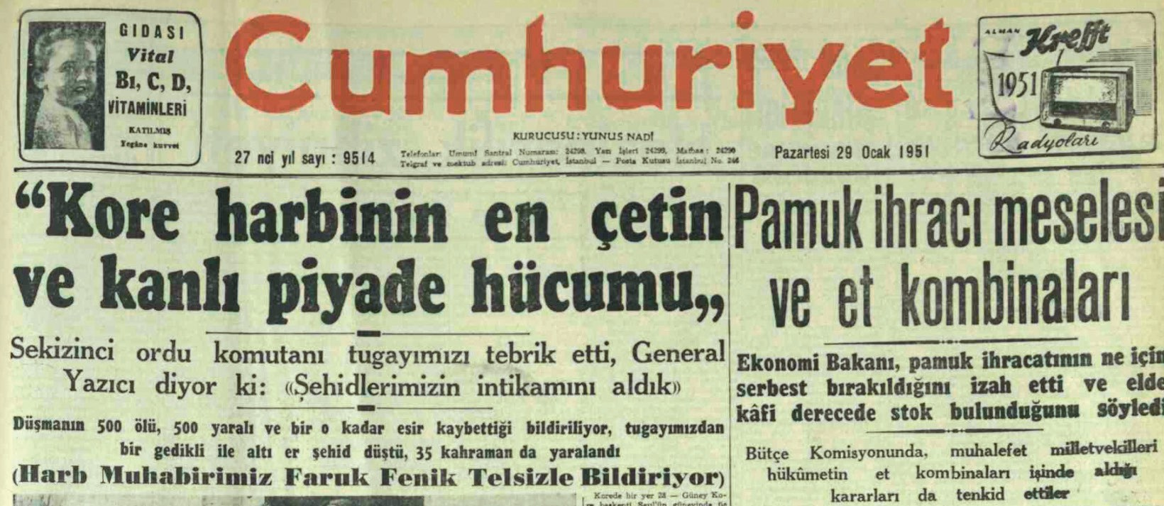
“The fiercest and bloodiest infantry assault of the Korean War”
The commander of the Eighth Army congratulated our brigade. General Tahsin Yazıcı stated, “We have avenged our martyrs.”
It was reported that the enemy suffered five hundred killed, five hundred wounded, and a similar number taken prisoner. At the same time, one non-commissioned officer and six enlisted soldiers from our brigade were martyred, with thirty-five heroes being wounded.
Turkish soldiers demonstrated great heroism against Chinese forces during the Korean War. By breaching enemy trenches with bayonet charges, they captured strategically important hills. While the opposing forces suffered heavy losses in both casualties and prisoners, Turkish losses remained relatively low. The American commanders and journalists expressed their admiration for the courage of the Turkish soldiers. They stated that the Turks employed a simple yet effective tactic, defeating the enemy through direct bayonet attacks. Tahsin Yazıcı particularly praised the soldiers’ success, emphasizing that despite the Chinese forces being numerically superior and better equipped, the Turkish troops prevailed. These victories provided great morale to the Turkish nation, and the bravery of Turkish soldiers was highly valued by the Allied states. These battles have gone down in military history as enduring examples of heroism.
Source L: A news report from the Cumhuriyet Newspaper dated 29 January, 1951 (Cumhuriyet, 1951a)

Step 9: The students are asked/invited to answer the following questions in line with the information presented in Sources I, J, K, and L.
- According to Source I, which side gained the upper hand in Korea during the approximately three-month period following the Battles of Kunuri?
- Students are asked/invited to find a map of the Korean Peninsula online and mark the cities of Pyongyang and Seoul on the map. Then, by comparing the sketches provided in Source F and Source J with the map information, students are asked/invited to evaluate how United Nations forces performed during the period between the Battles of Kunuri and Kumyangjang-ni.
- According to Source K, how did Turkish units gain the advantage over the enemy during the Battles of Kumyangjang-ni?
- According to Colonel Dora, how should the success of the Turkish units in the Battles of Kumyangjang-ni be interpreted/understood?
- When Source L is examined, what key factor enabled the Turkish units to succeed against an enemy that was both numerically superior and better equipped (with more and higher-quality weapons and equipment)?
- According to Sources I, K, and L, what impact did the performance of the Turkish units in the Battles of Kumyangjang-ni have on public morale in Türkiye and on the soldiers of the countries fighting alongside the United Nations?
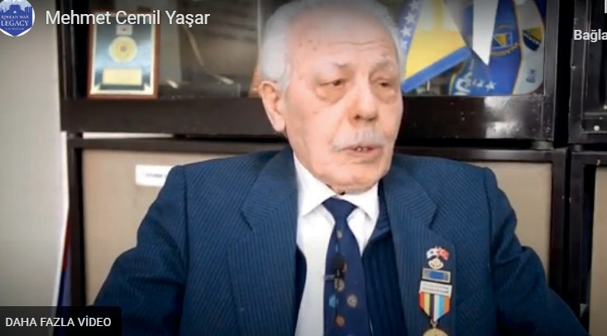
Step 10: The students are asked/invited to examine Source M and Source N.

Source M: Oral history study. An excerpt from an oral history interview with Korean War veteran Mehmet Cemil Yaşar (https://koreanwarlegacy.org/interviews/ mehmet-cemil-yasar/)
🕒 15:55-19:57

M. C. Yaşar: If you wish, I can tell you about the final battle. It took place on 25 January. On that day, our General delivered a speech. Yes, those were the dates, I had noted them simply as 25 January, just for information. Our General gave a speech there. He said that we are mortal beings, merely guests in this world. It was a farewell speech. He explained that the battle ahead would be tough. When we advanced on foot toward the area where the battle would take place, we encountered a chain of mountains, very high terrain. Our military unit, members of our brigade, split into two groups, moving through the streams on the right and left sides of the mountain. To maintain communication, our liaison soldiers moved diagonally from right to left and from left to right, ensuring coordination and checking whether there was any ambush or danger. In this way, we descended into the valley. On the far side of that valley, there was a town, though I cannot recall its name. In that area, there was a Chinese unit known as the ‘Lightning Steel Army’, regarded as the most combat-capable unit among the Chinese forces that had previously fought at Kunuri. This unit fought in its positions until death. Yes, I also wrote this down as a record. That battle changed the fate of Korea and the Korean people. The Turkish Brigade achieved the first victory of the United Nations there. The Americans came personally to witness it; delegations arrived. Only after seeing the enemy soldiers lying dead in their positions did they believe it. For that battle, the General accepted a medal of honor on behalf of the Turkish soldier. He did not want a medal for the services we had rendered, but he was compelled to accept it on that occasion. Yes, when we crossed the ridge and reached the valley, our soldiers attacked from two directions; from the right and the left. By attacking from both sides, the enemy was not given any opportunity to escape or withdraw. That victory was achieved with the fewest casualties we had suffered. As a result of that victory, the fate of Korea, its independence and freedom, was changed.

Source N: The Story of a Soldier Martyred in the Battle of Kumyangjang-ni
At 14:00, the enemy withdrew from Hill 266 in an face of the assault carried out by the Third Company under the command of Captain Necdet Serman and pulled back to a dominant ridge line consisting of steep, rocky hills rising to an elevation of four hundred and thirty-one meters. At that time, Second Lieutenant Selahattin Erkemen, who was the Platoon Commander of the Second Platoon of the Second Company positioned behind the II Battalion, and who was well known among all regimental personnel for his exceptional bravery displayed during the Battles of Kunuri and Hill 156, was martyred while leading his platoon in an attack against the enemy for the success of the II Battalion. His loss deeply affected us all (Dora, 1963, p. 219).
…When, in the darkness, I descended with great difficulty to the path at the foot of the hill by holding onto the rocks, I saw the body of Second Lieutenant Selahattin Erkemen, who had been martyred during the day in the II Battalion sector, being carried on a stretcher on the shoulders of four soldiers from his own platoon.
When the soldiers carrying their lieutenant approached us and recognized me, one of them said: “…he left us orphaned and heartbroken.” We said, ‘Do not do it, my lieutenant, do not go, machine-gun fire is coming; let us silence it first and then move on.’ However, he replied, “Come on now, can’t you see they are pressing the Seventh Company ahead? Is this a place to stop?” Moreover, he rushed forward, saying, “Follow me”, and had not taken more than fifteen steps when he was suddenly shot in the head and fell lifeless to the ground (Dora, 1963, pp. 221–222).

Step 11: The students are asked/invited to answer the following questions based on Source M and Source N.
- Considering the account presented in Source M, what kind of impact can be said to have been created by the speech delivered by the General (General Tahsin Yazıcı) on Turkish soldiers? Why is this?
- How does Veteran Mehmet Cemil Yaşar personally evaluate the Battles of Kumyangjang-ni?
- What might be the reasons why the Americans did not initially believe the success achieved by Turkish units at Kumyangjang-ni and wanted to witness it firsthand?
- Based on the information provided in Source M, what can be said about the personality of the martyred Second Lieutenant Selahattin Erkemen and the values he embraced?

Guiding Question 3: What kind of impact did the performance displayed by Turkish units in the Battles of Kunuri and Kumyangjang-ni create in Türkiye and abroad?
Task 3: The students are asked/invited to examine Sources O, P, R, S, T, U, V, and Y, to answer the related questions, and to carry out the medal design activity requested in Step 15.

Step 12: The students are asked/invited to examine Source O.
Source O: On the Psychological and Strategic Effects of the Successes Achieved in the Battles of Kunuri and Kumyangjang-ni
Between 27 and 30 November, through the battles fought at Wawon, Simnimni, and the Kunuri and Sunchon passes, the Turkish Brigade halted the Chinese offensives by engaging in close combat. In doing so, it prevented the encirclement of the 9th Corps and the destruction of the 2nd Division. Securing three critical days and sufficient space required for withdrawal enabled the Eighth Army to retreat safely. The success achieved by the Turkish Brigade at Kunuri demonstrated that victory was possible for United Nations forces and significantly increased the morale and motivation of all the UN units.
The victory achieved at Kumyangjang-ni provided great morale to the United Nations Army. Until that victory, the UN forces had been unable to hold their ground against the Chinese and had continuously withdrawn. In this battle, however, the Turkish forces defeated the Chinese within two days, inflicted heavy casualties on them, and pushed them back ten kilometers from their strongest defensive positions. This proved that the Chinese were not invincible. With this renewed morale, the UN Army did not retreat even a single step thereafter. Just one week earlier, plans had been made to withdraw to the Pusan perimeter and even to evacuate Korea entirely. Once again, the Turkish Brigade had changed the course of the war. With this victory, which not only defeated the Chinese Army but also, in the words of the great Atatürk, overcame the ill fate of the United Nations Army as well (Yücel, 2001, p. 52).

Step 13: The students are asked/invited to answer the following questions based on Source O.
  - According to Source O, what kind of psychological impact did the performance displayed and the successes achieved by the Turkish units in the Battles of Kunuri and Kumyangjang-ni have on the United Nations forces?
  - According to Source O, how did the success achieved by the Turkish units in the Battles of Kunuri and Kumyangjang-ni shape the overall course of the Korean War?
Step 14: The students are asked/invited to examine Sources P, R, S, T, and U.
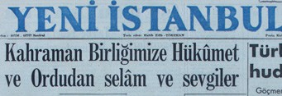
Source P: The Headline of the Yeni İstanbul Newspaper,
dated 3 December, 1950 (Yeni İstanbul, 1950)
The Prime Minister and the Chief of the General Staff sent messages of appreciation to our Korean brigade
Adnan Menderes: “The great sacrifice and heroism displayed by our forces have filled our hearts with rightful pride.”
Nuri Yamut: “Friend and foe alike, without exception, the entire world has come to admire and appreciate your heroism.”
Source R: A few sentences from the Vatan Newspaper dated 2 December, 1950 (Vatan, 1950b)
In the words of an American officer, the statement, “I have never seen soldiers like this before” became a symbol of the courage displayed. The lines held by the Turkish forces secured the safe withdrawal of the allied troops, enabling nine divisions to retreat to new defensive positions without losses. In this way, the Turkish Brigade assumed a role that changed the fate of the United Nations forces during the Korean War.

Source U: International Reaction to the Success of Turkish Units in the Battles of Kunuri
“The heroic battles fought by the Turkish Brigade created an elixir-like effect on all the United Nations forces.” - The Times.
“4,500 soldiers knew how to work wonders in the middle of the line of fire. The sacrifices made by the Turks will never be forgotten.” - The Washington Tribune.
“The surprise of the Korean battles was not the Chinese, but the Turks. At present, it is impossible to find a word capable of describing the heroism shown by the Turks in these battles.” - Abend Post.
“At Kunuri, the Turks displayed a heroism worthy of their glorious history. Through their valiant fighting, the Turks earned the admiration of the entire world.” - Le Figaro
“While the Turks were fighting and dying for a long time in the face of the enemy, the British and Americans were withdrawing. When their ammunition ran out, the Turks fixed bayonets and attacked the enemy, and a fierce hand-to-hand struggle began. Fighting as they withdrew and carrying their wounded comrades on their backs, the Turks managed to pull back. In Pyongyang, they marched in a parade with their heads held high.” - G.G. Murtin.
189

Source S: A message from the Commander of the U.S. Eighth Army, W. H. Walker.
Following the battles of Kunuri, the Commander of the Eighth Army, General Walton H. Walker, stated in his message to the Turkish Brigade in Korea that the Turkish combat unit, operating together with the 2nd Division, prevented the encirclement and destruction of the army through its heroic courage and the delaying actions it carried out over four days. He emphasized that on the night of 28 November, 1950, the Turkish combat unit was surrounded near Wawon by communist forces estimated to be of divisional strength; however, the Turkish soldiers fought with great bravery and killed two hundred enemy soldiers with bayonets in close combat. He further stated that despite the enemy forces in this sector reaching the strength of six divisions after two days of fighting, they failed to break through the lines, and that the Turkish combat unit, together with the 2nd Division, secured the necessary time to prevent the encirclement of the Eighth Army (Yazıcı, 1963, p. 217).

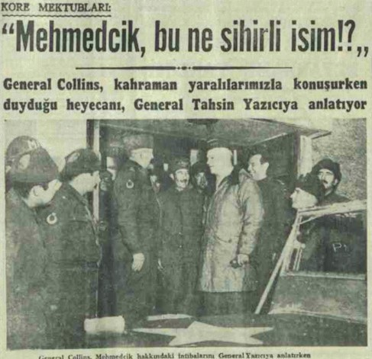
Source T: A news report from the Cumhuriyet Newspaper, dated 29 January, 1951. (Cumhuriyet, 1951b)
During the Korean War, the Turkish Brigade held the front line alone for days, saving the United Nations forces from a major defeat. Matthew Ridgway and J. Lawton Collins personally visited the front to congratulate the Turkish soldiers and expressed their admiration. The wounded Turkish soldiers drew attention with their endurance in the face of pain; during examinations conducted by doctors using needles, they showed no reaction and proudly responded, “I am a Turkish soldier. Does a needle hurt?” While conveying this situation to Collins, Tahsin Yazıcı stated that even when wounded by bullets, Turkish soldiers would say, “I am fine, my commander!” These examples symbolized the Turkish soldiers’ resilience to pain and unwavering dedication to duty. The generals spoke highly of the heroism of the Turkish unit and emphasized that they were inspired by its courage.
*Mehmedçik or Mehmetçik is a title given to Turkish soldiers.

“We owe the certain escape of thousands of United Nations soldiers from encirclement to the heroism of Turkish soldiers. The Turkish soldiers in Korea added yet another new and unforgettable page of honor to the heroic traditions and legends of the Turkish Nation.” - Emanuel Shinwell, Minister of Defence of the United Kingdom.
“The Turks are heroes among heroes. For the Turkish Brigade, there is no such thing as impossible.” - Douglas MacArthur, Commander-in-Chief of United Nations Forces.
“This time, it was the Turks who saved you.” (Referring to the American Army). - TASS (Sipahi, 2007)

Step 15: The students are asked/invited to answer the following questions based on Sources P, R, S, T, and U.
- How did the Prime Minister of the period, Adnan Menderes, and the Chief of the General Staff, General Nuri Yamut, respond to the success achieved by the Turkish units in Korea?
- According to Source R, what role did the Turkish Brigade’s struggle at Kunuri play in the overall course of the Korean War?
- In Source S, how is the combat situation described in the statement attributed to the Commander of the
U.S. Eighth Army that, “The Turks fought bravely and killed two hundred enemy soldiers with bayonets in hand-to-hand combat”? The students are asked/invited to discuss this with their classmates.
- In the newspaper report presented in Source T, how realistic and accurate are the expressions, “Mehmetçik-what a magical name!” and “I am a Turkish soldier. Does a needle hurt?”? What might have been the purpose of General Collins, or the newspaper officials likely writing on his behalf, in using such expressions?
- What perspective do the individuals and institutions whose views are conveyed in Sources R, S, T, and U present regarding the role played by the Turkish units in the Battles of Kunuri, and on what common point do they converge?
- How can it be interpreted that even TASS, the official news agency of the Soviet Union, a country that supported North Korea during and after the Korean War, used the statement, “This time, it was the Turks who saved you,” addressing the Americans?
Step 16: The students are asked/invited to examine Source V and Source Y.
Source V: Reactions of the United States and South Korean Governments to the Victory at Kumyangjang-ni
The successes achieved by the Turkish Brigade also had a substantial impact on American public opinion. Upon the recommendation of the Commander of the Eighth Army, the Turkish Brigade was awarded the Distinguished Unit Citation and its official citation by the United States for its outstanding achievements in the battles fought between 25-27 January 1951. Until that time, this decoration had been awarded only to two American units of this kind. Apart from these, the Turkish Brigade became the first unit of a foreign nation to receive this distinction. This decoration and its citation were sent to the Turkish Brigade together with a message from the Commander-in-Chief of United States Army Forces in the Far East, Matthew Ridgway. In the message, it was stated that ‘there are very few occasions on which the highest decoration of the American Government has been awarded more appropriately’, and the success demonstrated by the Turkish Brigade was formally commended. The decoration was affixed to the regimental flag of the 241st Regiment during a ceremony held on 6 July, 1951, by the Commander of the Eighth Army, James Van Fleet. In the official citation of the decoration, the performance of the Turkish Brigade during the battles of 25-27 January was praised in detail (Erkilet et al., 1975, p. 216).
As a result of the same victory, the President of South Korea, Syngman Rhee, awarded the Korean Presidential Unit Citation to the Turkish Brigade on 17 September, 1952 (Artuç, 1980).

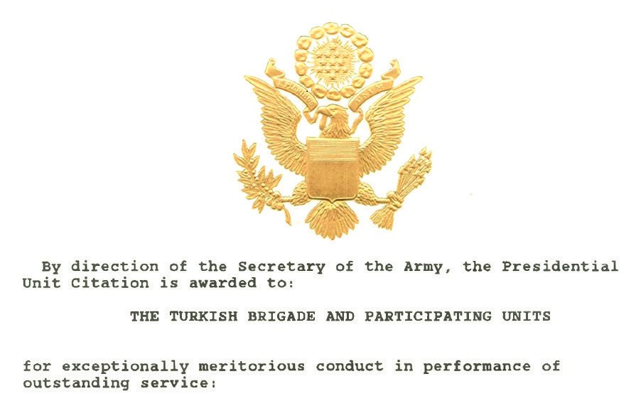
Source Y: The Opening Section of the citation of the Distinguished Unit Citation Awarded to the Turkish Brigade by the United States Congress (Denizli, 2009, p. 165)

The Turkish Brigade and its attached units
In accordance with the briefing and guidance of the Army Command, they were awarded this Distinguished Unit Citation in recognition of their exceptional, virtuous, and morally exemplary conduct, as well as the extraordinary courage and heroism they displayed.

Step 17: The students are asked/invited to answer the following questions based on Source V and Source Y.
- What does the fact that the United States awarded the Distinguished Unit Citation to the Turkish Brigade for the first time as a unit belonging to another country indicate about the level of success achieved by Turkish soldiers in the Battles of Kumyangjang-ni?
- What does General Ridgway’s statement, “There are very few occasions on which the highest decoration of the American Government has been awarded more appropriately”, mean? Explain.
- How can the decision of South Korean President Syngman Rhee to award the Turkish Brigade the Korean Presidential Unit Citation be interpreted?
Step 18: The students are asked/invited to form groups of three, four, or five and design a badge/medal to be awarded to Turkish soldiers as a symbol of the success they displayed during the Korean War. It is emphasized that the designed medals should include the following elements/features:
- The geographical distance and cultural closeness between Türkiye and Korea
- Symbols representing Türkiye, South Korea, and the United Nations
- The courage, heroism, and self-sacrifice of Turkish soldiers
- The inclusion of written expressions (in appropriate proportion) as well as visual elements

The students may place their designs here.

Note II:
During the Korean War, Turkish units undertook many different missions beyond the Battles of Kunuri and Kumyangjang-ni and successfully fulfilled these duties. Among the most significant of these were the defense of Seoul and the Battle of Bloody Vegas, which are briefly addressed below.
Defense of the Capital Seoul - The Taegyewon-ni Battle (13-18 May, 1951): The Turkish Brigade, assigned to positions around the capital city of Seoul, prevented the city from falling into enemy hands for the third time through its successful defensive operations.
The Battle of Bloody Vegas (28–29 May, 1953): On the night of 28-29 May, 1953, the Chinese army launched an attack on the forward outpost units defending the hills located approximately six hundred meters ahead of the main battle line held by the brigade. These hills were designated by the Americans as Carson, Elko, Little Vegas, Big Vegas, East Berlin, and West Berlin. The objective of the Chinese forces was to gain an advantage at the negotiating table by strengthening their position during the armistice talks intended to bring the war to an end. Turkish forward outpost units fought heroically and succeeded in halting the enemy advance. Among these hills, the one that came to be known in history as Bloody Vegas changed hands several times in a single night but was never surrendered to the enemy. As a result, China failed to gain the advantage it sought in the armistice negotiations. This battle made a significant contribution to the signing of the armistice agreement and the end of the war. During these engagements, 151 of our soldiers were martyred, and 241 were wounded (Kore Savaşı ve İzleri, 2025).

🎯Assessment and Evaluation
- What meanings do the terms offensive and defensive convey to you? Define them in your own words.
- What are the main differences between the Battles of Kunuri and Kumyangjang-ni?
- When the numbers of martyrs, wounded, and missing soldiers of the Turkish units in the Battles of Kunuri and Kumyangjang-ni are compared, in which battle can it be said that greater success was achieved? Why is this so?
- Against which forces did the Turkish units fight during the Battles of Kunuri and Kumyangjang-ni?
- For success displayed in which battles were Turkish soldiers awarded medals?
- How did the performance of the Turkish units in the Battles of Kunuri and Kumyangjang-ni resonate in Türkiye and around the world?

References
Artuç, İ. (1980). Kore Savaşlarında Mehmetçik [Mehmetçik in the Korean Wars]. Kartaş Yayınları.
Cumhuriyet Gazetesi. (1951a). Kore Harbinin en çetin ve kanlı piyade hücumu [The fiercest and bloodiest infantry assault of the Korean War]. Cumhuriyet Gazetesi. https://www.gastearsivi.com/gazete/cumhuriyet/1951-01-29/1 Access Date: 17.06.2025.
Cumhuriyet Gazetesi. (1951b). Mehmedçik’ bu ne sihirli isim [“Mehmedçik” — what a magical name]. Cumhuriyet Gazetesi. https://www.gastearsivi.com/gazete/cumhuriyet/1951-01-29/1 Access Date: 11.03.2025.
Denizli, A. (2009). Kore savaşındaki Kumyangjang-ni kahramanları [The heroes of Kumyangjang-ni in the Korean War]. Denizli, A. (2010). Kore Harbinde Kunuri zaferi [The victory of Kunuri in the Korean War]. Turhan Kitabevi.
Denizli, A. (2011). Kore Savaşı kahramanı Bandırmalı şehit Topçu Üsteğmen Mehmet Günenç [Korean War hero: Martyr Artillery First Lieutenant Mehmet Günenç of Bandırma]. Turhan Kitabevi.
Dora, C. (1963). Kore Savaşında Türklerle 1950–1951 [With the Turks in the Korean War 1950–1951]. İsmail Akgün Matbaası.
Erkilet, H. E., Bıyıklıoğlu, T., & Arun, H. (1975). Kore Harbinde Türk Silahlı Kuvvetlerinin muharebeleri (1950–1953) [The battles of the Turkish Armed Forces in the Korean War (1950–1953)]. Genelkurmay Basımevi.
Han, J. (2018a). Interview with Ali Rıza Yurtnaç. https://koreanwarlegacy.org/interviews/ali-riza-yurtnac/ Access Date: 20.08.2025.
Han, J. (2018b). Interview with Mehmet Cemil Yaşar. https://koreanwarlegacy.org/interviews/mehmet-cemil-yasar/ Access Date: 18.03.2025.
Kore Savaşı ve İzleri. (2025). Türk tugaylarının muharebeleri [The battles of the Turkish brigades]. https://koresavasiveizleri. com/kore-savasi-1950-1953-turk-tugaylarinin-muharebeleri-turkiye-muharip-gaziler-dernegi-brosur-metni/ Access Date: 17.03.2025.
Milliyet Gazetesi. (1951). Birliğimizin Kore’de yeni muvaffakiyetleri [New successes of our unit in Korea]. Milliyet Gazetesi. (28.01.1951). https://www.gastearsivi.com/gazete/milliyet2/1951-01-28/1 Access Date: 21.03.2025.
Rusçuklu, B. (2005). Kore Savaşı: Unutulan savaş ve Gazi Faruk Pekerol’un anıları [The Korean War: The forgotten war and the memoirs of Veteran Faruk Pekerol]. Arvo Yayınları.
Sipahi, S. (2007). Kore Savaşı ve Türk kamuoyu [The Korean War and Turkish public opinion] (Yayımlanmamış yüksek lisans tezi). Dokuz Eylül Üniversitesi, Atatürk İlkeleri ve İnkılap Tarihi Enstitüsü.
Ülgen, E. (2007). Bir Kore şehidimiz ve ardından yazılanlar [One of our Korean War martyrs and what was written afterwards]. Türklük Bilimi Araştırmaları, (22), 203–215.

Vatan Gazetesi. (1950a). Birliğimizin başarısı [The success of our unit]. Vatan Gazetesi. (02.12.1950). https://www. gastearsivi.com/gazete/vatan/1950-12-02/1 Access Date: 20.08.2025
Vatan Gazetesi. (1950b). Bir Amerikalı subayın ifadesiyle [In the words of an American officer]. Vatan Gazetesi. (02.12.1950). https://www.gastearsivi.com/gazete/vatan/1950-12-02/1 Access Date: 20.08.2025
Yazıcı, T. (1963). Kore 1. Türk Tugayında hatıralarım [My memoirs in the 1st Turkish Brigade in Korea]. Ülkü Basımevi.
Yeni İstanbul Gazetesi. (1950). Kahraman birliğimize hükûmet ve ordudan selam ve sevgiler [Greetings and regards from the government and the army to our heroic unit]. Yeni İstanbul Gazetesi. (03.12.1950). https://www.gastearsivi.com/ gazete/yeni_istanbul/1950-12-03/1 Access Date: 29.08.2025
Yücel, E. (2001). Kore Harbi Kore Türk Tugayı ve BM askerlerinden alınan dersler [The Korean War: Lessons learned from the Turkish Brigade in Korea and UN soldiers]. EDOK Yayınları.
Zafer Gazetesi. (1950). Kore birliğimizin kahramanlığı: Beş misli üstün düşmana karşı bir adım gerilemeden savaşıyoruz [The heroism of our Korean unit: We are fighting without retreating a single step against an enemy five times superior]. Zafer Gazetesi. (30.11.1950). https://www.gastearsivi.com/gazete/zafer/1950-11-30/1 Access Date: 20.08.2025

🏠
Homework
The students are asked/invited to access the newspaper issues used in this activity, dated 26 November to 4 December 1950 and 25 to 29 January 1951, online. Using ChatGPT or a similar AI tool, the students are asked/invited to analyze news reports, commentaries, and opinion columns related to the Korean War, especially the Battles of Kunuri and Kumyangjang-ni, and to prepare a written text that demonstrates the impact of Turkish units on the overall course of the war and their concrete contributions to the United Nations forces. The product is saved in the students’ electronic portfolios.

