PRISONERS AND CAPTIVITY
Unit 8
🎓 Grade Level:
9th, 10th, and 11th Grades
⏰ Teaching Time: 40 + 40 minutes

Concepts to Digest: Prisoner, captivity, Geneva Convention, prisoner of war
Skills to Improve: Historical empathy, historical inquiry, and analysis
Core Values: Solidarity, patience, courage




Methods-Techniques: Evidence-based historical inquiry, direct instruction, questioning
Teaching-Learning Materials: Archival documents, secondary sources, oral history studies, maps, photographs
Learning Aim: To examine international legal norms concerning prisoners of war.
Key Question: To what extent were the practices during the Korean War consistent with international legal norms concerning prisoners of war?
Guiding Question 1

According to international law, what do captivity and prisoner of war status mean, and what rights do prisoners have?
Objective 1

To develop an understanding of how the concepts of captivity and prisoner of war are used
in international legal texts and what rights are granted to prisoners.
Task 1

The students are asked/invited to examine Sources B, C, and D, answer the related questions, and to carry out the newspaper (news/ commentary) writing activity.
Guiding Question 2

How were the perspectives of the United Nations forces and the Turkish Brigade regarding the treatment of prisoners and the measures to be taken to avoid capture by the enemy reflected in the relevant directives during the Korean War?
Objective 2

To understand, through the analysis of directives prepared within the United Nations forces in general and the Turkish Brigade in particular, what measures were taken to prevent soldiers from being captured and how prisoners were expected to be treated.

Task 2

The students are asked/invited to examine Sources E, F, G, and H and to answer the related questions.
Guiding Question 3

How did the experiences of soldiers who were captured during the Korean War affect their lives while they were in captivity?
Objective 3

To develop an empathetic perspective on how captivity affects human life by examining the experiences of soldiers who were taken prisoner during the Korean War.
Task 3

The students are asked/invited to examine Sources I, J, K,
L, M, N, and O, to answer the related questions, and to prepare the speech-writing activity presented in Step 12.

Teaching and Learning Plan

‼ Focus on Activity
The students are asked/invited to examine Source A and to answer the related questions.
5 min.

🛎 Task 1
The students are asked/invited to examine Sources B, C, and D, to answer the related questions, and to carry out the newspaper (news/commentary) writing activity.
15 min.
🛎 Task 2
The students are asked/invited to examine Sources E, F, G, and H and to answer the related questions.
30 min.
🛎 Task 3
The students are asked/invited to examine Sources I, J, K, L, M, N, and O, to answer the related questions, and to complete the speech-writing activity presented in Step 12.
25 min.
🎯 Assessment and Evaluation
The students are asked/invited to respond to open-ended assessment and evaluation questions.
5 min.
🏠 Homework
The students are asked/invited to conduct online research on the provisions of the Geneva Conventions related to prisoners of war and on institutions and organizations that ensure these rights are upheld, and to prepare a written text based on their findings.

Teaching and Learning Process

197
Focus on Activity: The students are asked/invited to examine Source A and to predict who the individuals shown in the photograph might be and what kind of event may have taken place at the moment the picture was taken.
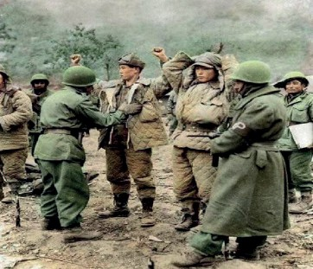
Source A: A photograph from the time of the Korean War (Denizli, 2024, p. 5)
Guiding Question 1: Uluslararası hukuka göre esaret ve esirlik nedir, esirler hangi haklara sahiptir?
Task 1: The students are asked/invited to examine Sources B, C, and D, to answer the related questions, and to carry out the newspaper writing activity (news/commentary) presented in Step 3.
Step 1: The students are asked/invited to examine Sources B, C, and D.
Source B: Captivity and Prisoners
In the Turkish Language Association (TDK) dictionary, the word ‘esir’ is defined as ‘slave’ or ‘captive’ (TDK, 2025) and is most commonly used to refer to a prisoner of war. Being captured, in captivity, or in imprisonment is one of the most painful aspects of war. Because captivity usually occurs in an environment of hostility during wartime, prisoners have historically remained highly vulnerable to abuse. At the same time, prisoners have also been regarded as an essential instrument or source of power used by the parties involved in war or conflict against one another.
In the past, the treatment of prisoners was entirely left to the will or discretion of the individual or institution that captured them. However, beginning in the nineteenth century, alongside developments in human rights, discussions emerged emphasizing that prisoners should also be entitled to certain rights, and efforts to improve conditions were initiated. One of the most significant developments following the Second World War was the Geneva Conventions, which laid the foundations of international law governing the treatment of prisoners of war (Geneva Conventions, 1949; İnan, 1972; International Committee of the Red Cross, 2025).

Source C: Those recognized and not recognized as prisoners of war under the Geneva Convention
Following the harm suffered by large numbers of civilians during wars, a conference was first held in Geneva in 1864 through the initiatives of the Swiss government. Later, in 1906 and 1929, the convention was revised with various amendments and additions, and four conventions were drafted. The third of these four conventions, titled ‘The Geneva Convention of 12 August, 1949, relative to the treatment of prisoners of war’ and signed by states worldwide on 9 December, 1949, forms the foundation of contemporary international humanitarian law.
According to the provisions of the Geneva Convention, those recognized as prisoners of war include:
- Members of a country’s armed forces;
- Personnel serving in non-combat roles within the armed forces, such as doctors and military chaplains;
- Members of militias and volunteer forces that a responsible leader commands, carry visible, distinctive signs, and openly bear arms;
- Civilians who rise and take up arms collectively;
- Civilian personnel accompanying the armed forces, such as war correspondents attached to military aircraft;
- Spies who enter enemy territory without changing their uniform.
Those not considered prisoners of war include:
- Individuals such as spies and armed civilians (guerrillas) who conduct covert or overt hostile activities against the enemy while disregarding the laws and customs of war. Such individuals are subject to various penalties under the laws of the enemy state (Geneva Convention, 1949; İnan, 1972).
Source D: Article 13 of the Geneva Convention on the protection of the rights of prisoners of war
- Prisoners of war must be treated humanely at all times. Any unlawful act or omission that causes the death of a prisoner of war or seriously endangers their health is prohibited.
Prisoners of war may not be confined in cells or similar closed detention facilities solely because of their status as prisoners of war. However, they may be detained in camps in order to prevent their return to the battlefield. They must be released and repatriated without delay after the cessation of active hostilities. Prisoners of war must be able to maintain contact with the outside world, particularly with their families and friends. They have the right to correspond by letter and message and to receive individual parcels or collective consignments containing food, clothing, or medical supplies.
- Prisoners of war must at all times be protected, particularly against acts of violence or intimidation, and against insults and public curiosity.
To protect their dignity and security, their images and personal information must not be made public.
- Reprisals against prisoners of war are prohibited.
Throughout their detention, prisoners of war must be treated humanely and with respect for their personality and dignity. They may not be subjected to coercive interrogation. International humanitarian law sets out minimum conditions of detention for prisoners of war, including provisions related to accommodation, food, clothing, hygiene, and medical care. Prisoners of war must receive adequate medical treatment. Seriously wounded or sick prisoners of war must be repatriated without delay (summarized from the Geneva Convention, 1949; İnan, 1972; International Committee of the (Red Cross, 2025).

Step 2: The students are asked/invited to answer the following questions based on Sources B, C, and D.

199
It has come to the attention of the United States Eighth Army that, from time to time, prisoners
of war have been subjected to improper treatment by units belonging to the United Nations. Such improper actions carried out by United Nations forces are contrary to the Geneva Convention of 1949. The enemy is also using them as a means to prevent their own soldiers from surrendering and seeking refuge within our lines as prisoners of war. On the other hand, due to the mistreatment of prisoners, we will also lose opportunities for propaganda in any future struggle against communism.
1.
CT.53-27 / 3 December 1951
U.N. 1st Turkish Armed Forces Command
Section: I Number:
Focusing on the treatment to be applied to prisoners of war
Source E: A directive prepared by the United Nations Forces Headquarters on how captured prisoners should be treated, and distributed to all units, including the Turkish Brigade (ATASE, 48-0-43a)
- According to Source B, what is captivity? What are the most important dangers, risks, or problems that prisoners may face?
- In an international legal text such as the Geneva Convention, why might it be necessary to specify in detail who is recognized as a prisoner of war and who is not? The students are asked/invited to research possible reasons/justifications.
- According to the Geneva Convention, what might be the reasons for not recognizing a person as a prisoner of war, who was captured by the enemy in arms at the time of a war?
- What is the primary purpose of the provisions summarized in Article 13 of the Geneva Convention presented in Source D? The students are asked/invited to discuss this.
Step 3: The students are asked/invited to research to what extent the provisions presented in Source D are taken into account by the parties involved in contemporary conflicts or wars (for example, the Russia-Ukraine War or Israel’s occupation in Gaza), and whether prisoners are treated in accordance with these provisions. Based on the data they obtain, the students are asked/invited to prepare a short newspaper text (news report/ opinion piece) that includes both their findings and their personal reflections on the evidence.

International Law and the Realities of War
..................................................................................................................................................................
..................................................................................................................................................................
..................................................................................................................................................................
..................................................................................................................................................................
..................................................................................................................................................................

Guiding Question 2: Kore Savaşı’na katılan BM Ordusu ve Türk Tugayı’nın esirlere nasıl yaklaşılması gerektiği ile düşmana esir düşmemek için alınacak tedbirlere yönelik bakış açısı ilgili talimatlara nasıl yansıtılmıştır?
Task 2: The students are asked/invited to examine Sources E, F, G, and H and to answer the related questions.
Step 4: The students are asked/invited to examine Sources E, F, and G.

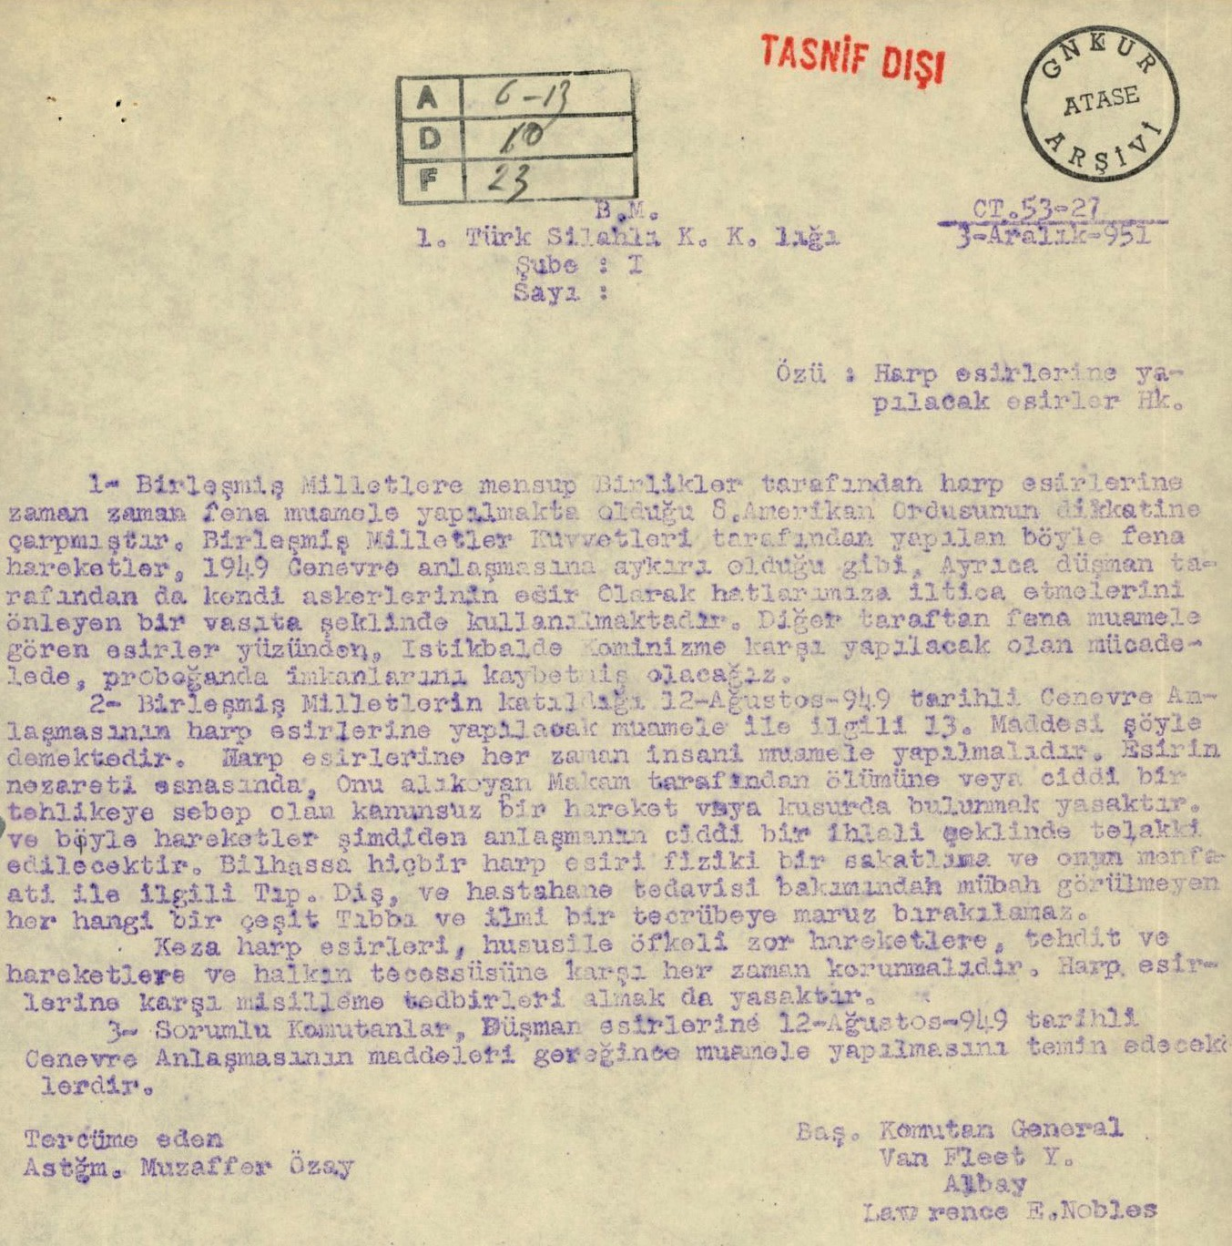
  - Article 13 of the Geneva Convention dated 12 August, 1949, to which the United Nations is a party, concerning the treatment of prisoners of war, states that prisoners of war must at all times be treated humanely. Any unlawful act or omission by the detaining authority that causes the death of a prisoner of war or seriously endangers their health is prohibited, and such acts shall be regarded as serious violations of the Convention. In particular, no prisoner of war may be subjected to physical mutilation or to any medical or scientific experiment that is not justified by medical, dental, or hospital treatment carried out in the interests of the prisoner.
Likewise, prisoners of war must at all times be protected, especially against violent or coercive acts,
threats, insults, and public curiosity. Reprisals against prisoners of war are also prohibited.
  - Responsible commanders shall ensure that enemy prisoners are treated in accordance with the provisions of the Geneva Convention dated 12 August, 1949.
Translated by For the Commander-in-Chief
Second Lieutenant Muzaffer Özsoy General Van Fleet (on behalf of) Colonel
Lawrence E. Nobles

Source F: Instructions sent by the Turkish Brigade to all its subordinate units regarding how prisoners taken should be treated (ATASE, 48-0-43b)
1st Turkish Armed Forces Command CT. / 4 December 1951 Section: V Number: 19376
The army order concerning the mistreatment of captured prisoners is attached. Article 128 on page 80 of the Internal Service Regulations regarding prisoners states as follows: “Every soldier must always bear in mind that harassing the unarmed civilians of the enemy country, especially women, children, and the elderly, and violating their lives, property, honor, and dignity are forbidden by religion and by law, Moreover, he must take honor and humanity as his guide in this matter. If civilians (women or men) within enemy territory are seen or suspected of attempting treason against the army or resorting to the use of weapons, they shall be treated as combatants. Prisoners of war must be treated well in a manner befitting Turkishness. Showing humanity to the wounded, to those weakened by illness or neglect, and to those who have fallen into helplessness and are no longer capable of bearing arms is the duty of every honorable soldier. The enemy dead must also be treated with respect. War is waged against the armed forces of the enemy. This means that once the enemy lays down or is made to lay down his arms and falls into the status of a prisoner,

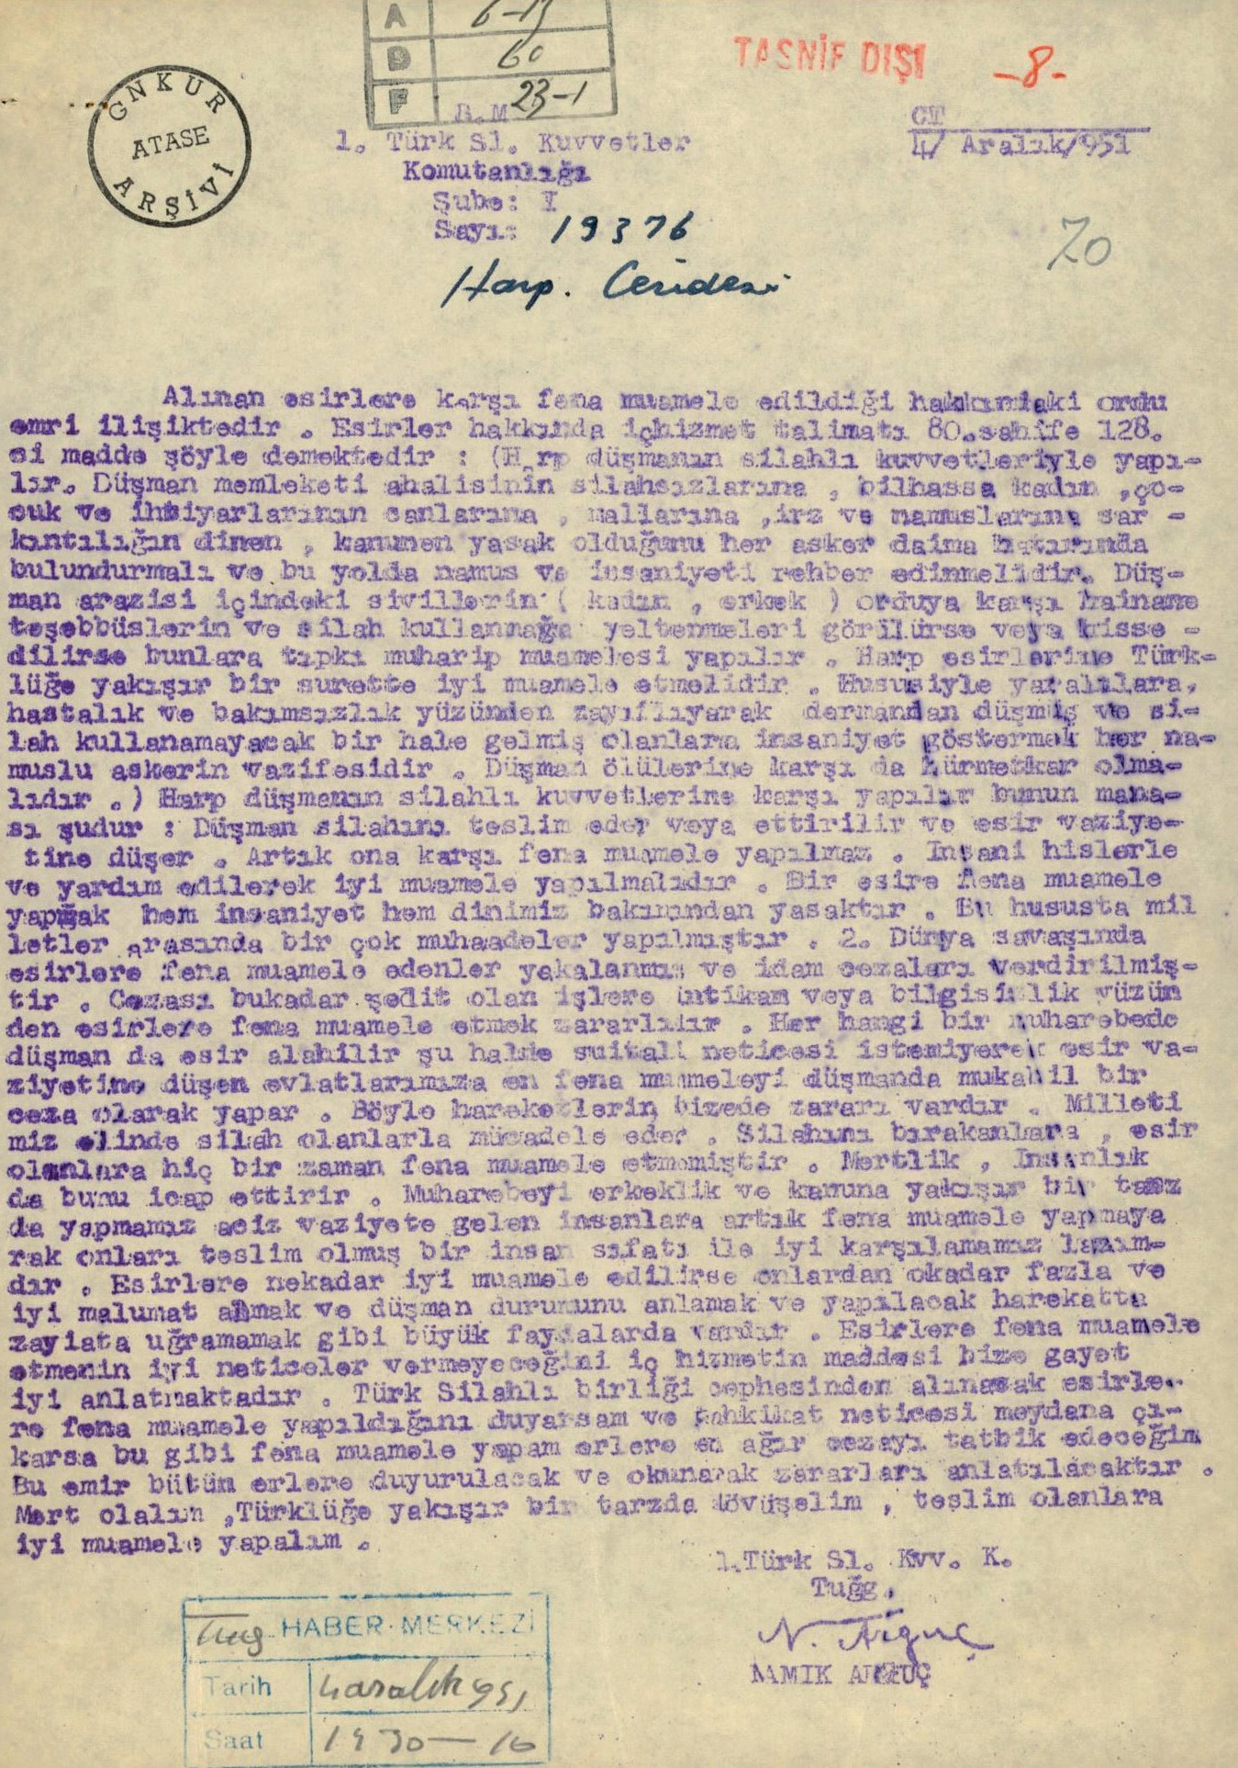
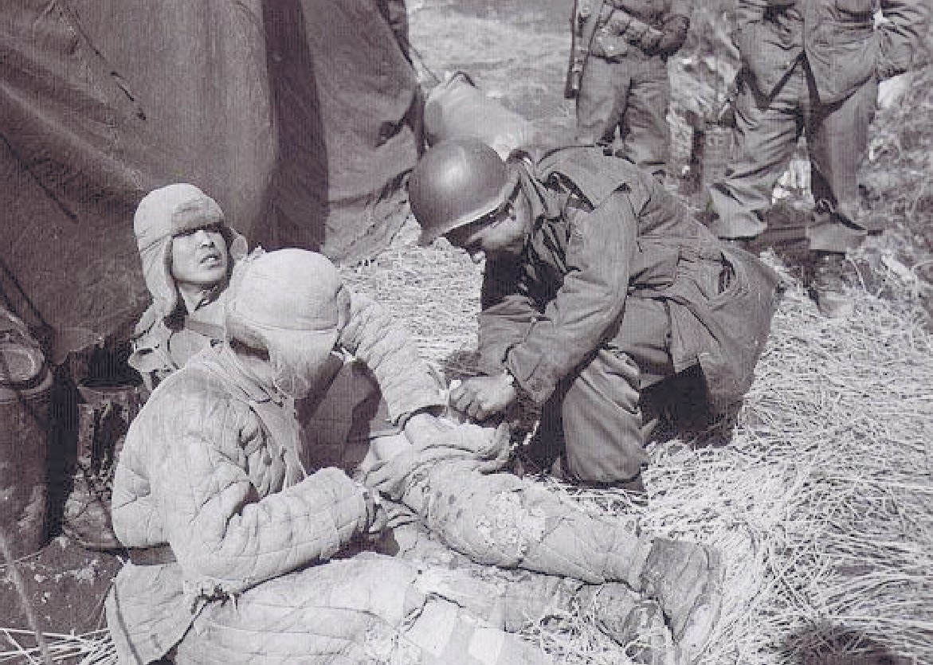
no ill treatment shall be inflicted upon him. He must be treated well with humane feelings and assistance. Mistreating a prisoner is forbidden both by humanity and by our religion. Many international deliberations have been held on this matter. Those who mistreated prisoners during the Second World War were captured and sentenced to execution. Given the severity of such punishment, mistreating prisoners out of revenge or ignorance is harmful. In any battle, the enemy may also take prisoners; therefore, as a retaliatory measure, the enemy may inflict the worst treatment upon our sons who fall into captivity unwillingly. Such actions are also harmful to us. Our nation fights those who bear arms. Those who lay down their arms and become prisoners have never been mistreated. Honor and humanity require this. We must conduct warfare in a manner befitting manhood and the law; once people become eligible for lawful treatment, we must no longer mistreat them and must receive them as surrendered human beings. The better prisoners are treated, the greater the benefits gained, such as obtaining more and better information from them, understanding the enemy’s situation, and avoiding casualties in future operations. The Internal Service Regulations clearly explain that mistreating prisoners will not yield positive
results. If I hear of or determine through investigation that prisoners taken by Turkish armed units have been mistreated, I will impose the heaviest punishment on the soldiers responsible. This order shall be announced and read to all soldiers, and its harmful consequences shall be explained. Let us be honorable; let us fight in a manner befitting Turkishness and treat those who surrender well.”
Turkish Armed Forces
Signature
Brigadier General NAMIK ARGUÇ

Source G: A photograph from the Korean War (Denizli, 2010, p. 90)

Step 5: The students are asked/invited to answer the following questions based on Sources E, F, and G.
- Why did the United Nations Army Command consider it necessary to prepare the directive presented in Source E?
- The students are asked/invited to compare the directive presented in Source F with the United Nations directive in Source E. What are the similarities and differences between these two directives in terms of their approach to how prisoners should be treated and the way they address the issue?
- Who might the people shown in Source G be? What appears to be taking place at the moment the photograph was taken?
- Do the scenes shown in Source G indicate how carefully the United Nations forces and the Turkish Brigade implemented the directives in Sources E and F? Why?
- With the statement, ‘Our nation fights those who bear arms. Those who lay down their arms and become prisoners have never been mistreated. Honor and humanity require this’, what message is the Turkish Brigade Commander trying to convey to the soldiers or other audiences beyond the Geneva Convention?
Step 6: The students are asked/invited to examine Source H.

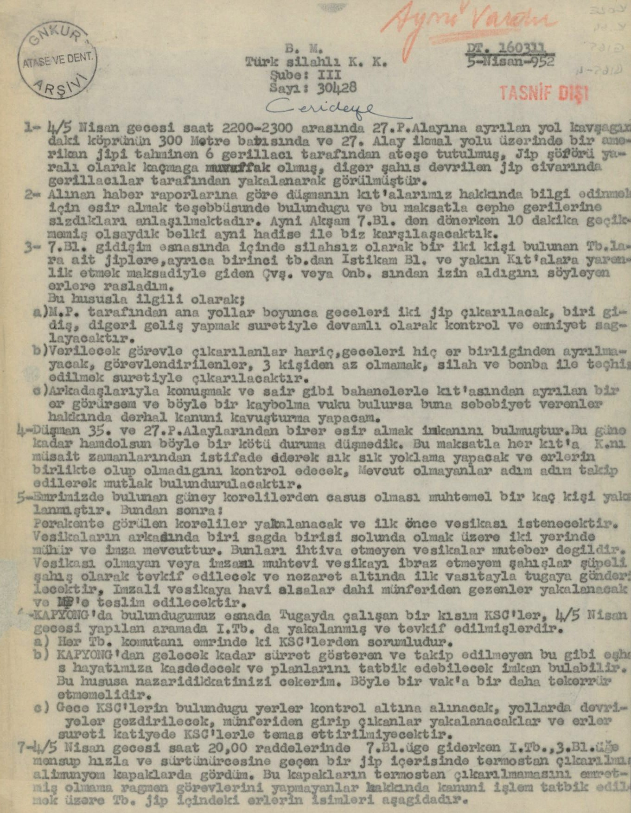
Source H: A directive outlining the measures to be taken to prevent soldiers from being captured by the enemy (ATASE, 25-1-39)
U.N. Turkish Armed Forces Command DT. 160311 / 5 April 952
Section: 304 Number: 30428
    - On the night of 4/5 April, 1951, an American jeep was fired upon by North Korean guerrillas, while the driver escaped wounded, the other individual was captured (taken prisoner).
    - Intelligence reports indicate that the enemy is attempting to capture personnel in order to obtain information about the United Nations forces.
    - Cases have been observed in which military vehicles carrying unarmed soldiers were approached by soldiers claiming that they had permission from a sergeant or corporal and stating that they were going to assist units other than their own.
About this matter;
▷ Two jeeps shall be deployed at night along main roads by the M.P. (Military Police); one operating outbound and the other inbound, in order to provide continuous control and security.
▷ Except for those officially assigned, no soldier shall leave his unit at night. Those who are assigned duties shall be dispatched in groups of no fewer than three, equipped with weapons and grenades.
▷ If any soldiers leave their units under pretexts such as talking with friends or similar excuses, immediate legal action shall be taken against both those individuals.

- The enemy has captured a number of soldiers attached to American units, whereas no such incident has occurred on the Turkish side. In order to prevent such incidents, roll calls shall be conducted frequently at appropriate times.
- Certain South Koreans assigned to the Turkish Brigade may be spies. Therefore, from now on:
▷ Koreans found wandering in a dispersed manner shall be detained, and their documents shall be checked first.
▷ Those without documents or with missing or problematic documents shall be detained as suspicious persons and sent to the Brigade. Those who have documents but are found wandering independently shall be apprehended and handed over to the Military Police.
▷ During the search conducted on the night of 4/5 April, several KSCs (Korean Civilian Employees) working within the Brigade were apprehended and detained on suspicion of being enemy agents. Each Battalion Commander is responsible for the KSCs under his command. Enlisted soldiers must under no circumstances have contact with KSCs.
- It has also been learned that soldiers have moved away from their units for purposes such as obtaining drinking water and have encountered various incidents. Commanders shall procure the water required by their units during the daytime, and no-one shall be sent to fetch water at night. Non-commissioned officers, sergeants, and corporals shall not have the authority to grant leave to enlisted soldiers and shall not dare to do so.
- Night inspections shall be conducted frequently within the Brigade. All matters specified in this order shall be read and explained collectively to enlisted soldiers. At appropriate places and times, signatures shall be obtained from officers, and no further tolerance shall be shown for such inappropriate conduct.
Please ensure that the necessary actions are taken accordingly.
Commander of the Turkish Armed Forces Brigadier General Namık ARGUÇ

Step 7: The students are asked/invited to answer the following questions based on Source H.
- According to Source H, what are the sources of risks and problems experienced within the United Nations forces and the Turkish Brigade regarding captivity, being taken prisoner by the enemy, and espionage activities?
- According to Source H, why do forces involved in war and armed conflict attempt to capture prisoners from the opposing side?
- Based on the information provided in Source H, what measures were taken against the risks of being captured by the enemy and/or espionage activities, as well as other related threats?
Guiding Question 3: How did the experiences of soldiers who were captured during the Korean War affect their lives while they were in captivity?
Task 3: The students are asked/invited to examine Sources I, J, K, L, M, N, and O, to answer the related questions, and to complete the speech-writing activity presented in Step 12.

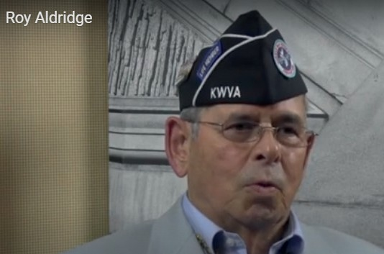
Step 8: The students are asked/invited to examine Source I.

Source I: Two excerpts from an oral history interview with American Korean War veteran Roy Aldridge (https://koreanwarlegacy.org/interviews/roy-aldridge/)
🕒 27:42-28:59
R. Aldridge: … and, uh, I was a passenger, and I opened up and

I kick the hatch out of the Bombay doors, and I dropped out. I think I tumbled. When I opened my chute, when I tumbled, just as I opened my chute, I saw the aircraft disintegrate. I was the only one survivor. I was the only survivor. Everybody’s asked me how high we were. All I can say is when my chute opened, I swung about three times and hit the ground in a rice paddy. You had Korean brown earth and, uh, before I could get my chute completely off, I was, they had me. Yeah. April the 13th. I don’t know if it was a Friday or not… You know, and, uh. Yes, Uh huh. They blindfolded me, they hit me two or three times and, uh, kept saying ‘chungee, chungee’, and I kept saying look, look, look, you know, you know?
🕒 30:16-35:51

R. Aldridge: I was transferred into a camp or what it is officially called, it was a holding area. If you look at the maps with all the prisoner of war camps, called Pak’s Palace, P-A-K’-S Palace, P-A-L-A-C-E. It was just outside of Pyongyang, North Korea. I was put in a small cell, and I was given some gruel-type soup. Looked like barley or something, oat, oats and rice or something and a small piece of bread to eat. One meal a day. There were no lights or anything. I mean, it was, wasn’t total darkness. There was, you could see a little light like through the curtains or something like that, you know. But, uh, you could see through the cracks of the cell. No, this was a hard building. It was a hard building. They took me out of that and took me into a marbled hall, very elegant hall. And there were three Koreans sitting up on this bench, and they were dressed. Hm. Very elegant, and they were all speaking Korean, North Korean, I don’t know if there’s a difference between two languages and I still don’t. And, uh, the one Korean officer sitting by me, uh. He was asking my name and I told him my name, and I said I’m Airman Second Class, or Airman First Class Roy E. Aldridge, AF19453530, and he asked me did you drop bombs, and I said, unfortunately I said yes cause that’s, they knew, and, uh. He was my translator. I guess, uh. Anyway, they read and stood up and read my name. I understood my name, and when it was all over with, uh, my translator told me I was a war criminal and I’d just been convicted for crimes against humanity for biological and chemical warfare against the People’s Republic of North Korea, and I was sentenced to die. And they tied my hands behind my back, walked me down the hall, and then they untied my hands and said now, this is the interpreter. Had another North Korean officer, and they hit me two or three times, and, uh, he says if you sign these papers where you confessed to doing crimes against humanity, you will receive life in prison. You will not die. Well, stubborn I guess, I don’t know. I would not disgrace my country, and I wouldn’t, not disgrace my family, and I told him to go to hell. No. And they hit me two or three more times and asked me to sign, I said no. Then they tied my hands behind my back, took me outside the compound, and I dug a hole. A shallow grave. And they tied my hands behind my back again, pushed me down on my knees, put a blindfold on me, and I felt the gun muzzle at the back of my head, and it went click, and they got me up, and I urinated all over myself and, and, and, and then defecated in my pants, and they took me back to my cell. Six times they did that to me. Six times. And there was 20, 30 of us, I can’t remember, I have no idea as to how many were in there. Only Air Force. It was South African Air Force, Australian Air Force, British Air Force, U.S. Air Force, prisoners there, and then one day they came in and, time means nothing now.

204

Step 9: The students are asked/invited to answer the following questions based on Source D and Source I.
- If the experiences Roy Aldridge went through during his capture had happened to you, what would you think and how would you feel?
- What kind of treatment was Roy Aldridge subjected to while he was in captivity?
- To what extent is the treatment Roy Aldridge experienced during captivity consistent with the provisions of the Geneva Convention summarized in Source D? Why?
- What might be the reason for the North Korean officer’s attempt to force Roy Aldridge to sign documents confessing to crimes against humanity, with the promise that his death sentence would be commuted to life imprisonment if he did so? For what purpose might the North Koreans have intended to use a document signed by Roy Aldridge? Discuss.
Step 10: The students are asked/invited to examine Source J and Source K.
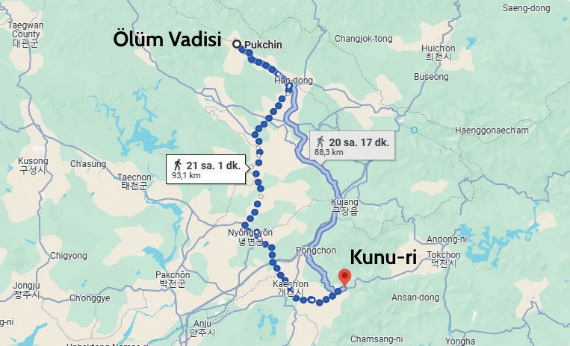
Source J: The Death March and the Valley of Death
During the Battles of Kunuri, a group of soldiers was taken prisoner. This group of captured soldiers was marched toward the borders of North Korea and Manchuria. Their route led to a temporary camp located in Hofong, known as the ‘Cold Camp’ or the ‘Valley of Death’. The captured prisoners were forced to march for hours in winter conditions, at temperatures ranging from −20 to −25 degrees Celsius, while suffering from hunger and sleep deprivation. During this march, some developed pneumonia, while others lost their lives due to frozen and gangrenous fingers caused by the extreme cold, as they were barefoot, or because their bleeding wounds froze. Guards repeatedly forced the prisoners to keep moving using bayonets and kicks. As the prisoners had no plates or utensils, they ate the food thrown in front of them by placing it on their clothing or in their hats (summarized from Onur Çifci, 2020, pp. 90-98).
Source K: A map of North Korea showing the Kunuri area and the Valley of Death (Google, 2025)

Step 11: The students are asked/invited to answer the following questions based on Source J and Source K.

206
  - According to Source J, what kinds of difficulties did the prisoners experience during the march to the temporary camp?
  - What might be the reasons for subjecting prisoners to the treatment and hardships described in Source J?
  - How might the experiences described in Source J during the journey have affected the prisoners physiologically and psychologically?
  - Apart from those mentioned in Source J, what other risks and dangers might the prisoners have been exposed to? Discuss.
  - Source K shows the route along which the death march took place. Consider how prisoners, many of whom were likely wounded or ill, lacked seasonally appropriate clothing and footwear, and were forced to walk approximately ninety km mostly at night during the coldest days of winter, might have endured this journey. If you were in their place, what would you think and how would you feel?
Step 12: The students are asked/invited to examine Source L and Source M.
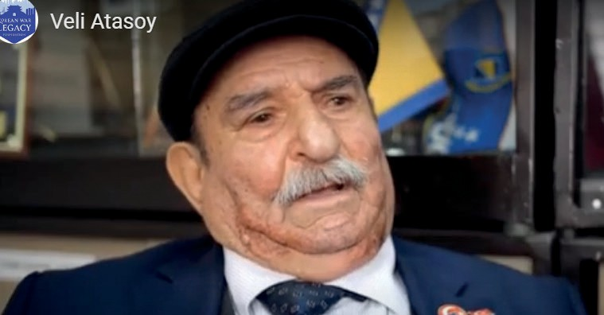
Source L: Captivity experiences of Turkish Prisoners
Prisoners were given boiled, unsalted grains, either shaped into balls or made into porridge, twice a day. The food tasted so bad that it was almost inedible. On one occasion, Captain Yüksel and his soldiers marched without food for two days. Malnutrition caused many prisoners to suffer from night blindness, commonly known as ‘chicken blindness’, which made night marches even more difficult. When food was not provided or was insufficient, the Turkish prisoners tried to meet their energy needs by collecting edible grass, leaves, and hot peppers from the roadside (summarized from Onur Çifci, 2020, pp. 165–166).
When the convoy stopped to rest in a village reduced to ruins, one of the Turkish prisoners shouted at the top of his voice, “Run, run, I found it, I found meat.” When the crowd of Chinese guards and prisoners reached the spot, they saw that what had been found was the skin of a cow or ox that had been lying there for a long time and had become maggot-infested and rotten. The prisoners lit a fire there and placed the skin over it, first watching the maggots embedded throughout burn away, then the hair on the skin burn. Afterwards, they shared and ate the thoroughly roasted skin among themselves (summarized from Rusçuklu, 2007, pp. 238–239).
Source M: Two excerpts from an oral history interview with Korean War veteran Veli Atasoy (https://koreanwarlegacy.org/interviews/veli-atasoy/)
🕒 12:21 - 13:05
V. Atasoy: Even when we were still in the unit, it turns out that
our letters were being stolen, the stamps were removed, and the letters were torn up. Before we were captured, there was a fake sergeant in the unit, he was called ‘Müfrüt sergeant’, and he was the one doing this. Later, we caught him. We never saw letters being delivered or received in the unit, and we did not see any during captivity either, in the prisoner camp. In other words, there was no correspondence with Türkiye at all; no letters.
🕒 19:26 - 20:10
V. Atasoy: There was no contact at all from Korea until we returned to Türkiye. No contact whatsoever. My father even went to the consulate and, asking what had happened to his son, beat himself against stones and walls, but there was nothing that could be done; we had become prisoners. In the unit, incoming letters were being torn up, so we did not know about them. Then we were captured, and again there was nothing from home. The Americans were corresponding by letters, some of them could communicate, but we did not receive any letters.

Step 13: The students are asked/invited to answer the following questions based on Source L and Source M.
- According to Source L, what are the main problems that prisoners experience during captivity?
- According to Source L, what methods did Turkish prisoners resort to in order to cope with malnutrition or hunger?
- Considering that prisoners were willing even to eat the skin of a maggot-infested animal due to hunger and malnutrition, discuss what the hardships and limitations of life in captivity can compel individuals to do.
- According to veteran Veli Atasoy, what was the reason for the communication problems experienced by Turkish soldiers while they were still in their units?
- Put yourself in the place of veteran Veli Atasoy’s mother or father and imagine that you had not received any news for years from your son who had been sent to Korea with his unit. What would you feel, what actions would you take, and where would you seek help? Why?
Step 14: The students are asked/invited to form groups of three, four, or five and prepare a speech evaluating the extent to which the treatment of prisoners by North Korea and China, with Soviet support, during the Korean War was consistent with international law. In preparing their speeches, the students are asked/invited to compare the relevant provisions of the Geneva Convention with the prisoner experiences presented in Sources I, J, L, and M.

Was the law also held captive?
..................................................................................................................................................................
..................................................................................................................................................................
..................................................................................................................................................................
..................................................................................................................................................................
..................................................................................................................................................................

Step 15: The students are asked/invited to examine Source N and Source O.
Source N: An interrogation report of an enemy soldier captured during the Korean War (ATASE, 114-0-53)
Initial Interrogation Report of a Prisoner of War 11 May 1953
1. Identity of the prisoner and his unit
- Name: T’ING-SI
Nationality: Chinese Rank: Private
Duty: Battalion Messenger Education: None
Age: 22
Occupation: Textile worker Date of enlistment: August 1952
Gender, physical traits, relatives: None
- Unit: 1st Field Army, 65th Army, 195th Division 585th Regiment, 1st Battalion.

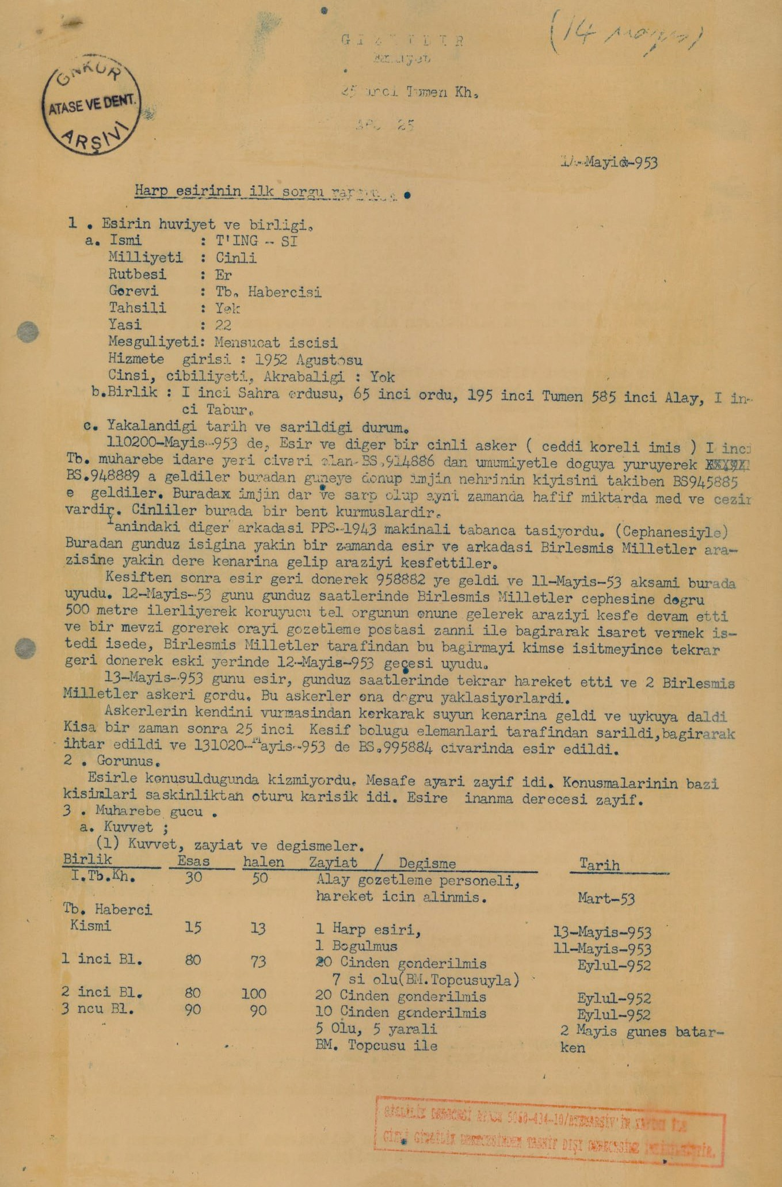
c. Date and circumstances of capture:
At 110200-May-953, the prisoner and another Chinese soldier (reportedly of Korean origin) departed from BS.94886, located near the 1st Battalion combat command post, generally proceeding eastward and arriving at XXXX ES.94889. From there, they turned south and followed the bank of the Imjin River, reaching BS.945885. At this location, the Imjin River is narrow and shallow and also shows slight tidal activity. The Chinese had constructed a small dam there.
The other soldier accompanying him was carrying a PPS-1943 submachine gun (with ammunition). Near daylight hours, the prisoner and his companion approached a stream close to United Nations territory and conducted reconnaissance of the area. After the reconnaissance, the prisoner returned to 958882 and slept there on the evening of 11 May, 1953.
During daylight hours on 12 May, 1953, he advanced approximately five hundred meters toward the United Nations front, reached the front of the protective wire obstacle, and continued reconnaissance. Upon observing a position, which he assumed to be an observation post, he attempted to shout and signal. As no-one on the United Nations side heard him, he returned and slept again at his previous location on the night of 12 May, 1953.
On 13 May, 1953, during daylight hours, the
prisoner moved again and saw two United Nations' soldiers were approaching him. Fearing that the soldiers might shoot him, he went to the water’s edge and fell asleep. After a short time, he was surrounded by elements of the 25th Reconnaissance Company, warned by shouting, and was captured at 131020-May-953 in the vicinity of BS.995884.
- Appearance
During questioning, the prisoner became flushed. His distance perception was weak. Some parts of his statements were confused due to disorientation. The degree of credibility attributed to the prisoner was low.
- Combat Capability
a. Strength (1)
Unit |  | Authorized | Present | Losses / Changes | Date
Hq. Bn. Sec. |  | 30 | 50 | Regimental observation personnel assigned for movement | March-53
Bn. Messenger Section |  | 15 | 13 | One prisoner of war, one drowned | May-953
1st Company |  | 80 | 73 | Twenty sent from China | 11-May-953
 |  |  |  | Seven killed (by U.N. artillery) | Sept-952
2nd Company |  | 80 | 100 | Twenty sent from China | Sept-952
3rd Company |  | 90 | 90 | Ten sent from China | Sept-952
 |  |  |  | Five dead, five wounded | 2 May sunset time
 |  |  | With UN artillery
208

Source O: A photograph taken during the Korean War (ATASE, 2016, p. 161)

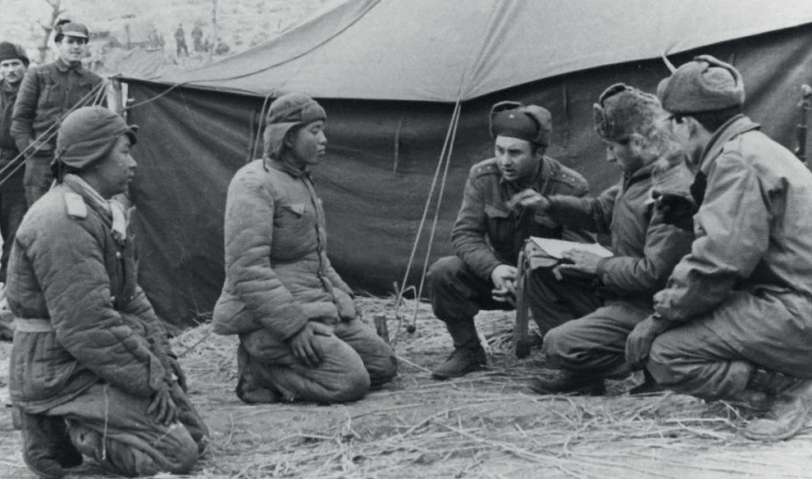
Step 16: The students are asked/invited to answer the following questions based on Source N and Source O.
- What sections does the interrogation report of the captured Chinese soldier consist of? Why might the report have been structured in this way?
- From whose perspective is the account of what the prisoner did before being captured written? Why might this narrative choice have been made?
- Based on the initial interrogation of the captured soldier, what information did the Turkish Brigade Command obtain about the enemy?
- To what extent do the scenes shown in Source O appear to be consistent with what is described in Source N? Why?
- Considering Sources N and O together, what can be said about how enemy soldiers captured by Turkish forces were treated? Why?
🎯Assessment and Evaluation
- Based on the experiences of a number of Turkish soldiers whose captivity stories are summarized in this study unit, students are asked/invited to define the concept of ‘captivity’.
- The students are asked/invited to explain what soldiers should do and what kinds of precautions they should take in order to avoid being captured by the enemy.
- The students are asked/invited to discuss which values can be associated with the ability of captured Turkish soldiers to endure hardships and survive with resilience. Why did they?
- If you were assigned the task of establishing a body of war law that all countries must follow, students are asked/invited to explain what additional principles they would include, beyond those stated in Source D, regarding how prisoners of war should be treated. Why?

References

210
ATASE. (2016). Ateşkesin 60’ıncı yıldönümünde Kore Savaşı [The Korean War on the 60th anniversary of the Armistice].
Genelkurmay Personel Başkanlığı Askerî Tarih ve Stratejik Etüt (ATASE) Başkanlığı Yayınları.
Denizli, A. (2010). Kore Harbinde Kunuri zaferi [The victory of Kunuri in the Korean War]. Turhan Kitabevi. Denizli, A. (2024). Kore’de barış: Türk-Kore ilişkileri [Peace in Korea: Turkish–Korean relations]. Sonçağ Akademi.
Cenevre Sözleşmesi. (1949). Üçüncü Cenevre Sözleşmesi [Third Geneva Convention]. http://www.madde14.org/ index.php?title=Harp_Zaman%C4%B1nda_Sivillerin_Korunmas%C4%B1na_%C4%B0li%C5%9Fkin_1949_ Cenevre_S%C3%B6zle%C5%9Fmesi Access Date: 23.07.2025
Çiftci, A. O. (2020). Ben Türk: Kore Savaşı’nda Türk esirler [Me Turk: Turkish Prisoners in the Korean War] (2nd ed.).
Istanbul: Timaş Yayınları.
Cumhurbaşkanlığı Devlet Arşivleri Başkanlığı Millî Savunma Bakanlığı Askeri Tarih Arşivi. [Presidency of State Archives, Ministry of National Defense, Military History Archive]. ATASE Place No: 48-0-43a, (1951).
Cumhurbaşkanlığı Devlet Arşivleri Başkanlığı Millî Savunma Bakanlığı Askeri Tarih Arşivi. [Presidency of State Archives, Ministry of National Defense, Military History Archive]. ATASE Place No: 48-0-43b, (1951).
Cumhurbaşkanlığı Devlet Arşivleri Başkanlığı Millî Savunma Bakanlığı Askeri Tarih Arşivi. [Presidency of State Archives, Ministry of National Defense, Military History Archive]. ATASE Place No: 114-0-53, (1952).
Cumhurbaşkanlığı Devlet Arşivleri Başkanlığı Millî Savunma Bakanlığı Askeri Tarih Arşivi. [Presidency of State Archives, Ministry of National Defense, Military History Archive]. ATASE Place No: 25-1-39, (1953).
Google. (2025). Pukchin, Kuzey Pyongan, Kuzey Kore → Aril-li, Kuzey Kore [Pukchin, North Pyongan, North Korea → Aril-li, North Korea] Google Maps. https://www.google.com/maps/dir/Pukchin,+Kuzey+Pyongan,+Kuzey+Kore/Aril-li,+Kuzey+Kore/@39.926994, 125.8662458,299314m/data=!3m1!1e3!4m15!4m14!1m5!1m1!1s0x5fd4a5d33b44023d:0x23b461152f4b19d
7!2m2!1d125.7537464!2d40.1894286!1m5!1m1!1s0x5fd45a0a19917d3d:0xd2ba70e1685d68f6!2m2!
1d126.033333!2d39.7!3e2!5i1!5m1!1e2?entry=ttu&g_ep=EgoyMDI1MDkxNS4wIKXMDSoASAFQAw%3D%3D Access Date: 18.07.2025
Han, J. (2018a). Interview with Roy Aldridge. https://koreanwarlegacy.org/interviews/roy-aldridge/ Access Date: 13.02.2025 Han, J. (2018b). Interview with Veli Atasoy. https://koreanwarlegacy.org/interviews/veli-atasoy/ Access Date: 20.08.2025. İnan, Y. (1972). Harp esirleri [Prisoners of war]. Ankara Üniversitesi SBF Dergisi, 27(3), 259–264.
Rusçuklu, B. (2005). Kore Savaşı: Unutulan savaş ve Gazi Faruk Pekerol’un anıları [The Korean War: The forgotten war and the memoirs of veteran Faruk Pekerol]. Istanbul: Arvo Yayınları.
International Committee of the Red Cross. (2025). Prisoners of war: What you need to know. https://www.icrc.org/en/ document/prisoners-war-what-you-need-know Access Date: 03.09.2025
🏠
Homework
The students are asked/invited to examine the articles of the Geneva Convention related to the treatment of prisoners of war through online research. They are asked/invited to investigate whether, and to what extent, individuals held in captivity as a result of contemporary conflicts and wars benefit from the rights set out in the Convention. In addition, the students are asked/invited to identify institutions and organizations that monitor the implementation of these rights and work to ensure their protection, and to research the types of activities these bodies carry out. The information and findings obtained are to be compiled into a written text and stored in the students’ electronic portfolios.

