TURKISH MARTYRS IN KOREA
Unit 9
🎓 Grade Level:
9th, 10th, and 11th Grades

⏰ Teaching Time:
40 + 40 + 40 minutes

Concepts to Digest: Martyr, catechism, religious practices
Skills to Improve: Historical empathy, historical inquiry and analysis
Core Values: Friendship, altruism, patriotism, helpfulness

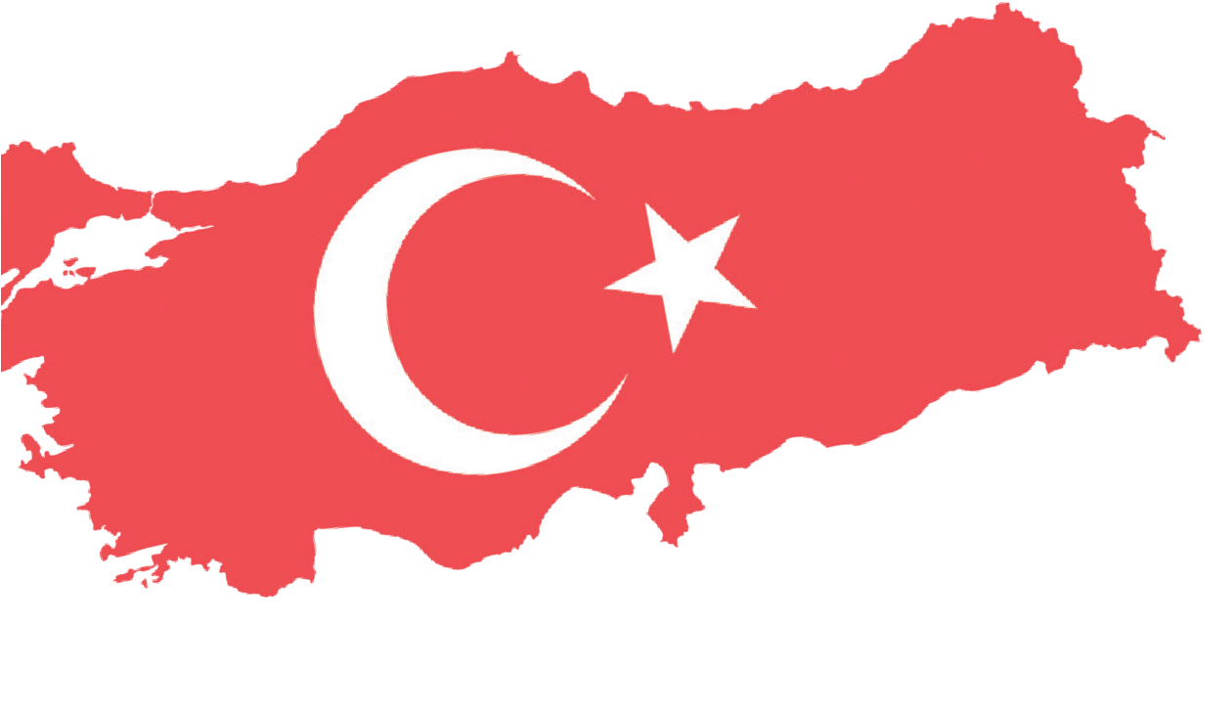
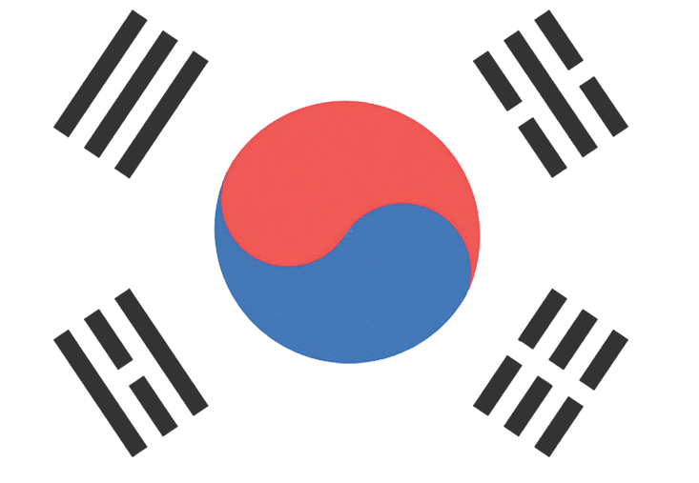

Methods-Techniques: Direct instruction, historical inquiry, case study analysis, questioning, oral history, role play
Teaching-Learning Materials: Archival documents, oral history interviews, photographs
Learning Aim: Based on the experiences and stories of Turkish soldiers who participated in the Korean War, this study unit aims to enable students, to draw inferences about the concept of martyrdom and the religious and worldly meanings attributed to it, and to develop an evidence-based understanding of how Turkish soldiers who were martyred in Korea are remembered and commemorated.
Key Question: How do beliefs and values influence an individual’s capacity to cope with the difficulties they encounter?
Guiding Question 1

What kinds of spiritual and moral support do soldiers need to endure and fight in wars, and what measures were taken to meet these needs for the Turkish soldiers who participated in the Korean War?

Objective 1

To understand the types of moral motivation soldiers require and to comprehend what was done to meet these needs for the Turkish soldiers who took part in the Korean War.
Task 1
By examining Note 1 and Sources B, C, D, E, F, and G, the students are asked/
invited to answer the related questions and to carry out the presentation preparation activity given in Step 5.
Guiding Question 2

How do the martyrdom stories of those who fell in the Korean War and the memories of veterans offer a perspective
on the Turkish soldiers’ moral motivation during the war and their approach to martyrdom?

Objective 2

To develop an understanding of the Turkish soldiers’ moral motivation during the war and their approaches to martyrdom by analyzing the martyrdom stories of those who fell in the Korean War and the memories of the veterans.

Task 2

By examining Sources H,
I, J, K, L, and M, students are asked/invited to answer the related questions and to complete the letter-writing
activity in Step 12 and the role-playing activity in Step 15.
Guiding Question 3

What has been done, and what is still being done, to
honor the rights of the Turkish soldiers who were martyred in Korea and to remember and commemorate them?
Objective 3

To develop an evidence-based awareness of the actions taken to honor the rights of the Turkish soldiers who were martyred in Korea and to remember and commemorate them.
Task 3

By examining Sources N, O, P, and R, students are asked/ invited to answer the related questions.

Teaching and Learning Plan

‼ Focus on Activity
The students are asked/invited to examine Source A together and to answer the related questions.
5 min.
🛎 Task 1
By examining Information Note 1 and Sources B, C, D, E, F, and G, the students are asked/
invited to answer the related questions and to carry out the presentation preparation activity given in Step 5.
35 min.
🛎 Task 2
By examining Sources H, I, J, K, L, and M, the students are asked/invited to answer the
related questions and to complete the letter-writing activity given in Step twelve and the role-playing activity in Step fifteen.
35 min.
🛎 Task 3
By examining Sources N, O, P, and R, the students are asked/invited to answer the related questions.
40 min.
An assessment activity which involves answering open-ended questions.
5 min.
🎯 Assessment and Evaluation

🏠 Homework
After examining Sources S and T and Information Note 2, the students are asked/invited to prepare a booklet using the information and visuals provided in these sources. The completed booklet is saved in the students’ digital portfolios.

Teaching and Learning Process
Focus on Activity: The students are asked/invited to examine Source A and to speculate on when and where the photograph was taken, who the people in the picture might be, and what was taking place at the time.
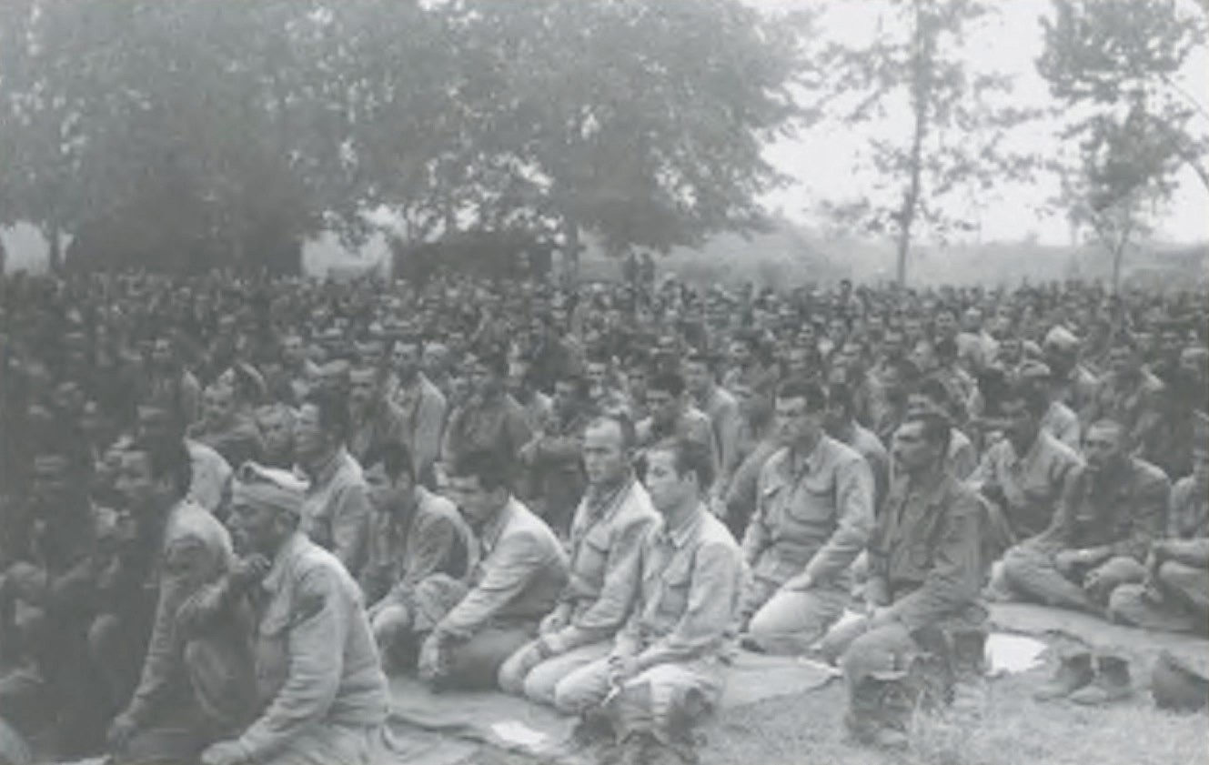
Source A: A photograph from the time of the Korean War (AsMvKSK, 2019, p. 216)

Guiding Question 1: Askerler, savaşlarda mücadele edebilmeleri için manevi açıdan ne tür desteklere ihtiyaç duyarlar ve Kore Savaşı’na katılan Türk askerlerinin bu ihtiyaçlarını karşılamak için neler yapılmıştır?
Task 1: The students are asked/invited to examine Note 1 and Sources B, C, D, E, F, and G, to answer the related questions, and to complete the presentation preparation activity in Step 5.
Step 1: The students are asked/invited to examine Information Note 1, Source B, and Source C.
Note 1:
Military service, as a duty or profession, is perhaps one of the most difficult yet most sacred callings, as it requires individuals to risk, and when necessary, to sacrifice their lives. In situations such as conflict and war especially, soldiers need a spiritual force, namely moral motivation, that will multiply their material strength when facing life-threatening risks. In such circumstances, a soldier must first possess a strong state of mind to use effectively not only physical strength, such as arm and muscle power, but also weapons, equipment, and other resources at their disposal. In other words, regardless of which tools, weapons, machines, or equipment are used in a conflict or war, it is ultimately the human being who uses them and benefits from them. This is when the central element is the human being, the values, attitudes, tendencies, and beliefs that person holds, in short, their morale and motivation, become decisive (prepared by the authors).

Source B: The soldiers’ morale and motivation
Morale, in general terms, is a state of mind that determines desire, hope, confidence, and determination. In other words, morale is a psychological state characterized by mental and emotional excitement and reflects individuals' and groups' feelings and thoughts about their work and duties. In military life, the personal dimension of morale is the feelings a soldier has about their duty. It is a matter of job satisfaction and personal fulfillment for the soldier.
As a concept, motivation refers to the process of encouraging, stimulating, or prompting action. In Turkish, it is commonly associated with terms such as drive, incentive, or activating force. Functionally, motivation can be defined as ‘individuals acting of their own will and desire to achieve a specific goal’. In the military, motivation can be understood to be a soldier’s readiness to carry out every duty with great willingness and to take any risks encountered during the execution of assigned tasks.
In situations such as conflict or war, values and beliefs are commonly invoked to motivate soldiers and boost their morale. In this context, within the Islamic faith, the most essential concepts referred to are martyrdom and being a veteran (Gülhan, 1996).

Source C: Martyrdom and being a Veteran
A martyr is defined in dictionaries as a person who dies for a sacred cause or belief. In Islamic belief, a martyr is defined as a person who sacrifices his life in the path of God, aspiring to something better than this world and all that it contains. Another meaning of martyrdom is to voluntarily renounce worldly life and its blessings to attain the highest spiritual rank and remain in that state (Atar, 2010; Gülhan, 1996; TDK, 2025).
The concepts of martyr and martyrdom are found not only in Islam but also in Judaism, Christianity, and Sikhism. Scholars who have examined these religions and belief systems have identified specific characteristics of martyrdom. A number of these include the willing acceptance of death, the heroic manner in which it occurs and is witnessed by others, the benefits it provides to others, and the expectation of salvation or reward in the afterlife (Gürkan, 2010).
A veteran (gazi) is a title and honorific used especially by Turks for those who fight for religion, originally as an equivalent to the term ‘mujahid’. Over time, however, this meaning has narrowed, and the concept of being a veteran has come to be used mainly for those who fought for religious reasons and survived the conflict (Özcan, 1996; TDK, 2025).

Step 2: The students are asked/invited to answer the following questions based on Information Note 1, Source B, and Source C.
- According to Note 1, what do soldiers need most during moments of conflict or war?
- In Source B, what kinds of risks faced by a soldier are implied by the statement ‘…being willing to take any risks that may be encountered during the execution of assigned duties’?
- Based on the information provided in Source B, define the concepts of morale and motivation in your own words.
- According to Islamic belief, what reward is promised to a person who voluntarily renounces worldly life and its blessings? Research this issue.
- How might the concepts of martyrdom and being a veteran, and the meanings they convey, have influenced Turkish soldiers fighting in Korea? Discuss with your classmates.

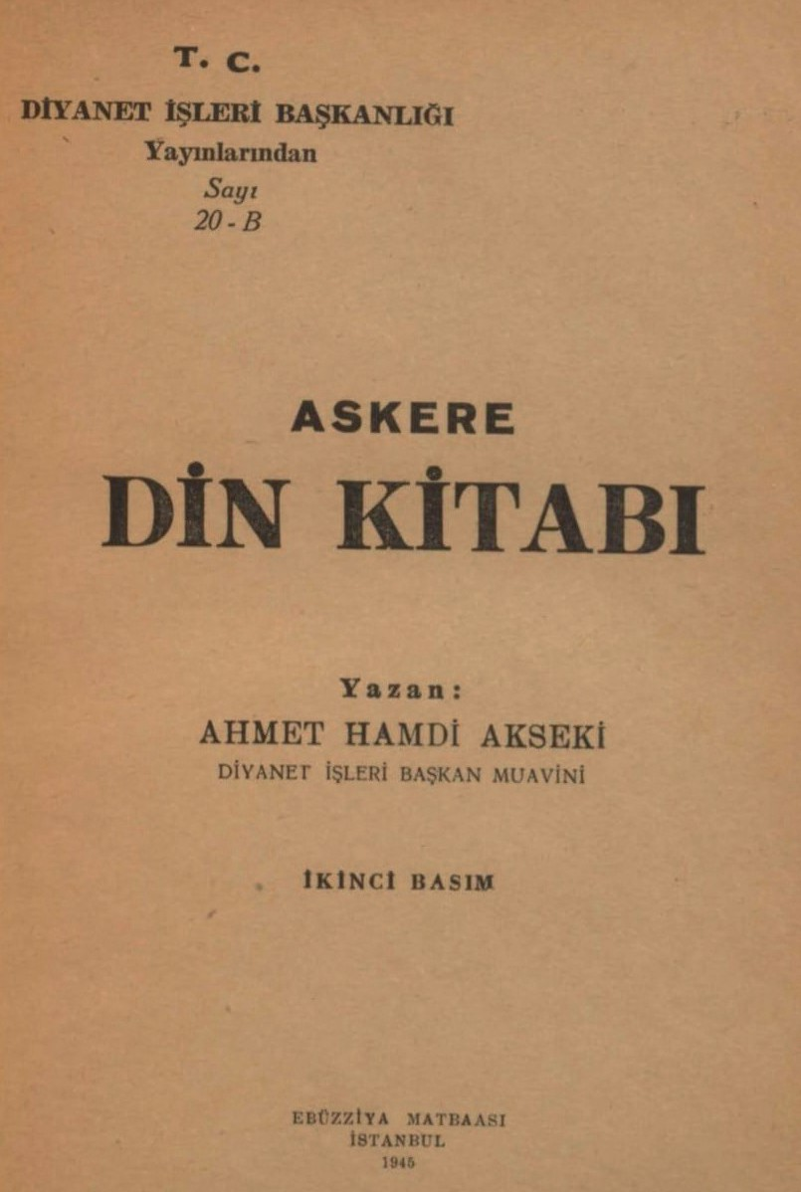
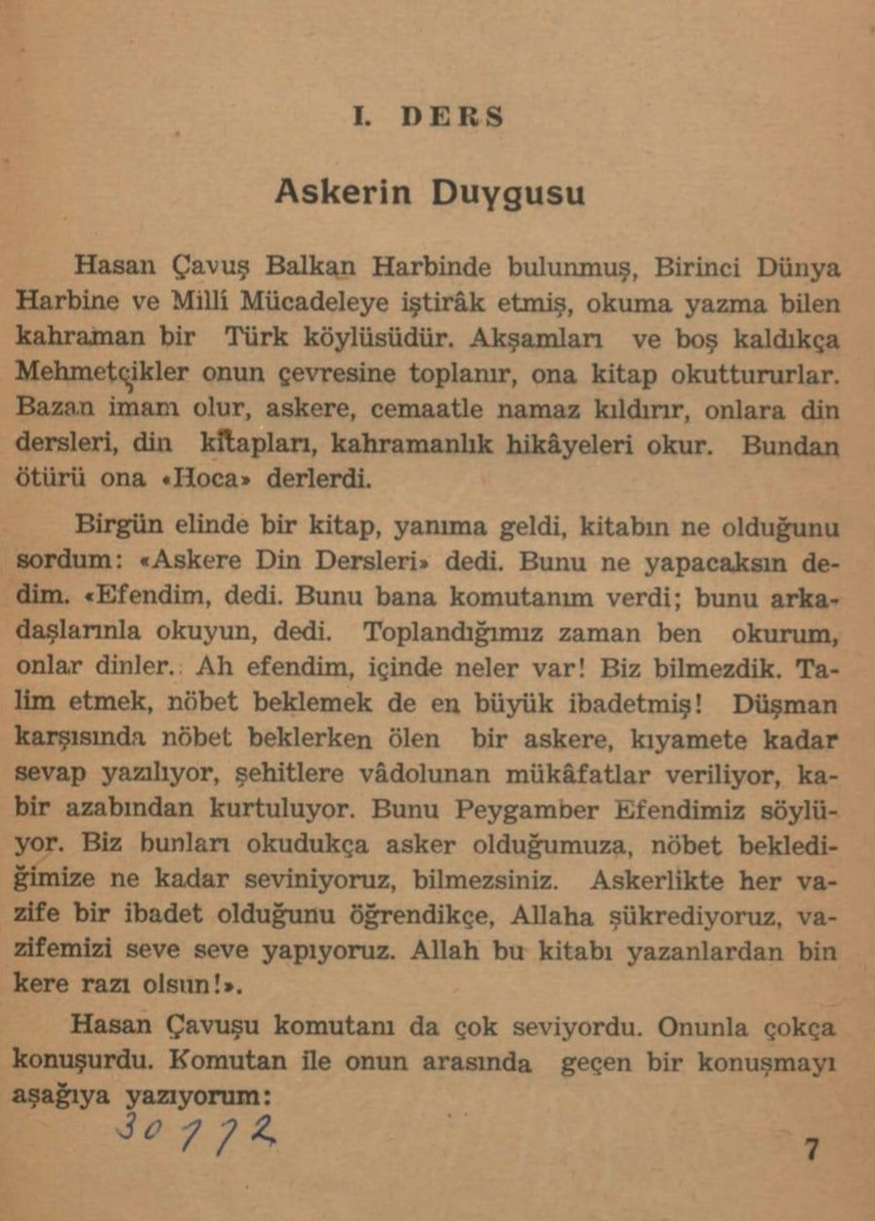
Step 3: The students are asked/invited to examine Source D and the related source.

Source D: ‘A Religious Guidebook for Soldiers’ prepared by the Presidency of Religious Affairs of the Republic of Türkiye (Akseki, 1945).

LESSON I
The Soldier's Feelings
Participated in the Balkan War, the First World War, and the National Struggle, Hasan Çavuş is an educated heroic Turkish peasant. In the evenings and whenever they are free, the ‘Mehmetçiks’ (Turkish soldiers) gather around him and have him read books to them. Sometimes he becomes the imam, leads the soldiers in congregational prayer, and reads them religious lessons, religious books, and stories of heroism. Because of this, they used to call him ‘Hoca’ (the teacher).
One day he came to me with a book in his hand; I asked him what the book was and he replied, ‘Religious Lessons for the Soldier’. I asked, what will you do with this? He replied, "Sir, my commander gave this to me and said to read this with your friends. When we gather, I read and they listen. Oh sir, if you only knew what is inside! We did not know. It turns out that training and keeping watch are also the greatest forms of worship! For a soldier who dies while keeping watch against the enemy, merit (thawab) is recorded until the Day of Judgment; they are given the rewards promised to martyrs and are saved from the torment of the grave. Our Prophet says this. You cannot imagine how happy we are to be soldiers and to keep watch as we read these things. As we learn that every duty in military service is an act of worship, we thank Allah and perform our duty gladly. May Allah be pleased a thousand times over with those who wrote this book!"

Source E: Values
Friendship: This value refers to the affection, attachment, companionship, and loyalty that individuals show toward one another. During the Korean War, the sense of camaraderie, loyalty, and commitment among soldiers can be considered a reflection of the value of friendship.
Altruism: Described also as selflessness, altruism refers to a person’s willingness to make sacrifices for the well-being of others without considering personal interests. A soldier who gives the last drop of water from his canteen to a wounded comrade at the front exemplifies altruism.
Patriotism: This value means loving one’s homeland and nation with a deep passion and being willing to make every kind of sacrifice for this cause. Those who translate this value into action are described as patriotic. It reflects an individual’s love for and loyalty to their country.
Helpfulness: This value refers to enjoying helping others and sincerely choosing to do good for them. Under wartime conditions, the support and assistance that Turkish soldiers provided both to one another and to Korean civilians can be shown as examples of this value (TDK, 2025).

Step 4: The students are asked/invited to answer the following questions based on Source D and Source E.
- Why might the Presidency of Religious Affairs have felt the need to prepare a religious guidebook specifically for soldiers?
- Besides their beliefs, which values do soldiers draw upon when they risk their lives and fight the enemy during war?
- According to Source D, what is promised in Islam to those who are martyred while performing their military duty?
- What is meant by the statement in Source D that every duty performed in military service is regarded as an act of worship?
- Why might the author of Source D have preferred to present religious knowledge through a narrative using a character named Hasan Corporal, rather than conveying it directly?
- Which of the values defined in Source E are addressed in the text on the book page presented in Source D?

Step 5: The students are asked/invited to form groups of three or four and research a real-life story from their own lives, or from the lives of a relative or a friend, related to each of the values defined in Source E. Afterwards, as a group, they are asked/invited to examine the stories they have found and to identify the one with the most impact. Finally, they are asked/invited to prepare a presentation to share this story with their teacher and classmates.

Our Values
..................................................................................................................................................................
..................................................................................................................................................................
..................................................................................................................................................................
..................................................................................................................................................................

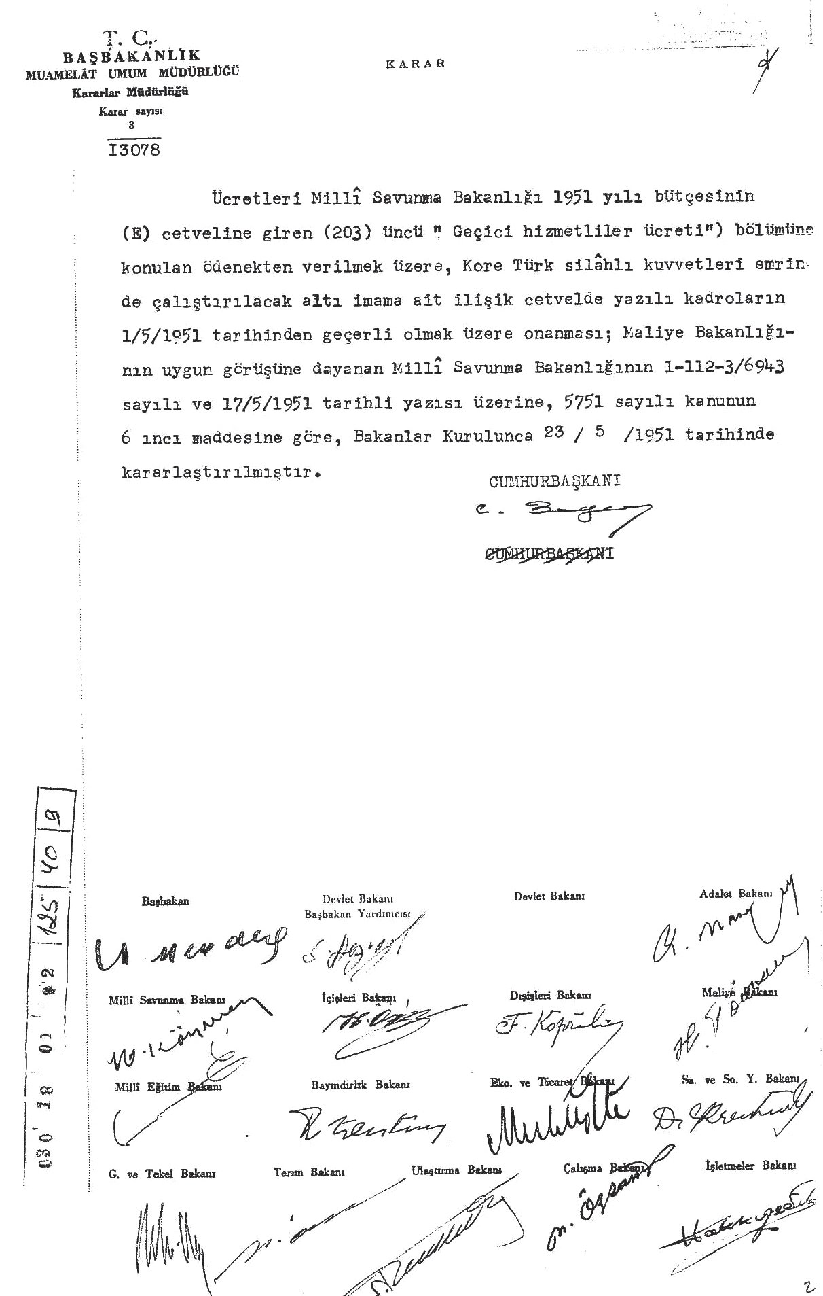
Step 6: The students are asked/invited to examine Source F and Source G.
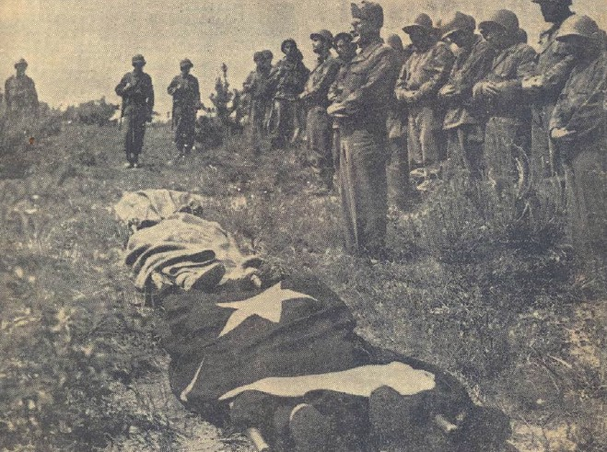

Source F: A photograph from the Korean War (Denizli, 2010, p. 235)

Source G: A Council of Ministers decision on the appointment of six imams to serve under the Command of the Korean Turkish Armed Forces (ATASE, 125-40-9)
Republic of Türkiye Prime Ministry
General Directorate of Procedures Department of Decisions Decision No: 3/13078
Decision
The approval of the positions listed in the attached schedule for six imams to be employed under the command of the Korean Turkish Armed Forces, with their salaries to be paid from the appropriation allocated to Section (203), ‘Wages of Temporary Personnel’, included in Table (B) of the Ministry of National Defense’s 1951 budget, to be adequate as of 1 May 1951. This is based on the favorable opinion of the Ministry of Finance and upon the letter of the Ministry of National Defense dated 17 May 1951 and numbered 1-112-3/6943 and has been decided by the Council of Ministers on 23 May 1951 pursuant to Article 6 of Law No. 5751.

President
C. Bayar

Prime Minister
A. Menderes

The signatures of the Deputy Prime Minister and other ministers are present.

217

Step 7: The students are asked/invited to answer the following questions based on Source F and Source G.
- What is the event shown in the photograph in Source F? Who are the people seen in the image?
- Why might there have been a need for a religious official, such as an imam, at the front during wartime?
- What kinds of services might the imams appointed through Source G have provided for Turkish soldiers fighting in Korea?
- Which beliefs and values might soldiers have relied on in order to cope with the hardships they faced at the front?
Guiding Question 2: How do the martyrdom stories of those who fell in the Korean War and the memories of veterans offer a perspective on Turkish soldiers’ moral motivation during the war and their approach to martyrdom?
Task 2: The students are asked/invited to examine Sources H, I, J, K, L, and M, to answer the related questions, and to complete the letter-writing activity in Step 12 and the role-playing activity in Step 15.
Step 8: The students are asked/invited to examine Sources H, I, and J.
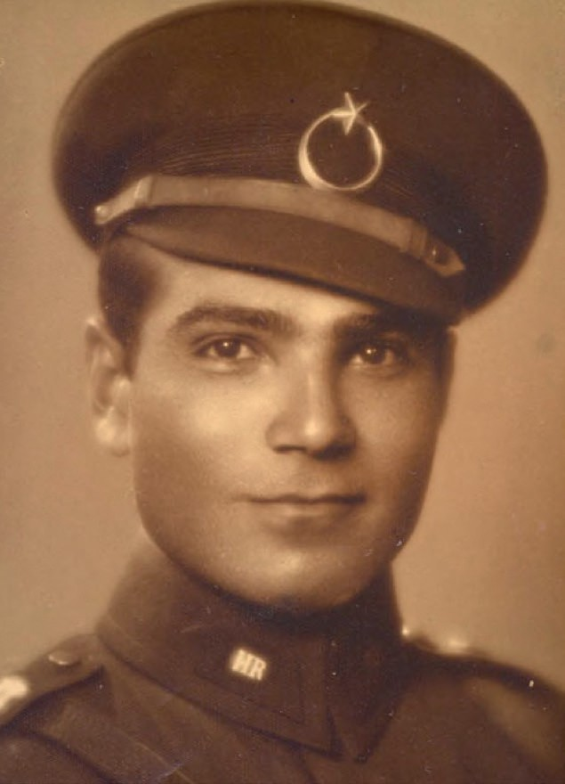
Source H: The moral motivation of Turkish soldiers during the Gallipoli Campaign
“The distance between the opposing trenches was eight meters; in other words, death was inevitable… Those in the first trench were all martyred without exception; those in the second trench took their place. They knew they would die within three minutes, yet they showed not the slightest fear; there was no sign of wavering. Those who could read held the Qur’an in their hands, preparing to enter paradise. This is an admirable example that demonstrates the spiritual strength of the Turkish soldier. You can be certain that it was this lofty spirit that won the Battle of Gallipoli” (quoted from M. Kemal Atatürk; Öner, 1989, p. 28).
Source I: A martyr: Captain Kaya Aldoğan
When the Korean War began, Senior Captain Kaya Aldoğan was serving as the Head of the Kuşadası Military Recruitment Office. He was only included in the unit to be sent to Korea after submitting his application for a third time. Appointed as the Commander of the 1st Company of the 4th Battalion in the Korean Turkish Brigade, Kaya Aldoğan and his company were among the first units to take part in the Battles of Kunuri. On the night of 28/29 November 1950, on the Simninni hills northeast of Kunuri, the enemy initially retreated in the face of the 1st and 2nd Turkish Battalions on the front line but soon launched a very strong counter attack. The withdrawal of friendly units on both flanks, leaving the area exposed, further weakened the situation of the Turkish unit. Toward midnight, it was learned that an enemy column advancing from the left was attempting to seize a pass north of Kaechon. Captain Aldoğan’s company, which was in reserve, undertook this mission, quickly secured the pass, and opened fire on the enemy. After realizing that a large number of enemy soldiers were attempting to encircle them, Captain Aldoğan ordered Platoon Commander Lieutenant Halil Akdoğan to withdraw with part of the
company, stating that he and the remaining soldiers would stay behind to cover them. While they were withdrawing, a grenade battle began between the enemy group approaching the position and those who

remained with Captain Aldoğan. The enemy was forced to retreat, leaving hundreds of dead behind. A soldier who survived that clash wounded later described what he witnessed that night as follows:

“My captain, Corporal Abdullah, and Mustafa took cover behind a ruined wall. The captain threw perhaps more than twenty grenades. At one point, he said, ‘I have been hit, boys’, but he kept throwing grenades. Just as he was about to throw the last grenade, we were caught in a rain of fire. My captain cried out once more, ‘Oh my mother!’ and collapsed. The grenade in his hand fell beside him. One or two seconds later, a tremendous explosion threw everything into chaos.”
Captain Aldoğan was shot in the wrist just as he had pulled the pin of the grenade and was about to throw it. The grenade fell from his hand and exploded, causing his death. When the positions were re-entered the following morning after the enemy had withdrawn, only a few pieces of clothing, eight grenade rings, bloodstains splattered on the rocks, and the buckle of the strap of the camera he had brought with him to Korea were found (summarized from Denizli, 2010, pp. 1-29).

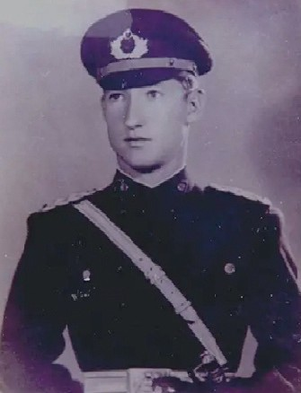
Source J: A Martyr: Lieutenant Mehmet Günenç
On the evening of 22 April 1951, while intense fighting in the Korean War was continuing, enemy forces began attacking UN troops along the entire front near the Han River. Turkish units were ordered to make the necessary preparations and defend the sector placed under their control. At around 11:00 p.m., the officers of the 9th Turkish Company, positioned on Hill 425, realized that the U.S. Company of the 24th U.S. Regiment, deployed on their right flank, was no longer in its position. They also saw that the Philippine Battalion, which was supposed to secure their left flank and rear, had already abandoned its position. As a result, enemy forces approached the defensive positions where Turkish units were resisting with relative ease. Despite everything, the 9th Turkish Company tried to hold its position as long as possible. The enemy captured many soldiers, and a large number were martyred. After midnight, radio communication between the 9th Company and the Turkish Brigade Headquarters became very weak. At around 12:20 a.m. on the night of
23 April, the officers at the Turkish Artillery Battalion Headquarters heard a voice coming through the radio. It was First Lieutenant Mehmet Günenç speaking.

“The enemy has taken control of the hill where we are positioned. We have suffered heavy losses. The Infantry Company Commander has been captured, and our radio operator has been killed. I am now giving you the coordinates where all artillery batteries must open fire.”
A short while later, the liaison officer at the Turkish Artillery Battalion Headquarters replied:

“The location you have described is exactly the place where you are right now.”
First Lieutenant Mehmet Günenç responded:

“Yes, you are right. We do not want to be captured by the enemy. Do not allow us to be taken prisoner. We are ready and willing to die under our own fire. I am giving the coordinates again. All artillery batteries must open fire to destroy the hundreds of enemy soldiers surrounding us.”

After this transmission, the radio fell silent.
The officers at the Turkish Artillery Battalion Headquarters were stunned by this request. A fellow officer was asking for artillery fire to be directed at the very location where he and other Turkish soldiers were fighting. After assessing the situation, they decided to fulfil First Lieutenant Mehmet Günenç’s final request. Shortly thereafter, not only the batteries of the Turkish Artillery Battalion but also many other batteries belonging to UN Forces opened fire on Hill 425. The following day, UN forces recaptured Hill
425. Turkish forces suffered sixty-two martyrs and thirty-five wounded, while the enemy captured one hundred and five soldiers; a number which included those who went missing. The Chinese Division, on the other hand, suffered approximately one thousand casualties and more than two thousand wounded. The remains of First Lieutenant Mehmet Günenç were never located (summarized from Denizli, 2011, pp. 175-181).

Step 9: The students are asked/invited to answer the following questions based on Sources H, I, and J.
- According to the statements given in Source H, to which characteristic of the Turkish soldier does Mustafa Kemal Atatürk attribute the victory of the Gallipoli Campaign? Why is this?
- According to the information in Source I, Captain Kaya Aldoğan gave up his relatively comfortable post as the Head of the Kuşadası Military Recruitment Office and applied three times to go to Korea. Which values he embraced might have motivated him to act in this way?
- What might have been the reason for Captain Aldoğan ordering the platoon commander to withdraw with part of the company? With which value or values can this action be associated? Why do you think this way?
- In Source J, it is stated that despite the withdrawal of the allied units assigned to defend the right and left flanks in the face of increasingly intense enemy attacks, the Ninth Turkish Company continued to resist and tried to hold its position. What kind of sense of duty does this behavior of the Turkish soldiers demonstrate? Why?
- Lieutenant Mehmet Günenç’s request to direct artillery fire onto the positions he and a few of his comrades were defending shows what kind of moral and spiritual strength he and his comrades possessed.
- What values does Lieutenant Mehmet Günenç’s making such a request indicate that he embraced?
- Based on the stories of Captain Kaya Aldoğan and Lieutenant Mehmet Günenç, what might the relatives who sent their husbands, fathers, brothers, or children to Korea alive and well, but could not even reach their bodies, have felt, thought, and experienced?

Step 10: The students are asked/invited to examine Source K.

Source K: A record document listing the belongings of a soldier martyred in Korea; Hasan, the son of Mustafa Taşkın. (ATASE, 42-0-55)
The personal effects listed below, indicating their type and quantity, belong to Corporal No. 8569 Hasan, son of Mustafa Taşkın, a martyr from our 4th Battalion on 28 September 1951, registered in Izmir (930).
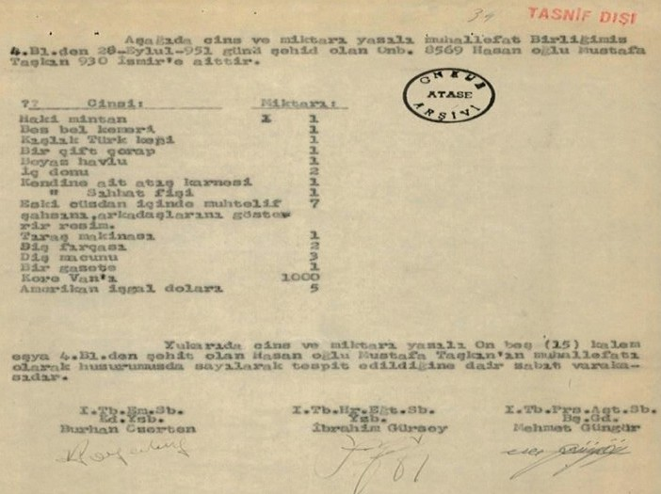
Type Quantity
Khaki shirt 1
Canvas belt 1
Winter Turkish cap 1
One pair of socks 1
White towel 1
Underwear 2
Personal marksmanship record 1
Personal medical record 1

Photographs in an old wallet | 7
Shaving razor | 1
Toothbrush | 1
Toothpaste | 1
Newspaper | 1
Korean Won 1000
U.S. occupation dollars 5
This is the official record stating the fifteen (15) items listed. The above were counted and identified in our presence as the personal effects of Hasan, son of Mustafa Taşkın, who was martyred in the 4th Battalion.
1st Bn. Training Section 1st Bn. Training & Education Sec. 1st Bn. Personnel and Logistics
Section.
Sr. Capt. Burhan Özerten Capt. İbrahim Gürsoy Master Sgt. Mehmet Güngör

Step 11: Answer the following questions based on Source K.
- What might be the reason for preparing this official record?
- What clues do the belongings found on the fallen Turkish soldier give us about the conditions under which the war was fought?
- Classify the items listed in the record according to their type or purpose of use.
- Why do you think the document bears the signatures of three different individuals? Research and discuss.

Step 12: Put yourself in the place of one of the close comrades-in-arms of a soldier who was martyred in Korea and write a letter to inform his family of his martyrdom. In your letter, you may include your memories of your fallen friend, his words and actions at the moment of his martyrdom, the belongings he left behind, and how you will remember and honor him. Those who wish may choose, instead of writing a letter, to find a poem written for martyrs and write it down.

Dear, loyal, and long-suffering family of my martyred brother,
..................................................................................................................................................................
..................................................................................................................................................................
..................................................................................................................................................................
..................................................................................................................................................................

Step 13: The students are asked/invited to examine Sources L and M.

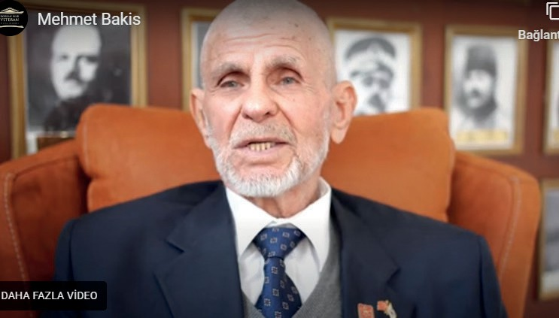
Source L: Two excerpts from an oral history interview with Korean War veteran Mehmet Bakış (https://koreanwarlegacy. org/interviews/mehmet-bakis/)
🕒 05:51 – 07:29
M. Bakış: First, we went to Vegas, then to Chorwon, and after that to the front I which mention last. There were major clashes there; we suffered heavy casualties. We
did not see much at first, we did not engage, but when we finally did, the fighting lasted twenty-four hours straight. There were places where the enemy was that close to us; 10 meters, 15 meters away. Yes, that is close. Opposite us were Koreans, North Koreans. I was not wounded, but the men next to me went through a lot. In fact, a wounded man came, he was utterly exhausted, and his life was basically gone. I gave him some water from the cap of my canteen, and then he passed away.
🕒 08:01 - 09:49
M. Bakış: After that, the Americans came and took over from us. They could not defend the place either, so they abandoned it. It fell to the North Koreans. We took very heavy losses there, maybe around forty martyrs, three lieutenants, one senior sergeant major, and one staff sergeant. The bodies of these men were never found. Unfortunately, we could not find them. What happened was the following: when we withdrew, we said, “We will go to collect the bodies.” They said we should go to collect the bodies, but unfortunately, we never had the chance. The weapons we had were no longer usable. What remained stayed there, we could not retrieve them, sadly.

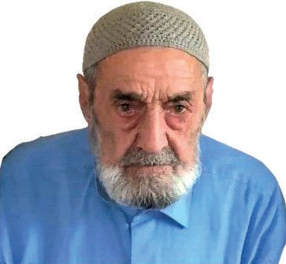
Source M: An excerpt from an oral history interview with Korean War veteran Mustafa Süt (https://koreanwarlegacy.org/interviews/mustafa-sut/)
M. Süt: We experienced a great disaster. I went to Korea and took part in the war. I fought. I had a friend named Mustafa Çoban. He was wounded after stepping on a mine, and one of his legs was amputated. There was a sheikh from my hometown Adıyaman; his name was Sufi Mehmet. He was wounded and returned home, but he later became a martyr. I did not see where he was wounded. I stayed with them for almost a year; five
months at the front and five months in support services. They opened fire on the tent where we were staying. They threw hand grenades. Twelve of our comrades were martyred. We responded there, and the enemy retreated. While we were fighting at the front, America betrayed us and poured bullets on us. I stayed at the heart of the war for three months.

Step 14: The students are asked/invited to answer the following questions based on Sources L and M.
- Imagine that you are in the combat situation described by Veteran Mehmet Bakış, facing an armed and fully equipped enemy at a distance of only 10-15 meters, almost face-to-face. How would you feel?
- What did Veteran Mehmet Bakış do as a final duty for the wounded Turkish soldier? Do you think this action was appropriate and meaningful? Why do you think so?
- The fact that the Turkish unit could not even find an opportunity to recover the bodies of their fallen soldiers highlights which aspect of war?
- Imagine witnessing, as Veteran Mustafa Süt did, the loss of twelve of your friends right before your eyes in a single moment of the war. How would you feel and what would you think?
Step 15: Role Playing
Based on the story presented in Source L by Veteran Mehmet Bakış, the students are invited to perform a creative drama using the roles below.
Scenario 1: ‘The Last Drop of Water’ A scene is reenacted in which a soldier gives water from the lid of his canteen to his wounded comrade, followed by the comrade’s martyrdom.
Scenario 2: ‘The Bond of Brotherhood’ A scene is reenacted depicting soldiers who voluntarily take risks by entering enemy-controlled territory to recover the bodies of their martyred comrades, their experiences during this mission, and a dialogue that takes place when informing the family about the martyrdom of their loved one.
After the role-playing activity, students who take part are asked/invited to share with their classmates what they thought and how they felt while performing their roles.
Guiding Question 3: Kore’de şehit olan askerlerin haklarını teslim ederek onları hatırlamak ve anmak neler yapılmış ve yapılmaktadır?
Task 3: The students are asked/invited to answer the relevant questions by examining Sources N, O, P, and R.

Step 16: The students are asked/invited to examine Source N.

Source N: Information on the countries that participated in the Korean War on behalf of the United Nations and the Units they deployed (Türkiye Muharip Gaziler Derneği, 2025)
Country and Type of Unit Deployed (Combat: C, Medical Support: MS) | Initial Number of Troops Deployed | Number of Troops Deployed During the Course of the War | Missing/ Lost and Killed/ Dead | Dates of Entry and Withdrawal
Turkey (C) | 5.726 | 56.536 | 724* | 17.10.1950 / 1971
USA (C) | 302.482 | 1.789.000 | 36.94 | 27.06.1950 / 1957
United Kingdom (C) | 14.198 | 56 | 1.078 | 29.06.1950 / 1957
Canada (C) | 6.146 | 25.687 | 321 | 26.07.1950 / 1957
Australia (C) | 2.282 | 8.407 | 339 | 29.06.1950 / 1957
New Zealand (C) | 1.389 | 3.794 | 23 | 30.07.1950 / 1955
Philippines (C) | 1.4 | 7.42 | 112 | 19.09.1950 / 1955
France (C) | 1.119 | 3.421 | 262 | 29.07.1950 / 1965
Thailand (C) | 1.294 | 6.326 | 129 | 16.07.1950 / 1955
Greece (C) | 1.263 | 4.099 | 192 | 01.12.1950 / 1955
Ethiopia (C) | 1.271 | 3.518 | 121 | 06.05.1951 / 1965
Colombia (C) | 1.068 | 5.1 | 163 | 08.05.1951 / 1955
Belgium (C) | 900 | 3.498 | 99 | 31.01.1951 / 1955
Netherlands (C) | 819 | 5.322 | 120 | 16.07.1951 / 1955
Luxembourg (C) | 44 | 3.794 | 2 | 31.01.1951 / 1953
South Africa (C) | 826 | 826 | 34 | 16.11.1950 / 1963
Sweden (MS) | 154 | 162 | – | 28.09.1950 / 1957
Norway (MS) | 105 | 623 | 3 | 22.06.1950 / 1954
India (MS) | 70 | 627 | 1 | 20.11.1950 / 1953
Italy (MS) | 72 | 623 | – | 16.11.1951 / 1955
Denmark (MS) | 100 | 630 | – | 07.03.1951 / 1953
* It has not been determined whether the information in this table was obtained from sources of the Ministry of Foreign Affairs of the Republic of Korea, nor has it been found to be consistent with various Turkish sources.

Step 17: The students are asked/invited to answer the following questions based on Source N.
- According to Source N, which country sent the most troops to assist South Korea following the UN call? What is Turkey’s rank in the order?
- According to the table, which country suffered the highest number of casualties in the Korean War? What is Turkey’s rank in this regard?
- What kind of relationship can be observed between the number of troops sent by countries participating in the Korean War and the casualties they suffered?
- A number of countries sent only medical support units to Korea. What might be the reasons for this? Research and discuss.

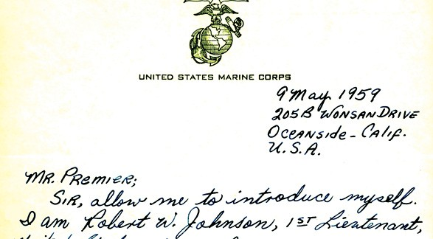
Step 18: The students are asked/invited to examine Source O.

Source O: A letter sent by an American officer who participated in the Korean War to the Prime Minister of the time, Adnan Menderes (ATASE, 58-359-8)

United States Marine Corps
9 May 1959
205B Wonsan Drive, Oceanside,
U.S.A.
Mr. Premier,
Sir, allow me to introduce myself. I am Robert W. Johnson, 1st Lieutenant, United States Marine Corps. In 1952, I was a corporal in the USMC and served in Korea until May 1953. In that year, I had the honor of fighting alongside your soldiers. My admiration for your country has never ceased. I truly wish every nation were half as good an ally as Turkey, and their combat units even half as good as your soldiers.
Sir, the reason I write to you is to secure the address where I may send a small sum to purchase a wreath of flowers to be put on the grave of one of your unidentified dead service members.
Please do not be offended by my writing directly to you, as I am sure you have many pressing matters at hand.
I would greatly appreciate your help, sir. Respectfully yours,
Robert W. Johnson
1st Lt., 0972337, U.S.M.C.R.
205B Wonsan Drive Oceanside, Calif.

Step 19: Students are asked/invited to answer the following questions based on Source O.
- Why did American First Lieutenant Johnson feel the need to send this letter?
- What kind of opinion does Lieutenant Johnson hold about the Turkish soldiers who participated in the Korean War? What might be the source or reason for these views?
- By requesting that the wreath purchased with the money he sent be placed on the grave of an unidentified soldier, and through the feelings and thoughts he expressed in his letter, which values does Lieutenant Johnson demonstrate that he embraces? Why?
Step 20: The students are asked/invited to examine Sources P and R.
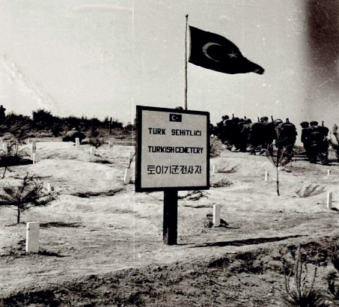
Source P: The Turkish martyrs’ section at the United Nations Memorial Cemetery in Busan, South Korea (Denizli, 2011, p. 114)

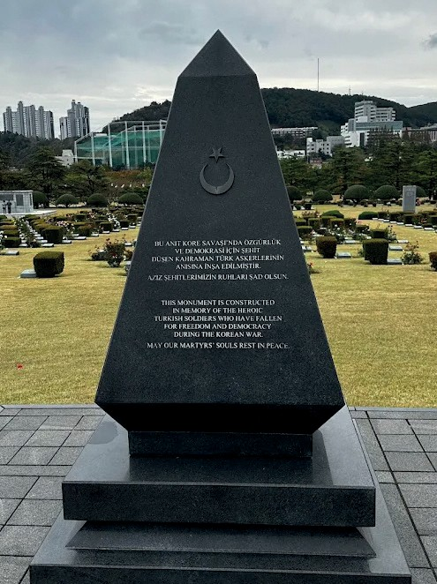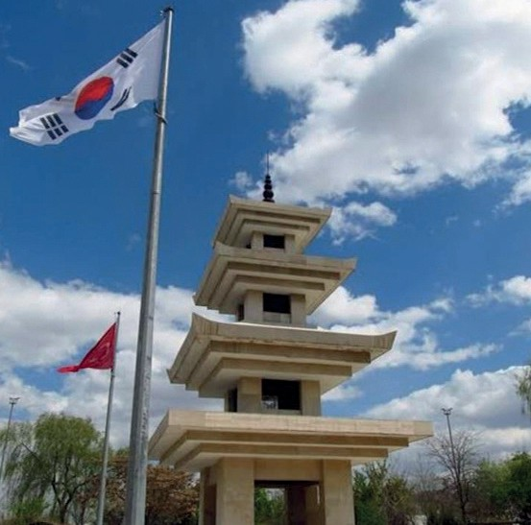

Source R: The monument at the entrance of the Turkish martyrs’ section in the United Nations Memorial Cemetery in Busan, South Korea (Kim, 2024), and the monument in Ankara to Turkish Soldiers who fought in Korea (Prepared by the authors)
Step 21: The students are asked/invited to answer the following questions based on Sources P and R.
- Source P shows the condition of the Turkish martyrs’ section within the UN Memorial Cemetery in Busan, South Korea, in the 1950s. In contrast, Source R shows its condition in a more recent period. What does the change between the two photographs tell us about the value given to the martyrs and the respect shown to their memory?
- Which values are emphasized in the inscriptions on the monument shown in Source R?
- What do the architectural elements of the monument to Turkish Soldiers who fought in Korea, shown in the second image in Source R, symbolize or evoke?
Step 22: The students are asked/invited to examine Sources S and T and Information Note 2.
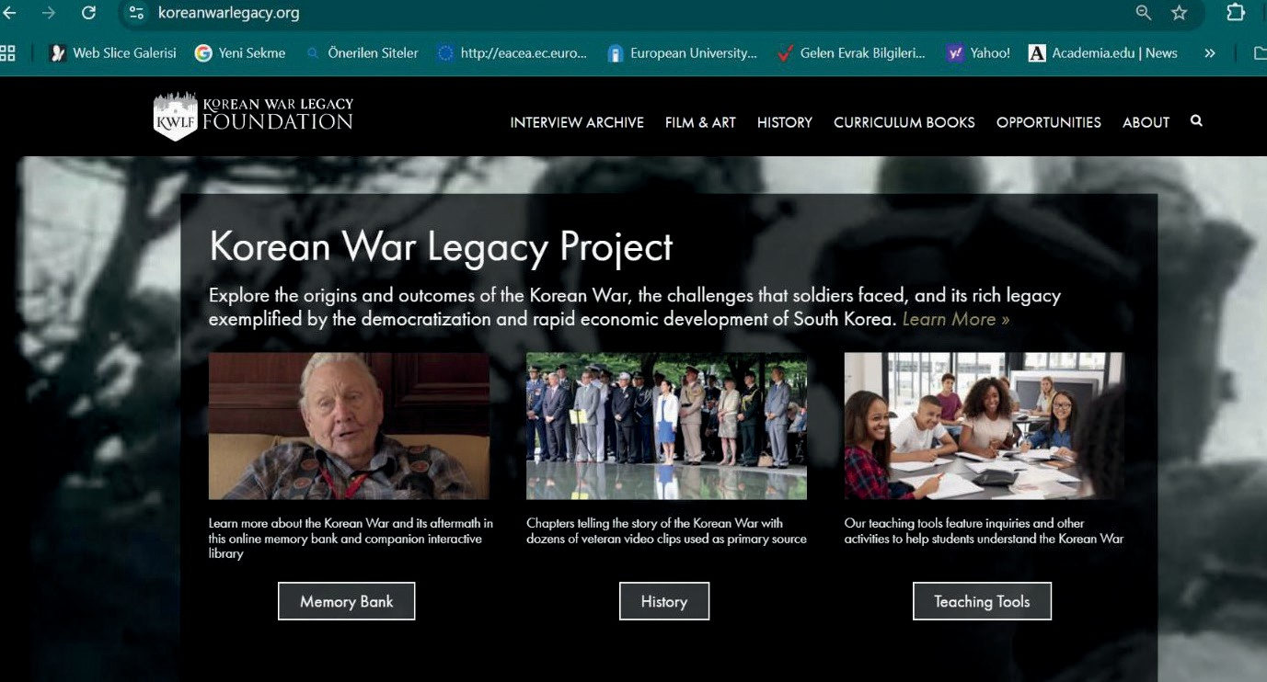
Source S: The website of the Korean War Legacy Foundation (https://koreanwarlegacy.org/)

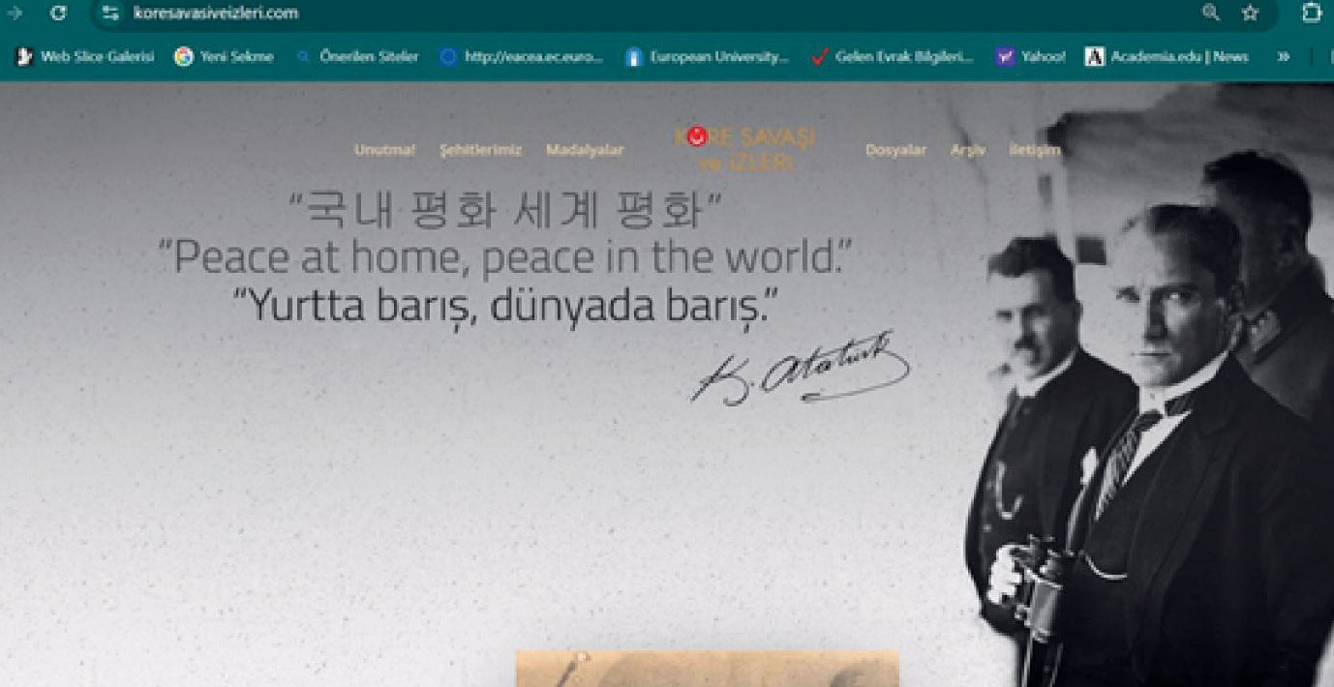
Source T: The website titled ‘Kore Savaşı ve Izleri’ (The Korean War and its traces)
(https://koresavasiveizleri.com)
Note 2:
The Korean War Legacy Foundation (also known as the Foundation for Preserving the Memory of the Korean War) is a U.S.-based foundation established with the encouragement and support of the Government of the Republic of Korea. It is an organization that works to ensure that the Korean War is not forgotten in the countries that fought on the side of the United Nations for the independence of South Korea, and to preserve the memory of those who sacrificed their lives during the war. The foundation’s website offers a rich digital archive consisting of oral history interviews conducted with approximately one thousand six hundred veterans from many countries who had participated in the war, as well as source books, teaching materials, and visual resources prepared for the teaching of the Korean War in the United States, the United Kingdom, Canada, and many other countries.
The website titled ‘Kore Savaşı ve İzleri’ (The Korean War and its Traces) is a digital archive prepared by Prof. Dr. Hakan Kumbasar, the son of the late retired Colonel and Korean War veteran Cihan Kumbasar, in order to preserve the memory of his father and his comrades-in-arms. The archive was later entrusted to the Turkish Association of Combat Veterans. The website includes various periodical and non-periodical publications, photographs, and activities organized over the years to commemorate the Korean War (prepared by the authors).
🏠
Homework
After the students are divided into groups of three, they are asked/invited to examine Source S, Source T, and Note 2, and to prepare a booklet introducing the services these websites provide to ensure that the Korean War is not forgotten and to keep alive the memory of those who sacrificed their lives during the war. The brochure should also include visuals and/or screenshots taken from the mentioned websites. If the teacher deems it appropriate, each group may alternatively be assigned to examine only one website and prepare a promotional brochure specifically for that site.

🎯Assessment and Evaluation
- What measures did the Turkish Government take to enable Turkish soldiers to meet their religious needs at the front?
- What beliefs and values contributed to the moral motivation of Turkish soldiers who participated in the Korean War? Explain this.
- What kind of state of mind (moral motivation) do the stories of our martyred soldiers show that Turkish soldiers fighting in Korea possessed?
- Write your opinion, with reasons, on whether the efforts made to commemorate the soldiers who were martyred in the Korean War are appropriate and sufficient.

References
Akseki, A. H. (1945). Askere din kitabı [Religious handbook for soldiers]. Ankara: T.C. Diyanet İşleri Başkanlığı.
Atar, F. (2010). Şehid [Martyr]. TDVİA, 38, pp. 428-431. https://islamansiklopedisi.org.tr/sehid Access Date: 21.09.2025. Cumhurbaşkanlığı Devlet Arşivleri Başkanlığı Millî Savunma Bakanlığı Askeri Tarih Arşivi. [Presidency of State Archives,
Ministry of National Defense, Military History Archive]. ATASE Place No: 42-0-55, (1951).
Cumhurbaşkanlığı Devlet Arşivleri Başkanlığı Millî Savunma Bakanlığı Askeri Tarih Arşivi. [Presidency of State Archives, Ministry of National Defense, Military History Archive]. ATASE Place No: 125-40-9, (1951).
Cumhurbaşkanlığı Devlet Arşivleri Başkanlığı Millî Savunma Bakanlığı Askeri Tarih Arşivi. [Presidency of State Archives, Ministry of National Defense, Military History Archive]. ATASE Place No: 58-359-8, (1951).
Denizli, A. (2010). Kore Harbinde şehitlerimiz: On kahraman [Our martyrs in the Korean War: Ten heroes]. Ankara: Turhan Kitabevi.
Denizli, A. (2011). Kore Kahramanı Bandırmalı Şehit Topçu Üsteğmen Mehmet Günenç [Korean War hero: Martyr Artillery First Lieutenant Mehmet Günenç of Bandırma]. Ankara: Turhan Kitabevi.
Askeri Müze ve Kültür Sitesi Komutanlığı (AsMvKSK). (2019). Fotoğraflarla Kore Savaşı’nda Türk Askeri [The Turkish soldier in the Korean War in photographs]. Askeri Müze ve Kültür Sitesi Komutanlığı.
Gülhan, T. (1996). Manevi kültürün ordu ve asker üzerindeki etkisi [The impact of spiritual culture on the army and the soldier]. Köprü, 56 (Güz). https://www.koprudergisi.com/guz-1996/manevi-kulturun-ordu-asker-uzerindeki-etkisi/ Access Date: 07.09.2025.
Gürkan, S.L. (2010). Şehid [Martyr]. TDVİA, 38, pp. 431-433. https://islamansiklopedisi.org.tr/sehid Access Date: 21.09.2025.
Han, J. (2018). Interview with Mehmet Bakış. https://koreanwarlegacy.org/interviews/mehmet-bakis/ Access Date: 09.09.2025.
Han, J. (2025). Interview with Mustafa Süt. https://koreanwarlegacy.org/interviews/mustafa-sut/ Access Date: 21.09.2025.
Kim, D. (2024). [Photograph of United Nations Memorial Cemetery in Busan, South Korea]. Google Maps. https://maps.google.com Access Date: 21.09.2025.
Korean War Legacy Foundation. (2024). https://koreanwarlegacy.org/ Access Date: 06.09.2024. Kore Savaşı ve İzleri. (2024). https://koresavasiveizleri.com Access Date: 06.09.2024.
Öner, N. (1989). Stres ve dini inanç [Stress and religious belief]. Ankara: Diyanet Vakfı Yayınları.
Özcan, A. (1996). Gazi [Veteran]. TDVİA, 13, pp. 443-445. https://islamansiklopedisi.org.tr/gazi Access Date: 21.09.2025.
Türk Dil Kurumu. (2024). https://tdk.gov.tr Access Date: 06.09.2024.
Türkiye Muharip Gaziler Derneği. (2025). Kore Savaşı: Türk Tugaylarının muharebeleri (1950–1953) [The Korean War: The battles of the Turkish brigades (1950–1953)]. https://www.muharipgaziler.org.tr/kore-savasi Access Date: 19.3.2025.

